Modelling Care Delivered to Women during the Antenatal Period within the Thanzi La Onse Model
Background: The Thanzi La Onse Model
As part of the Thanzi La Onse program a model is being developed which aims to capture the health experiences of the population of Malawi and the consequent interactions with the health care system. The intent is that this model will help to inform future delivery of health care in Malawi. The model is an individual based model – which means we explicitly simulate the individual life and health experiences of a representative proportion of population of Malawi. The simulation initiates on 1 Jan 2010 and we attempt to simulate the attributes of the population at that point. We can run the model forward to any specified future time point. Each potential intervention and its associated diseases are being modelled. This is being divided into separate disease/intervention modules. This document describes the interventions that can be delivered to women during the antenatal period of pregnancy
Background: General approach to decisions on modelling causal influences and effects of interventions
This module was designed in the context of an overall approach to modelling causal effects in general and causal effects of interventions in particular. The overall intent is to adopt as simple a structure as can be conceived, whilst still capturing the essential elements of a disease and the interventions used to prevent or treatment. We include a causal link between a “variable” (by which we mean a characteristic or property of an individual, whether that be demographic, social or biologic), and risk of disease or another variable if there is strong evidence from an overall body of studies that such a causal link exists and is at least moderately strong. In informing such decisions we place particular value on RCTs or studies with a quasi-experimental design such as analyses based on an instrumental variable. There is no expectation that such studies will be from Malawi or even from Africa. If there are such local studies and in the unlikely event that they provide strong evidence to suggest that the causal link is substantively different in Malawi then the intent is that this is taken into account and the Malawi-specific link included.
In the special case of a potential causal variable which relates to whether an individual has experienced or is experiencing an intervention the intent is to only include interventions if there is substantial RCT evidence of their beneficial effect, based on trials with objectively ascertained clinical endpoints with low risk of serious bias. Whilst DCP-3 (and to some extent the Malawi EHP) provides an initial list of such interventions and the evidence to support them, where possible our intent has been to form our own opinion on intervention efficacy based on the source trials.
Unless there is evidence to the contrary, the intent is to summarize and incorporate intervention effects into the model as relative risks or rates rather than absolute differences due to the fact that such measures are less likely to differ substantively by context. Interactions between characteristics (on the multiplicative scale) are only to be incorporated if there is strong evidence. Again, we have not intended to rely on data from Malawi or Africa for such evidence but if local evidence exists which strongly suggests a different effect than elsewhere then the intent is that this modified effect is incorporated in the model.
Background: Demographic and social characteristics modelled
Based on data on the distribution of the population in Malawi according to geographic location we assign individuals a geographic location, which maps onto whether they are classified as living in a rural or urban area. Informed largely by data from the Malawi DHS, variables are also created indicating the person’s wealth level (based on 5 quintiles), whether the person has access to improved sanitation, clean drinking water, hand washing facilities, and whether they experience indoor air pollution (wood burning stove). We assign individuals a current education status (none, primary, secondary) which is updated 3 monthly from age 5 to 20. We assign individuals a current education status (none, primary, secondary) which is updated 3 monthly from age 5 to 20. From age 15 on BMI (in 5 groups) is assigned, as well as using tobacco, drinking excess alcohol, having low exercise, high salt intake, high sugar intake. The status with regard to such variables for individuals can change over time. The influences between these variables are described in detail in a separate document.

Approach to modelling Antenatal Care (ANC): rationale for model structure and choice of parameter values
Broadly, this model describes health care interventions delivered to women during the antenatal period of pregnancy. These can be thought of as outpatient interventions (routine antenatal care, outpatient follow-up for management of anaemia/gestational diabetes) and inpatient interventions (post-abortion care, ectopic pregnancy case management, antenatal inpatient care for women during pregnancy)
Complications and/or diseases of pregnancy that antenatal interventions will effect are modelled separately and described in detail in the Pregnancy Supervisor documentation. We define ANC as the care of a woman from conception until the onset of labour, or the end of pregnancy. Care seeking for ANC is split across this model and the Pregnancy Supervisor model but is described in full here. Any definitions of terms related to complications/diseases of pregnancy can be found in the Pregnancy Supervisor document.
Variables modelled & updating variables
Broadly we store information within this module about a woman’s antenatal care schedule, interventions delivered during antenatal care and interventions delivered as an inpatient.
Regarding antenatal care scheduled we store the total number of visits a woman has attended in this pregnancy (integer), the type of facility in which she receives her antenatal care (health centre/hospital), the date on which she will attend her next contact.
Information about interventions delivered during ANC include whether a woman has been initiated on the following treatments; iron and folic acid (yes/no), daily calcium supplementation (yes/no), daily balanced energy and protein supplementation (yes/no), intermittent preventative treatment of malaria she has received (number of doses- integer), insecticide treated bed net (yes/no), tetanus toxoid booster (number of doses-integer).
Information about interventions delivered during inpatient care include whether a woman has been started on oral antihypertensives (yes/no), received case management for gestational diabetes (yes/no), undergone case management of ectopic pregnancy (yes/no), which interventions she has received as part of post abortion care (evacuation, blood, antibiotics, injury repair), received antibiotics for PROM (yes/no), received antibiotics for chorioamnionitis (yes/no), magnesium sulphate for pre-eclampsia/eclampsia (yes/no), received intravenous anti-hypertensives (yes/no), received a blood transfusion (yes/no) or has been admitted for delivery as treatment.
Routine Antenatal Care (ANC)
Context - ANC in Malawi
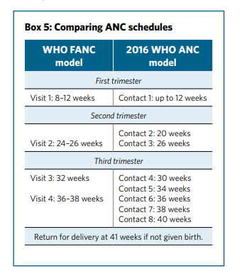
In 2016 Malawi, along with numerous other low income countries, adopted the newly released WHO ANC guidelines entitled ‘WHO recommendations on antenatal care for a positive pregnancy experience’ (WHO 2016). This new guidelines doubled the recommended number of ANC visits, now renamed ‘contacts’, from 4 to 8 in the duration of pregnancy, following a systematic review which reported a reduced risk of perinatal death during pregnancy in women who underwent ANC contact schedules with greater than 4 visits (Dowswell et al., 2015). The recommended schedule of these contacts can be seen in figure 1. Notably, over half of these contacts will occur in the final 10 weeks of pregnancy, and will largely focus on issues of birth preparedness (WHO 2016).
Figure 1. Comparison of FANC and the 2016 ANC schedules (WHO 2016)
Whilst this schedule is more reflective of ANC delivered in high income countries, it seems substantially less attainable in a number of low-income settings where access to ANC is already lower than recommended by the WHO 2002 Focused ANC guidelines (Saad-Haddad et al., 2016).
Data from the most recent Demographic and Health Survey (DHS) (2017) in Malawi shows that:
- Whilst 95% of women attend at least one ANC contact during their pregnancy;
- Only 51% attended 4 or more ANC contacts;
- And only 21% attended their first ANC contact in their first trimester (<12 weeks)
We will first simulate current coverage and uptake of ANC before running simulations of improved coverage to evaluate the impact on maternal and perinatal health. The recommended set of interventions delivered during each ANC contact in Malawi is taken from an adapted ‘Antenatal Care Matrix’ provided by the Reproductive Health Department of the Malawian Ministry of Health (year of publication unknown). This document is supported by Malawi’s most recent ANC guidelines also provided by the government (year of publication unknown) on request. The following sections will explore the logic behind care seeking and intervention delivery during ANC.
Care seeking
Due to the variation in both gestational age at attendance of first ANC and number of ANC contacts per pregnancy there are a number of questions that must be addressed in order to accurately simulate care seeking for ANC in Malawi:
- When, if at all, will a newly pregnant woman present for the first ANC contact of her pregnancy?
- Will she return for a subsequent ANC contact after the first?
- If so, how many contacts is she likely to attend during pregnancy?
Scheduling First Antenatal Care Contact
At week 3 of a woman’s gestation we determine if and when a newly pregnant woman will attend her first ANC contact (ANC1) during her pregnancy. Probability of gestational age at ANC1 will be taken from a model developed by Mkandawire (2015). Mkandawire’s study applies a Lognormal Hazard model to the 2010 Malawi DHS data to output probability of attendance of ANC1 by gestational age.
From this model he derives Time Ratios (TR) to demonstrate the relationship between variables and early attendance of ANC1. A TR of less than one demonstrates ANC was initiated earlier than the reference category whilst a TR of more than one demonstrates later initiation. Multivariate hazard analysis demonstrates that being aged 20-29 (TR 1.05), 30-39 (TR 1.07), and 40-49 (TR 1.09) was significantly associated with later presentation to ANC1, compared to the reference group 15-19 year olds (Mkandawire, 2015). Similarly this being a woman’s second pregnancy (TR 1.02) or third or greater pregnancy (TR 1.05) was also a significant predictor of later attendance (Mkandawire, 2015). These predictors have not yet been modelled and this will be discussed with the wider team.
Using the probabilities of ANC1 by gestational age within a weighted a random draw we select a month of pregnancy that each woman will present for her first ANC and schedule this visit accordingly.
At this time we will also predict if this woman will attend four or more ANC visits during her pregnancy (ANC4+). This probability is derived from a model developed by Wingston Ng’ambi, an epidemiologist from the Malawian College of Medicine and TLO team member, and includes a number of predictors to determine if a woman will attend ANC4+. The current analysis uses a combined outcome variable of ANC4+ with the first visit occuring in, or before, month 4. We will re-run the analysis to determine accurate predictors for ANC4+ only and document accordingly.
This is stored as a Boolean variable associated with the Pregnancy Supervisor module and is used as part of the sequence of events which schedules additional ANC contacts for women (as seen in figure 1).
Subsequent Antenatal Care Visits
ANC contacts 2-8 are scheduled via a daisy-chaining method. At each ANC contact we determine if this woman will return for the next contact in the schedule in a number of ways (demonstrated in figure 2):
- At ANC1, 2 and 3, women who are predicted to undertake four or more ANC contacts (ANC4+) are automatically scheduled to attend the next ANC contact in the schedule until they reach contact 4

- Women who are predicted to attend ANC4+ and have already attended 4 visits, will have a probability of continuing to the next contact in the schedule applied at the end of every additional ANC contact

- Women who are not predicted to achieve ANC4+ will have a probability of continuing their ANC schedule applied at every visit from ANC1 till visit 3. Following visit 3 they are blocked from seeking additional ANC
Probability of ANC continuing
We currently apply a dummy probability of a woman continuing to the next contact in her ANC schedule at the end of each contact. It is assumed that this probability of attending the next ANC contact is not the same for all women and will likely be impacted by a number of predictors, most likely complications or present symptoms. This equation will be developed as we move forward with the model
Gestation and scheduling additional ANC contacts
We assume that all women who present for ANC1 (and choose to return for ANC2) will be scheduled their next contact dependent on their gestational age at presentation to ANC1. We scheduled women to return at the recommended gestational age for the next contact in the schedule. For example if a woman presents for ANC1 at 27 weeks, she will be booked to return at 30 weeks, the nearest next visit in the schedule. We discuss how late presentation effects administration of interventions in the next section.
Figure 2. Diagram illustrating logic behind care seeking
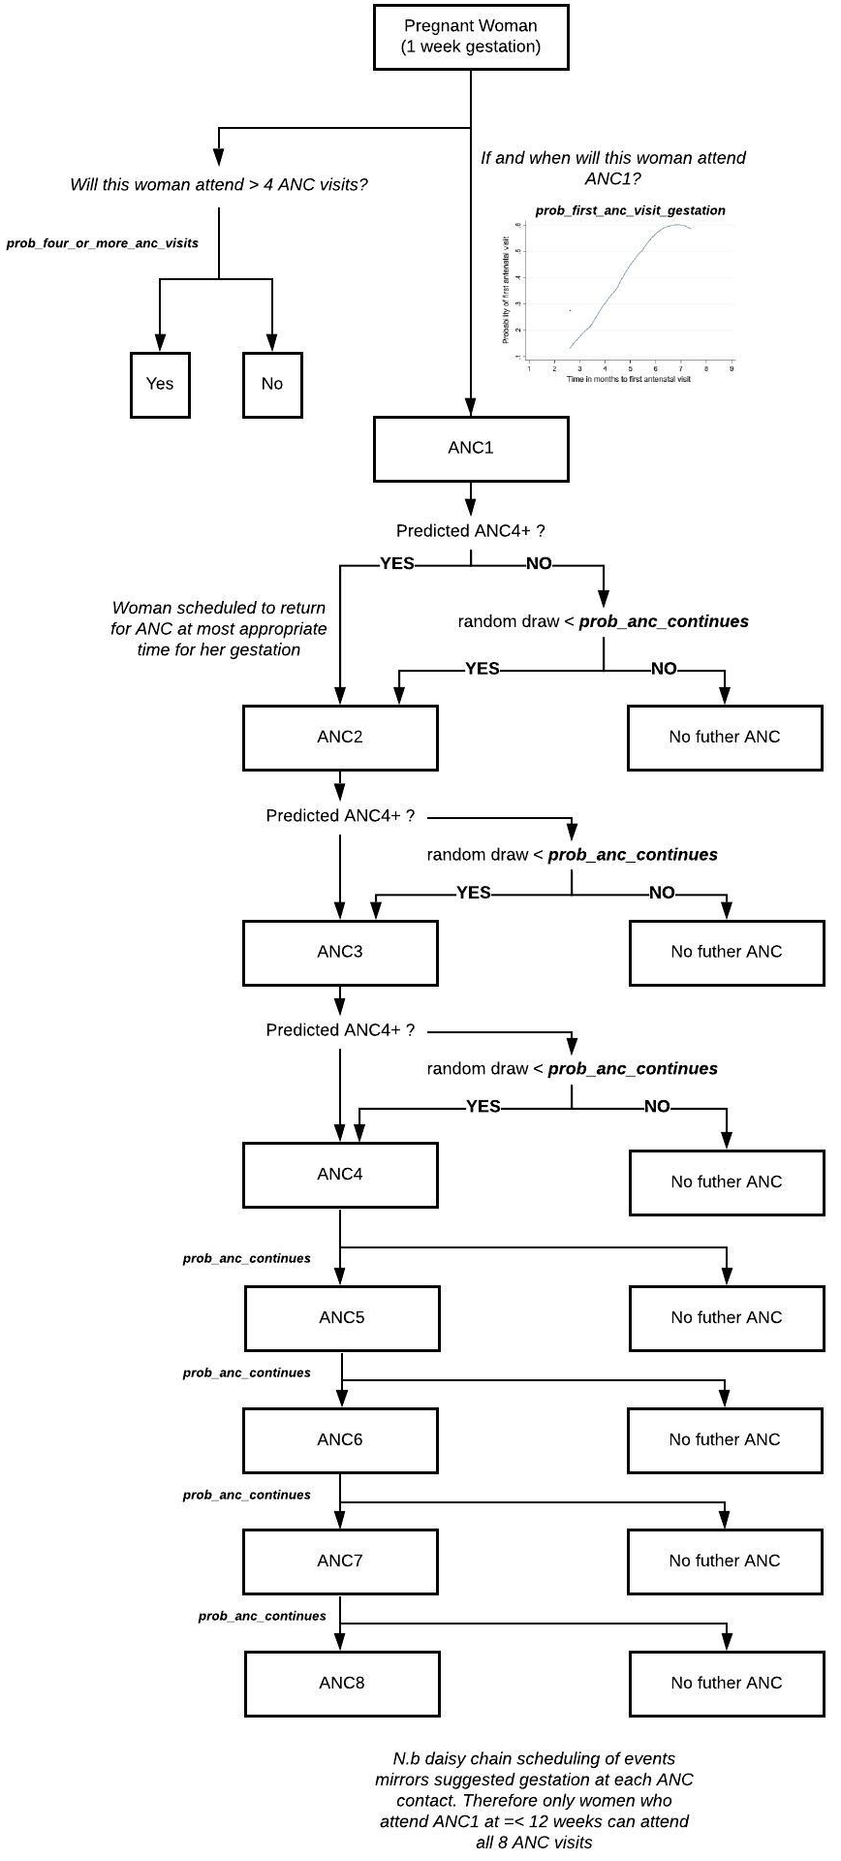

Table 1. Description of variables created relating to health care during pregnancy
Variable | Description | Notes and Major Assumptions
ac_total_anc_visits_current_pregnancy | Rolling total of antenatal visits this woman has
ac_facility_type | Type of facility that a woman will receive ANC in for her pregnancy | The facility type a woman presents to for ANC 1 is the facility type they present at for all future visits
ac_date_next_contact | Date on which this woman is scheduled to return for her next ANC contact
ac_to_be_admitted | Whether this woman requires admission following an ANC visit | From ANC to the antenatal ward
ac_receiving_bep_supplements | whether this woman is receiving daily balanced energy protein supplementation
ac_receiving_calcium_supplements | whether this woman is receiving daily calcium supplementation
ac_doses_of_iptp_received | 'Number of doses of intermittent preventative treatment in pregnancy received during this pregnancy
'ac_itn_provided' | 'Whether this woman is provided with an insecticide treated bed net during the appropriate ANC visit
'ac_ttd_received' | Number of doses of tetanus toxoid administered during this pregnancy
ac_gest_htn_on_treatment | Whether this woman has been initiated on treatment for gestational hypertension | Represents oral antihypertensives
ac_gest_diab_on_treatment | Treatment this woman is receiving for gestational diabetes, categories=['none', 'diet_exercise', 'orals', 'insulin']
ac_ectopic_pregnancy_treated | 'Whether this woman has received treatment for an ectopic pregnancy
'ac_post_abortion_care_interventions' | bitset list of interventions delivered to a woman undergoing post abortion care | Interventions include blood, antibiotics, injury repair
'ac_received_abx_for_prom' | 'Whether this woman has received antibiotics as treatment for premature rupture of membranes
'ac_received_abx_for_chorioamnionitis': | Whether this woman has received antibiotics as treatment for chorioamnionitis rupture of membranes
ac_mag_sulph_treatment | Whether this woman has received magnesium sulphate for treatment of severe pre-eclampsia/eclampsia
ac_iv_anti_htn_treatment | 'Whether this woman has received intravenous antihypertensive drugs for treatment of severe Hypertension
ac_received_blood_transfusion | 'Whether this woman has received a blood transfusion antenatally
ac_admitted_for_immediate_delivery | Admission type for women needing urgent delivery in the antenatal period' categories=['none', 'induction_now', 'induction_future',  'caesarean_now','caesarean_future'] | From antenatal ward to labour ward
ac_inpatient | 'Whether this woman is currently an inpatient on the antenatal ward'

Table 2. Description of parameters and proposed values.
Value provided in this table are not finalised and are pending a more detailed review of the relevant literature
Variable | Value | Description
prob_anc_continues | 0.7 | This is a dummy
prob_an_ip_at_facility_level_1_2_3 | [0.33, 0.33, 0.34]
prob_intervention_delivered_urine_ds | 0.9
prob_intervention_delivered_bp | 0.9
prob_intervention_delivered_ifa | 0.9
prob_intervention_delivered_bep | 0.9
prob_intervention_delivered_llitn | 0.9
prob_intervention_delivered_tb_screen | 0.9
prob_intervention_delivered_tt | 0.9
prob_intervention_delivered_calcium | 0.9
prob_intervention_delivered_poct | 0.9
prob_intervention_delivered_albendazole | 0.9
prob_intervention_delivered_hepb_test | 0.9
prob_intervention_delivered_syph_test | 0.9
prob_intervention_delivered_hiv_test | 0.9
prob_intervention_delivered_iptp | 0.9
prob_intervention_delivered_gdm_test | 0.9
sensitivity_bp_monitoring | 0.9
specificity_bp_monitoring | 0.9
sensitivity_urine_protein_1_plus | 0.9
specificity_urine_protein_1_plus | 0.9
sensitivity_poc_hb_test | 0.9
specificity_poc_hb_test | 0.9
sensitivity_fbc_hb_test | 0.9
specificity_fbc_hb_test | 0.9
sensitivity_blood_test_glucose | 0.9
specificity_blood_test_glucose | 0.9
effect_of_ifa_for_resolving_anaemia | 0.5
treatment_effect_blood_transfusion_anaemia | 0.95
effect_of_iron_replacement_for_resolving_anaemia | 0.75
effect_of_iron_replacement_for_resolving_iron_def | 0.4
effect_of_folate_replacement_for_resolving_anaemia | 0.75
effect_of_folate_replacement_for_resolving_folate_def | 0.4
effect_of_b12_replacement_for_resolving_anaemia | 0.75
effect_of_b12_replacement_for_resolving_b12_def | 0.4
treatment_effect_mag_sulph | 0.4
treatment_effect_iv_anti_htn | 0.5
treatment_effect_bt_aph | 0.75
prob_evac_procedure_pac | [0.43, 0.554, 0.016]

Approach to modelling interventions related to Antenatal Care
Women are recommended to attend 8 ANC contacts during their pregnancy. At each contact a number of interventions are delivered including nutritional interventions, maternal and foetal assessment, preventative measure and management of common physiological symptoms of pregnancy (WHO 2016).
We have selected key interventions from the Malawian ANC matrix to include in the model. The schedule of intervention administration, adapted from this matrix is shown in figure 3.
Figure 3. Adapted Malawi ANC matrix
Gestation | First | Second Trimester |  |  | Third trimester
Contact Number | 1 | 2 |  | 3 | 4 |  | 5 |  | 6 |  | 7 |  | 8
Recommended Gestation Per Contact | up to 12 wks | 20 wks |  | 26 wks | 30 wks |  | 34 wks |  | 36 wks |  | 38 wks |  | 40 wks
Observations and clinical investigations
Blood pressure | √ | √ |  | √ | √ |  | √ |  | √ |  | √ |  | √
Laboratory investigations and Ultrasound
Blood
Haemoglobin | √ |  |  |  |  |  |  |  | √
Syphilis testing | √ |  |  |  |  |  | √
Hepatitis B testing | √ |  |  |  |  |  | √
Ultrasound | √ | √ |  |  |  |  | (√)
Urine
Protein | √ | √ |  | √ | √ |  | √ |  | √ |  | √ |  | √
Sugar | √ | √ |  | √ | √ |  | √ |  | √ |  | √ |  | √
Acetone | √ | √ |  | √ | √ |  | √ |  | √ |  | √ |  | √
Nitrate | √ | √ |  | √ | √ |  | √ |  | √ |  | √ |  | √
Leucocytes | √ | √ |  | √ | √ |  | √ |  | √ |  | √ |  | √
TB testing (if applicable)
Pregnancy test | √
Drug administration , supplementation and immunization
Iron | √ | √ |  | √ | √ |  | √ |  | √ |  | √ |  | √
Folic acid | √ | √ |  | √ | √ |  | √ |  | √ |  | √ |  | √
Tetanus toxoid | √ | √
Albendazole |  | √
IPTp-SP (or other antimalarias) |  | √ |  | √ | √ |  | √ |  |  |  | √
Calcium daily supplementation (1.5-2.0 gr oral element) For high risk group for preeclampsia |  | √ |  | √ | √ |  | √ |  | √ |  | √ |  | √
Food Supplementation | √ | √ |  | √ | √ |  | √ |  | √ |  | √ |  | √
LLITN distribution | √

Effect of late presentation on intervention delivery
WHO (2016) guidelines recommend that for women who present late to ANC1, should receive any/all interventions they have missed from any previous contacts that they have not attended.
For example if a woman presents to ANC1 at 31 weeks gestation, she scheduled to return for ANC2 at 34 weeks gestation (according to the above care seeking equation), which is contact 5 in the ANC schedule. She will receive all the interventions she has missed from the first 4 ANC contacts on her first visit, plus any interventions delivered specifically at contact 5. Consumables for daily interventions (i.e. iron and folic acid) will correspond with the remaining estimated number of days left in each woman’s pregnancy.
This methodology means that all women seeking ANC1 later than recommended enter the contact schedule at the right gestational age. This also means we are able to model the effect of late presentation to ANC as these women will not have received any daily interventions in pregnancy (such as iron/folic acid) which will reduce monthly risk of negative outcomes (i.e. anaemia).
The effect of late presentation on contact schedule is demonstrated in table 3.

Table 3. Description of intervention delivery for each ANC contact by gestational age at first presentation
Gestational age at ANC1  (weeks) | Interventions delivered 1STcontact | Interventions delivered 2nd contact | Interventions delivered 3rd contact | Interventions delivered 4th contact | Interventions delivered 5th contact | Interventions delivered 6th contact | Interventions delivered 7th contact | Interventions delivered 8th contact
< 20 | ANC1 | ANC2 | ANC3 | ANC4 | ANC5 | ANC6 | ANC7 | ANC8
20-25 | ANC1-2 | ANC3 | ANC4 | ANC5 | ANC6 | ANC7 | ANC8
26-29 | ANC1-3 | ANC4 | ANC5 | ANC6 | ANC7 | ANC8
31-34 | ANC1-4 | ANC5 | ANC6 | ANC7 | ANC8
35-36 | ANC1-5 | ANC6 | ANC7 | ANC8
36-38 | ANC1-66 | ANC7 | ANC8
39 | ANC1-7 | ANC8

Quality of care
As with skilled birth attendance, quality of care delivered at each ANC contact is an important predictor of outcomes and service use (Creanga et al., 2017). Data from the Malawi Service Provision Assessment (SPA) (2014) shows that quality of care provided by HCW during ANC is low, when considering proportion of key interventions delivered per visit, and varies significantly between facility type.
Presently we apply probabilities that each intervention will be delivered during an ANC contact. These probabilities will be informed by the SPA data (2014) for each intervention to replicate the quality of care of ANC contact in Malawi. These probabilities appear to vary by facility type (hospital vs health centre) and this will need to be modelled accordingly. Including this logic, delivery of interventions is therefore condition on:
- Probability that the HCW will initiate this intervention/screening process
- (if applicable) sensitivity and specificity of the screening test
- Probability that the consumables required for this intervention are available at the facility level
Once the availability of consumables are available within the model we will use the probability parameters to calibrate the outcome of the model to the SARA survey data so that we can map the likelihood a woman will receive an intervention to the facility type she is receiving care in.
Interventions – Screening
Blood pressure monitoring
Malawian ANC guidelines recommend measuring a woman’s blood pressure at every ANC contact in the schedule, and is part of the WHO (2011) guidelines for ‘Prevention and treatment of pre-eclampsia and eclampsia’ during pregnancy. We will apply a sensitivity and specificity parameter to blood pressure test, as auscultation of blood pressure is not always accurate in detecting systolic or diastolic hypertension in pregnancy (Nathan et al., 2015). These values have not yet been included in the model.
If a woman has had her blood pressure tested and is discovered to be hypertensive she will be scheduled to be admitted to the antenatal ward for initiation of treatment (described below).
Urine dipstick
Similar to blood pressure monitoring, Malawian guidelines recommend that women should have a dipstick test performed on a urine sample at every visit. As per Malawian Standard Treatment Guidelines (Malawian Ministry of Health, 2015) and Malawian Obstetrics and Gynaecology Guidelines (The Association of Obstetricians & Gynaecologists of Malawi, 2014) proteinuria in the presence of hypertension should be diagnosed as pre-eclampsia and treated accordingly. Women with diagnosed pre-eclampsia will be admitted to the antenatal ward for initiation of treatment (described below)
Point of care haemoglobin testing
Guidelines recommend that women have their haemoglobin tested at 12 and 36 weeks gestation to detect anaemia. We assume this testing is done via point of care Hb testing and any women found to be anaemic will be admitted to the antenatal ward for initiation of treatment (described below).
Screening for HIV
Screening for HIV is not included in the ANC matrix provided by Malawi’s MoH but we understand it is recommended within national HIV policy. We assume that HIV testing occurs in the first ANC contact and woman are passed to the HIV model for management. The HIV model is described in detail elsewhere.
Screening for TB
Similarly to screening for HIV, screening for TB is not included in the ANC matrix. We assume all woman are screened for TB during the first ANC visit. Testing and treatment is managed by the TB model which is described in detail elsewhere.
Screening for Hepatitis B and Syphilis
Currently neither Hepatitis B of Syphilis are modelled explicitly within the TLO framework but these screening interventions have been included in this model to map to consumables.
Interventions – Drug administration
The screening interventions above, if delivered, will trigger additional care either within this model or within another related model. In addition to screening women who receive antenatal care should receive a number of medical interventions to improve potential outcomes of pregnancy. The effect of these interventions is summarised in table 3 and the contact that they are delivered during can be found in the ANC matrix (figure 3).
Table 3. Overview of treatment effects for interventions delivered within ANC
Intervention | Treatment effect | Source for intervention effect
Iron and folic acid supplementation | Reduces monthly risk of iron deficiency (RR 0.44)  Reduces monthly risk of folate deficiency (RR 0.44) | Daily oral iron supplementation during pregnancy, source (Pena-Rosas et al. 2015)
Calcium supplementation | Reduces monthly risk of mild pre-eclampsia onset (RR 0.41)  Reduces monthly risk of mild gestational hypertension onset (RR 0.55)  Reduces monthly risk of preterm labour onset (RR 0.88) | Role of calcium supplementation during pregnancy in reducing risk of developing gestational hypertensive disorders: a metaanalysis of studies from developing countries (Imdad et al. 2011)
Balanced energy and protein supplementation | Reduces monthly risk of still birth (RR 0.3) | Effect of balanced protein energy supplementation during pregnancy on birth outcomes (Imdad et al. 2011)
Albendazole | No treatment effect modelled due to lacking evidence of effect | N/A
Tetanus toxoid | Treatment effect modelled via EPI model | Please see EPI documentation
IPTp | Treatment effect modelled via Malaria model | Please see Malaria documentation
Insecticide treated nets | Treatment effect modelled via Malaria model | Please see Malaria documentation

Women are initiated on/given medication interventions during the correct visit of the ANC matrix. We currently assume that
Intervention – Admission
The basic components of ANC (as depicted in the ANC matrix in figure 3) can be considered to be an extended process of monitoring and preventative treatment to prevent/minimise the risk of negative maternal and perinatal outcomes. In the instance that women who have attended ANC are determined to require additional treatment, outside of the remit of care delivered via basic ANC, they may need referral for additional treatment. Detection of the following complications during any of a woman’s ANC contacts trigger referral for admission:
- Anaemia (of any severity)
- Gestational hypertension or pre-eclampsia (of any severity)
- Gestational diabetes
Women are immediately admitted to the antenatal ward for the initiation of more advanced care which is described in detail below.
Antenatal Inpatient Care
Within this model women can arrive for inpatient care via two distinct pathways:
- The woman self presents after the onset of a complication of her pregnancy which she identifies and seeks care for
- The woman is referred following any of her ANC contacts due to positive screening for a complication of her pregnancy (in the bullets above)
Care is delivered to women according to the underlying condition they present with. There is no diagnostic algorithm within this model therefore women will receive the correct treatment according to the conditions they present to the inpatient ward with (if the consumables are available). Treatment protocols are adapted from the Malawian Standard Treatment Guidelines (Malawian Ministry of Health, 2015) and Malawian Obstetrics and Gynaecology Guidelines (The Association of Obstetricians & Gynaecologists of Malawi, 2014) and simplified where appropriate.
Treatment and monitoring for Anaemia in pregnancy
Treatment for anaemia is determined by Haemoglobin level (Hb) following testing. On presentation to inpatient care women will receive a full blood count (FBC) test which will return the severity of a woman’s anaemia as either none, mild/moderate or severe.
Figure 4. Treatment cascade for anaemia inpatient care

If anaemia is not detected via the FBC that woman is discharged and no additional care is delivered. If mild anaemia is detected the HCW will start a woman on regular iron and folic acid supplementation (if she has not been initiated on this treatment during her routine ANC). We apply a probability that initiation of iron and folic acid will rectify this woman’s anaemia prior to follow-up (in 4 weeks’ time). Currently we take this treatment effect from a Cochrane review of the effect of daily iron and folic acid supplementation on iron deficiency at term (RR 0.43; 95% CI 0.27 to 0.66 (Peña-Rosas et al., 2015)). If the treatment is effective her anaemia is reset to ‘none’ and no additional treatment will be taken at follow-up. This woman will also now be at reduced risk of future iron and folic acid deficiencies
Additionally we assume women are tested for any anaemia causing deficiencies (iron/folate/b12) and receive the following treatments as per the Malawian Obstetrics and Gynaecology Guidelines:
- For iron deficiency - elemental iron 200 mg PO OD.
- For B12 deficiency - vitamin B12 1000 mg IM monthly.
- For folate deficiency - folate 1 mg PO OD.
Here we again apply a probability that these treatment will rectify this woman’s underlying deficiency (reducing her risk of anaemia reoccurring in the next month of her pregnancy) and rectify her anaemia prior to her next follow up appointment, currently using dummy probabilities prior to final search of treatment effects.
Women with severe anaemia receive all treatments described above in addition to blood transfusion. We apply an assumed treatment effect of close to 0 that a blood transfusion will rectify this woman’s severe anaemia.
All women, regardless of severity, are scheduled to return for an outpatient FBC to confirm if their anaemia has resolved. If no anaemia is detected there is no further action taken. If they are determined to be anaemic again they are readmitted for treatment.
Treatment and monitoring for Gestational Diabetes
Gestational diabetes detected during ANC is treated via first-line, second-line and third-line interventions. Women are first initiated on a trial of diet and exercise in an attempt to control their hyperglycaemia and scheduled to return for a blood glucose test in four weeks’ time. After initiation of treatment a probability that this treatment will effectively control a woman’s hyperglycaemia is applied via the PregnancySupervisor module (currently using dummy values) prior to the follow-up appointment. If the treatment is effective no additional action will be taken during the follow-up appointment and no further follow up is scheduled. If the initial treatment has not been effective, and a woman’s GDM is still ‘uncontrolled’ then she will be started on the next treatment and so on – please see figure 5.
Only women who are on treatment and their diabetes is ‘controlled’ will benefit from treatment. The treatment effect currently modelled is a modest effect in the reduction of antenatal still birth take from the a paper used to populate the LIST (RR 0.9 (Syed et al., 2011))

Figure 5. Treatment cascade for gestational diabetes

Treatment and monitoring for mild hypertension in pregnancy
As with anaemia, treatment of hypertension for inpatients is varied by severity. Women with more mild hypertension (mild gestational hypertension/mild pre-eclampsia) are simply initiated on regular oral antihypertensives and discharged. A recent Cochrane review evaluating oral antihypertensives in pregnancy found that medication was effective in reducing risk of developing severe gestational hypertension (RR 0.49 (Abalos et al., 2018)) but no other significant effects on maternal or perinatal outcomes. Therefore in this model women are only at reduced monthly risk of progression to severe disease. However this will have an effect on mortality due the woman’s increased risk of death during pregnancy whilst suffering from severe hypertension (described in pregnancy model documentation).
Figure 6. Treatment cascade for the hypertensive disorders of pregnancy

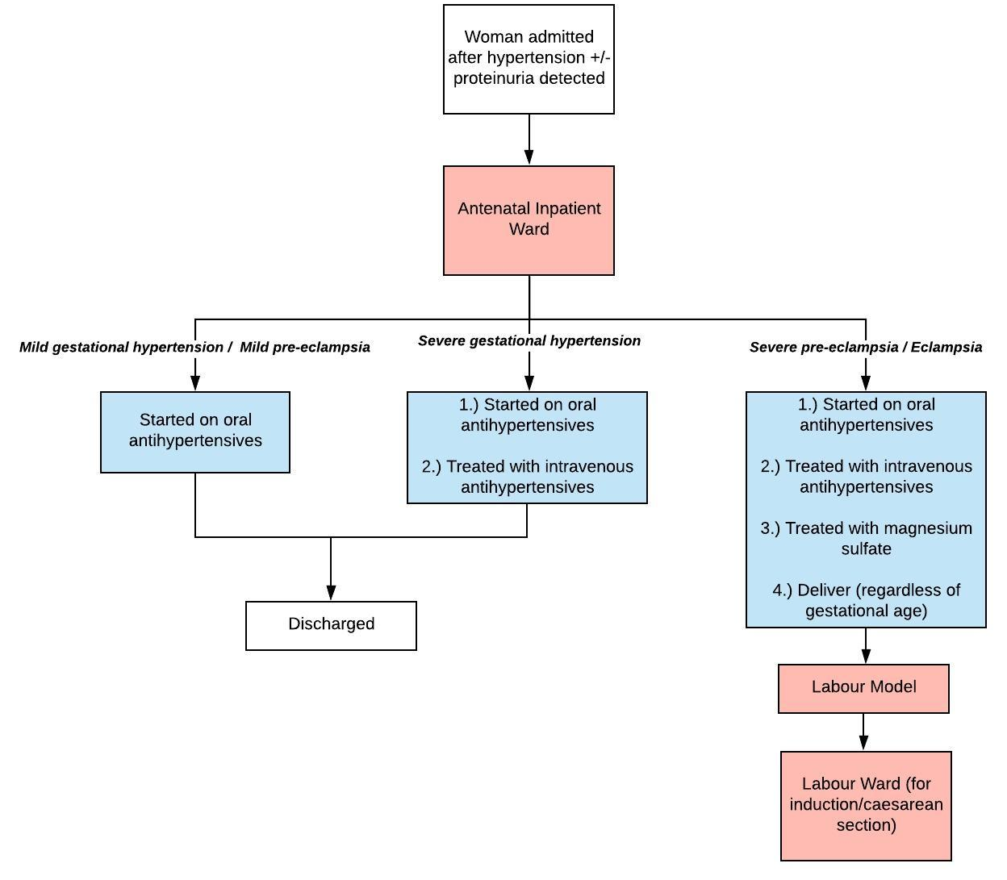

Treatment for severe hypertensive disorders in pregnancy
Malawian Obstetrics and Gynaecology Guidelines do not specifically differentiate between the treatment of mild/moderate gestational hypertension and severe hypertension however in the Malawian Standard Treatment Guidelines (Malawian Ministry of Health, 2015) intravenous hypertensive therapy is recommended for severe hypertension. As seen in figure 6 we initiate all woman with severe gestational hypertension on intravenous antihypertensives. We assume their hypertension is therefore reverted to mild, implicitly reducing their risk of death as their pregnancy continues.
Women with severe pre-eclampsia/eclampsia have a more complex treatment protocol:
- Initiated on intravenous antihypertensives which reduce risk of death (RR 0.5 (Pollard, Mathai and Walker, 2013))
- Treated with magnesium sulphate which
  - Reduces risk of death if woman is already eclamptic (RR 0.5 (Pollard, Mathai and Walker, 2013) )
  - Reduces risk of progression from severe pre-eclampsia to eclampsia (RR 0.41 (Duley et al., 2010))
- Admitted for delivery, regardless of gestation, which reduces risk of antenatal stillbirth (women may still experience still birth in the intrapartum period)
When being admitted for delivery woman are passed to the labour module (described elsewhere) which calculates a woman’s risk of death and stillbirth secondary to these complications, mitigated by the treatment she has received in the antenatal inpatient ward.
Treatment for Antepartum haemorrhage
The assumed aetiology of antepartum bleeding within this framework is placental in nature, either being placenta praevia or placental abruption. There is mild variation in treatment depending on the underlying conditions leading to bleeding as seen in figure 7. As per guidelines women with bleeding are indicated to undergo delivery to deliver foetus and placenta and prevent further bleeding. For milder bleeding secondary to placenta praevia women will remain as inpatients until their gestation has increased prior to delivery.
Women with antepartum haemorrhage will receive additional treatment in the labour model including blood transfusion which will reduce risk of maternal death (RR 0.75 Pollard, Mathai and Walker, 2013)). As with mentioned above a woman’s risk of death and stillbirth secondary to these complications, mitigated by the treatment she has received in the antenatal inpatient ward is calculated in the labour model.

Figure 7. Treatment cascade for antepartum bleeding

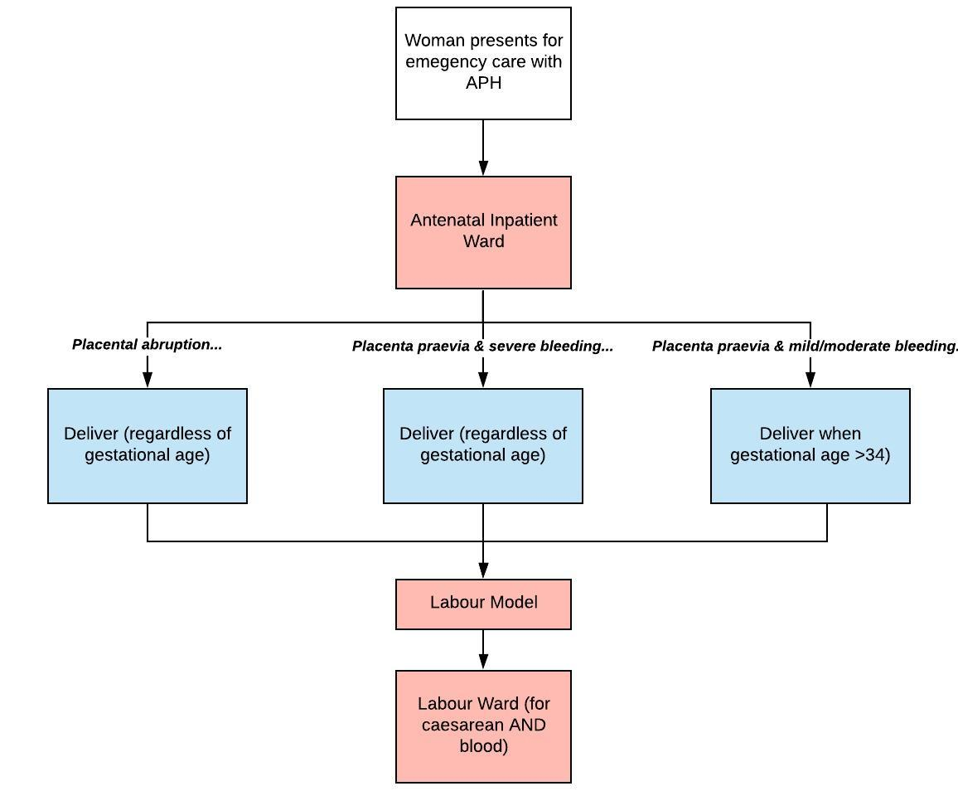

Treatment for PROM and chorioamnionitis
PROM is assumed to be a pregnancy emergency which may trigger care seeking outside of routine antenatal care. Women who present for inpatient treatment due to PROM receive slightly modified treatment depending on whether a woman is also experiencing chorioamnionitis as seen in figure 7. Women with PROM are provided with prophylactic antibiotics which reduce risk of newborn sepsis (RR 0.61 (Cousens et al., 2010)). Additionally women will be scheduled to deliver via induction when they have reached a gestational age of 34 weeks.
If a woman is admitted due to PROM and chorioamnionitis she will receive full sepsis case management which will reduce her risk of death from sepsis in labour (RR 0.2 Pollard, Mathai and Walker, 2013)) and will be immediately delivered regardless of gestational age

Figure 7. Treatment cascade for PROM +/- chorioamnionitis
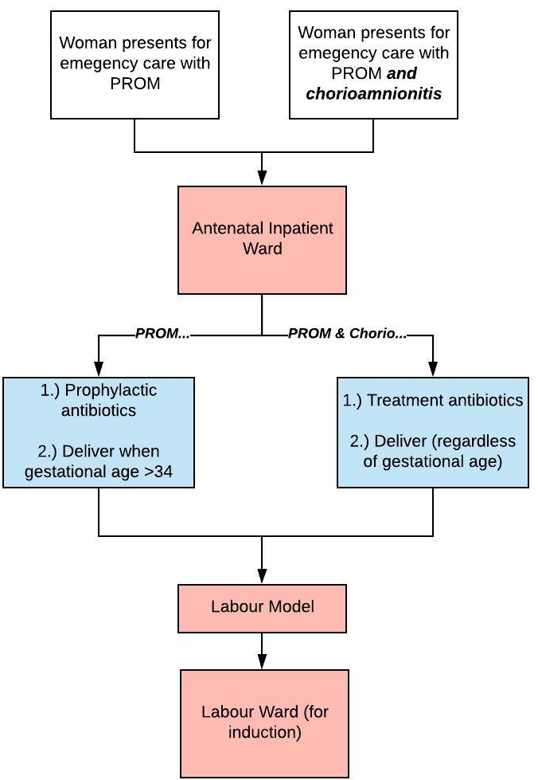

Table 4. Overview of treatment effects for interventions delivered via the antenatal ward
Condition | Treatment (s) | Treatment effect | Source for intervention effect
Mild Anaemia
Severe Anaemia
Gestational diabetes
Mild pre-eclampsia
Mild gestational hypertension
Severe gestational hypertension
Severe pre-eclampsia
Eclampsia
Antepartum Haemorrhage
PROM
Chorioamnionitis

Ectopic Pregnancy Case Management
Following possible onset of symptoms of ectopic pregnancy between 5 and 8 weeks gestation women may choose to seek care for treatment (prior to rupture). We assume women present through a generic emergency appointment and are then scheduled to receive surgical management of ectopic pregnancy. Currently there is no diagnostic algorithm in this first generic emergency appointment and we assume all women who present with ectopic pregnancy will get the correct treatment.
Treatment for ectopic pregnancy, as described in the Malawian Obstetrics and Gynaecology Guidelines includes either laparoscopy or laparotomy for removal of the pregnancy. If the woman has sought treatment before she experiences rupture we assume she is not at risk of death as rupture is on the causal pathway to death and has been avoided. If she presents post-rupture we assume she is at risk of death and apply a case fatality rate which is modified by the treatment effect (RR 0.1 (Pollard, Mathai and Walker, 2013)).
Post abortion care
Following either induced or spontaneous abortion women may experience complications leading them to seek Post Abortion Care. All women who experience complications have a case fatality applied which is modified of a treatment effect if they have received interventions (RR 0.2 (Pollard, Mathai and Walker, 2013)). Currently the model stores the type of interventions delivered during Post Abortion Care (type of evacuation, blood transfusion, injury repair, antibiotics) as a property of the woman but this is just mapped to consumable use and each intervention is not assumed to have a specific effect of death (as a fixed case fatality rate is applied to women who experience any complications of abortion regardless of type of complication)

References
Abalos, E. et al. (2018) ‘Antihypertensive drug therapy for mild to moderate hypertension during pregnancy’, Cochrane Database of Systematic Reviews. John Wiley and Sons Ltd. doi: 10.1002/14651858.CD002252.pub4.
Cousens, S. et al. (2010) ‘Antibiotics for pre-term pre-labour rupture of membranes: Prevention of neonatal deaths due to complications of pre-term birth and infection’, International Journal of Epidemiology. Int J Epidemiol, 39(SUPPL. 1). doi: 10.1093/ije/dyq030.
Creanga, A. A. et al. (2017) ‘Is quality of care a key predictor of perinatal health care utilization and patient satisfaction in Malawi?’, BMC Pregnancy and Childbirth. BioMed Central Ltd., 17(1). doi: 10.1186/s12884-017-1331-7.
Dowswell, T. et al. (2015) ‘Alternative versus standard packages of antenatal care for low-risk pregnancy’, Cochrane Database of Systematic Reviews. John Wiley and Sons Ltd. doi: 10.1002/14651858.CD000934.pub3.
Duley, L. et al. (2010) ‘Magnesium sulphate and other anticonvulsants for women with pre-eclampsia’, Cochrane Database of Systematic Reviews. John Wiley & Sons, Ltd, (11). doi: 10.1002/14651858.CD000025.pub2.
Mkandawire, P. (2015a) ‘Gestational Age at First Antenatal Care Visit in Malawi.’, Maternal and child health journal, 19(11), pp. 2366–74. doi: 10.1007/s10995-015-1754-6.
Mkandawire, P. (2015b) ‘Gestational Age at First Antenatal Care Visit in Malawi’, Maternal and Child Health Journal. Springer New York LLC, 19(11), pp. 2366–2374. doi: 10.1007/s10995-015-1754-6.
Nathan, H. L. et al. (2015) ‘Blood pressure measurement in pregnancy’, The Obstetrician & Gynaecologist. John Wiley & Sons, Ltd, 17(2), pp. 91–98. doi: 10.1111/tog.12173.
Peña-Rosas, J. P. et al. (2015) ‘Daily oral iron supplementation during pregnancy’, Cochrane Database of Systematic Reviews. John Wiley and Sons Ltd, pp. 1–527. doi: 10.1002/14651858.CD004736.pub5.
Pollard, S. L., Mathai, M. and Walker, N. (2013) ‘Estimating the impact of interventions on cause-specific maternal mortality: A Delphi approach’, BMC Public Health. BioMed Central, p. S12. doi: 10.1186/1471-2458-13-S3-S12.
Saad-Haddad, G. et al. (2016) ‘Patterns and determinants of antenatal care utilization: Analysis of national survey data in seven countdown countries’, Journal of Global Health. University of Edinburgh, 6(1). doi: 10.7189/jogh.06.010404.
Syed, M. et al. (2011) Effect of screening and management of diabetes during pregnancy on stillbirths, BMC Public Health. doi: 10.1186/1471-2458-11-S3-S2.
The World Health Organisation. (2011). WHO recommendations for Prevention and treatment of pre-eclampsia and eclampsia. Available: https://apps.who.int/iris/bitstream/handle/10665/44703/9789241548335_eng.pdf?sequence=1. Last accessed 25/06/2020.
The World Health Organisation. (2013). Diagnostic Criteria and Classification of Hyperglycaemia First Detected in Pregnancy. Available: https://apps.who.int/iris/bitstream/handle/10665/85975/WHO_NMH_MND_13.2_eng.pdf?sequence=1. Last accessed 25/06/2020.
The World Health Organisation. (2016). WHO recommendations on antenatal care for a positive pregnancy experience. Available: https://apps.who.int/iris/bitstream/handle/10665/250796/9789241549912-eng.pdf;jsessionid=03ABCEA02065D3F162AF3BE0A2DF1C91?sequence=1. Last accessed 25/06/2020.

