Modelling the Antenatal Period of Pregnancy within the Thanzi La Onse Model
Background: The Thanzi La Onse Model
As part of the Thanzi La Onse program a model is being developed which aims to capture the health experiences of the population of Malawi and the consequent interactions with the health care system. The intent is that this model will help to inform future delivery of health care in Malawi. The model is an individual based model – which means we explicitly simulate the individual life and health experiences of a representative proportion of population of Malawi. The simulation initiates on 1 Jan 2010 and we attempt to simulate the attributes of the population at that point. We can run the model forward to any specified future time point. Each potential intervention and its associated diseases are being modelled. This is being divided into separate disease/intervention modules. This document describes the module of the antenatal period of pregnancy.
Background: General approach to decisions on modelling causal influences and effects of interventions
This module was designed in the context of an overall approach to modelling causal effects in general and causal effects of interventions in particular. The overall intent is to adopt as simple a structure as can be conceived, whilst still capturing the essential elements of a disease and the interventions used to prevent or treat it. We include a causal link between a “variable” (by which we mean a characteristic or property of an individual, whether that be demographic, social or biologic), and risk of disease or another variable if there is strong evidence from an overall body of studies that such a causal link exists and is at least moderately strong. In informing such decisions we place particular value on RCTs or studies with a quasi-experimental design such as analyses based on an instrumental variable. There is no expectation that such studies will be from Malawi or even from Africa. If there are such local studies and in the unlikely event that they provide strong evidence to suggest that the causal link is substantively different in Malawi then the intent is that this is taken into account and the Malawi-specific link included.
In the special case of a potential causal variable which relates to whether an individual has experienced or is experiencing an intervention the intent is to only include interventions if there is substantial RCT evidence of their beneficial effect, based on trials with objectively ascertained clinical endpoints with low risk of serious bias. Whilst DCP-3 (and to some extent the Malawi EHP) provides an initial list of such interventions and the evidence to support them, where possible our intent has been to form our own opinion on intervention efficacy based on the source trials.
Unless there is evidence to the contrary, the intent is to summarize and incorporate intervention effects into the model as relative risks or rates rather than absolute differences due to the fact that such measures are less likely to differ substantively by context. Interactions between characteristics (on the multiplicative scale) are only to be incorporated if there is strong evidence. Again, we have not intended to rely on data from Malawi or Africa for such evidence but if local evidence exists which strongly suggests a different effect than elsewhere then the intent is that this modified effect is incorporated in the model.

Background: Demographic and social characteristics modelled
Based on data on the distribution of the population in Malawi according to geographic location we assign individuals a geographic location, which maps onto whether they are classified as living in a rural or urban area. Informed largely by data from the Malawi DHS, variables are also created indicating the person’s wealth level (based on 5 quintiles), whether the person has access to improved sanitation, clean drinking water, hand washing facilities, and whether they experience indoor air pollution (wood burning stove). We assign individuals a current education status (none, primary, secondary) which is updated 3 monthly from age 5 to 20. From age 15 onwards BMI (in 5 groups) is assigned, as well as using tobacco, drinking excess alcohol, having low exercise, high salt intake, high sugar intake. The status with regard to such variables for individuals can change over time. The influences between these variables are described in detail in a separate document.
Approach to modelling a natural history of the antenatal period of pregnancy: rationale for model structure and choice of parameter values
Table 1. Definitions used within this module
Term | Definition and Source
Ectopic pregnancy | Implantation of the embryo outside of the uterus (Panelli, Phillips and Brady, 2015)
Multiple pregnancy | The carriage of more than one foetus in a single pregnancy
Induced abortion | The termination of pregnancy using drugs or surgical intervention after implantation and before the embryo or foetus has become independently viable (Faúndes and Alvarez, 2008)
Spontaneous abortion | Any pregnancy loss, excluding induced abortion or ectopic pregnancy, in the first 28 weeks of pregnancy
Stillbirth | A baby born with no signs of life at or after 28 weeks' gestation  (WHO, 2016)
Gestational hypertension | Blood pressure greater than or equal to 140/90 mmHg at greater than 20 weeks gestation with no proteinuria that resolves by 12 weeks postnatal (The Association of Obstetricians & Gynaecologists of Malawi, 2014)
Severe gestational hypertension

Mild pre- eclampsia | Blood pressure of 140-150/90-109mmHg at greater than 20 weeks gestation with proteinuria (300mg/l or 1+ on dipstick) that resolves by 12 weeks postnatal(The Association of Obstetricians & Gynaecologists of Malawi, 2014)
Severe pre-eclampsia | Blood pressure greater than or equal to 160/110 mmHg at greater than 20 weeks gestation with proteinuria (5g/L or ≥3+ on dipstick) that resolves by 12 weeks postnatal and may include the following diagnostic signs: Severe headache, visual disturbance, epigastric pain, vomiting, liver tenderness, low platelets, abnormal LFTs, HELLP, IUGR  (The Association of Obstetricians & Gynaecologists of Malawi, 2014)
Eclampsia | Tonic-clonic seizures in pregnancy that cannot be attributed to any other causes and no past history of seizure disorder (The Association of Obstetricians & Gynaecologists of Malawi, 2014)
Gestational Diabetes Mellitus | Carbohydrate intolerance resulting in hyperglycaemia of variable severity with onset or first recognition during pregnancy (WHO, 2013)
Anaemia in pregnancy | Haemoglobin of < 11 g/dL at any gestational age (The Association of Obstetricians & Gynaecologists of Malawi, 2014)
Antepartum Haemorrhage | Bleeding from or in to the genital tract, occurring from 24+0 weeks of pregnancy and prior to the birth of the baby (Royal College of Obstetricians and Gynaecologists 2011)
Placenta praevia | A placenta that covers the internal os (opening to the uterus) completely (Jauniaux et al., 2019)
Placental abruption | The premature separation of the implanted placenta before the delivery of the foetus (Ananth et al., 2016)
Premature rupture of membranes | Draining of amniotic fluid before the onset of labour (The Association of Obstetricians & Gynaecologists of Malawi, 2014)
Chorioamnionitis

Variables modelled
This model describes the antenatal period of pregnancy which is defined as the time period from conception to the onset of labour or the termination of pregnancy. The model generates and stores information about the status of a woman’s pregnancy, unsuccessful outcomes of pregnancy, common maternal pathophysiological conditions associated with pregnancy (referred to as ‘complications of pregnancy throughout this document), the progression of these complications and the incidence of antepartum stillbirth and maternal death. In addition this model calculates and applies a woman’s individual risk of premature onset of labour and schedules the onset of labour for these women via the Labour model, which is described in detail in another document.
When modelling complications of pregnancy a natural history approach was taken in that we have modelled the onset and progression of each complication in a population of pregnant women at relevant gestational time points (varied by complication), including the impact of variables for which there is significant evidence for their effect of individual risk , in the absence of healthcare interventions. This is demonstrated in the flow diagrams depicting the natural history of a certain condition are provided in the text. Healthcare delivered in the antenatal period, including routine antenatal care services, are modelled separately and described elsewhere. Likelihood of antenatal death is applied to all women who experience life threatening complications as described below.
Individual level variables stored within this model describing the status of pregnancy include gestational age of a woman’s pregnancy in weeks and whether a woman is pregnant with multiple foetuses (yes/no). Variables describing possible unsuccessful outcomes of a pregnancy included are whether a woman’s pregnancy is ectopic (yes/no), if this pregnancy has ended in spontaneous or induced abortion (and any associated complications following this pregnancy loss) and antepartum still birth (yes/no).
Variables detailing a woman’s current history of pregnancy complications within this model include whether a woman has placenta praevia (yes/no), nutritional deficiencies associated with anaemia (iron/folate/B12), anaemia (mild/moderate/severe), premature rupture of membranes (yes/no), chorioamnionitis (yes/no), hypertensive disorder of pregnancy (mild gestational hypertension/severe gestational hypertension/ mild pre-eclampsia / severe pre-eclampsia/ eclampsia), gestational diabetes (yes/no), placental abruption (yes/no) and antepartum haemorrhage (yes/no) and its severity (mild or moderate/severe). History of pre-eclampsia or gestational diabetes in a prior pregnancy is also stored (yes/no).
Updating Variables
Foetal and Gestational age
The most common measure of ‘length’ of pregnancy is gestational age (in weeks or days). Gestational age does not start at conception but rather the first day of a woman’s last menstrual period, meaning that for approximately 2 weeks of gestation a woman is not pregnant. Alternatively foetal age is the age of a foetus from conception. We use gestational age within the model to align with the published literature on onset of complications and outcomes of pregnancy. Date of conception is stored in the model when women are assigned to be pregnant, therefore gestational age is calculated by adding 2 weeks to the number of weeks from conception, or foetal age. As the simulation moves forward in time gestational age of all pregnancies that remain viable are updated weekly.
Time points
Individual variables within this model are updated for pregnant woman at a number of key time points of gestational age. Risk of ectopic pregnancy, multiple gestation and placenta praevia is applied, and the relevant variables updated on the first true week of a woman’s pregnancy (gestational age in weeks will be equal to 3).
Where appropriate, the risk of complications described above are applied on the fourth week of every month of gestation from months 1-9, along with the risk of unsuccessful maternal pregnancy outcomes. In the following sections more information is provided about when certain conditions are eligible to onset during pregnancy. Figures 1 and 2 demonstrates the sequential application of individual risk at each monthly time point during a woman’s pregnancy.
For women who develop hypertensive disorders a probability of progression of these diseases is applied monthly and variables are updated or not updated accordingly (this is not shown in the figures). For women whose pregnancy extends beyond 42 weeks we apply a weekly risk of antepartum still birth until the pregnancy ends.
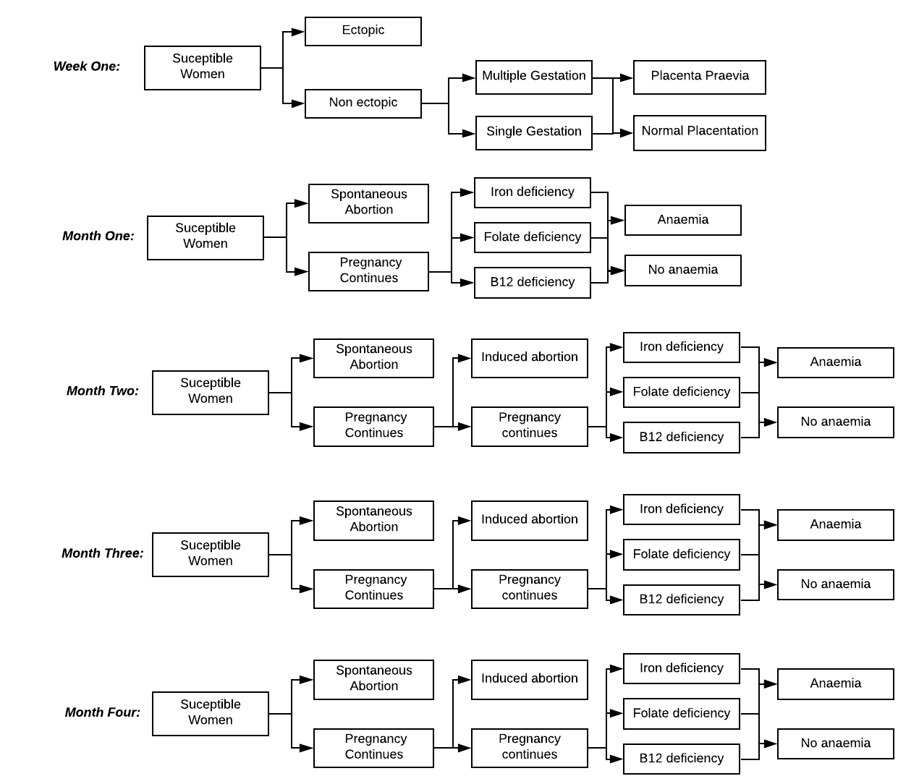

Figure 1-Applying risk in pregnancy model (conception- month 4)

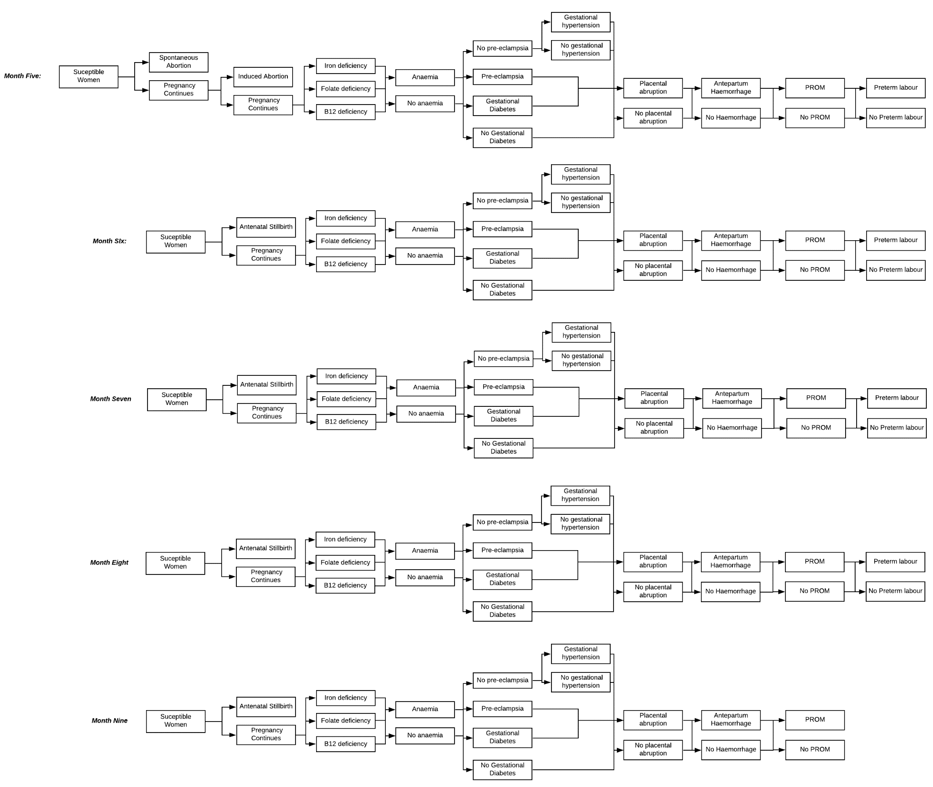

Figure 2- Applying risk in pregnancy model (month 5-9)

Complications of pregnancy - Risk factors
Concurrently to the process of developing natural history models for each complication/outcome associated with pregnancy rapid reviews of the literature were conducted to identify relevant relationships between modelled variables (as described above). For each of the following complications/outcomes a search was ran exploring predictors or risk factors for each complication/outcome first in Malawi, then neighbouring countries and finally sub-Saharan Africa. Studies exploring risk factors for complications within Malawi, or a similar setting, were given precedent over other settings due to the likely difference in populations and disease burden. Systematic reviews and meta-analyses of studies from relevant settings were given specific attention. This process was guided by clinical review with an expert obstetrician highlighting any important relationships to be explored.
Incidence and Progression of Pregnancy Loss
Ectopic Pregnancy
An individual risk per pregnancy of non-uterine implantation or fertilisation of an ovum outside of the uterus is applied to all pregnant women following onset of pregnancy. We assume a per-pregnancy risk of ectopic pregnancy of 0.02 (Panelli, Phillips and Brady, 2015). We have chosen to exclude the possibility of non-tubal ectopic pregnancies (incidence 5-8% of all ectopic pregnancies (Shen et al., 2014)) due to low incidence within an already rare event. As such we assume all ectopic pregnancies in the model end in abortion of the foetus.
Currently, smoking status (Adjusted Odds Ratio (AOR) 2.68) is the only predictor included in the model following review of the literature (Mindjah et al., 2018) and discussion with clinicians. There is strong evidence of the effect of previous sexually transmitted infection (STI) on probability of ectopic pregnancy (Anorlu et al., 2005; Mindjah et al., 2018; Mpiima et al., 2018; Asah-Opoku et al., 2019) but as STIs are not currently explicitly modelled in TLO this is not currently included. There was mixed evidence around the effect of certain contraceptive types/device use on risk of ectopic pregnancy, age and previously having an ectopic pregnancy and therefore these have not been included.
At between 6-8 weeks gestational age women in the model who have developed an ectopic pregnancy may choose to seek care as it is likely that most women have developed some symptoms by this time (symptoms are not modelled explicitly in pregnancy modules). All women who don’t seek care, or who seek care but are unable to obtain treatment, will experience rupture of the fallopian tube secondary to the ectopic pregnancy between 2-4 weeks from when they were first liable to seek care. Women who experience rupture may then again chose to seek care for additional treatment. Risk of death is only applied to women who experience rupture, as rupture is on the casual pathway to death.

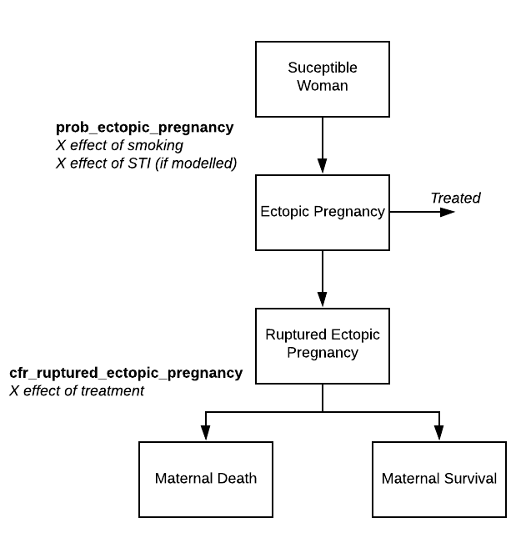

Figure 3- Natural history of ectopic pregnancy

Abortion
Spontaneous abortion (Miscarriage)
A monthly risk of spontaneous abortion is applied to women on the final week of each month of pregnancy up until 28 weeks gestation- following 28 weeks foetal death will be categorised as an antepartum stillbirth (WHO, 2016). Due to the difficulty in using spontaneous abortion as a primary outcome (especially in settings with restrictive laws around induced abortion) a limited number of studies were identified which explored possible risk factors for miscarriage in Malawi/similar settings. From two key studies and review by clinicians the following literature review, predictors in the model include maternal age 31-34 years, maternal age > 35 years and previously having experienced a spontaneous abortion (Dellicour et al., 2016).
Induced Abortion
For women who do not experience a spontaneous abortion a monthly risk of induced abortion is applied. We assume women pregnancy awareness occurs from 8 weeks gestational age and women are liable to seek induced abortion from this time point. In 2015 an estimated 16% of all pregnancies in Malawi ended in induced abortion (Polis et al., 2017a) therefore we assume a per month (allowing abortion to occur in months 2-5) of 0.04. The literature on risk factors for induced abortion in sub-Saharan Africa was dense however it was deemed that the majority of associations identified in studies were related to a whether a woman wanted to become pregnant. Unwanted pregnancy will be captured via the contraception module and will be used to trigger induced abortion- this is currently not finalised.
While termination of pregnancy is illegal in Malawi (except to save a woman’s life), and therefore occurs almost exclusively outside of the formal health system, we do not include abortion as a health system interaction (i.e. it will not use any of the resources of the system).
Complications of abortion
A systematic review of the severity of abortion-related morbidity in setting with limited access to abortion services concluded that maternal sepsis, haemorrhage and injury were the most prevalent complications associated with abortion (Calvert et al., 2018). We apply individual risk of developing each of these complications after abortion to all women post pregnancy loss- however risk of injury is only applied to women post induced abortion. Development of any of these complications may trigger care seeking for Post Abortion Care (described within the methods document of the antenatal care module). Women who develop a complication will have a risk of death applied mitigated by the effect of treatment, if treatment is sought and delivered. Currently dummy values are employed for these risks prior to final review.
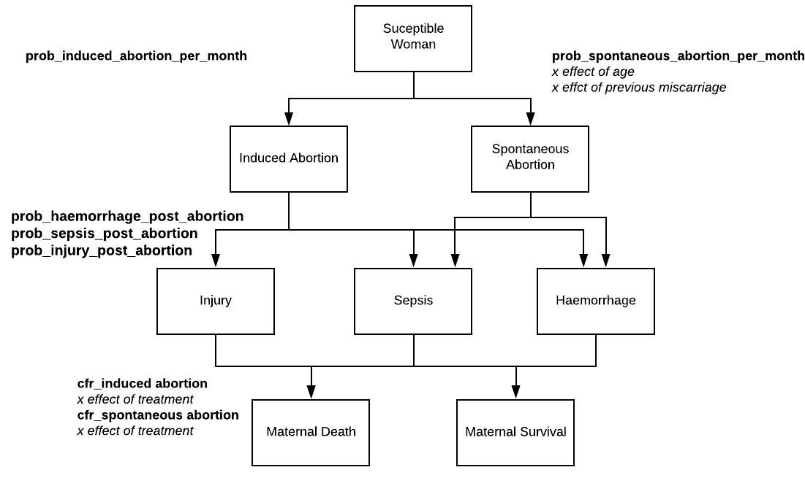

Figure 4- Natural history of induced and spontaneous abortion

Incidence and Progression of Maternal Disorders of Pregnancy
In this section each of the key maternal disorders of pregnancy will be described including application of incidence and risk factors which have been identified. Care seeking and how these conditions contribute to death or intrapartum stillbirth is described afterwards. Treatment is described in another document.

Multiple Pregnancy
TBD.
Micronutrient Deficiencies and Maternal Anaemia
Anaemia and associated deficiencies of key micronutrients are extremely prevalent during pregnancy in Malawi (Broek et al., 2000; Munasinghe and van den Broek, 2006; Adamu et al., 2017). We assume all pregnant women have a baseline monthly probability of developing anaemia due to pregnancy, often referred to as dilatational anaemia as plasma volume increases (Munasinghe and van den Broek, 2006). Similarly in this model women have a monthly risk of developing any of three key micronutrient deficiencies (iron, folate and b12) using a set probability each month.
Following literature review we determined that baseline risk of anaemia is increased in the model due to a series of key risk factors including the presence of iron deficiency, folate deficiency, b12 deficiency (Munasinghe and van den Broek, 2006), HIV infection (Adamu et al., 2017) and malaria infection(Kalilani et al., 2010). For women who will develop anaemia that monthly we select a severity of anaemia (mild, moderate or severe) using a weighted random choice from prevalence of severity in an anaemic pregnant population to match with both DALY weights and treatment. Furthermore we do not currently allow for progression from mild to severe anaemia. If untreated, anaemia severity is fixed for length of pregnancy.
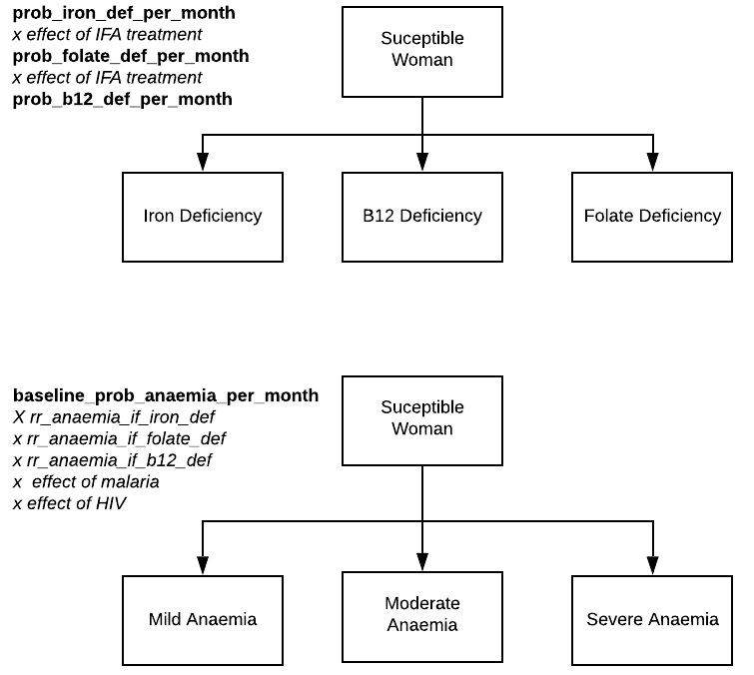

Figure 5- Natural histories of nutrient deficiency and anaemia

Placenta Praevia, Placental Abruption and Antepartum Haemorrhage
Placenta Praevia
A one-off risk of a woman developing placenta praevia is applied to all women at the start of pregnancy, on gestational week 3 if the pregnancy is not ectopic. Placenta praevia is one of the leading causes of haemorrhage during the antepartum and intrapartum periods of pregnancy (Fan et al., 2017; Takai et al., 2017, Jauniaux et al., 2019). The current recommended definition of placenta praevia is a placenta that covers the internal os completely (Jauniaux et al., 2019) but previously definitions have been based on proximity of the placenta to the internal os (grade I – grade IV praevia).
As its likely variable definitions have been applied in the literature evaluating incidence and risk we do not assume all placenta praevia is complete. Women with placenta praevia therefore have a higher monthly risk of antenatal bleeding both in this module and during the labour model, where bleeding due to placenta praevia is even higher as the baby descends. The search for risk factors for placenta praevia has not yet bee completed.
Placental Abruption
Monthly risk of placental abruption, another leading cause of antepartum haemorrhage (Takai et al., 2017) is applied months 5-9. As with placenta praevia, placental abruption significantly increases a woman’s risk of haemorrhage that month. Risk factors for placental abruption have not yet been identified. Once a woman has experienced an abruption this variable remains set at True for the length of pregnancy- meaning each month the mother remains at high risk of antepartum haemorrhage.
Antepartum Haemorrhage
From month five we also begin to apply a monthly risk of antepartum haemorrhage in keeping with the definition provided by the Royal College of Obstetricians (UK- see table). Only women who have placenta praevia or have developed placental abruption (or both) are able to develop antepartum haemorrhage within the model. We determine if women who experience haemorrhage will develop mild, moderate or severe bleeding using a random draw weighted using prevalence of severity of bleeding. Severity of bleeding is mapped to DALY weights to capture disability and can lead to variation in treatment pathway. Treatment is described in detail in the methods document of the antenatal care module.
Women who survive an episode of bleeding without treatment have their bleeding status reset, but they will remain high risk for another bleed in the next month.

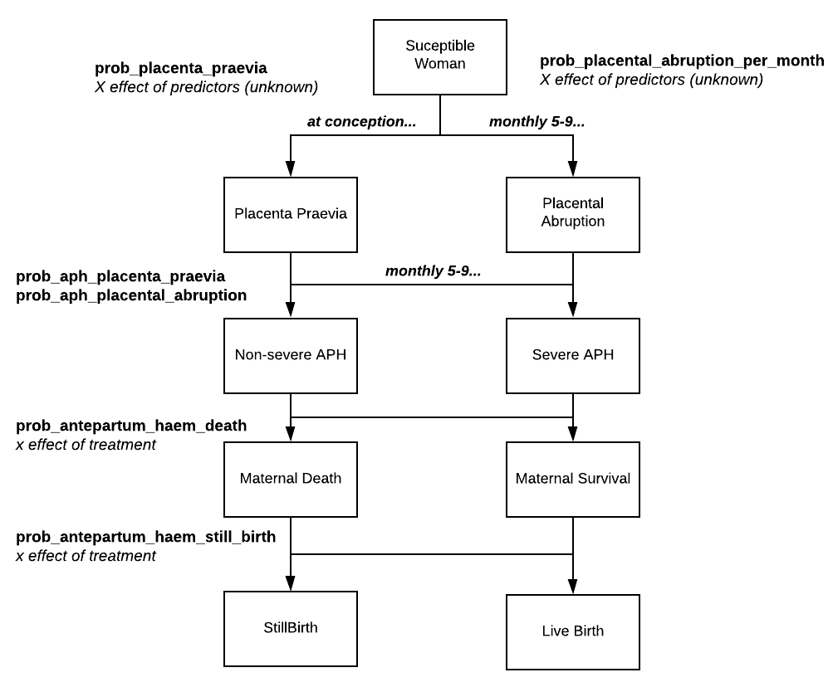

Figure 6- Natural histories of placenta praevia, abruption and antepartum haemorrhage
Gestational Diabetes
Within all healthy pregnancies some degree of insulin resistance occurs towards the second or third trimester to facilitate mild hyperglycaemia leading to glucose transportation across the placenta to the foetus, aiding growth and development (Sonagra, 2014; Plows et al., 2018) . Where normal metabolic processes do not occur and insulin resistance leads to uncontrolled hyperglycaemia, women develop Gestational diabetes mellitus (Plows et al., 2018). Therefore the majority of gestational diabetes occur later in pregnancy and we apply a monthly risk of gestational diabetes in pregnancy, starting at month 5 (22 weeks in the model), of 0.02 (dummy).
The two primary risk factors identified through review include obesity during pregnancy and family history of diabetes mellitus (Mwanri et al., 2015; Muche, Olayemi and Gete, 2019). As only mother-child family links are included in the TLO model we cannot model familial history as a risk factor and therefore only obesity is included. We assume that when GDM onsets and a woman has not been diagnosed or treated her hyperglycaemia is ‘uncontrolled’ whereas a woman on treatment is ‘controlled’. Currently we assume all GDM resolves at the termination of pregnancy

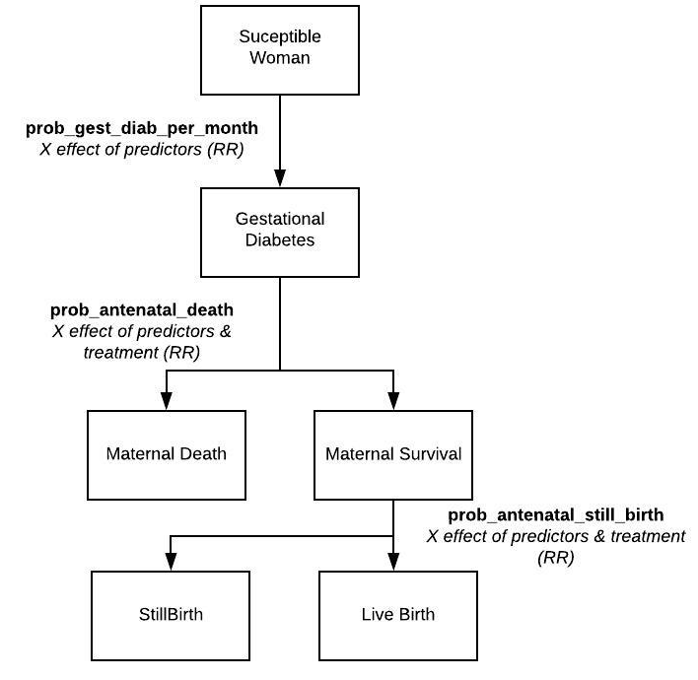

Figure 6- Natural history of gestational diabetes

The Hypertensive Disorders of Pregnancy
Hypertension in pregnancy within this model can be considers as explicit modelling of the two primary forms of disease, gestational hypertension and pre-eclampsia, and their more severe stages.
Gestational Hypertension
Gestational hypertension within the model can be mild or severe (see definitions above). Gestational hypertension is differentiated from pre-eclampsia by the absence of proteinuria. Presently a dummy incidence of mild gestational hypertension is applied monthly (0.02) to susceptible pregnant women (those without another form of hypertensive disorder) starting at month 5 (22 weeks in the model). Individual risk of gestational hypertension is increased in obese women ()
Within the model women with mild gestational hypertension have a monthly risk of progression applied to determine if their disease will become more severe. We assume that gestational hypertension can either progress to severe gestational hypertension OR pre-eclampsia. Although there remains debate in the literature if gestational hypertension and pre-eclampsia are distinct conditions due to difference in clinical outcomes and predictors (Melamed et al., 2014; Shen et al., 2017) it is seemingly accepted that gestational hypertension can and does progress into pre-eclampsia (Chen, Seow and Chen, 2017).
Mild pre-eclampsia
As with gestational hypertension, we apply that a baseline per-pregnancy monthly incidence of pre-eclampsia in a multiparous population with no previous pregnancies complicated by pre-eclampsia or current hypertensive disorders of 0.02 (dummy) starting at month 5 (22 weeks in the model). We assume that risk of developing mild pre-eclampsia is distinct from the risk of developing gestational hypertension, as the aetiology of these diseases are different. Risk factors for pre-eclampsia have not yet been finalised in the model.
For women who are suffering from mild-pre eclampsia we apply a monthly risk of progression from mild to severe disease of 0.1 (dummy). Progression in the hypertensive disorders is assumed to be linear i.e. a woman can only progress to the next stage up in ‘severity’ and could not go, for example, from mild pre-eclampsia to eclampsia.
Severe pre-eclampsia and Eclampsia
Both the severe forms of pre-eclampsia contribute significantly to maternal and perinatal mortality internationally (Lawn et al., 2009; Abalos et al., 2013; Alkema et al., 2016). As described above we do not apply a direct incidence rate of severe pre-eclampsia/eclampsia within the pregnant population but instead apply risk of progression for women suffering from hypertension. Due to this current mechanism within the model we do not apply risk factors for progression but simply a rate.
We assume that eclampsia is episodic and therefore women who progress from severe pre-eclampsia to eclampsia revert back to severe pre-eclampsia following application of risk of death/still birth described below. Women who are severely pre-eclamptic whose pregnancy continues without treatment remain at risk of developing eclampsia monthly throughout their pregnancy.

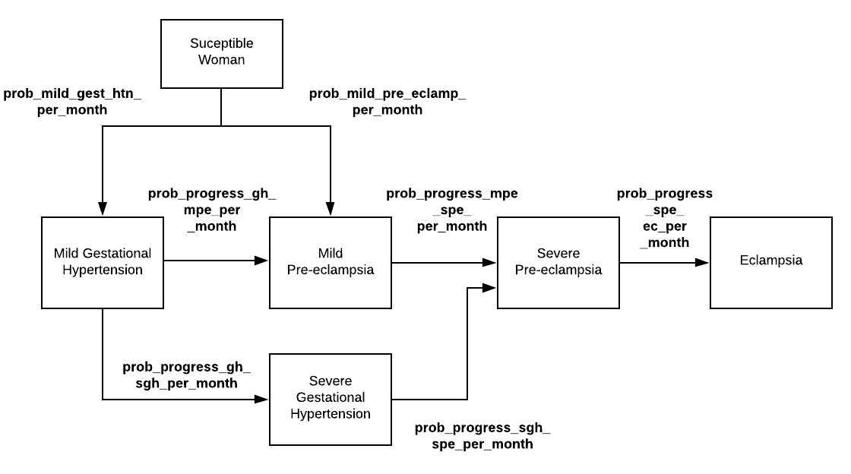

Figure 7- Natural history of onset and progression of the hypertensive disorders of pregnancy

Premature Rupture of Membranes (PROM) and Chorioamnionitis
Women are at risk of experiencing PROM and chorioamnionitis from 22 weeks gestation. Infection of the genital tract appears to be closely associated with a woman’s risk of PROM occuring (Okeke et al., 2016; Assefa et al., 2018) however we don’t explicitly model these infections within the TLO framework so at present we apply a fixed monthly risk of PROM occuring to all women. One of the infections that is both a possible trigger for and result of PROM is chorioamnionitis. For simplicity we assume only women who experience PROM may experience chorioamnionitis – and therefore we apply a one off risk of infection to all these women at one week following onset of PROM. All women who develop PROM have a risk of chorioamnionitis applied one week after membrane rupture.
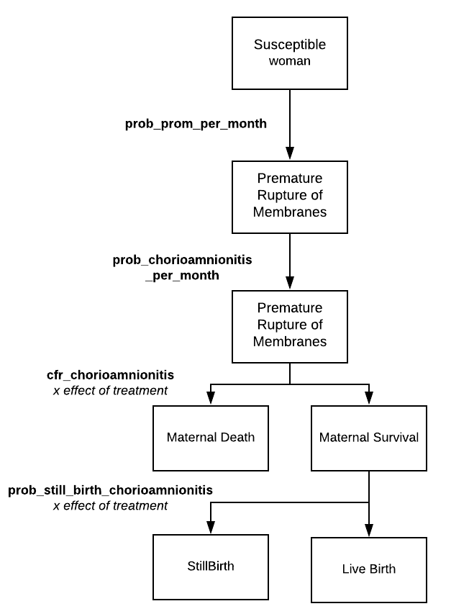

Figure 8- Natural history of PROM and chorioamnionitis

Preterm labour
When a pregnancy is generated within the model each woman is scheduled to go into labour (described in detail in the labour methods document) between 37 and 45 weeks gestational age. This ensure that all generated pregnancies either end in birth or pregnancy loss. Within the antenatal model a monthly risk of early labour onset is applied from month 5 until month 8. When a woman’s pregnancy will onset early we randomly allocate labour to onset before her next month of pregnancy. She will arrive at the labour model on that date and that model will determine if and where she will seek care for delivery. Currently the only risk factor for preterm labour is PROM occuring in the same month.
Care seeking for pregnancy complications
The following conditions, described in detail above, do not trigger care seeking (outside of the routine ANC schedule) as they are assumed to be asymptomatic or have mild symptoms:
- Placenta praevia (without bleeding)
- Placental abruption (without bleeding)
- Deficiencies and/or Anaemia (any severity)
- Gestational diabetes
- Gestational hypertension (any severity)
- Mild pre-eclampsia

Identification and treatment of these conditions is therefore conditional on whether a woman attends routine antenatal care and receives screening that would identify the presence of these conditions. This is described in detail in the antenatal care document.
The following conditions are conceptualised as pregnancy emergencies and as such are very likely to be identified by the mother in the community and can therefore trigger care seeking outside of routine ANC:
- Severe pre-eclampsia
- Eclampsia
- PROM
- Chorioamnionitis
- Antepartum Haemorrhage (any severity)
If a woman experiences one or more of these complications during a month of pregnancy then a probability that she will choose to seek emergency care for treatment is applied and the appropriate health system interaction, in this case care delivered in the antenatal ward, is scheduled. Currently we use a fixed probability of care seeking for all of these conditions but this will hopefully be refined.

Applying risk of antenatal maternal death
For women who have developed either eclampsia, antepartum haemorrhage or chorioamnionitis a risk of antenatal death is applied immediately if she chooses not to seek treatment following onset. If she survives this emergency the disease state is reset (i.e. it is assumed she is no longer haemorrhaging, her eclampsia or infection has resolved). She may go on to develop these complications again as her pregnancy progresses where she is liable to seek care and be at risk of death again.
Additionally women with severe gestational hypertension or severe pre-eclampsia have a monthly risk of death applied. This is to capture the increased risk of cerebrovascular outcomes that can lead to death such a stroke.
The proportion of maternal deaths per complication/cause, disaggregated by gestation, will be informed by Ahmed et al., 2018 prospective cohort study in 11 community-based research sites in south Asia and sub-Saharan Africa which will then be calibrated using Malawi’s maternal mortality ratio. This data will be used to calibrate risk of death and stillbirth.
Applying risk of antenatal still birth
Classification of underlying cause of stillbirth within the antenatal period is complex and significantly hampered by under reporting of stillbirth in the community, numerous different classification tools, use of verbal autopsy and limited placental histology. From the literature that has attempted to classify underlying causes of antenatal stillbirth in contexts similar to Malawi we have categorised four broad underlying causes of stillbirth that can occur in the antenatal period including:
- Still birth due to haemorrhage secondary to placental issues
- Infection
- Other medical maternal disorders (i.e. gestational diabetes)
- Other or unknown (such as non-survivable structural foetal anomalies, pathological placental conditions, unknown cause) (Metaferia and Muula, 2009; Madhi et al., 2019; McClure and Goldenberg, 2019) (Ahmed et al., 2018)(Reinebrant et al., 2018)
Therefore to capture this risk of stillbirth is applied in two different ways in this module:
- Following an acute emergency in which the life of both mother and foetus are at risk including antepartum haemorrhage, eclampsia and chorioamnionitis. This risk is applied to woman who do not seek care but have survived the complication.

- Monthly to capture:
  - Unknown/non-modelled causes of stillbirth
  - the effect of the ‘chronic’ complications of pregnancy such as hypertension, gestational diabetes
  - Other infections such as malaria

Table 1. Description of variables created relating to Pregnancy
Variable | Description | Notes and Major Assumptions
ps_gestational_age_in_weeks | Gestation of this woman’s pregnancy in weeks
ps_date_of_anc_1 | Date this woman is scheduled to attend her first ANC visit
ps_ectopic_pregnancy | Status of ectopic pregnancy: ‘none’, ‘not_ruptured’, ‘ruptured’ | Refers only to tubal ectopic pregnancies. Set to false when woman is not pregnant.
ps_multiple_pregnancy | Whether this woman is pregnant with multiple foetuses | We exclude multiples higher than twins due to very low incidence
ps_anaemia_in_pregnancy | Status of a womans anaemia in pregnancy: ‘none’, ‘mild’, ‘moderate’, ‘severe’
ps_will_attend_four_or_more_anc | Whether this woman is predicted to attend ANC4+ | Using results of wingstons analysis
ps_previous_stillbirth | Whether this woman has ever experienced a stillbirth her lifetime | This is could be either antepartum or intrapartum
ps_abortion_complications | Bitset column containing abortion complications: ‘sepsis’, ‘haemorrhage’, ‘injury’
ps_prev_spont_abortion | Whether this woman has ever experience a spontaneous abortion before
ps_htn_disorders | Current hypertensive disorders of pregnancy: None, gestational hypertension, severe gestational hypertension, mild pre-eclampsia, severe pre-eclampsia, eclampsia
ps_prev_pre_eclamp | Whether this woman has had pre-eclampsia in a previous pregnancy
ps_gest_diab | Whether this woman has from gestational diabetes: ‘none’, ‘controlled’, ‘uncontrolled’
ps_prev_gest-diab | Whether this woman has had gestational diabetes in a previous pregnancy
ps_antepartum_haemorrhage | Whether this woman is experiencing an antepartum haemorrhage during her pregnancy
ps_premature_rupture_of_membranes | Whether this woman has experienced a premature rupture of membranes

Table 2. Description parameters and proposed values.
Values provided in this table are not finalised and are pending a more detailed review of the relevant literature

Parameter | Proposed value | Description and source
prob_ectopic_pregnancy | 0.02
rr_ectopic_smoker | 2.68
prob_multiples | 0.02
prob_placenta_praevia | 0.05
prob_spontaneous_abortion_per_month | 0.06
rr_spont_abortion_age_35 | 4
rr_spont_abortion_age_31_34 | 2.31
rr_spont_abortion_prev_sa | 2
prob_induced_abortion_per_month | 0.06
prob_haemorrhage_post_abortion | 0.1
prob_sepsis_post_abortion | 0.1
prob_injury_post_abortion | 0.1
baseline_prob_early_labour_onset | 0.045
rr_preterm_labour_post_prom | 2
treatment_effect_calcium_ptl | 0.88
prob_iron_def_per_month | 0.04
prob_folate_def_per_month | 0.02
treatment_effect_iron_def_ifa | 0.44
treatment_effect_folate_def_ifa | 0.44
prob_b12_def_per_month | 0.02
baseline_prob_anaemia_per_month | 0.05
rr_anaemia_iron_folic_acid | 0.3
rr_anaemia_maternal_malaria | 1.2
rr_anaemia_if_iron_deficient | 1.5
rr_anaemia_if_folate_deficient | 1.25
rr_anaemia_if_b12_deficient | 1.25
prob_mild_mod_sev_anaemia | [0.33, 0.33, 0.34]
prob_pre_eclampsia_per_month | 0.02
treatment_effect_calcium_pre_eclamp | 0.41
prob_gest_htn_per_month | 0.02
treatment_effect_gest_htn_calcium | 0.55
treatment_effect_anti_htns_progression | 0.49
prob_gest_diab_per_month | 0.02
rr_gest_diab_obesity | 3.5
prob_glycaemic_control_diet_exercise | 0.7
prob_glycaemic_control_orals | 0.8
prob_glycaemic_control_insulin | 0.9
prob_placental_abruption_per_month | 0.01
prob_antepartum_haem_per_month | 0.02
prob_aph_placenta_praevia | 0.125
prob_aph_placental_abruption | 0.9
prob_mod_sev_aph | [0.5, 0.5]
prob_prom_per_month | 0.012
prob_chorioamnionitis_post_prom | 0.3
prob_still_birth_per_month | 0.02
rr_still_birth_gest_diab | 1.2
rr_still_birth_mild_pre_eclamp | 1.2
rr_still_birth_gest_htn | 1.2
rr_still_birth_severe_gest_htn | 1.2
rr_still_birth_severe_pre_eclamp | 1.2
rr_still_birth_maternal_malaria | 1.5
treatment_effect_still_birth_food_sups | 0.3
treatment_effect_gdm_case_management | 0.9
prob_ectopic_pregnancy_death | 0.0014
treatment_effect_ectopic_pregnancy_treatment | 0.5
prob_induced_abortion_death | 0.0014
treatment_effect_post_abortion_care | 0.2
prob_spontaneous_abortion_death | 0.0014
prob_antepartum_haem_stillbirth | 0.05
prob_antepartum_haem_death | 0.0014
prob_antenatal_spe_death | 0.0014
prob_antenatal_ec_still_birth | 0.1
prob_antenatal_ec_death | 0.0014
prob_monthly_death_severe_htn | 0.01
cfr_chorioamnionitis | 0.1
prob_still_birth_chorioamnionitis | 0.1
prob_first_anc_visit_gestational_age | [ 0.05, 0.05, 0.1, 0.1, 0.2, 0.3, 0.1, 0.05, 0.025, 0.025]
prob_four_or_more_anc_visits | 0.49
prob_eight_or_more_anc_visits | 0.05
prob_anc_at_facility_level_0_1_2 | [0.33, 0.33, 0.34]
probability_htn_persists | 0.6
prob_seek_care_pregnancy_complication | 0.65
prob_seek_care_pregnancy_loss | 0.65

References
Abalos, E. et al. (2013) ‘Global and regional estimates of preeclampsia and eclampsia: a systematic review.’, European journal of obstetrics, gynecology, and reproductive biology, 170(1), pp. 1–7. doi: 10.1016/j.ejogrb.2013.05.005.
Adamu, A. L. et al. (2017) ‘Prevalence and risk factors for anemia severity and type in Malawian men and women: Urban and rural differences’, Population Health Metrics. BioMed Central Ltd., 15(1), p. 12. doi: 10.1186/s12963-017-0128-2.
Ahmed, I. et al. (2018) ‘Population-based rates, timing, and causes of maternal deaths, stillbirths, and neonatal deaths in south Asia and sub-Saharan Africa: a multi-country prospective cohort study’, The Lancet Global Health. Elsevier Ltd, 6(12), pp. e1297–e1308. doi: 10.1016/S2214-109X(18)30385-1.
Alkema, L. et al. (2016) ‘Global, regional, and national levels and trends in maternal mortality between 1990 and 2015, with scenario-based projections to 2030: A systematic analysis by the un Maternal Mortality Estimation Inter-Agency Group’, The Lancet. Lancet Publishing Group, 387(10017), pp. 462–474. doi: 10.1016/S0140-6736(15)00838-7.
Ananth, C. V. et al. (2016) ‘Severe placental abruption: Clinical definition and associations with maternal complications’, American Journal of Obstetrics and Gynecology. Mosby Inc., 214(2), pp. 272.e1-272.e9. doi: 10.1016/j.ajog.2015.09.069.
Anorlu, R. I. et al. (2005) ‘Risk factors for ectopic pregnancy in Lagos, Nigeria’, Acta Obstetricia et Gynecologica Scandinavica. Acta Obstet Gynecol Scand, 84(2), pp. 184–188. doi: 10.1111/j.0001-6349.2005.00684.x.
Asah-Opoku, K. et al. (2019) ‘Risk factors for ectopic pregnancy among pregnant women attending a tertiary healthcare facility in Accra, Ghana’, International Journal of Gynecology and Obstetrics. John Wiley and Sons Ltd., 147(1), pp. 120–125. doi: 10.1002/ijgo.12928.
Assefa, N. E. et al. (2018) ‘Risk factors of premature rupture of membranes in public hospitals at Mekele city, Tigray, a case control study’, BMC Pregnancy and Childbirth. BioMed Central, 18(1), p. 386. doi: 10.1186/s12884-018-2016-6.
Assouni Mindjah, Y. A. et al. (2018) ‘Risk factors for ectopic pregnancy in a population of Cameroonian women: A case-control study’, PLOS ONE. Edited by C. Mitchell. Public Library of Science, 13(12), p. e0207699. doi: 10.1371/journal.pone.0207699.
Broek, N. R. et al. (2000) ‘Anaemia in pregnancy in southern Malawi: prevalence and risk factors’, BJOG: An International Journal of Obstetrics and Gynaecology. John Wiley & Sons, Ltd, 107(4), pp. 445–451. doi: 10.1111/j.1471-0528.2000.tb13260.x.
Calvert, C. et al. (2018) ‘The magnitude and severity of abortion-related morbidity in settings with limited access to abortion services: a systematic review and meta-regression’, BMJ Global Health. BMJ Specialist Journals, 3(3), p. e000692. doi: 10.1136/bmjgh-2017-000692.
Chen, K. H., Seow, K. M. and Chen, L. R. (2017) ‘Progression of gestational hypertension to pre-eclampsia: A cohort study of 20,103 pregnancies’, Pregnancy Hypertension. Elsevier B.V., 10, pp. 230–237. doi: 10.1016/j.preghy.2017.10.001.
Dellicour, S. et al. (2016) ‘Weekly miscarriage rates in a community-based prospective cohort study in rural western Kenya’, BMJ Open, 6(4). doi: 10.1136/bmjopen-2016-011088.
Fan, D. et al. (2017) ‘Prevalence of antepartum hemorrhage in women with placenta previa: A systematic review and meta-analysis’, Scientific Reports. Nature Publishing Group, 7. doi: 10.1038/srep40320.
Faúndes, A. and Alvarez, F. (2008) ‘Abortion’, in International Encyclopedia of Public Health. Elsevier Inc., pp. 1–12. doi: 10.1016/B978-012373960-5.00468-8.
Gebremedhin, S. (2015) ‘Multiple Births in Sub-Saharan Africa: Epidemiology, Postnatal Survival, and Growth Pattern’, Twin Research and Human Genetics. Cambridge University Press, 18(1), pp. 100–107. doi: 10.1017/thg.2014.82.
Jauniaux, E. R. M. et al. (2019) ‘Placenta Praevia and Placenta Accreta: Diagnosis and Management: Green-top Guideline No. 27a’, BJOG: An International Journal of Obstetrics and Gynaecology. Blackwell Publishing Ltd, 126(1), pp. e1–e48. doi: 10.1111/1471-0528.15306.
Kalilani, L. et al. (2010) ‘The effect of timing and frequency of Plasmodium falciparum infection during pregnancy on the risk of low birth weight and maternal anemia’, Transactions of the Royal Society of Tropical Medicine and Hygiene. Trans R Soc Trop Med Hyg, 104(6), pp. 416–422. doi: 10.1016/j.trstmh.2010.01.013.
Lawn, J. E. et al. (2009) ‘Two million intrapartum-related stillbirths and neonatal deaths: Where, why, and what can be done?’, International Journal of Gynecology & Obstetrics. John Wiley & Sons, Ltd, 107(Supplement), pp. S5–S19. doi: 10.1016/j.ijgo.2009.07.016.
Madhi, S. A. et al. (2019) Causes of stillbirths among women from South Africa: a prospective, observational study, The Lancet Global Health. doi: 10.1016/S2214-109X(18)30541-2.
McClure, E. M. and Goldenberg, R. L. (2019) ‘Understanding causes of stillbirth: moving in the right direction’, The Lancet Global Health. Elsevier Ltd, 7(4), pp. e400–e401. doi: 10.1016/S2214-109X(19)30055-5.
Melamed, N. et al. (2014) ‘Gestational Hypertension and Preeclampsia: Are They the Same Disease?’, JOGC.
Metaferia, A. M. and Muula, A. S. (2009) ‘Stillbirths and hospital early neonatal deaths at Queen Elizabeth Central Hospital, Blantyre-Malawi’. doi: 10.1186/1755-7682-2-25.
Mpiima, D. P. et al. (2018) ‘Association between Prior Chlamydia trachomatis Infection and Ectopic Pregnancy at a Tertiary Care Hospital in South Western Uganda’, Obstetrics and Gynecology International. Hindawi Limited, 2018. doi: 10.1155/2018/4827353.
Muche, A. A., Olayemi, O. O. and Gete, Y. K. (2019) ‘Prevalence and determinants of gestational diabetes mellitus in Africa based on the updated international diagnostic criteria: A systematic review and meta-analysis’, Archives of Public Health. BioMed Central Ltd., 77(1), p. 36. doi: 10.1186/s13690-019-0362-0.
Munasinghe, S. and van den Broek, N. (2006) ‘Anaemia In Pregnancy In Malawi- A Review.’, Malawi medical journal : the journal of Medical Association of Malawi, 18(4), pp. 160–74. Available at: http://www.ncbi.nlm.nih.gov/pubmed/27529009 (Accessed: 16 September 2019).
Mwanri, A. W. et al. (2015) ‘Gestational diabetes mellitus in sub-Saharan Africa: Systematic review and metaregression on prevalence and risk factors’, Tropical Medicine and International Health. Blackwell Publishing Ltd, pp. 983–1002. doi: 10.1111/tmi.12521.
Okeke, T. et al. (2016) ‘Morbidities, concordance, and predictors of preterm premature rupture of membranes among pregnant women at the University of Nigeria Teaching Hospital (UNTH), Enugu, Nigeria’, Nigerian Journal of Clinical Practice, 19(6), p. 737. doi: 10.4103/1119-3077.181361.
Panelli, D. M., Phillips, C. H. and Brady, P. C. (2015) ‘Incidence, diagnosis and management of tubal and nontubal ectopic pregnancies: a review’, Fertility Research and Practice. Springer Science and Business Media LLC, 1(1), p. 15. doi: 10.1186/s40738-015-0008-z.
Plows, J. et al. (2018) ‘The Pathophysiology of Gestational Diabetes Mellitus’, International Journal of Molecular Sciences, 19(11), p. 3342. doi: 10.3390/ijms19113342.
Polis, C. B. et al. (2017a) ‘Incidence of induced abortion in Malawi, 2015’, PLOS ONE. Edited by A. M. Foster. Public Library of Science, 12(4), p. e0173639. doi: 10.1371/journal.pone.0173639.
Polis, C. B. et al. (2017b) ‘Incidence of induced abortion in Malawi, 2015’, PLoS ONE. Public Library of Science, 12(4). doi: 10.1371/journal.pone.0173639.
Reinebrant, H. et al. (2018) ‘Making stillbirths visible: a systematic review of globally reported causes of stillbirth’, BJOG: An International Journal of Obstetrics & Gynaecology, 125(2), pp. 212–224. doi: 10.1111/1471-0528.14971.
Shen, L. et al. (2014) ‘Interventions for non-tubal ectopic pregnancy’, Cochrane Database of Systematic Reviews. John Wiley and Sons Ltd. doi: 10.1002/14651858.CD011174.
Shen, M. et al. (2017) ‘Comparison of risk factors and outcomes of gestational hypertension and pre-eclampsia’, PLOS ONE. Edited by S. H. Räisänen, 12(4), p. e0175914. doi: 10.1371/journal.pone.0175914.
Sonagra, A. D. (2014) ‘Normal Pregnancy- A State of Insulin Resistance’, JOURNAL OF CLINICAL AND DIAGNOSTIC RESEARCH. JCDR Research and Publications, 8(11), p. CC01. doi: 10.7860/jcdr/2014/10068.5081.
Takai, I. U., Sayyadi, B. M. and Galadanci, H. S. (2017) ‘Antepartum Hemorrhage: A Retrospective Analysis from a Northern Nigerian Teaching Hospital’, International Journal of Applied and Basic Medical Research. Wolters Kluwer -- Medknow Publications, 7(2), p. 112. doi: 10.4103/2229-516X.205819.
The Association of Obstetricians & Gynaecologists of Malawi (2014) ‘Obstetrics & Gynaecology Protocols and Guidelines’, (September), pp. 1–105.
The World Health Organisation (2013) Diagnostic Criteria and Classification of Hyperglycaemia First Detected in Pregnancy.
The World Health Organisation (2016) Stillbirths, WHO. World Health Organization. Available at: http://www.who.int/maternal_child_adolescent/epidemiology/stillbirth/en/ (Accessed: 30 July 2020).

