Modelling of HPV infection and cervical cancer within the Thanzi La Onse Model

Background: The Thanzi La Onse Model
As part of the Thanzi La Onse program, a model is being developed which aims to capture the health experiences of the population of Malawi and the consequent interactions with the health care system. The intent is that this model will help to inform future delivery of healthcare in Malawi. The model is an individual based model – which means we explicitly simulate the individual life and health experiences of a representative proportion of the population of Malawi. The simulation initiates on 1 Jan 2010 and we simulate the attributes of the population at that point. We can run the model forward to any specified future time point. Each potential intervention and its associated diseases are being modelled. This is being divided into separate disease/intervention modules. This document describes the module on cervical cancer.
Background: General approach to decisions on modelling causal influences and effects of interventions
This module was designed in the context of an overall approach to modelling causal effects in general and causal effects of interventions in particular. The overall intent is to adopt as simple a structure as can be conceived, whilst still capturing the essential elements of a disease and the interventions used to prevent or treat. We include a causal link between a “variable” (by which we mean a characteristic or property of an individual, whether that be demographic, social or biologic), and risk of disease or another variable if there is strong evidence from an overall body of studies that such a causal link exists and is at least moderately strong. In informing such decisions we place particular value on RCTs or studies with a quasi-experimental design such as analyses based on an instrumental variable. There is no expectation that such studies will be from Malawi or even from Africa. If there are such local studies and in the unlikely event that they provide strong evidence to suggest that the causal link is substantively different in Malawi then the intent is that this is taken into account and the Malawi-specific link included.
In the special case of a potential causal variable which relates to whether an individual has experienced or is experiencing an intervention, the intent is to only include interventions if there is substantial RCT evidence of their beneficial effect, based on trials with objectively ascertained clinical endpoints with low risk of serious bias.
Unless there is evidence to the contrary, the intent is to summarize and incorporate intervention effects into the model as relative risks or rates rather than absolute differences because such measures are less likely to differ substantially by context. Interactions between characteristics (i.e. differences in intervention effects by population subgroup) are only to be incorporated if there is strong evidence. Again, we have not intended to rely on data from Malawi or Africa for such evidence but if local evidence exists which strongly suggests a different effect than elsewhere then the intent is that this modified effect is incorporated in the model.
Background: Demographic and social characteristics modelled
Based on data on the distribution of the population in Malawi according to geographic location we assign individuals a geographic location which maps onto whether they are classified as living in a rural or urban area. Informed largely by data from the Malawi DHS 2015-16, variables are also created indicating the person’s wealth level (based on 5 quintiles), whether the person has access to improved sanitation, clean drinking water, hand washing facilities, and whether they experience indoor air pollution (wood burning stove). We assign individuals a current education status (none, primary, secondary) which is updated 3 monthly from age 5 to 20. From age 15 we assign body mass index (BMI) in 5 categories: tobacco use status, drinking excess alcohol, having low exercise, high sugar intake, high salt intake, and marital status (never, currently, widowed/divorced). The status of a person, as described by such variables, can change over time. The influences between these variables are described in detail in a separate document.
HPV / cervical cancer model structure
Properties modelled
The model updates information on each individual with regard to HPV infection and cervical intra-epithelial neoplasia / cervical cancer status every month. The model structure is described in Figure 1. Variables that we create for each female aged 15 in relation to cervical cancer are shown in Table 1.

Parameters
Parameters are listed in Table 2. The rate of receiving vaccination, screening and treatment is dependent on the health care system and not directly determined in this module.

Disability weights
- For persons with any stage of cancer prior to stage 4 and have never had any treatment or treatment has been unsuccessful, a disability-weight of 0.288 is applied, corresponding to "Diagnosis and primary therapy phase of cancer: Cancer, diagnosis and primary therapy, has pain, nausea, fatigue, weight loss and high anxiety”.
- For persons with any stage of cancer prior to stage 4 and have been successfully treated a disability-weight of 0.05 is applied for 5 years
- For persons with a cancer in metastatic stage (stage 4) and with no palliative care, a disability-weight of 0.451 is applied, corresponding to “Metastatic phase of cancer: Cancer, metastatic: has severe pain, extreme fatigue, weight loss and high anxiety."
- For persons with a cancer in stage 4 and with palliative care, a disability-weight that is applied that is equal to those with earlier stage cancers without treatment (0.288).
- CIN does not carry a disability weight.
Health System Interactions
Care Seeking & Diagnosis
Vaginal bleeding or abnormal vaginal discharge due to cervical cancer is assumed to potentially trigger (Odds ratio = 1) healthcare seeking to a Non-Emergency Generic Appointment at Facility Level 1, whereupon referral to further health system interaction is indicated. In that appointment, a biopsy test is undertaken on suspected cervical cancer at examination: HSI_CervicalCancer_Biopsy

Cervical Cancer Screening and preventive treatment
There are two screenings considered for HPV infection and cervical cancer. The referral of individuals to either of these screenings depends on the date in which the patient is referred for screening. Given the differences in the result reports that may be obtained from each screening, the required medical care is dependent on the screening type.

- Visual inspection with acetic acid (VIA)
  - Corresponding HSI: HSI_CervicalCancer_AceticAcidScreening
  - Date recommended: Before 2024 (personal communication: Dr Lameck Chinula)
  - Required Medical Care:
    - If VIA positive is suggestive of severe cervical dysplasia (stage 1 to 4) this leads to cervical biopsy (HSI_CervicalCancer_Biopsy).
    - If VIA positive is suggestive of CIN2 or CIN3, then CIN treatment occurs. If it is before the year 2024, then Cryotherapy is carried out (HSI_CervicalCancer_Cryotherapy_CIN) and if it is the year 2024 or after, then thermoablation is carried out (HSI_CervicalCancer_Thermoabl_CIN).
- GeneXpert: Cervical sampling (self sampling or done by a health care provider) to produce a sample for HPV testing
  - Corresponding HSI: HSI_CervicalCancer_XpertHPVScreening
  - Date recommended: 2024 onwards
  - Required Medical Care:
    - If an individual has HIV (hv_diagnosis True), then the individual is sent directly for CIN treatment (either HSI_CervicalCancer_Cryotherapy_CIN or HSI_CervicalCancer_Thermoabl_CIN depending on the year). Once at the HSI for treatment, if the individual has ce_hpv_cc_status as severe cervical dysplasia (stage 1 to 4), this leads to cervical biopsy (HSI_CervicalCancer_Biopsy). Else, they receive CIN treatment.
      - Note: Xpert screening does not support visualization of lesion, so required to be sent for CIN treatment first
    - If an individual does not have HIV (hv_diagnosis False), then they will be recommended for VIA screening for confirmation.Then they will follow VIA screening logic above.

Screening eligibility is based on sex, age, HIV diagnosis status, and recency of screening or treatment. Females diagnosed with HIV are eligible for screening between ages of 25 and 50 and screening should be every 3 years. For females without HIV, they are eligible for screening between the ages of 30 and 50, with a screening interval of every 5 years. Regardless of HIV status, if an individual has undergone CIN treatment, they will be advised to re-screen sooner, so they are eligible for re-screening after 1 year.

Treatment Initiation & Monitoring
If investigation of possible cervical cancer following presentation with vaginal bleeding or screening confirms cervical cancer (with HSI_CervicalCancer_Biopsy) and if the stage of cancer is stage 3 or below then the patient is referred to initiate treatment (HSI_CervicalCancer_StartTreatment), although the probability of treatment leading to removal of the cancer decreases substantially with stage of treatment. After treatment the person is scheduled to have 3 monthly check-ups (HSI_CervicalCancer_PostTreatmentCheck). If the cancer is confirmed and is in stage 4, the patient is referred to Palliative Care: HSI_CervicalCancer_PalliativeCare.

Palliative Care
Patients initiated on palliative care remain on palliative care and receive a monitoring appointment each month. This results in a lower disability weight but not a reduced risk of death.
Calibration
Comparison of model outputs with observed data is shown in Table 3.
Main Limitations
The main limitations are the relative lack of data to directly inform many of the parameter values. Underlying progression of the condition is assumed to follow a similar course as in studies in other parts of the world. For incidence of cervical cancer and rates of diagnosis and availability of curative treatment it is necessary to consider data from Malawi itself given that these are likely to depend on the setting. As it becomes possible to perform more analyses in collaboration with the cancer registry we expect to be able to further inform our parameter values. In future iterations we will consider breaking down attempted curative treatment into surgery, chemotherapy, radiotherapy, and endocrine therapy etc. We can also potentially refine modelling of specific HPV subtypes and whether they are susceptible to specific vaccines in use. There is also uncertainty over disability weights.
Figure 1.
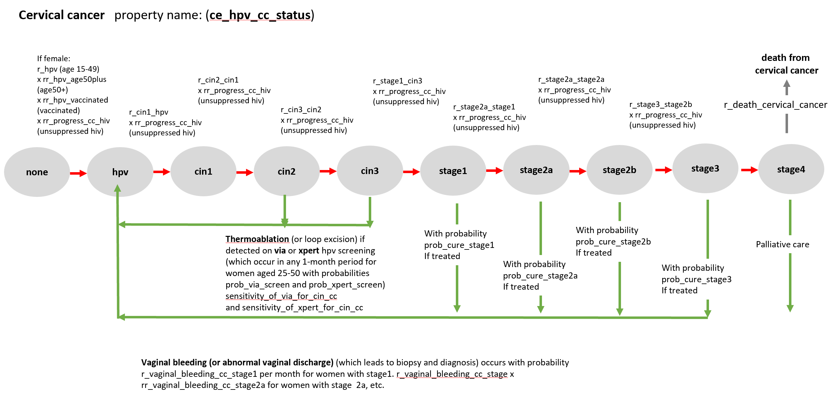

Table 1. Properties modelled.

Parameter Name | Description
ce_hpv_cc_status | Current HPV / cervical cancer status (see figure 1). Categories: [none, hpv, cin1, cin2, cin3, stage1, stage2a, stage2b, stage3, stage4]
ce_date_diagnosis | The date of diagnosis of cervical cancer stage (pd.NaT if never diagnosed)
ce_stage_at_diagnosis | The cancer stage at which cancer diagnosis was made. Categories: [none, stage1, stage2a, stage2b, stage3, stage4]
ce_date_cin_removal | The date of last CIN removal (pd.NaT if never diagnosed)
ce_date_treatment | Date of first receiving attempted curative treatment (pd.NaT if never started treatment)
ce_ever_screened | Whether ever been screened
ce_ever_treated | Ever been treated for CC
ce_cured_date_cc | Ever cured of cervical cancer date
ce_cc_ever | Ever had CC
ce_stage_at_which_treatment_given | The cancer stage at which treatment was given (because the treatment only has an effect during the stage at which it is given). Categories: [none, hpv, cin1, cin2, cin3, stage1, stage2a, stage2b, stage3, stage4]
ce_date_palliative_care | Date of first receiving palliative care (pd.NaT if never had palliative care)
ce_ever_diagnosed | Ever diagnosed with cervical cancer (even if now cured)
ce_date_death | Date of cervical cancer death
ce_new_stage_this_month | New stage this month
ce_xpert_hpv_ever_pos | HPV positive on Xpert test ever
ce_via_cin_ever_detected | CIN ever detected on VIA
ce_date_last_screened | Date of last screening
ce_date_thermoabl | Date of thermoablation for CIN
ce_date_cryotherapy | Date of cryotherapy for CIN
ce_current_cc_diagnosed | Currently has diagnosed cervical cancer (which until now has not been cured)
ce_selected_for_via_this_month | Selected for VIA this period
ce_selected_for_xpert_this_month | Selected for Xpert this month
ce_biopsy | CE biopsy done

Table 2. Description of parameters and proposed values
Parameter Name
Parameter Name | Proposed Value | Description | Notes
init_prev_cin_hpv_cc_stage_hiv | [0.90, 0.06, 0.005, 0.005, 0.005, 0.005, 0.005, 0.005, 0.005, 0.005] | Initial prevalence of CIN, HPV, and cervical cancer in stage (HIV+). | Inferred from calibration shown in Table 3.
init_prev_cin_hpv_cc_stage_nhiv | [0.97, 0.026, 0.0005, 0.0005, 0.0005, 0.0005, 0.0005, 0.0005, 0.0005, 0.0005] | Initial prevalence of CIN, HPV, and cervical cancer in stage (HIV-). | Inferred from calibration shown in Table 3.
r_hpv | 0.0005 | Probability per month of persistent oncogenic HPV infection | Inferred from calibration to prevalence of HPV infection
r_cin1_hpv | 0.05 | Probability per month of incident CIN1 amongst people with HPV | Currently rates of progression through stages are assumed to be equal, but this can be modified if data suggest otherwise. The value is arrived at based on calibration to numbers of cases and deaths.
prob_revert_from_cin1 | 0.01 | Probability per month of reverting from CIN1 to HPV-negative or lower stage | Reversion can occur but rate unknown.
r_cin2_cin1 | 0.05 | Probability per month of incident CIN2 amongst people with CIN1 | The value is arrived at based on calibration to numbers of cases and deaths.
r_cin3_cin2 | 0.05 | Probability per month of incident CIN3 amongst people with CIN2 | as above
r_stage1_cin3 | 0.05 | Probability per month of incident stage 1 cervical cancer amongst people with CIN3 | as above
r_stage2a_stage1 | 0.05 | Probability per month of incident stage 2a cervical cancer amongst people with stage 1 | as above
r_stage2b_stage2a | 0.05 | Probability per month of incident stage 2b cervical cancer amongst people with stage 2a | as above
r_stage3_stage2b | 0.05 | Probability per month of incident stage 3 cervical cancer amongst people with stage 2b | as above
r_stage4_stage3 | 0.05 | Probability per month of incident stage 4 cervical cancer amongst people with stage 3 | as above
rr_hpv_age50plus | 0.1 | Rate ratio for HPV if age 50 plus | Older people tend to have less sexual activity and hence lower HPV risk
rr_progress_cc_hiv | 3 | Rate ratio for progressing through CIN and cervical cancer stages if have unsuppressed HIV | People living with unsuppressed HIV have increased risk of cervical cancer, which is an AIDS defining condition
rr_hpv_vaccinated | 0.5 | Rate ratio for HPV if vaccinated | This is combined effect of probability the HPV is vaccine-preventable and vaccine efficacy against vaccine-preventable HPV. Vaccine in use so far has been against HPV 16/18 only.
prob_cure_stage1 | 0.8 | Probability of cure if treated in stage 1 cervical cancer | Higher probability that treatment leads to elimination of the cancer in earlier stages. Link
prob_cure_stage2a | 0.7 | Probability of cure if treated in stage 2a cervical cancer | as above
prob_cure_stage2b | 0.2 | Probability of cure if treated in stage 2b cervical cancer | as above
prob_cure_stage3 | 0.05 | Probability of cure if treated in stage 3 cervical cancer | as above
r_death_cervical_cancer | 0.1 | Probability per month of death from cervical cancer amongst people with stage 4 cervical cancer | High mortality rate in stage 4. As above.
r_vaginal_bleeding_cc_stage1 | 0.005 | Rate per month of initiation of vaginal bleeding if have stage 1 cervical cancer | Vaginal bleeding represents symptoms of cervical cancer that will lead to presentation and referral for biopsy. This parameter value is partially determined through calibration to the number of women diagnosed by stage.
rr_vaginal_bleeding_cc_stage2a | 2 | Rate ratio for vaginal bleeding if have stage 2a cervical cancer | as above
rr_vaginal_bleeding_cc_stage2b | 3 | Rate ratio for vaginal bleeding if have stage 2b cervical cancer | as above
rr_vaginal_bleeding_cc_stage3 | 5 | Rate ratio for vaginal bleeding if have stage 3 cervical cancer | as above
rr_vaginal_bleeding_cc_stage4 | 10 | Rate ratio for vaginal bleeding if have stage 4 cervical cancer | as above
prob_referral_biopsy_given_vaginal_bleeding | 0.8 | Probability of being referred for a biopsy if presenting with vaginal bleeding | The value is arrived at based on calibration to numbers of cases and deaths.
prob_via_screen | 0.03 | Probability per month for 30-50 year old women of being screened with VIA | Screening rates will change over time – this is largely a placeholder
prob_xpert_screen | 0.03 | Probability per month for 30-50 year old women of being screened with GeneXpert for HPV | Screening rates will change over time – this is largely a placeholder
sensitivity_of_biopsy_for_cervical_cancer | 0.85 | Sensitivity of biopsy for detecting cervical cancer | Colposcopy-directed biopsy has high sensitivity
sensitivity_of_via_for_cin_cc | 0.75 | Sensitivity of VIA for detecting CIN and cervical cancer | Placeholder Mustafa et al 2016
sensitivity_of_xpert_for_hpv_cin_cc | 0.75 | Sensitivity of Xpert for detecting HPV, CIN, and cervical cancer | Placeholder Mustafa et al 2016
prob_thermoabl_successful | 0.85 | Probability of successful thermoablation | Liu et al 2024
prob_cryotherapy_successful | 0.85 | Probability of successful cryotherapy | Liu et al 2024
transition_screening_year | 2024 | Before 2024 recommend VIA, after 2024 recommend Xpert | This is approximate time of transition
transition_testing_year | 2024 | Before 2024 recommend Cryotherapy, after 2024 recommend Thermoablation | This is approximate time of transition
min_age_hpv | 15 | Minimum age an individual may be diagnosed with HPV | Assumption
screening_min_age_hv_neg | 30 | Minimum age for screening for HPV negative women | Malawi National Cervical Cancer Strategic Plan 2022-2026
screening_max_age_hv_neg | 50 | Maximum age for screening for HPV negative women | Malawi National Cervical Cancer Strategic Plan 2022-2026
screening_min_age_hv_pos | 25 | Minimum age for screening for HPV positive women | Malawi National Cervical Cancer Strategic Plan 2022-2026
screening_max_age_hv_pos | 50 | Maximum age for screening for HPV positive women | Malawi National Cervical Cancer Strategic Plan 2022-2026
yrs_between_screen_hv_pos | 3 | Years between screening for HPV positive women | Assumption
yrs_between_screen_hv_neg | 5 | Years between screening for HPV negative women | Assumption
palliative_care_bed_days | 15 | Number of palliative care bed days per person | Assumption
stage_1_3_daly_wt | 0.5 | Disability-adjusted life year weight for stage 1-3 treated cervical cancer | GBD disability weights.
stage_1_3_treated_daly_wt | 0.2 | Disability-adjusted life year weight for stage 1-3 treated cervical cancer | GBD disability weights.
stage4_daly_wt | 0.9 | Disability-adjusted life year weight for stage 4 cervical cancer | GBD disability weights.
min_yrs_between_screening_if_cin_treated | 1 | Minimum years between screening if CIN treated | Assumption

Table 3. Cervical cancer: Model outputs and observed data from Malawi
 | Model Output | Observed Data | Notes
Number of incident diagnoses of cervical cancer in women per year | 3250 (2024) | 4145 (2023)  ~1800  1200 registered cases | https://hpvcentre.net/statistics/reports/MWI_FS.pdf  https://www.wcrf.org/cancer-trends/cervical-cancer-statistics/  Extrapolation from Rudd et al 2017  Msyamboza et al. (period 2007 – 2010)
Cervical cancer screening coverage in Malawi | 15% of women ever screened (year 2024) | 17% (in 2021 - Twabi et al) | Twabi et al 2024
Number of women given cryotherapy or thermal ablation for CIN | 1000 (in 2024) | — | No data identified
Rate of diagnosed cervical cancer cases  (/100,000 women aged > 15 per year) in 2024 | 27 per 100000 per year (2024) | 45 (in 2008 – 2010) | During 2008 – 2010, Blantyre. Chasimpha et al. 2017.  Crude rate
Proportion of cervical cancer cases that are in women with HIV | 53% (2024) | 47% in 2015 | Rudd et al 2017
Stage at presentation to referral hospital | 38%  26%  14%  22% | stage 1 44%  stage 2 26% stage 3 23% stage 4 7% | Rudd et al 2017
Number of women living with cervical cancer (any stages 1 - 4) in 2024, whether diagnosed or not (Those diagnosed but cured not included) | 13,500 | Not available by definition
Number of women ever having been with diagnosed with cervical cancer (any stages 1 - 4, including those since treated) in 2024 | 106,000 | No data identified so far to inform. | Globocan*
Number of women given attempted curative treatment for cervical cancer per year | 2600
% of women living with diagnosed cervical cancer who are aged < 30, 30-49, 50+ | 31%, 54%, 15% | ---
1 year survival from diagnosis | 46%
Number of deaths from cervical cancer per year in women (includes women never diagnosed) | 2700 (in 2024) | 2905 | Globocan* (Method: Estimated from national incidence estimates by modelling, using incidence:mortality ratios derived from cancer registry data in neighbouring countries)  https://hpvcentre.net/statistics/reports/MWI_FS.pdf
Prevalence of HPV 16/18 (vaccine preventable) infection | ~4% with any oncogenic HPV |  | East Africa: 4.7% of women in the general population are estimated to harbour cervical HPV16/18 infection at a given time, and 67.9% of invasive cervical cancers are attributed to HPVs 16 or 18. https://hpvcentre.net/statistics/reports/MWI_FS.pdf
* Globocan Methods: Incidence Country-specific data source: National Cancer Registry of Malawi Method: Most recent rates from a single registry applied to 2018 population Mortality Country-specific data source: No data Method: Estimated from national incidence estimates by modelling, using incidence:mortality ratios derived from cancer registry data in neighbouring countries Prevalence Computed using sex-; site- and age-specific incidence to 1-;3- and 5-year prevalence ratios from Nordic countries for the period (2000-2009), and scaled using Human Development Index (HDI) ratios

Number of deaths from cervical cancer and comparison of model outputs with GBD
The figure below shows the model output for numbers of deaths from cervical cancer. As in the table above this is broadly consistent with https://hpvcentre.net/statistics/reports/MWI_FS.pdf
https://www.wcrf.org/cancer-trends/cervical-cancer-statistics/
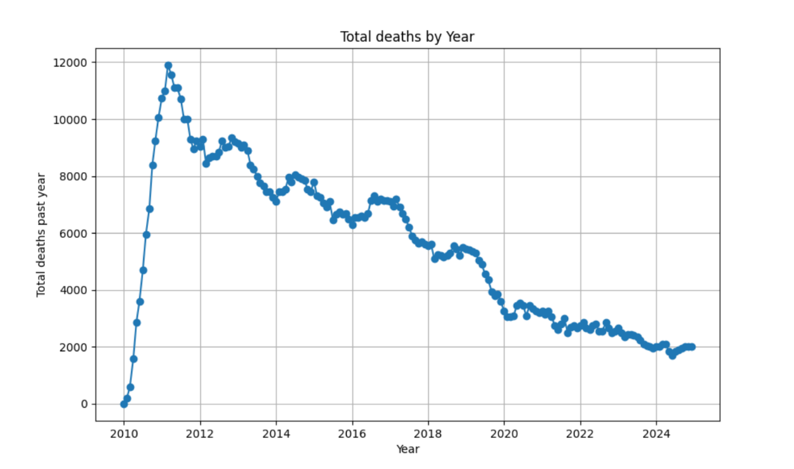

The comparison with deaths from cervical cancer from the GBD exercise is shown below. The absolute numbers of deaths in the GBD in the graph are much lower than the number from Globocan and we have chosen to calibrate to the Globocan figure. The comparison with GBD highlights that the distribution of age at death from cervical cancer from the model is likely too low and this is something to return to as further calibration data become available and if we are focussing specifically on a policy question relating to cervical cancer.

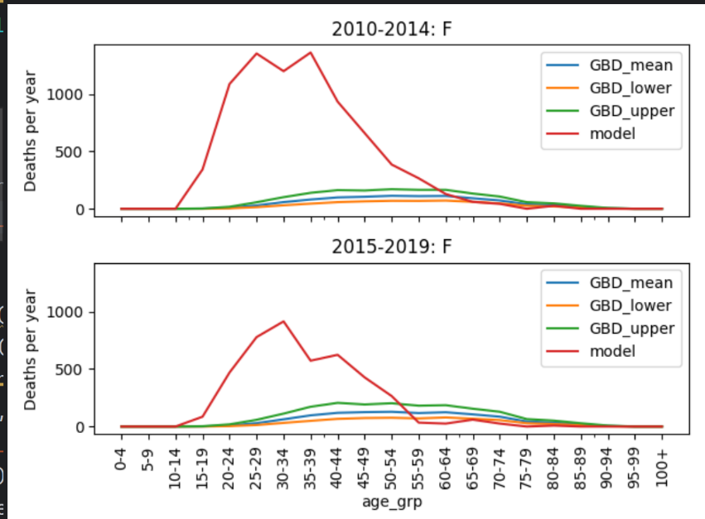
References
https://www.hpvworld.com/articles/use-of-the-genexpert-test-in-malawi/#:~:text=Xpert%C2%AE%20HPV%20is%20a,same%20day%20screening%20and%20treatment.
https://hpvcentre.net/statistics/reports/MWI_FS.pdf
Rudd P., et al. Cervical cancer in southern Malawi: A prospective analysis of presentation, management, and outcomes. Malawi Medical Journal 2017.
Chasimpha et al. Three-year cancer incidence in Blantyre, Malawi (2008–2010). Int. J. Cancer: 141, 694–700 (2017).
https://www.cancerresearchuk.org/health-professional/cancer-statistics/statistics-by-cancer-type/cervical-cancer
Moses et al. Risk factors for common cancers among patients at Kamuzu Central Hospital in Lilongwe, Malawi: A retrospective cohort study. Malawi Medical Journal 29 (2): June 2017
Masamba et al. The state of oncology in Malawi in 2015. Malawi Medical Journal; 27(3): 77-78 September 2015.
Msyamboza et al. Burden of cancer in Malawi; common types, incidence and trends: National population-based cancer registry. BMC Research Notes 2012, 5:149 http://www.biomedcentral.com/1756-0500/5/149
Msyamboza KP, Phiri T, Sichali W, Kwenda W, Kachale F. Cervical cancer screening uptake and challenges in Malawi from 2011 to 2015: retrospective cohort study. BMC Publ Health. 2016;16(1):806. https://doi.org/10.1186/s12889-016-3530-y.
Mukhula et al. Characterising cancer burden and quality of care at two palliative care clinics in Malawi. Malawi Medical Journal 29 (2): June 2017
Malawi DHS 2010, 2015/16 https://dhsprogram.com/
Disability weights for the Global Burden of Disease 2013 study. Salomon et al. 2015 DOI: https://doi.org/10.1016/S2214-109X(15)00069-8
Stefan et al. Cancer Care in Africa: An Overview of Resources Volume 1, Issue 1, October 2015.. J Glob Oncol 1:30-36. © 2015 by American Society of Clinical Oncology.
Cornelissen et al. The Cost of Providing District-Level Surgery in Malawi. World J Surg (2018) 42:46–53 DOI 10.1007/s00268-017-4166-5
Globocan http://gco.iarc.fr/today/data/factsheets/populations/454-malawi-fact-sheets.pdf
Gopal S, Krysiak R, Liomba NG, Horner M-J, Shores CG, et al. (2013) Early Experience after Developing a Pathology Laboratory in Malawi, with Emphasis on Cancer Diagnoses. PLoS ONE 8(8): e70361. doi:10.1371/journal.pone.0070361
Cancer treatment guidelines for SSA https://www.nccn.org/harmonized/
Parkin DM et al. Cancer in Sub-Saharan Africa. International Agency for Research on Cancer Lyon, France 2018
Ministry of Health and Population. Malawi national cancer control strategic plan. https://www.iccp-portal.org/system/files/plans/MALAWI%20NATIONAL%20CANC ER%20CONTROL%20STRATEGIC%20PLAN-%202019-2029.pdf; 2019-2029.
Malawi National Cervical Cancer Strategic Plan 2022-2026. https://www.iccp-portal.org/news/malawi-national-cervical-cancer-strategic-plan-2022-2026 https://www.iccp-portal.org/system/files/plans/Malawi%20Cervical%20Cancer%20Strategic%20Plan_2022-2026-%20Final%20Print%20Ready%20Version%2016.12.2021%5B1796%5D.pdf
National Service Delivery Guidelines for Cervical Cancer Prevention and Control. April 2019
Mustafa RA, Santesso N, Khatib R, Mustafa AA, Wiercioch W, Kehar R, Gandhi S, Chen Y, Cheung A, Hopkins J, Ma B, Lloyd N, Wu D, Broutet N, Schünemann HJ. Systematic reviews and meta-analyses of the accuracy of HPV tests, visual inspection with acetic acid, cytology, and colposcopy. Int J Gynaecol Obstet. 2016 Mar;132(3):259-65. doi: 10.1016/j.ijgo.2015.07.024. Epub 2015 Nov 12. PMID: 26851054.
Jie Liu, Hengxi Chen, Xueping Peng. Clin. Exp. Obstet. Gynecol. 2024; 51(3): 72 https://doi.org/10.31083/j.ceog5103072 Systematic Review Efficacy and Safety of Thermocoagulation vs. Cryotherapy for Cervical Precancerous Lesions: A Systematic Review and Meta-Analysis
Gerstl et al. BMC Public Health (2022) 22:295 https://doi.org/10.1186/s12889-022-12547-9
Twabi HH, Msosa TC, Meja SJ, Mukoka M, Semphere R, Chipungu G, et al. (2024) Spatial distribution and characteristics of women reporting cervical cancer screening in Malawi: An analysis of the 2020 to 2021 Malawi Population-based HIV Impact Assessment survey data. PLoS ONE 19(10): e0309053. https://doi.org/10.1371/journal. pone.0309053

Rasmussen et al. BMC Health Services Research https://doi.org/10.1186/s12913-024-11226-2

Tang, J.H.; Lee, F.; Chagomerana, M.B.; Ghambi, K.; Mhango, P.; Msowoya, L.; Mkochi, T.; Magongwa, I.; Mhango, E.; Mbendera, J.; et al. Results from Two HPV-Based Cervical Cancer Screening-Family Planning Integration Models in Malawi:

