Modelling Neonatal Outcomes following birth within the Thanzi La Onse Model
Background: The Thanzi La Onse Model
As part of the Thanzi La Onse program a model is being developed which aims to capture the health experiences of the population of Malawi and the consequent interactions with the health care system. The intent is that this model will help to inform future delivery of health care in Malawi. The model is an individual based model – which means we explicitly simulate the individual life and health experiences of a representative proportion of population of Malawi. The simulation initiates on 1 Jan 2010 and we attempt to simulate the attributes of the population at that point. We can run the model forward to any specified future time point. Each potential intervention and its associated diseases are being modelled. This is being divided into separate disease/intervention modules. This document describes the module on neonatal outcomes following birth and neonatal health care in Malawi.
Background: General approach to decisions on modelling causal influences and effects of interventions
This module was designed in the context of an overall approach to modelling causal effects in general and causal effects of interventions in particular. The overall intent is to adopt as simple a structure as can be conceived, whilst still capturing the essential elements of a disease and the interventions used to prevent or treatment. We include a causal link between a “variable” (by which we mean a characteristic or property of an individual, whether that be demographic, social or biologic), and risk of disease or another variable if there is strong evidence from an overall body of studies that such a causal link exists and is at least moderately strong. In informing such decisions we place particular value on RCTs or studies with a quasi-experimental design such as analyses based on an instrumental variable. There is no expectation that such studies will be from Malawi or even from Africa. If there are such local studies and in the unlikely event that they provide strong evidence to suggest that the causal link is substantively different in Malawi then the intent is that this is taken into account and the Malawi-specific link included.
In the special case of a potential causal variable which relates to whether an individual has experienced or is experiencing an intervention the intent is to only include interventions if there is substantial RCT evidence of their beneficial effect, based on trials with objectively ascertained clinical endpoints with low risk of serious bias. Whilst DCP-3 (and to some extent the Malawi EHP) provides an initial list of such interventions and the evidence to support them, where possible our intent has been to form our own opinion on intervention efficacy based on the source trials.
Unless there is evidence to the contrary, the intent is to summarize and incorporate intervention effects into the model as relative risks or rates rather than absolute differences due to the fact that such measures are less likely to differ substantively by context. Interactions between characteristics (on the multiplicative scale) are only to be incorporated if there is strong evidence. Again, we have not intended to rely on data from Malawi or Africa for such evidence but if local evidence exists which strongly suggests a different effect than elsewhere then the intent is that this modified effect is incorporated in the model.
Background: Demographic and social characteristics modelled
Based on data on the distribution of the population in Malawi according to geographic location we assign individuals a geographic location, which maps onto whether they are classified as living in a rural or urban area. Informed largely by data from the Malawi DHS, variables are also created indicating the person’s wealth level (based on 5 quintiles), whether the person has access to improved sanitation, clean drinking water, hand washing facilities, and whether they experience indoor air pollution (wood burning stove). We assign individuals a current education status (none, primary, secondary) which is updated 3 monthly from age 5 to 20. We assign individuals a current education status (none, primary, secondary) which is updated 3 monthly from age 5 to 20. From age 15 on BMI (in 5 groups) is assigned, as well as using tobacco, drinking excess alcohol, having low exercise, high salt intake, high sugar intake. The status with regard to such variables for individuals can change over time. The influences between these variables are described in detail in a separate document.
Approach to modelling newborn outcomes: rationale for model structure and choice of parameter values
This model describes the outcomes of neonates, immediately following birth, that are generated during a run of the simulation. Detailed documentation on modelling of pregnancy and birth within the Thanzi La Onse project is compiled in another methods document and is available on request.
The model described in this document aims to simulate the first 48 hours of a neonate’s life – application of incidence of complications, diseases or healthcare use for the remainder of the neonatal period occurs within the postnatal module and is described in detail within the associated methods documentation (also available on request).
As with other modules in Thanzi La Onse we use a natural history approach when developing models of the underlying epidemiology of complications and disease within the neonatal period. We have modelled the onset and progression of each condition/complication contributing to the highest burden of disease in the early neonatal period, including the causal impact of predictor variables, in the absence of healthcare interventions. Likelihood of death, calculated as described in the following sections, is applied to all neonates who develop complications following birth.
This model, along with the postnatal model, will be calibrated to national level data, from Malawi, on historical neonatal mortality rates, cause specific neonatal mortality and health service utilisation data (i.e. rate of facility delivery, rate of neonatal inpatient service use, rate of postnatal care etc.). The primary data sources for calibration currently include the Demographic and Heath Survey (DHS), the Basic and Emergency Obstetric and Newborn Reports (BEmONC) and the Harmonised Health Facilities Assessment Report (HHFA).
Through the process of parameterisation and calibration the model will replicate the incidence of neonatal complications and death across the days of neonatal period, reflective of the burden of disease Malawi. Importantly, country data and published research (such as the data shown in figure 1) will be used to ensure we replicated the disproportionally high burden of neonatal morbidity and mortality associated with the first few days of life

Figure 1. Distribution of neonatal deaths by cause in two study sites in Malawi. Source: (Fottrell et al., 2015)
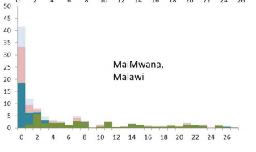
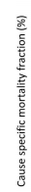
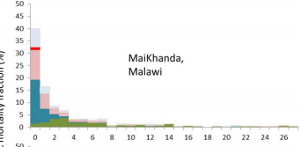
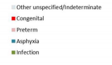

Additionally to the epidemiology of diseases within this period the immediate treatment of neonates who experience complications and referral of neonates to special care/inpatient treatment through relevant health system interactions is also modelled. The interventions included in this model are those which would reasonably be delivered by a “skilled birth attendant” immediately following delivery and do not extend to inpatient or intensive care at this time . Tables 1 and 2 provide the key definitions of terms used within this document and the model itself.
Table 1. Definitions of the time periods
Term | Definition and Source
Neonatal period | The first 28 days of a child’s life (WHO 2006)
Early neonatal period | Days 0-6 of a child’s life (Oza et al., 2015)
Late neonatal period | Days 7-28 of a child’s life (Oza et al., 2015)

Table 2. Definitions of key terms used within the model
Term | Definition and Source
Early preterm neonate | A neonate born between 24 and 33 weeks gestation
Late preterm neonate | A neonate born between 34 and 37 weeks gestation
Low birth weight | A birth weight of less than 2500g (up to and including 2499g) (World Health Organisation (WHO), 2004)
Small for gestational age | Foetuses or newborns which are those smaller in size than normal for their gestational age, most commonly defined as a weight below the 10th percentile for the gestational age (de Onis et al, 1996).
Early onset neonatal sepsis | Sepsis evident within the first 7 days of life (Chan et al., 2015)
Not breathing at birth (Neonatal respiratory depression) | The failure to initiate breathing at birth (with causes including but not limited intrapartum hypoxia, respiratory distress syndrome–preterm birth, infection, general anaesthesia during labour, meconium aspiration, intracranial disease, and neuromuscular disease) (Lee et al., 2013)
Neonatal encephalopathy | “A disturbance of neurological function in the earliest days of life in the term infant manifested by difficulty initiating and maintaining respiration, depression of tone and reflexes, abnormal level of consciousness and often by seizures”, which may follow an intrapartum hypoxic insult or be due to another cause (Lee et al., 2013)
Retinopathy of prematurity | An arrest of normal retinal neuronal and vascular development in the preterm infant, with ultimately pathological compensatory mechanisms that result in abnormal vascularisation of the retina (Hellström, Smith and Dammann, 2013)
Respiratory Distress Syndrome | Syndrome caused by developmental insufficiency of surfactant production and function, as well as by structural immaturity of the lungs (Pickerd and Kotecha, 2008)

Variables modelled
Variables (properties of an individual) within this model can be broadly grouped into anthropometric variables, complications following birth, disability following birth and treatment received. The section provides a list of these variables whilst the following sections describe how these variables are applied in the model.
Anthropometric variables generated and stored for neonates include:
- Birth weight status
  - extremely low birth weight (<1000g)
  - very low birth weight (<1500g)
  - low birth weight (<2500g)
  - normal birth weight (>2500g)
- Size for gestational age
  - Small for gestational age,
  - Average for gestational age
  - Large for gestational age (weight above the 90th percentile for gestational age).
Complications which are evident at birth, or shortly after, which constitute the majority of the disease burden in the first 48 hours of life include:
- Prematurity (early or late)
  - Respiratory distress syndrome secondary to prematurity (True/False)
  - Retinopathy of prematurity (mild, moderate, severe, blindness)
- Early onset neonatal sepsis (True/False)
- Neonatal encephalopathy (none, mild, moderate or severe)
- Neonatal respiratory depression - ‘not breathing at birth’ (True/False).
- Congenital birth anomalies (Musculoskeletal, Neural tube defects, Cardiovascular, Gastrointestinal, Orofacial, Urogenital and Down syndrome)
We capture morbidity associated with these complications in a disability variable associated with each complication that leads to an accrual of a disability weight. Disability weights for each complication are taken from Salamon (2013). In the instance of neonatal sepsis, encephalopathy and prematurity these disability categories include mild, moderate or severe motor impairment or mild motor and cognitive impairment. Disability outcomes for retinopathy of prematurity include none, mild, moderate or severe visual impairment and blindness. We currently assume that all disability secondary to newborn complications last for the entirety of the life course.
Finally treatment variables indicating if a neonate has received specific treatment for a complication or routine care following delivery include:
- Essential newborn care such as cord care (True/False), clean birth and postnatal practices (True/False) and initiation of breastfeeding (True/False)
- Kangaroo mother care (True/False) for low birth weight neonates
- Intravenous antibiotics (True/False) and full supportive care for sepsis (True/False)
- Neonatal resuscitation (True/False).

Updating the variables
Variables within models are updated at different time points as the simulation moves forward. In this model all variables pertaining to birth weight, size for gestational age, prematurity and all associated complications are updated on birth, dependent on each neonate’s individual risk. This is calculated from baseline incidence, intrapartum risk factors and individual risk factors.
Variables denoting receipt of interventions such as early breastfeeding and kangaroo mother care are updated on the date at which the health system interaction is actioned. The same is true for variables storing neonatal death and death date.
Over the next few sections we will provide rationale for the structure of natural history models of complications/diseases within the model followed by a description of treatment in the model.

Incidence of low birth weight and small for gestational age
Currently we randomly allocate a birthweight to a neonate by drawing a random value from a normal distribution of weights. The mean of this distribution is dependent on the neonate’s gestational age at delivery. We have yet to find complete data for mean birthweights at delivery by gestational age for Malawian neonates so are currently parameterising this function with a mixture of data from Malawi (Kalanda et al., 2005) and the United States (Boghossian et al., 2016) prior to further evaluation of the literature.
The distribution for each neonate is then used to classify their size for gestational age. The 10th and 90th percentile are calculated for a distribution around the mean value and neonates falling below the 10th percentile for their gestation are classified as ‘small for gestational age’ and those above the 90th percentile are ‘large for gestational age’. This method however does not yet consider maternal or pregnancy causal influences on neonatal birth weight or small for gestational age and this will require review.

Incidence of neonatal complications
The following sections will provide an overview of assumed natural history models of each of the complications neonates are at risk of within our model. We make a distinction between neonates depending on the gestational age at birth regarding the complications they may experience as seen in figure 2. Figure 2 is an overview of the entire newborn natural history model with black boxes denoting variables (states of disease) and the bold text denoting parameter values (i.e. prob_early_onset_neonatal_sepsis_day_0 represents an individual’s probability of developing sepsis following birth)

Figure 2. Overview of the newborn outcomes model
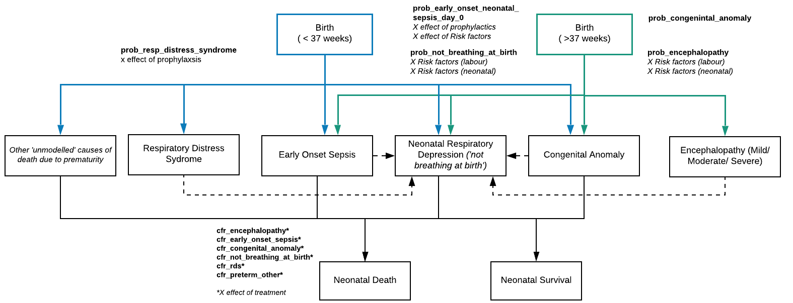

Please note that this diagram does not fully describe the temporality of risk application within the model in regards to the variable neonatal respiratory depression which will be described fully in the next section.
Prematurity
As you can see from figure 2, within our model preterm neonates are liable to develop a number of complications at birth, some overlap with term neonates such as early onset sepsis and congenital anomaly, whilst others are specific to preterm births such as respiratory distress syndrome (RDS).
Traditionally within child health, complications associated with prematurity have categorised as one distinct contributing cause of death in neonates and children, often referred to as ‘prematurity’ (Muhe et al., 2019) However there are multiple physiological complications associated with or exacerbated by prematurity which may contribute to death and disability and vary between high and low income settings (Muhe et al., 2019) and according to gestational age at delivery (Manuck et al., 2016). Muhe et al. (2019) evaluated the outcomes of nearly 5000 preterm neonates in five health facilities across Ethiopia including underlying primary cause of death in those participants who died. They found the leading primary causes of death in their study (deaths n=1109) were respiratory distress syndrome (45%), neonatal infection (including meningitis, pneumonia and sepsis, (30%)), asphyxia (13%), other (includes intraventricular haemorrhage, necrotising entercolitis and others, (9%) and congenital anomalies (3%). These conditions are therefore included in the model with risk applied to both preterm and term neonates.
In addition, we are aware that there are a number of other common complications attributed to prematurity however following review of relevant literature and review with clinical experts, it was deemed appropriate to explicitly model the leading underlying causes of death and then apply a background risk of death due to other ‘non-modelled causes’ (such as intraventricular haemorrhage or necrotising entercolitis), as seen in figure 2.
Respiratory Distress Syndrome (RDS)
As described above, RDS is one of the leading causes of death in preterm infants (Muhe et al., 2019). We currently apply a fixed probability that any preterm newborn will experience RDS following birth, regardless of gestational age. A preliminary review of the literature has identified gestational age at delivery and maternal diabetes (Li, Wang and Zhang, 2019)to be leading risk factors for the development of RDS. The effect of these risk factors on individual risk will be included in the model following review with a clinician.
Retinopathy of prematurity (ROP)
Retinopathy of prematurity is explicitly modelled to allow for DALY weight mapping. In severe cases ROP can lead to permanent visual disturbances or blindness. Retinopathy of prematurity is an emerging disease across sub-Saharan Africa, attributed in part to advances in health system development and neonatology, as the administration of high concentration of oxygen in neonatal care has been identified as causal influence on ROP (Wang et al., 2019, ). Because of this ROP may eventually need to be managed by NICU module(s).

‘Not breathing at birth’
Neonates are liable to experience depression of respiratory function at birth for a variety of reasons. We have opted to use terminology employed by Lee et al. (2013) as defined in the table 2. Within this model we assume that any newborns who are not breathing adequetly at birth is because of one of the following reasons:
- Neonatal encephalopathy (secondary to hypoxia, infection etc.)
- Preterm RDS (as described above)
- Other (causes not explicitly modelled)
The ‘not breathing at birth’ variable used within the model to indicate that this neonate would benefit clinically from resuscitation and otherwise will be at increased risk of death (please see section on treatment). Encephalopathic neonates or neonates with RDS are automatically assumed to have this variable set to True.
We have also opted to apply a one-off probability of ‘not breathing at birth’ to all other neonates to capture the effect of non-modelled causes on the individual risk of respiratory depression. We have not yet identified the risk factors we will include to influence individual risk of respiratory depression in neonates without encephalopathy or respiratory distress syndrome (these conditions are described below) but there will imaginably be some overlap between risk for respiratory depression and risk of those complications and this may require discussion again with a clinician.
Neonatal encephalopathy (NE)
Early attempts to systematically evaluate the contribution of intrapartum related events to neonatal mortality and morbidity, within the Global Burden of Disease studies, found ‘Birth Asphyxia’ (defined by the WHO as “failing to initiate or maintain regular breathing at birth” (ref.)) to be one of the leading causes of death and disability in the world (Lee et al. 2013). However this definition failed to consider other contributory factors to respiratory depression in neonates and therefore the term NE is now favoured, and as defined by Lee et al. (2013) can be caused by a complex constellation of intrapartum and immediately postpartum factors (Lee et al. 2013, Tann et al., 2018). In the following figure taken from that paper the authors provide a schematic for evaluating deaths associated to ‘intrapartum related events’ within the global burden of disease study:

Figure 2. Global burden of disease schematic for intrapartum-related events “birth asphyxia”: Source - Lee et al. 2013
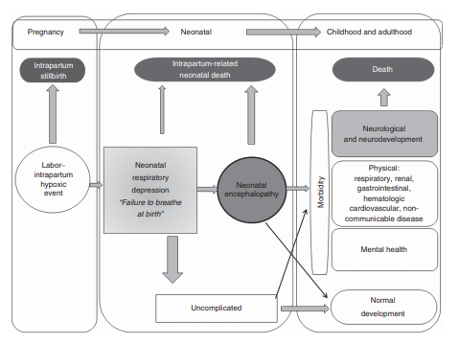

Through consultation with experts in the field of neonatal encephalopathy we have developed the following natural history diagram which accounts for the contribution of both intrapartum and postpartum hypoxia and other neonatal factors (i.e. infection) on likelihood of neonatal encephalopathy following birth

Figure 3. Natural history model of neonatal encephalopathy

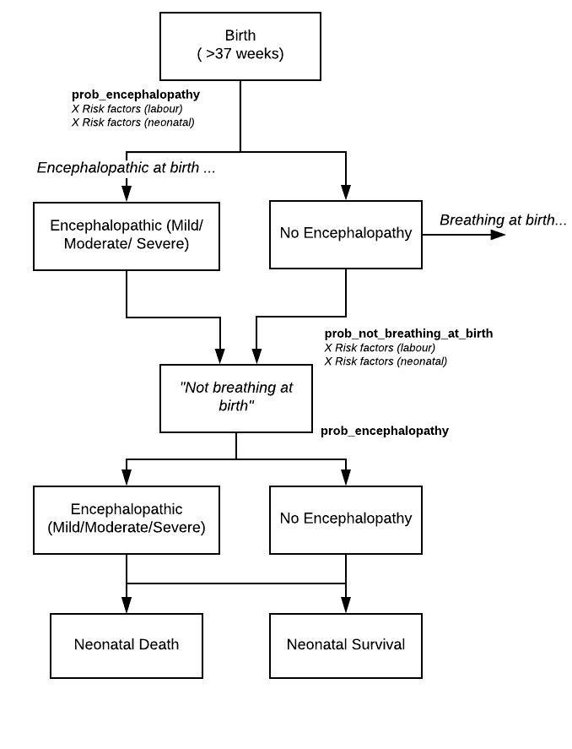

Figure 3 demonstrates how individual risk of encephalopathy is applied in the model and was developed in consultation with Dr Cally Tann who is an expert in the field. We assume that on birth neonates may already be encephalopathic due to injury or infection that may have occurred in-utero.
Any encephalopathic neonates are assumed to be ‘not breathing at birth’-as we are using the Lee et al. (2013) definition of NE in which the condition is ‘manifested by difficulty initiating and maintaining respiration,’ - and are at risk of death associated with their encephalopathy. Currently we do not model the possibility of worsening encephalopathy for neonates who do not receive adequate respiratory support (resuscitation, oxygen – described below) following birth (assuming additional hypoxia following delivery could lead to more advance injury).
For neonates born without encephalopathy we apply a probability that they will also fail to initiate adequate respiration after birth (as neonates are liable to not initiate breathing without being encephalopathic). All neonates who are not already encephalopathic but do not immediately initiate breathing are then at risk of developing encephalopathy, secondary to hypoxic injury (see Figure 3).
Presently the risk of encephalopathy is only applied to term neonates as clinical identifiers of encephalopathy used in term infants are common within preterm neonates and arriving at a diagnosis of encephalopathy in preterm infants is difficult, leading to limited reporting of incidence or outcome (Logitharajah, Rutherford and Cowan, 2009). We assume that increased risk of mortality associated with encephalopathy in preterm neonates is implicitly captured in case fatality rates applied to preterm infants in the model.
We have assumed a risk of all-severity encephalopathy of 0.012, in the instance of a positive case we then apply a probability of severity as 0.422 that the case is mild, 0.338 for moderate and 0.24 for severe (Lee et al., 2013). Causal factors in the model are taken from a case control study of Ghanaian neonates by Tann et al., (2018) and include current neonatal sepsis (AOR 8.67), maternal hypertension (AOR 3.77 ), being male (AOR 2.51), and obstructed labour during delivery (AOR 3.8). As we are using the Lee et al. (2013) definition of NE in which the condition is ‘manifested by difficulty initiating and maintaining respiration,’ we assume that all neonates with NE will require Neonatal Resuscitation as an intervention to assist with breathing.
Early onset neonatal sepsis
Varying definitions of early-onset neonatal sepsis have been provided within the literature dependent on gestation at birth and causative organism. The definition we apply from Chan et al (2015) is intended to capture both vertical transmission and nosocomial infection associated with sepsis- however we do not explicitly model pathogen/primary source of sepsis within this model. As mentioned above, the incidence rate of sepsis applied here will be reflective of the rate of sepsis which onsets between day 0-2 and this value has not yet been finalised.
Prior to a full review of the literature we assume a baseline risk of early-onset sepsis of 0.0063 (Seale et al., 2014) taken from a meta-analysis of incidence data of severe bacterial infection in neonates in Sub-Saharan Africa. These data included neonates born at >32 weeks gestation and >1500g birth weight so will not be accurate for all neonates in the model.
At present a final search of the literature to confirm all risk factors for sepsis has not been completed.
Figure 4. Natural history model of early onset neonatal sepsis
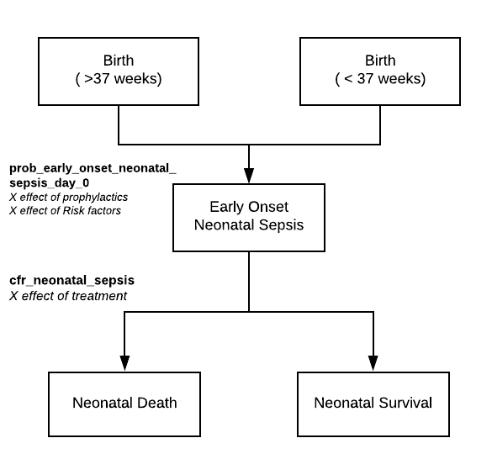

Congenital Birth Anomalies
The term ‘congenital anomaly’ describes a broad and complex group of physiological and cosmetic conditions contributing significantly to global neonatal and child mortality and morbidity (Liu et al., 2016). For simplicity, in this model, we assume that any neonate who survives until birth has a risk of being born with a congenital anomaly (and that non-survivable anomalies are implicitly modelled in rates of spontaneous abortion and still birth). Currently that risk is fixed and not modified by risk factors as the rate is intended to capture all anomalies within the population. If this neonate is born with an anomaly we use prevalence data taken from a systematic review and meta-analysis of prevalence of anomalies in sub-Saharan Africa to categorise the anomaly as either Musculoskeletal, Neural tube defects, Cardiovascular, Gastrointestinal, Orofacial, Urogenital and Down syndrome. A set case fatality is applied to any neonate with a congenital anomaly (Adane et al., 2020)

Table 3. Description of variables created by this model
Variable | Description | Notes and Major Assumptions
nb_early_preterm | Whether this neonate has been born early preterm (24-33wks)
nb_late_preterm | Whether this neonate has been born late preterm (33-36wks)
nb_preterm_birth_disab | Impairment associated with preterm birth: none, mild motor and cognitive, mild motor, moderate motor or severe motor
nb_congenital_anomaly | Congenital anomalies after birth: Musculoskeletal, Neural tube defects, Cardiovascular, Gastrointestinal, Orofacial, Urogenital and Down syndrome
nb_early_onset_neonatal_sepsis | Whether this neonate has developed early-onset neonatal sepsis
nb_inj_abx_neonatal_sepsis | Whether this neonate has received injectable antibiotics as treatment for neonatal sepsis
nb_supp_care_neonatal_sepsis | Whether this neonate has received full supportive care as treatment for neonatal sepsis
nb_neonatal_sepsis_disab | Impairment associated with neonatal sepsis: none, mild motor and cognitive, mild motor, moderate motor or severe motor
nb_not_breathing_at_birth | Whether this neonate is not breathing following delivery
nb_received_neonatal_resuscitation | Whether this neonate has received resuscitation following delivery
nb_encephalopathy | Whether this neonate has developed encephalopathy following birth. Categorical: None, mild, moderate, severe
nb_encephalopathy_disab | Impairment associated with encephalopathy: none, mild motor and cognitive, mild motor, moderate motor or severe motor
nb_retinopathy_prem | Whether this preterm neonate has developed retinopathy of prematurity and the severity of this. ‘none’, ‘mild’ , ‘moderate’, ‘severe’, ‘blindness’
nb_low_birth_weight_status | Weight at birth: extremely low-birth weight, very low birth-weight, low birth weight or normal birth weight. | Presently we are only applying the incidence of LBW.
nb_size_for_gestational_age | Size for gestational age: Small, average, large | Presently we are only applying the incidence of SGA and AGA
nb_early_breastfeeding | Whether this neonate started breast feeding within one hour after birth | May not need to be stored in main data frame
nb_breastfeeding_type | How this baby is being breastfed: none, non-exclusive, exclusive
nb_kangaroo_mother_care | Whether this low birth weight neonate has experienced kangaroo mother care following birth | May not need to be stored in main data frame
nb_clean_birth | Whether this neonate received clean birth practices during delivery
nb_received_cord_care | Whether this neonate received cord care with chlorhexidine
nb_death_after_birth | DUMMY | Dummy variables for quick analysis
nb_death_after_birth_date | DUMMY | Dummy variables for quick analysis

Case Fatality
Within the model we take a similar approach to the Labour module where an ‘untreated’ case fatality rate will be applied to neonates for each complication they experience allowing for multiple complications to contribute to death.
Regarding the complications directly associated with respiratory function (RDS, NE and NRD) we assume that the risk of death associated with ‘not breathing at birth’ is implicit in the case fatality rates for RDS & NE. For example, for a neonate with RDS and NRD set to True in the model only the risk of death from RDS is applied. However, for neonates experiencing NRD without NE/RDS we apply a separate case fatality associated with NRD. This is to capture the risk of death for neonates who are born with some degree of respiratory depression, not secondary to another respiratory condition, but without stimulation or resuscitation will not initiate breathing and will die.
This case fatality parameter will reflect the likelihood of death for a neonate experiencing a complication in the absence of any medical treatment. Likelihood of death will be modified by treatment effects. Current values within the model do not reflect untreated case fatality rates, this will need further consideration on how best to determine/estimate these values.
Disability Weights
Disability weights for neonatal complications are given in the following table and are taken from Salomon (2013). These disability weights are almost exclusively describe long-term impairments associated with neonatal illness and therefore this weight remains associated to an individual for the course of their life in the simulation.
We apply a varying probability of disability to each neonate that experiences a complication. Where complications are graded by severity, such as encephalopathy, the probability of disability is modified by severity level, where more severe cases are more likely to experience severe disability. Current values for probability of disability in the model are dummy but can been seen in table 5

Table 4. DALY weights included in this model
Condition | Weight | Notes
Mild motor plus cognitive impairments due to neonatal preterm birth complications <28wks | 0.031,0.018,0.05 | -
Mild motor plus cognitive impairments due to neonatal preterm birth complications 28-32wks | 0.031,0.018,0.05
Mild motor plus cognitive impairments due to neonatal preterm birth complications 32-36wks | 0.031,0.018,0.05
Mild motor impairment due to neonatal preterm birth complications <28wks | 0.01,0.005,0.019
Mild motor impairment due to neonatal preterm birth complications 28-32wks,"Motor impairment, mild | 0.01,0.005,0.019
Mild motor impairment due to neonatal preterm birth complications 32-36wks | 0.01,0.005,0.019
Moderate motor impairment due to neonatal preterm birth complications <28wks | 0.061,0.04,0.089
Moderate motor impairment due to neonatal preterm birth complications 28-32wks | 0.061,0.04,0.089
Moderate motor impairment due to neonatal preterm birth complications 32-36wks | 0.061,0.04,0.089
Severe motor impairment due to neonatal preterm birth complications <28wks | 0.402,0.268,0.545
Severe motor impairment due to neonatal preterm birth complications 28-32wks | 0.402,0.268,0.545
Severe motor impairment due to neonatal preterm birth complications 32-36wks | 0.402,0.268,0.545
Mild vision impairment due to retinopathy of prematurity | 0.003,0.001,0.007
Moderate vision impairment due to retinopathy of prematurity | 0.031,0.019,0.049
Severe vision impairment due to retinopathy of prematurity | 0.184,0.125,0.258
Blindness due to retinopathy of prematurity | 0.187,0.124,0.26
Mild motor impairment due to neonatal encephalopathy due to birth asphyxia and trauma | 0.01,0.005,0.019
Moderate motor impairment due to neonatal encephalopathy due to birth asphyxia and trauma | 0.061,0.04,0.089
Severe motor impairment due to neonatal encephalopathy due to birth asphyxia and trauma | 0.402,0.268,0.545
Mild motor plus cognitive impairments due to neonatal encephalopathy due to birth asphyxia and trauma | 0.031,0.018,0.05
Mild motor impairment due to neonatal sepsis and other neonatal infections | 0.01,0.005,0.019
Moderate motor impairment due to neonatal sepsis and other neonatal infections | 0.061,0.04,0.089
Severe motor impairment due to neonatal sepsis and other neonatal | 0.402,0.268,0.545
Severe infection due to neonatal sepsis and other neonatal infections | 0.133,0.088,0.19
Mild motor plus cognitive impairments due to neonatal sepsis and other neonatal infections | 0.031,0.018,0.05

Table 5. Description of natural history parameters included in the model
Parameter | Proposed value | Description | Reference Notes
mean_birth_weights | [657, 746, 851,  966,1096,1240,  1300,1600, 1850,  2150,2200,2442,  2736,2856, 2995, 3036, 3117, 3136] | Mean birth weights by gestational age in grams starting at 24 weeks and ending at 41 weeks | (Kalanda et al., 2005; Boghossian et al., 2016)
standard_deviation_birth_weights | [113, 140, 169,  196, 218, 235 ,  245, 260, 270,  285, 296, 460,  467, 398, 356,  351, 396, 351 ] |  | (Kalanda et al., 2005; Boghossian et al., 2016)
prob_disability_<28wks | [0.2, 0.2, 0.1, 0.2, 0.3] | Probability of a neonate born at less than 28 weeks gestation developing moderate motor impairment, moderate motor and cognitive impairment or moderate or severe motor impairment | DUMMY.
prob_disability_28_32wks | [0.4, 0.1, 0.3, 0.1, 0.1] | Probability of a neonate born between 28 and 32 weeks gestation developing moderate motor impairment, moderate motor and cognitive impairment or moderate or severe motor impairment | DUMMY.
prob_disability_33_36wks | [0.5, 0.1, 0.2, 0.1, 0.1] | Probability of a neonate born between 33 and 36 weeks gestation developing moderate motor impairment, moderate motor and cognitive impairment or moderate or severe motor impairment | DUMMY.
prob_congenital_ba | 0.008 | Probability of a neonate being delivered with a congenital anomaly | DUMMY.
prev_types_of_ca | [0.16, 0.14, 0.14, 0.14, 0.14, 0.14, 0.14] | Prevalence of each type of congenital anomaly within the model: Musculoskeletal, Neural tube defects, Cardiovascular, Gastrointestinal, Orofacial, Urogenital and Down syndrome | DUMMY.
prob_early_onset_neonatal_sepsis_day_0 | 0.062 | Probability of a neonate developing sepsis from day 0 | DUMMY.
prob_sepsis_disabilities | [0.4, 0.1, 0.3, 0.1, 0.1] | Probability of a neonate with early onset sepsis developing moderate motor impairment, moderate motor and cognitive impairment or moderate or severe motor impairment | DUMMY.
prob_respiratory_distress_preterm | 0.7 | Probability of a preterm neonate developing respiratory distress | DUMMY.
prob_failure_to_transition | 0.15 | Probability of a neonate without encephalopathy or respiratory distress  syndrome not breathing at birth | DUMMY.
odds_encephalopathy | 0.3 | odds of a neonate being born with neonatal encephalopathy | DUMMY.
odds_enceph_neonatal_sepsis | 8.67 | Odds ratio of encephalopathy for a neonate with sepsis | (Tann et al., 2018)
odds_enceph_hypertension | 3.77 | Odds ratio for encephalopathy for a neonate whose mother was hypertensive | (Tann et al., 2018)
odds_enceph_males | 2.51 | Odds ratio for encephalopathy in male neonates | (Tann et al., 2018)
odds_enceph_obstructed_labour | 3.8 | Odds ratio for encephalopathy following obstructed labour | (Tann et al., 2018)
odds_enceph_acute_event | 8.74 | Odds ration for encephalopathy following an acute intrapartum event | (Tann et al., 2018)
prob_enceph_severity | [0.422, 0.338, 0.24] | Probability of mild, moderate and severe encephalopathy in encephalopathic neonates | (Lee et al., 2013)
prob_mild_enceph_disabilities | [0.3, 0.3, 0.2, 0.1, 0.1] | Probability of a neonate with mild encephalopathy developing moderate motor impairment, moderate motor and cognitive impairment or moderate or severe motor impairment | DUMMY.
prob_mod_enceph_disabilities | [0.1, 0.2, 0.1, 0.4, 0.2] | Probability of a neonate with moderate encephalopathy developing moderate motor impairment, moderate motor and cognitive impairment or moderate or severe motor impairment | DUMMY.
prob_severe_enceph_disabilities | [0.1, 0.1, 0.1, 0.3, 0.4] | Probability of a neonate with severe encephalopathy developing moderate motor impairment, moderate motor and cognitive impairment or moderate or severe motor impairment | DUMMY.
prob_retinopathy_preterm | 0.15 | Probability of a preterm infant developing retinopathy | DUMMY.
prob_retinopathy_severity | [0.4, 0.3, 0.2, 0.1] | Probability of visual impairment associated with retinopathy being mild, moderate, severe or blindness | DUMMY.
cfr_mild_enceph | 0.3 | Untreated case fatality rate for mild encephalopathy | DUMMY.
cfr_moderate_enceph | 0.3 | Untreated case fatality rate for moderate encephalopathy | DUMMY.
cfr_severe_enceph | 0.3 | Untreated case fatality rate for severe encephalopathy | DUMMY.
cfr_failed_to_transition | 0.3 | Untreated case fatality for neonates not breathing at birth | DUMMY.
cfr_preterm_birth | 0.3 | Untreated case fatality for non-modelled causes of preterm birth
rr_preterm_death_early_preterm | 2 | Relative risk of preterm death in early preterm neonates | Place holder
cfr_neonatal_sepsis | 0.3 | Untreated case fatality for early onset neonatal sepsis
cfr_congenital_anomaly | 0.4 | Untreated case fatality for neonates born with congenital anomalies
cfr_rds_preterm | 0.4 | Untreated case fatality for preterm neonates with respiratory distress syndrome

Approach to modelling interventions related to care for neonates following delivery: rationale for model structure and choice of parameter values
Care Seeking
Neonates who are born to mothers who delivered in a health facility within the simulation are automatically scheduled to receive care following delivery at the highest priority. Neonates adopt the ‘characteristics’ of the facility delivery from the mother including the facility type they have been delivered in and the effect of certain prophylactic interventions delivered in the Labour model.
For neonates who develop complications following home birth we apply a probability that care will be sought and if so they are presented to health system in the same manner as if they were delivered in a facility. Currently we have not identified a suitable study providing data on the probability of care-seeking in this situation and the values within the model are dummies.
Skilled Birth Attendance Interventions
As with the labour model, neonates who are delivered in a facility may receive care that is would reasonably be delivered by a skilled birth attendant (or the team supporting them). This includes both prophylactic interventions to minimise the risk of any complications/death and curative interventions to treat complications should they arise immediately following birth.
Basic Emergency Obstetric and Newborn Care interventions that apply to neonates, and should be available at all facility levels include:
- Neonatal resuscitation
- Management of neonatal sepsis
We also include in the model essential newborn care interventions which are outlined in the Malawi Standard Treatment Guidelines (2015) and the Malawian EHP. These interventions include:
- Cord care with chlorhexidine solution to reduce incidence of sepsis
- Vitamin K prophylaxis to prevent haemorrhagic disease of the new born (although may not model HDNB so may not be needed)
- Tetracycline eye drops to prevent neonatal conjunctivitis secondary to gonorrhoea
- Early initiation of breastfeeding
- Kangaroo mother care for low birthweight neonates
We assume that all these interventions should be offered at all facilities that provide delivery (health centres/hospitals) as these interventions are not categorised as CEmONC interventions. As such there is no explicit referral for higher level neonatal care within the model. Future work will develop interventions to replicate the limited available of higher level neonatal intensive care delivered in Malawi.
Quality of care
To ensure consistency between the labour and newborn models we use the same framework to replicate quality of care in that each EmONC intervention is only delivered to a neonate, who is experiencing the relevant complication, if a number of predetermined criteria are met:
- The current ‘squeeze factor’ of the health system interaction is below the predetermined threshold under which the intervention can be delivered (i.e. the current demand on an indivudal health workers time is not so great that they can’t deliver the intervention)
- The individual is assessed by a healthcare worker who identifies their complication and that they require care – this varies by facility type
- If these first two conditions are met then the intervention will be delivered IF there are sufficient and correct consumables with which the intervention can be delivered – available consumables vary by facility level
Please see the documentation of the Labour module for further details.
BEmONC Interventions – All Facility Levels
Prophylactic interventions
As outlined above, neonates may benefit from a number of prophylactic interventions in the model. As outlined in the labour model documentation some interventions delivered prophylactically to mothers will effect neonatal outcomes (i.e. clean birth practices and antenatal corticosteroids). The effects of these interventions are documented here. Additionally neonates may benefit from additional interventions which have the following effects:
- Cord care – reduces the risk of early onset neonatal sepsis (RR 0.77 (Blencowe et al., 2011)
- Early initiation of breastfeeding –reduces the risk of early onset neonatal sepsis (RR 0.85 (LIST technical note))
- Vitamin K and tetracycline eye care- no current effect modelled due to lack of evidence for effect on modelled outcomes
- Early initiation of breastfeeding

Kangaroo Mother Care (KMC)
KMC was originally defined as skin‐to‐skin contact between a mother and her newborns, frequent and exclusive or nearly exclusive breastfeeding, and early discharge from hospital, has been proposed as an alternative to conventional neonatal care for low birthweight (LBW) infants (Conde-Agudelo, Belizán and Diaz-Rossello, 2011). Continuous KMC is recommended for all neonates who weigh less than 2000g once stable and if not possible intermittent KMC should be provided (WHO 2018). KMC for LBW infants has been shown to significantly reduce morbidity and mortality, incidence of sepsis, improve infant growth and breastfeeding (Conde-Agudelo, Belizán and Diaz-Rossello, 2011). We assume that only mothers who deliver in facilities will be encouraged to perform KMC and we apply a probability, taken from the Malawian Service Provision Assessment (2013), that a woman delivering in a facility will be encouraged to perform KMC.
Currently we apply the treatment effect on the risk of death associated prematurity (non-modelled causes) (RR 0.49 (Lawn et al., 2010)) in line with the LIST model and as we don’t apply risk of death specifically to low-birth-weight neonates without any additional complications

Curative interventions
Management of neonatal sepsis
The Malawi EHP documents that neonates should be able to receive both injectable antibiotics and full supportive care as part of the management of neonatal sepsis. Full supportive care is not defined explicitly within the EHP. We have taken our definition of full supportive care from Zaidi et al., (2011) who conducted a systematic review to evaluate the impact of a number of interventions on sepsis and pneumonia specific mortality in neonates to parameterise the LIST. Please see figure 5 for these definitions.
Figure 5. Interventions indicated for the management of neonatal sepsis. Source: Zaidi et al., (2011)
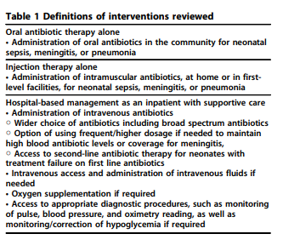

The review found no trials which assessed the impact of hospital-based management on sepsis specific mortality but through Delphi consensus reported 80% reduction in sepsis mortality for full hospital management (Zaidi et al., 2011). This is the effect used with this LIST model and we have applied this effect within this model (RR 0.2).
We assume that all neonates with sepsis who are delivered in/have sought care in a hospital will receive full supportive care (if the quality of care conditions described above have been met). Otherwise, neonates in a health centre will simply receive injectable antibiotics. We assume that injectable antibiotics alone reduce risk of death by 65% (RR 0.35 (Zaidi et al., 2011)).
Neonatal Resuscitation
Definitions for interventions delivered as part of resuscitation can be seen in figure 6
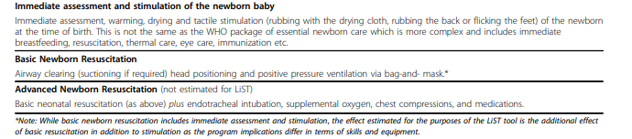
Figure 6. Definitions of resuscitation interventions. Source: (Lee et al., 2011)

Any neonates who are correctly identified as ‘not breathing at birth’ should receive both immediate assessment and stimulation followed by resuscitation (depending on consumables and squeeze). The treatment effects of neonatal resuscitation are taken from a systematic review and Delphi consensus conducted to populate the LIST model (Lee et al., 2011). This paper reported that immediate assessment and stimulation lead to a 10% reduction in mortality associated with ‘intrapartum related events’ and prematurity (Lee et al., 2011). In addition the authors reported that basic newborn resuscitation could lead to a 30% reduction in mortality associated with ‘intrapartum related events’ and 10% reduction in mortality associated with prematurity (Lee et al., 2011).
Due to the slight variation between the definitions used within the study and within this model we apply the effects in the following way:
- Immediate assessment and stimulation of neonate in addition to basic newborn resuscitation reduces risk of death associated with neonatal encephalopathy (RR 0.6)

- Immediate assessment and stimulation of neonate in addition to basic newborn resuscitation reduces risk of death associated with RDS in preterm neonates (RR 0.8)

- Immediate assessment and stimulation of neonate in addition to basic newborn resuscitation reduces risk of death associated with ‘not breathing at birth’ in neonates without encephalopathy or RDS (RR 0.8)

Referral for additional treatment
In the instance of encephalopathy, sepsis or complications associated with prematurity a neonate will likely require additional inpatient care either on the ward or possibly via the neonatal intensive care unit. The Malawi Standard Treatment Guidelines are not explicit in criteria for admission so we assume any neonate with one of the aforementioned complications will require at least one day as an inpatient. No interventions are delivered during this time but function will simply capture bed days accrued.

Table 6. Description of treatment parameters included in the model
Parameter | Proposed value | Description | Reference Notes
treatment_effect_resuscitation | 0.6 | Effect of newborn resuscitation on risk of death in term infants who are not breathing at birth | (Lee et al., 2011)
treatment_effect_resuscitation_preterm | 0.8 | Effect of newborn resuscitation on risk of death in preterm infants who are not breathing at birth | (Lee et al., 2011)
treatment_effect_inj_abx_sep | 0.35 | Effect of injectable antibiotics alone on sepsis mortality | (Zaidi et al., 2011)
treatment_effect_supp_care_sep | 0.2 | Effect of full supportive care on sepsis mortality | (Zaidi et al., 2011)
treatment_effect_cord_care | 0.77 | Effect of chlorhexidine cord care on risk of neonatal sepsis | (Blencowe et al., 2011)
treatment_effect_clean_birth | 0.73 | Effect of clean birth practices on risk of neonatal sepsis | (Cousens et al., 2010)
treatment_effect_early_init_bf | 0.85 | Effect of early initiation of breastfeeding on risk of neonatal sepsis | LIST technical note
treatment_effect_abx_prom | 0.61 | Effect of prophylactic antibiotics for PROM on risk of neonatal sepsis
treatment_effect_kmc | 0.49 | Effect of kangaroo mother care on risk of death associated with non-modelled causes of death in prematurity | (Lawn et al., 2010)
treatment_effect_steroid_preterm | 0.69 | Effect of antenatal corticosteroids on risk of RD in preterm neonates | (Roberts et al., 2017)
prob_care_seeking_for_complication | 0.5 | Probability care will be sought for a newborn with a complication | DUMMY.
sensitivity_of_assessment_of_neonatal_sepsis_hc | 0.4 | Sensitivity of a HCWs assessment for neonatal sepsis in a health centre | DUMMY.
sensitivity_of_assessment_of_neonatal_sepsis_hp | 0.8 | Sensitivity of a HCWs assessment for neonatal sepsis in a hospital | DUMMY.
sensitivity_of_assessment_of_ftt_hc | 0.4 | Sensitivity of a HCWs assessment for ‘not breathing at birth’ in a health centre | DUMMY.
sensitivity_of_assessment_of_ftt_hp | 0.8 | Sensitivity of a HCWs assessment for ‘not breathing at birth’ in a hospital | DUMMY.
sensitivity_of_assessment_of_lbw_hc | 0.4 | Sensitivity of a HCWs assessment for low birth weight in a health centre | DUMMY.
sensitivity_of_assessment_of_lbw_hp | 0.8 | Sensitivity of a HCWs assessment for low birth weight in a hospital | DUMMY.
squeeze_threshold_essential_newborn_care | 0.2 | Threshold for squeeze factor under which essential newborn care will be delivered | DUMMY.
squeeze_threshold_kmc | 0.2 | Threshold for squeeze factor under which KMC will be delivered | DUMMY.
squeeze_threshold_assist_with_breast_feeding | 0.2 | Threshold for squeeze factor under which assistance with breastfeeding will be delivered | DUMMY.
squeeze_threshold_neonatal_resus | 0.2 | Threshold for squeeze factor under which neonatal resuscitation will be delivered | DUMMY.
squeeze_threshold_sepsis_treatment | 0.2 | Threshold for squeeze factor under which sepsis treatment will be delivered | DUMMY.

Table 4. Model outputs (for 2019) and observed data from Malawi.
As outputs from this model will not be comparable to observed data (i.e. perinatal death rates in the absence of interventions) they will be currently used as a “sense check” and compared with estimates from settings where intervention coverage/uptake may have been very low.
Commonly used outcome measures of neonatal health include perinatal mortality rate and neonatal mortality rate. Perinatal mortality rate is number of stillbirths and deaths in the first week of life per 1,000 total births, the perinatal period commences at 28completed weeks (196 days) of gestation, and ends seven completed days after birth". The neonatal mortality rate is the number of deaths in the first 28 days of life per 1000 live births.
Inputs required to these model outputs will include information taken from other modules (Antenatal care, labour and neonatal modules) to calculate outputs.
In the absence of interventions...
 | Model Output | Observed data
Perinatal Mortality Rate (Yearly)
Neonatal Mortality Rate |  | 100 (Colbourn et al., 2015).
Incidence of preterm birth

In the presence of interventions...
 | Model Output | Observed data
Perinatal Mortality Rate (Yearly)
Neonatal Mortality Rate
Incidence of preterm birth

Appendices
Appendix 1- Temporary variables stored in the new born care dictionary

Temporary Variable | Description | Notes and Major Assumptions
cord_care | Whether this neonate received cord care with chlorhexidine (T/F)
bcg_vacc | Whether this neonate was vaccinated against BCG
polio_vacc | Whether this neonate was vaccinated against polio
vit_k | Whether this neonate received vitamin K prophylaxis following birth | Need to confirm if this will be included if we don’t model HDN
tetra_eye_d | Whether this neonate received tetracycline eye drops at birth | Need to confirm if we will model new born eye infection
proph_abx | Whether this neonate received prophylactic antibiotics after delivery due to maternal risk factors | Need to confirm with clinicians if this is practice and which risk factors are used
ongoing_sepsis_risk | This is the individual risk of sepsis for this newborns which will have previously been modified in the labour module (associated to this neonates mother) | This risk is stored in the maternal newborns information dictionary, created in labour

Appendix- 2 Required consumables per intervention

MOGPG 2014- The Association of Obstetricians & Gynaecologists of Malawi, Obstetrics & Gynaecology Protocols and Guidelines.

MSTG 2015 – Malawi Standard Treatment Guidelines 5th Edition

Health System Interaction Event | Intervention | Consumables modelled | Source/ Discrepancies (EmONC/EHP?)
Receives Skilled Attendance Following Birth  (All facility levels) | Cord Care | ‘Keep the umbilical cord clean and dry’ –MSTG 2015  Included in the SBA Package:  Chlorhexidine 1.5 solution  Umbilical cord clip x1 | Source  MSTG 2015  EHP / STG
 | Tetracycline eye drops | Tetracycline eye ointment 1% | Source  MSTG 2015  EHP / STG
 | Vitamin k | Vitamin K 1mg  Syringe x1  Needle x1 | Source  MSTG 2015  EHP / STG
 | Antibiotic prophylaxis | ???  ‘Full supportive care’? | Cant actually find this in the EHP or STG
 | Kangaroo Mother Care | Nil required
 | Neonatal resuscitation | Neonatal resuscitation (institutional) Pkg x1 | EHP/STG
 | Neonatal sepsis case | MSTG ‘give ampicillin and gentamicin’ no doses  Full supportive care pkg x1

n.b. not included Vitamin K as we don’t have an outcome it will effect (this may change as it probably does effect mortality)

REFERENCES
Adane, F. et al. (2020) ‘Prevalence and associated factors of birth defects among newborns in sub-saharan african countries: A systematic review and meta-analysis’, Pan African Medical Journal. African Field Epidemiology Network, 36, pp. 1–22. doi: 10.11604/pamj.2020.36.19.19411.
Blencowe, H. et al. (2011) ‘Clean birth and postnatal care practices to reduce neonatal deaths from sepsis and tetanus: A systematic review and Delphi estimation of mortality effect’, BMC Public Health. BioMed Central Ltd, 11(SUPPL. 3), p. S11. doi: 10.1186/1471-2458-11-S3-S11.
Boghossian, N. S. et al. (2016) ‘Anthropometric charts for infants born between 22 and 29 weeks’ gestation’, Pediatrics. American Academy of Pediatrics, 138(6). doi: 10.1542/peds.2016-1641.
Chan, G. J. et al. (2015) ‘Prevalence of early-onset neonatal infection among newborns of mothers with bacterial infection or colonization: a systematic review and meta-analysis’. doi: 10.1186/s12879-015-0813-3.
Colbourn, T. et al. (2015) ‘Cost-effectiveness and affordability of community mobilisation through women’s groups and quality improvement in health facilities (MaiKhanda trial) in Malawi’, Cost Effectiveness and Resource Allocation. BioMed Central Ltd., 13(1). doi: 10.1186/s12962-014-0028-2.
Conde-Agudelo, A., Belizán, J. M. and Diaz-Rossello, J. (2011) ‘Kangaroo mother care to reduce morbidity and mortality in low birthweight infants’, in Conde-Agudelo, A. (ed.) Cochrane Database of Systematic Reviews. Chichester, UK: John Wiley & Sons, Ltd. doi: 10.1002/14651858.CD002771.pub2.
Cousens, S. et al. (2010) ‘Antibiotics for pre-term pre-labour rupture of membranes: Prevention of neonatal deaths due to complications of pre-term birth and infection’, International Journal of Epidemiology. Oxford University Press, 39(SUPPL. 1), p. i134. doi: 10.1093/ije/dyq030.
Fottrell, E. et al. (2015) ‘Cause-specific neonatal mortality: analysis of 3772 neonatal deaths in Nepal, Bangladesh, Malawi and India’, Archives of Disease in Childhood - Fetal and Neonatal Edition. BMJ Publishing Group, 100(5), pp. F439–F447. doi: 10.1136/archdischild-2014-307636.
Hellström, A., Smith, L. E. H. and Dammann, O. (2013) ‘Retinopathy of prematurity’, The Lancet, 382, pp. 1445–1457. doi: 10.1016/S0140-6736(13)60178-6.
Kalanda, B. F. et al. (2005) ‘Anthropometry of Malawian live births between 35 and 41 weeks of gestation’, Annals of Human Biology. Taylor & Francis, 32(5), pp. 639–649. doi: 10.1080/03014460500228675.
Lawn, J. E. et al. (2010) ‘Kangaroo mother care’ to prevent neonatal deaths due to preterm birth complications’, International Journal of Epidemiology. Int J Epidemiol, 39(SUPPL. 1). doi: 10.1093/ije/dyq031.
Lee, A. C. et al. (2011) ‘Neonatal resuscitation and immediate newborn assessment and stimulation for the prevention of neonatal deaths: A systematic review, meta-analysis and Delphi estimation of mortality effect’, BMC Public Health. BMC Public Health, 11(SUPPL. 3). doi: 10.1186/1471-2458-11-S3-S12.
Lee, A. C. et al. (2013) ‘Intrapartum-related neonatal encephalopathy incidence and impairment at regional and global levels for 2010 with trends from 1990’, Pediatric Research. Nature Publishing Group, 74(S1), pp. 50–72. doi: 10.1038/pr.2013.206.
Li, Y., Wang, W. and Zhang, D. (2019) ‘Maternal diabetes mellitus and risk of neonatal respiratory distress syndrome: a meta-analysis’, Acta Diabetologica. Springer-Verlag Italia s.r.l., pp. 729–740. doi: 10.1007/s00592-019-01327-4.
Liu, L. et al. (2016) ‘Global, regional, and national causes of under-5 mortality in 2000–15: an updated systematic analysis with implications for the Sustainable Development Goals’, The Lancet. Lancet Publishing Group, 388(10063), pp. 3027–3035. doi: 10.1016/S0140-6736(16)31593-8.
Logitharajah, P., Rutherford, M. A. and Cowan, F. M. (2009) ‘Hypoxic-ischemic encephalopathy in preterm infants: Antecedent factors, brain imaging, and outcome’, Pediatric Research. Nature Publishing Group, 66(2), pp. 222–229. doi: 10.1203/PDR.0b013e3181a9ef34.
Manuck, T. A. et al. (2016) ‘Preterm neonatal morbidity and mortality by gestational age: A contemporary cohort’, American Journal of Obstetrics and Gynecology. Mosby Inc., 215(1), pp. 103.e1-103.e14. doi: 10.1016/j.ajog.2016.01.004.
Muhe, L. M. et al. (2019) ‘Major causes of death in preterm infants in selected hospitals in Ethiopia (SIP): a prospective, cross-sectional, observational study’, The Lancet Global Health. Elsevier Ltd, 7(8), pp. e1130–e1138. doi: 10.1016/S2214-109X(19)30220-7.
Oza, S. et al. (2015) ‘Neonatal cause-of-death estimates for the early and late neonatal periods for 194 countries: 2000-2013’, Bull World Health Organ, 93, pp. 19–28. doi: 10.2471/BLT.14.139790.
Pickerd, N. and Kotecha, S. (2008) Pathophysiology of respiratory distress syndrome, Paediatrics and Child Health. doi: 10.1016/j.paed.2008.12.010.
Roberts, D. et al. (2017) ‘Antenatal corticosteroids for accelerating fetal lung maturation for women at risk of preterm birth’, Cochrane Database of Systematic Reviews. John Wiley and Sons Ltd. doi: 10.1002/14651858.CD004454.pub3.
Seale, A. C. et al. (2014) ‘Estimates of possible severe bacterial infection in neonates in sub-Saharan Africa, south Asia, and Latin America for 2012: a systematic review and meta-analysis.’, The Lancet. Infectious diseases. Elsevier, 14(8), pp. 731–741. doi: 10.1016/S1473-3099(14)70804-7.
Tann, C. J. et al. (2018) ‘Perinatal risk factors for neonatal encephalopathy: an unmatched case-control study’, Arch Dis Child Fetal Neonatal Ed, 103, pp. 250–256. doi: 10.1136/archdischild-2017-312744.
Wang, D. et al. (2019) ‘Retinopathy of prematurity in Africa: a systematic review’, Ophthalmic Epidemiology. Taylor & Francis, 26(4), pp. 223–230. doi: 10.1080/09286586.2019.1585885.
Zaidi, A. K. M. et al. (2011) ‘Effect of case management on neonatal mortality due to sepsis and pneumonia’, BMC Public Health. BioMed Central, p. S13. doi: 10.1186/1471-2458-11-S3-S13.

