Modelling of Labour and Skilled Birth Attendance within the Thanzi La Onse Model
Background: The Thanzi La Onse Model
As part of the Thanzi La Onse program a model is being developed which aims to capture the health experiences of the population of Malawi and the consequent interactions with the health care system. The intent is that this model will help to inform future delivery of health care in Malawi. The model is an individual based model – which means we explicitly simulate the individual life and health experiences of a representative proportion of population of Malawi. The simulation initiates on 1 Jan 2010 and we attempt to simulate the attributes of the population at that point. We can run the model forward to any specified future time point. Each potential intervention and its associated diseases are being modelled. This is being divided into separate disease/intervention modules. This document describes the module on labour, delivery and skilled birth attendance.
Background: General approach to decisions on modelling causal influences and effects of interventions
This module was designed in the context of an overall approach to modelling causal effects in general and causal effects of interventions in particular. The overall intent is to adopt as simple a structure as can be conceived, whilst still capturing the essential elements of a disease and the interventions used to prevent or treatment. We include a causal link between a “variable” (by which we mean a characteristic or property of an individual, whether that be demographic, social or biologic), and risk of disease or another variable if there is strong evidence from an overall body of studies that such a causal link exists and is at least moderately strong. In informing such decisions we place particular value on RCTs or studies with a quasi-experimental design such as analyses based on an instrumental variable. There is no expectation that such studies will be from Malawi or even from Africa. If there are such local studies and in the unlikely event that they provide strong evidence to suggest that the causal link is substantively different in Malawi then the intent is that this is taken into account and the Malawi-specific link included.
In the special case of a potential causal variable which relates to whether an individual has experienced or is experiencing an intervention the intent is to only include interventions if there is substantial RCT evidence of their beneficial effect, based on trials with objectively ascertained clinical endpoints with low risk of serious bias. Whilst DCP-3 (and to some extent the Malawi EHP) provides an initial list of such interventions and the evidence to support them, where possible our intent has been to form our own opinion on intervention efficacy based on the source trials.
Unless there is evidence to the contrary, the intent is to summarize and incorporate intervention effects into the model as relative risks or rates rather than absolute differences due to the fact that such measures are less likely to differ substantively by context. Interactions between characteristics (on the multiplicative scale) are only to be incorporated if there is strong evidence. Again, we have not intended to rely on data from Malawi or Africa for such evidence but if local evidence exists which strongly suggests a different effect than elsewhere then the intent is that this modified effect is incorporated in the model.

Background: Demographic and social characteristics modelled
Based on data on the distribution of the population in Malawi according to geographic location we assign individuals a geographic location, which maps onto whether they are classified as living in a rural or urban area. Informed largely by data from the Malawi DHS, variables are also created indicating the person’s wealth level (based on 5 quintiles), whether the person has access to improved sanitation, clean drinking water, hand washing facilities, and whether they experience indoor air pollution (wood burning stove). We assign individuals a current education status (none, primary, secondary) which is updated 3 monthly from age 5 to 20. We assign individuals a current education status (none, primary, secondary) which is updated 3 monthly from age 5 to 20. From age 15 on BMI (in 5 groups) is assigned, as well as using tobacco, drinking excess alcohol, having low exercise, high salt intake, high sugar intake. The status with regard to such variables for individuals can change over time. The influences between these variables are described in detail in a separate document.
Approach to modelling a natural history of Labour and Delivery: Key definitions, rationale for model structure and choice of parameter values
This model describes the maternal outcomes of labour and the immediate postpartum period, including intrapartum still-birth. Excluding intrapartum stillbirth, outcomes for newborns during both the early and late neonatal periods are described within a number of separate models. Individual risk of poor neonatal outcomes are informed by the events of labour as explained later in this document. A natural history approach was used to develop this model. We have modelled the onset and progression of each condition (where appropriate), including the causal impact of predictor variables, in the absence of healthcare interventions. Likelihood of death, calculated as described below, is applied to all women who develop complications associated with labour. A detailed description of the modelling of skilled birth attendance is provided in the following section. Tables 1 and 2 provide the key definitions of terms used within this document and the model itself (n.b. the term skilled birth attendant is defined within its own subheading):
Table 1. Definitions of the time periods of pregnancy and early life
Term | Definition and Source
Antepartum Period | The period from conception until pregnancy loss or the onset of true labour
Intrapartum Period | The period from the commencement of true labour throughout the first, second, third and the fourth stage of labour, which last from one to two hours after delivery of placenta (Lowdermilk et al. 2012).
Post-partum Period | The period beginning immediately after the birth of the baby and extending up to six weeks (42 days) after birth (WHO 2010).
Neonatal period | The first 28 days of a child’s life (WHO 2006)
Early neonatal period | Days 0-6 of a child’s life (Oza et al., 2015)
Late neonatal period | Days 7-28 of a child’s life (Oza et al., 2015)
Table 2. Definitions of key terms used within the model
Term | Definition and Source
Early preterm labour | The onset of labour between 24 and 33 weeks gestation (Van Den Broek, Jean-Baptiste and Neilson, 2014)
Late preterm labour | The onset of labour between 34 and 36 weeks gestation (Van Den Broek, Jean-Baptiste and Neilson, 2014)
Post term pregnancy | A pregnancy that has reached or extended beyond 42 0/7 weeks of gestation from the last menstrual period (American College of Obstetricians and Gynaecologists, 2014)
Cephalopelvic disproportion
Malpresentation
Malposition
Obstructed labour | ‘A situation when the descent of the presenting part is arrested during labour due to an insurmountable barrier’ occuring in spite of strong uterine contractions and further progress cannot be made without assistance (Derman et al., 2015)
Antepartum haemorrhage | Bleeding from or in to the genital tract, occurring from 24+0 weeks of pregnancy and prior to the birth of the baby (Royal College of Obstetricians and Gynaecologists 2011)
Maternal sepsis | A life-threatening condition defined as organ dysfunction resulting from infection during pregnancy, childbirth, post-abortion, or postpartum period (The World Health Organisation 2017).
Eclampsia | The onset of seizures in a woman whose pregnancy is usually complicated by pre-eclampsia. The seizures may occur in pregnancy after 20 weeks gestation, in labour, or during the first 48 hours of the postpartum period (The World Health Organisation 2008)
Uterine rupture | Tearing of the uterine wall during pregnancy or delivery (Hofmeyr et al. 2005)
Postpartum haemorrhage | The loss of 500 ml or more of blood from the genital tract within 24 hours of the birth of a baby (WHO 2012)
Intrapartum stillbirth | Foetal death occurring after the onset of labour and prior to delivery. The infant is born without signs of life (Tavares et al., 2016)
Maternal Death | The death of a woman while pregnant or within 42 days of termination of pregnancy, irrespective of the duration and site of the pregnancy, from any cause related to or aggravated by the pregnancy or its management but not from accidental or incidental causes (WHO 2004)

Variables modelled
Broadly, the variables within this model can be categorised as obstetric history, status of current pregnancy and labour, labour complications, disability and treatment. Within the labour model we consider complications associated with the beginning of the postpartum period and model interventions which would reasonably be delivered by a skilled birth attendant for women following delivery, this is described later in this document. Complications and diseases associated with the remainder of the postpartum period are therefore managed within a separate model described elsewhere.
Obstetric history information stored as variables in the model include parity, if a woman has previously delivered preterm (yes/no) and if the woman has previously delivered via caesarean section. Variables detailing the status of current pregnancy and labour include the date a woman is due to go into labour and if a woman is currently in labour (yes/no) or if she is currently in the postpartum period (yes/no).
Labour complications which may occur intrapartum include:
- The preceding causes of obstructed labour (cephalopelvic disproportion, malpresentation or malposition)
- Obstructed labour (yes/no)
- Placental abruption (yes/no)
- Antepartum haemorrhage (yes/no)
- Uterine rupture (yes/no)
- The preceding maternal infections which may cause sepsis (chorioamnionitis/other)
- Maternal sepsis (yes/no)
- Intrapartum still birth (yes/no)
- Intrapartum maternal death (yes/no).
For women presenting to labour with pre-existing gestational hypertensive disorders we apply risk of those conditions progressing in severity in both the intrapartum and postpartum periods. The relevant variables are stored in the pregnancy supervisor module and described in detail elsewhere.
Outcomes of labour occurring at the post-partum stage include:
- The preceding causes of postpartum haemorrhage (uterine atony, retained placenta, lacerations, other)
- Post-partum haemorrhage (yes/no)
- The preceding maternal infections which may cause sepsis (endometritis, skin/soft tissue infection, urinary tract infection, other)
- Maternal sepsis (Yes/no)
- Postpartum maternal death
In order to monitor the burden of different diseases each condition is mapped to the appropriate Disability Adjusted Life Years (DALYs) weight, therefore, each complication has an associated disability variable (yes/no) which is switched on in the event of a complication - this will be discussed in more detail further on. Treatment variables for each complication denote whether treatment was received or not (Yes/No).
All model variables are depicted in Figure 1 and Table 3. Model parameter values are informed by studies from Malawi where available and studies from other sub-Saharan African counties where data from Malawi is unavailable.
Updating Variables
As the simulation moves forward in time variables are updated at pre-defined time-points of a woman’s pregnancy (at conception, at labour onset, during labour and immediately following labour) as opposed to reoccurring time-steps. The progress of pregnancy is measured in gestational age in weeks which is generated and monitored by the Pregnancy and Antenatal Period model and described elsewhere. Obstetric history variables, labour state and labour complications, disability and treatment variables are updated on the date of labour and the date of birth. This is discussed in more detail in the following sections
Transition from Pregnancy to Labour
At the initiation of a pregnancy within the simulation each newly pregnant individual is scheduled to go into labour between 37 and 45 weeks gestational age. This mechanism is to ensure all pregnancies that are generated in the model will end. Individual risk of early labour onset (prior to 37 weeks (preterm labour)) is applied via the Pregnancy Supervisor model to simulate the preterm birth rate in Malawi.
Variables storing information about labour outcomes are updated for each women when the simulation reaches the date stored within the due-date variable. Probability of postpartum complications are applied a number of days after the date of labour onset.
Incidence of Complications, Death and Stillbirth in this model
We assume that women are at risk of developing complications directly associated with labour and delivery at two time points, intrapartum (during labour) and the first 48 hours postpartum (immediately following delivery). Incidence of complications for the remainder of the postpartum period is applied in another model that is described in detail elsewhere. We will use incidence rates of these complications in contextually similar populations to parameterise this model as a natural history of labour and delivery.
For women who develop a complication during the intrapartum period we apply an ‘untreated’ (risk of death for a cause in the absence of any medical care) case fatality rate for each complication that she has experienced. This means that multiple complications may contribute to a woman’s death during labour. As there is a causal relationship between a number of complications in the model we felt this was appropriately reflective of real life. Women who do not develop an intrapartum complication or do develop a complication and survive may go on to develop postpartum complications. Again an untreated case fatality ratio is applied to determine likelihood of mortality. Additionally all woman are at risk of Intrapartum stillbirth during delivery. We apply a baseline risk of stillbirth to capture the considerable burden of stillbirth due to unknown cause and any modelled causes.
If the simulation is ran with treatment available to women then their individual risk of death or stillbirth is modified by treatment effects as described below.

The following headings outline the complications that a woman can experience in the model during labour and following delivery.
Complications of the Intrapartum Period
Obstructed Labour
The three most commonly attributed causes of labour becoming obstructed, as defined in table 2, include cephalopelvic disproportion (CPD), foetal malposition and foetal malpresentation (Dolea and Abouzahr, 2000; Neilson et al., 2003). During the intrapartum period of labour a woman will experience risk of developing each of these preceding causes. Experiencing one or more of these complications will lead to an increased risk of obstructed labour through an additive equation. We assume that each preceding cause of obstructed labour has an associated probability that it will lead to clinical obstruction- see Figure 1 (i.e. prob_obstruction_cpd). The equation calculating risk of obstructed labour sums the probabilities (if a woman has experienced more than one). Through this logic a woman who has not experienced any of these three causes cannot experience obstructed labour (her probability is 0) and a woman experiencing both CPD and malposition is at very high risk.
Figure 1. Natural history model of obstructed labour

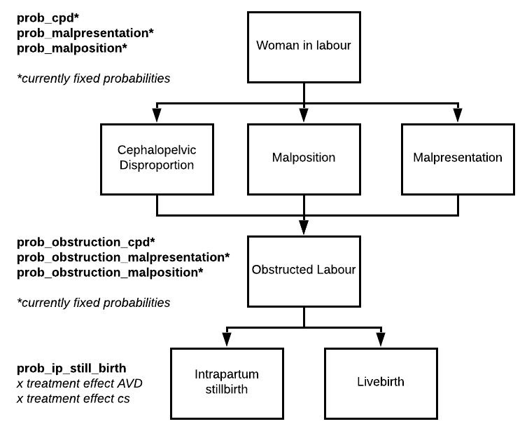

As women do not have a baseline risk of obstructed labour we cannot apply the effect of risk factors on a woman’s probability of obstructed labour. However, pending final review of the literature, risk factors will affect individual risk of either CPD – as there is a significant body of literature exploring this. Initial review of the literature and consultation with clinician-experts in obstetrics highlighted short stature as a likely risk factor for obstruction, likely due to CPD as shorter statured women are likely to have a smaller pelvis (Toh-Adam et al. 2012; Howells and Israel, 2018) and foetal macrosomia (birthweight >4kg) (Howells and Israel, 2018).
Antepartum Haemorrhage (APH)
Similarly with application of risk of obstructed labour, an individual in the model can only experience APH by first experiencing one of the preceding causes – placenta praevia and/or placental abruption, the leading causes of antenatal bleeding (Fan et al., 2017; Takai et al., 2017, Jauniaux et al., 2019). Risk of APH is first applied during the Pregnancy Supervisor module where women are at monthly risk of developing APH secondary to placental abruption (risk of abruption is applied monthly prior to risk of APH being calculated) and or placenta praevia (risk is applied following conception but assumed to only increase risk of bleeding). Please see documentation for full description of APH in the antennal period.
Figure 2. Natural history model of antepartum haemorrhage
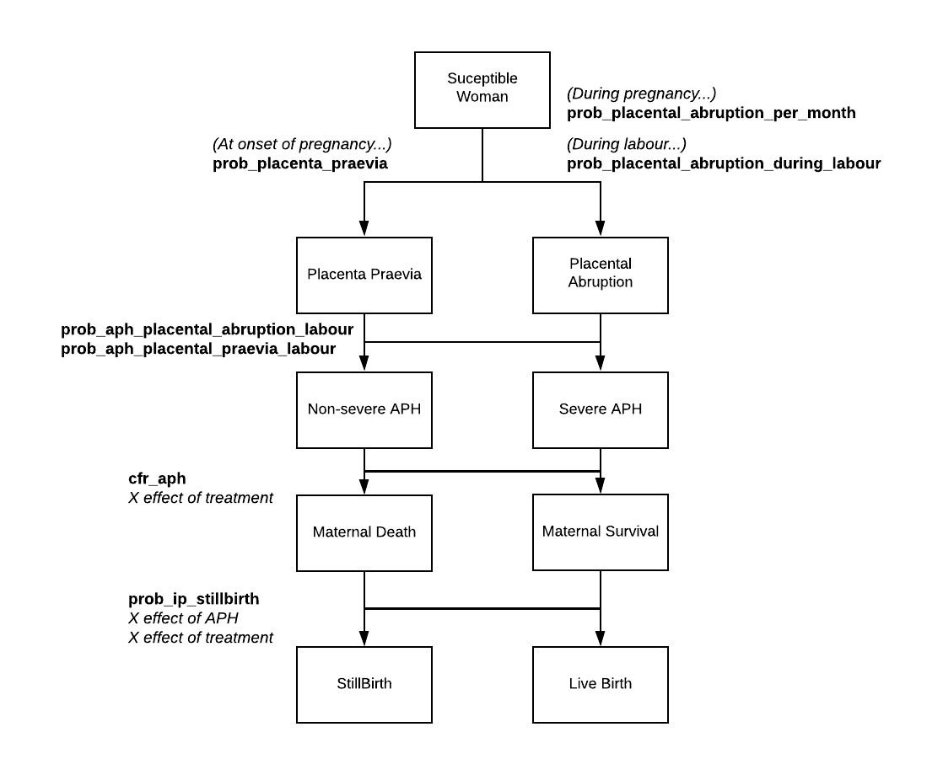

In addition to a monthly risk of placental abruption applied antenatally we also apply risk of abruption during the intrapartum phase, as data from other contexts show there is a considerable burden of abruption in labour (Tikkanen et al., 2006). Additionally whilst we don’t apply risk of the onset of placenta praevia in labour, we assume there is a distinct risk of bleeding during labour associated with placenta praevia due to the impact of contractions and attempted passage of the foetus on the placenta (Fan et al., 2017). Currently we do not apply risk factors that will increase risk of either preceding causes of APH but this will be included following review of the literature.
Once APH has onset a weighted random draw is used to determine the severity of the bleed which is used to map to DALY weights. The probability weights in this draw will be used to ensure the correct prevalence of bleeding severity is seen in the population following model calibration.
It is important to note that woman may be admitted for delivery following onset of APH during pregnancy (please see treatment information in the antenatal care documentation). These women will receive appropriate care and a new risk of antenatal bleeding is not applied during this model.
Intrapartum Maternal Infection and Sepsis
Following review with clinicians it was suggested to differentiate between direct and indirect causes of maternal sepsis within this model. Direct causes of sepsis will be inclusive of infective processes related to labour and the postpartum period. Whereas indirect sepsis is not directly attributable to pregnancy and is coincidental to labour, such as pneumonia or malaria. Indirect infective pathologies are modelled separately and therefore we will review labouring women to determine their infective status and likelihood of sepsis.
Data on common direct sources of maternal infection is taken from the Global Maternal Sepsis Study (GLOSS), a recent multi-national prospective study evaluating both frequency and management of maternal infection in across 52 countries for a sample of nearly 3000 patients (Bonet et al., 2020). The four leading primary sources of infection, in which the process of pregnancy is in some way directly responsible, within their sample included Urinary tract infections (27.9%), endometritis (15.1%), chorioamnionitis (14.9%) and skin/soft tissue infection (14.8%) (Bonet et al., 2020).
As with APH and obstructed labour, an individual can only develop sepsis if first she has developed an infection during the intrapartum period (or has been admitted for delivery with one). For simplicity we assume that the two primary causes of sepsis during the intrapartum period are chorioamnionitis or ‘other’. We use the ‘other’ variable so capture additional rate of infections not explicitly modelled here. Chorioamnionitis is a complication that can also occur during the pregnancy following Premature Rupture of Membranes meaning it is possible for a woman to present to labour with this infection already.

Figure 3. Natural history model of intrapartum maternal infection and sepsis
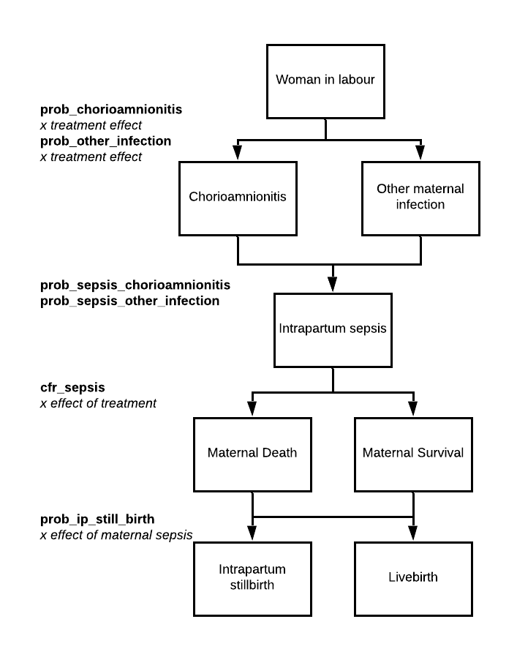

Uterine Rupture
Unlike APH, sepsis and obstructed labour all individuals in labour experience a baseline risk of uterine rupture which is increased in the presence of predictors. Predictors of uterine rupture included in the model are multiparity, if a woman has previously delivered via caesarean section and a current diagnosis of obstructed labour. The effect size of these predictors has not been finalised.
There is a strong evidence base for the causal link between obstructed labour and uterine rupture. Estimates from a Senegalese trial conducted by Delafield, Pirkle and Dumont (2018) and currently included in the model suggest over a 23 times risk of uterine rupture in women with obstructed labour. Again this will need to be reviewed in the context of the wider literature as the provide estimates of risk for both referred and non-referred cases of OL which seems to impact likelihood of UR. The effect of mode of delivery on a woman with obstructed labours risk of uterine rupture is described in the next section.

Figure 3. Natural history model of uterine rupture
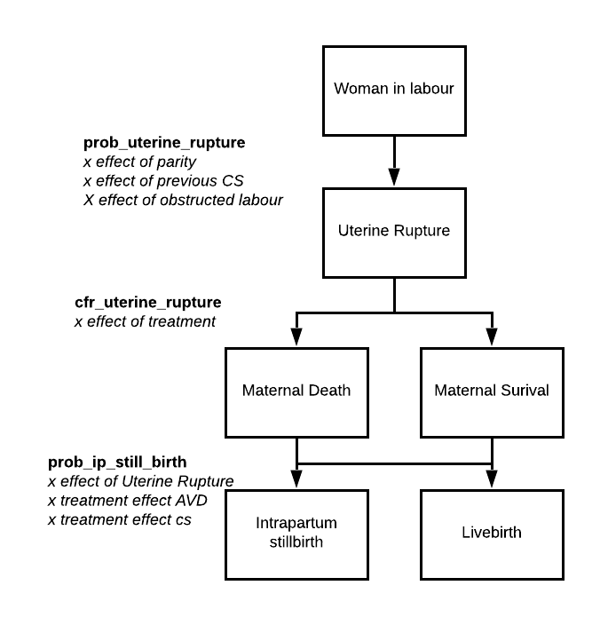

Hypertensive Disorders of Pregnancy
Incidence of the hypertensive disorder of pregnancy (gestational hypertension, mild/severe pre-eclampsia and eclampsia) is applied antenatally in the pregnancy supervisor model and we do not assume there is onset of new hypertension during or immediately following labour. Therefore women who go into labour and have been experiencing hypertension during pregnancy will have a risk of disease progression applied during the intrapartum and immediate postpartum periods. This is to ensure we include the onset of severe hypertensive disease during the intrapartum period.
Currently a dummy probability is applied to each women to determine progression. We assume possible linear progression from one ‘state’ to the ‘state’ above:
- Gestational hypertension may progress to mild pre-eclampsia
- Gestational hypertension may progress to severe gestational hypertension
- Mild pre-eclampsia may progress to severe pre-eclampsia
- Severe pre-eclampsia may progress to eclampsia
Risk of progression is modified by certain treatment types as described below. Individual case fatality rates are applied to women who develop either severe pre-eclampsia or eclampsia in labour and the effect of hypertension on risk of stillbirth is included in the stillbirth equation

Incidence of Postpartum Complications
Individuals who have survived the intrapartum period of labour (with or without experiencing complications) are then assessed to determine risk of complications immediately after birth as described below.
Postpartum Haemorrhage (PPH)
Application of risk of PPH again follows a similar structure to the majority of complications described above in that individuals in the model are first determined to be at risk of one or more preceding causes of PPH with risk being calculated via an additive model (figure 4). There are a considerable number of potential factors that can contribute to bleeding following labour documented within the literature. We have opted to model three of the greatest drivers of PPH, uterine atony, retained placenta and lacerations (Oyelese and Ananth, 2010; Sentilhes et al., 2016) and a final ‘other’ category to capture additional factors.
Figure 4. Natural history model of postpartum haemorrhage
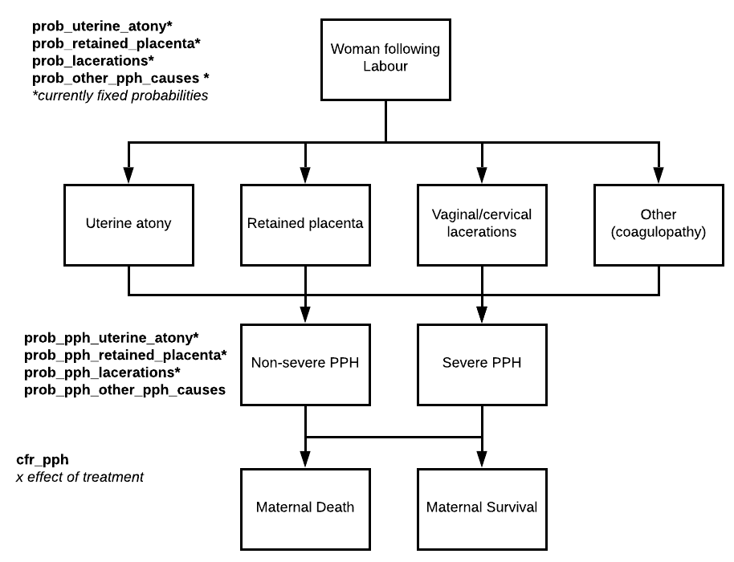

Individuals who deliver via caesarean section have a slightly different risk factor profile as we assume they cannot experience issues of placental retention as the placenta is delivered surgically during the procedure.
Currently we have not finalised any risk factors in the model which may increase individual risk of the preceding causes of PPH.

Postpartum Maternal Sepsis
The same approach of risk application as described for intrapartum sepsis above is used when determining if an individual will experience sepsis following labour. However the potential causative infections vary as shown in figure 5. This model of infection and sepsis is replicated for risk of infection in the remainder of the postnatal period as part of the Postnatal Supervisor model

Figure 5. Natural history model of postpartum sepsis.

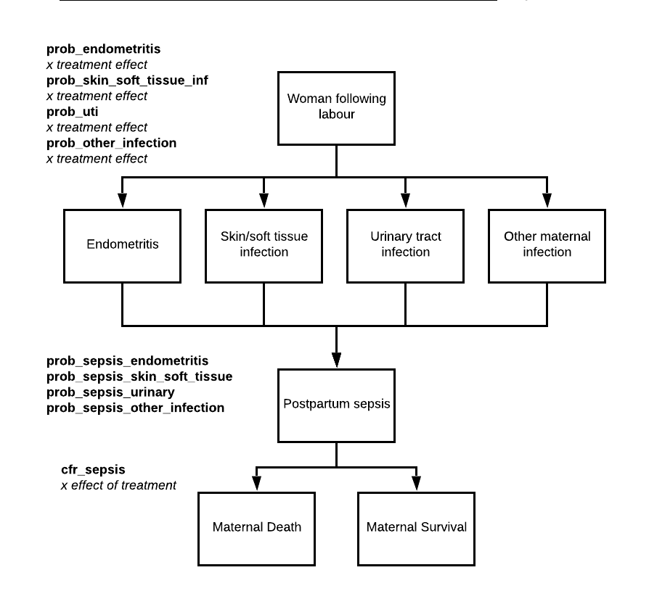

Hypertensive disorders
Individuals who have experienced any form of gestational hypertension during pregnancy will have a probability applied that their hypertension will resolve on birth, via the postnatal supervisor module. If hypertension does not resolve then, as in the intrapartum phase of labour, a risk of progression immediately after birth is applied.

Case Fatality and Still birth rates
Within the model, any individual who experiences a complication will have an ‘untreated’ case fatality rate for that complication applied to determine if that complication will contribute to their death. Each complication an individual experiences is cycled through to determine if it will contribute to an individual’s death. This parameter will reflect the likelihood of death for a woman experiencing a complication in the absence of any medical treatment. These case fatality rates are then multiplied by treatment effects to produces a treated case fatality- this reflects the reality that whilst treatment may reduce risk of death it does not block risk of death entirely. This process happens during labour- to generate intrapartum maternal deaths- and immediately after labour, contributing to postpartum maternal deaths.
Likelihood of intrapartum stillbirth will be applied to all women. Individual risk of stillbirth is increased for women who have experienced complications in labour which are known to impact lilkihood of perinatal death (hypertension, sepsis, haemorrhage, and uterine rupture). We do allow for foetal survival in the event of a maternal death although the risk of stillbirth following maternal death will likely be close to 1 in most situation.
As within the wider maternal and perinatal health modules the proportion of maternal deaths per complication/cause, will be informed by Ahmed et al., 2018 prospective cohort study in 11 community-based research sites in south Asia and sub-Saharan Africa which will then be calibrated using Malawi’s maternal mortality ratio. This data will be used to calibrate risk of death and stillbirth.
Disability weights for the natural history model
Disability weights for complication associated with Labour are given in the following table and are taken from Salomon (2012). These are weights associated with the acute event of each complication therefore they are captured once for each women who experiences the complication. The associated ‘disability’ variable is reset to false one week after delivery.
Condition | Weight | Notes
Obstructed Labour | 0.342 (0.227,0.478) | -
Maternal Haemorrhage >1L | 0.324 (0.22,0.442) | No differentiation between APH and PPH
Maternal Haemorrhage <1L | 0.114 (0.078,0.159) | -
Puerperal Sepsis (maternal) | 0.133 (0.088,0.19) | No differentiation between antepartum and post-partum sepsis
Uterine Rupture | 0.324 (0.22,0.442) | Uterine rupture is not listed in Salomon estimates. Previous DALY estimations for uterine rupture use the same weight as Maternal Haemorrhage >1L
Eclampsia | 0.263,0.173,0.367 | Eclampsia is listed but the weight is missing, The weight used in the model is for ‘Less severe epilepsy’, currently the closest match

Figure 6a. Directed acyclic graphs describing causal relationships currently included in model- pending structured review of risk factor literature

Figure 6a. Directed acyclic graph describing causal relationships included in model (Cont.)

Figure 6b. Diagram illustrating model structure and parameters.
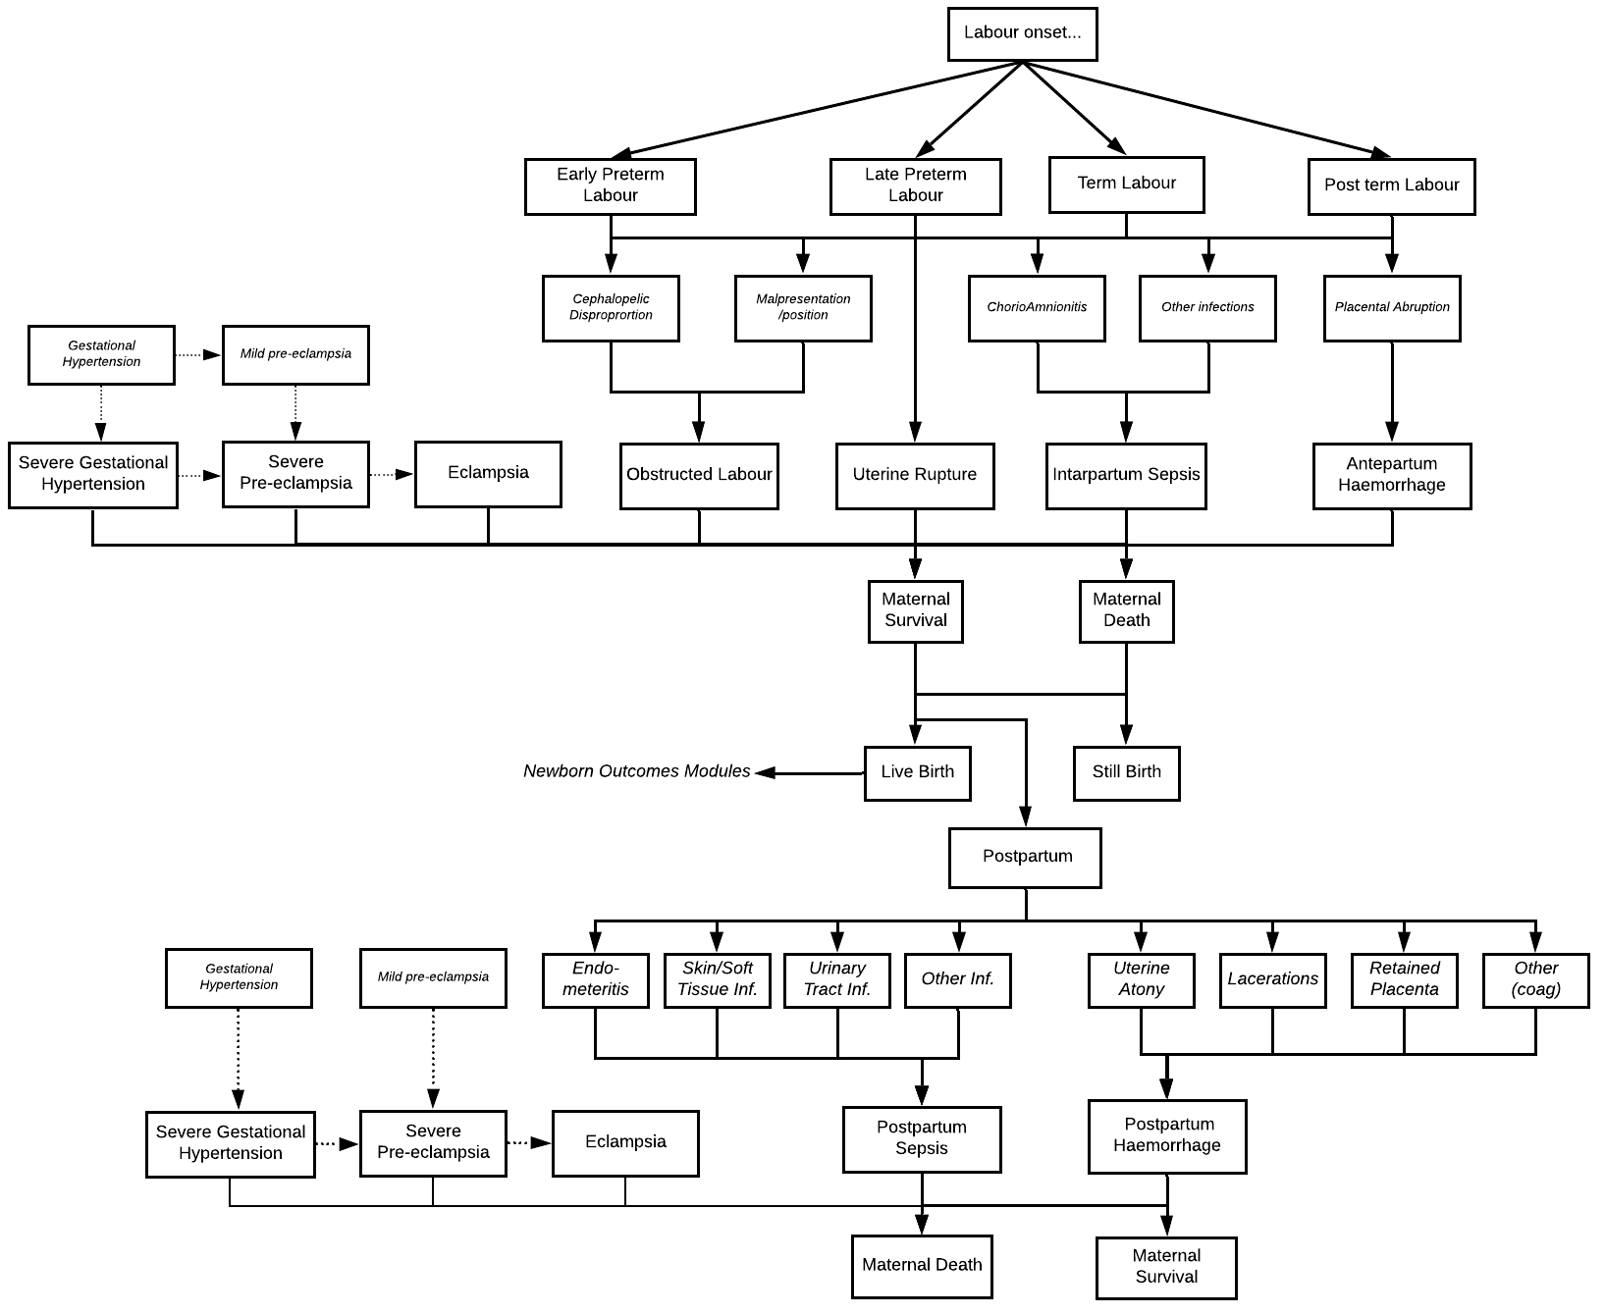

Table 3. Description of variables created relating to Labour and Delivery
Variable | Description | Notes and Major Assumptions
la_due_date_current_pregnancy | Date on which the woman will go into labour
la_currently_in_labour | Whether a woman is currently in labour
la_intrapartum_still_birth | Labour has ended in intrapartum stillbirth (Yes/no)
la_parity | Number of deliveries ending in live births this woman has experienced
la_previous_cs_delivery | Whether this woman has previously delivered via caesarean section
la_has_previously_delivered_preterm | Previous preterm birth (yes/no)
la_obstructed_labour | Whether this woman’s current labour is obstructed
la_obstructed_labour_causes | Bitset column holding the possible causes of obstructed labour: CPD, malpresentation and malposition
la_obstructed_labour_disab | Variable used to count DALYs for obstructed labour
la_antepartum_haem | Antepartum Haemorrhage during current labour (Yes/No) | Antepartum haemorrhage includes bleeding associated with placenta praevia and placental abruption
la_antepartum_haem_treatment | Received treatment for antepartum haemorrhage (Yes/No)
la_uterine_rupture | Uterine Rupture during current Labour (Yes/No)
la_uterine_rupture_disab | Variable used to count DALYs for uterine rupture
la_uterine_rupture_treatment | Received treatment for uterine rupture (Yes/No)
la_sepsis | Sepsis during current labour (Yes/No)
la_sepsis_pp | Sepsis following current labour (Yes/No)
La_maternal_ip_infection | Bitset column holding maternal infections which may lead to sepsis: chorioamnionitis and other
La_maternal_pp_infection | Bitset column holding maternal infections which may lead to sepsis: endometritis, skin/soft tissue, urinary tract, other
la_sepsis_disab | Variable used to count DALYs for sepsis
la_sepsis_treatment | Received treatment for sepsis (Yes/No)
la_eclampsia_disab | Variable used to count DALYs for eclampsia
la_eclampsia_treatment | Received treatment for eclampsia (Yes/No)
la_severe_pre_eclampsia_treatment | Received treatment for severe pre-eclampsia (Yes/No)
la_maternal_hypertension_treatment | Received treatment for maternal hypertension (Yes/No)
la_posptpartum_haem | Post-partum haemorrhage following current labour (Yes/No)
la_postpartum_haem_cause | Bitset column holding possible causes of postpartum haemorrhage: uterine atony, retained placenta, lacerations, other
la_postpartum_haem_treatment | Received treatment for postpartum haemorrhage (Yes/No)
la_maternal_haem_non_severe_disab | Variable used to count DALYs for non-severe maternal haemorrhage (<1L)
la_maternal_haem_severe_disab | Variable used to count DALYs for severe maternal haemorrhage (>1L)
la_has_had_hysterectomy | Woman has had hysterectomy as treatment and can no longer conceive (yes/no)
la_maternal_death_in_labour | Maternal death during/following current labour (Yes/No)
la_maternal_death_in_labour_date | Gives the date of maternal death
la_date_most_recent_delivery | Date on which this individual last gave birth
la_is_postpartum | Whether this woman is in the postpartum period of pregnancy (day 0-42) (Yes/No)
la_iron_folic_acid_postnatal | Whether this woman is receiving iron and folic acid postnatally (Yes/no)

Table 4. Description of natural history parameters and proposed values.
Value provided in this table are not finalised and are pending a more detailed review of the relevant literature. This is a working document updated regularly.
Parameter | Proposed value | Description | Reference Notes
intercept_parity_lr2010 | -3 | intercept value for linear regression equation predicating women’s parity at 2010 baseline | Malawi DHS (2015)
effect_age_parity_lr2010 | 0.22 | effect of an increase in age by 1 year in the linear regression equation predicating women’s parity at 2010 baseline | Malawi DHS (2015)
effect_mar_stat_2_parity_lr2010 | 0.91 | effect of a change in marriage status from comparison (level 1) in the linear regression equation predicating women’s parity at 2010 baseline | Malawi DHS (2015)
effect_mar_stat_3_parity_lr2010 | 0.16 | effect of a change in marriage status from comparison (level 1) in the linear regression equation predicating women’s parity at 2010 baseline | Malawi DHS (2015)
effect_wealth_lev_5_parity_lr2010 | -0.13 | effect of a change in wealth status from comparison (level 1) in the linear regression equation predicating women’s parity at 2010 baseline | Malawi DHS (2015)
effect_wealth_lev_4_parity_lr2010 | -0.13 | effect of an increase in wealth level in the linear regression equation predicating women’s parity at 2010 base line | Malawi DHS (2015)
effect_wealth_lev_3_parity_lr2010 | -0.26 | effect of an increase in wealth level in the linear regression equation predicating women’s parity at 2010 base line | Malawi DHS (2015)
effect_wealth_lev_2_parity_lr2010 | -0.37 | effect of an increase in wealth level in the linear regression equation predicating women’s parity at 2010 base line | Malawi DHS (2015)
effect_wealth_lev_1_parity_lr2010 | -0.9 | effect of an increase in wealth level in the linear regression equation predicating womens parity at 2010 base line | Malawi DHS (2015)
lower_limit_term_days | 259 | minimum number of days gestation at which a woman can go into labour and be categorised as term | N/A
upper_limit_term_days | 293 | maximum number of days gestation at which a woman can go into labour and be categorised as term | N/A
lower_limit_early_preterm_days | 148 | minimum number of days gestation at which a woman can go into labour and be categorised as early preterm | N/A
upper_limit_early_preterm_days | 230 | maximum number of days gestation at which a woman can go into labour and be categorised as early preterm | N/A
lower_limit_late_preterm_days | 231 | minimum number of days gestation at which a woman can go into labour and be categorised as early preterm | N/A
upper_limit_late_preterm_days | 258 | maximum number of days gestation at which a woman can go into labour and be categorised as late preterm | N/A
lower_limit_postterm_days | 294 | minimum number of days gestation at which a woman can go into labour and be categorised as post term | N/A
prob_cephalopelvic_dis | 0.02 | an individual’s probability of experiencing CPD | DUMMY VALUE
prob_malpresentation | 0.02 | an individual’s probability of experiencing malpresentation | DUMMY VALUE
prob_malposition | 0.02 | an individual’s probability of experiencing malposition | DUMMY VALUE
prob_obstruction_cpd | 0.9 | risk of obstruction in a woman with CPD | DUMMY VALUE
prob_obstruction_malpos | 0.3 | risk of obstruction in a woman with malposition | DUMMY VALUE
prob_obstruction_malpres | 0.3 | risk of obstruction in a woman with malpresentation | DUMMY VALUE
prob_chorioamnionitis_ip | 0.1 | probability of chorioamnionitis infection during labour | DUMMY VALUE
prob_other_maternal_infection_ip | 0.1 | probability of other obstetric infection in labour | DUMMY VALUE
prob_endometritis_pp | 0.1 | probability of endometritis infection following labour | DUMMY VALUE
prob_skin_soft_tissue_inf_pp | 0.1 | probability of a skin or soft tissue infection following labour | DUMMY VALUE
prob_urinary_tract_inf_pp | 0.1 | probability of a urinary tract infection following labour | DUMMY VALUE
prob_other_maternal_infection_pp | 0.1 | probability of other obstetric infections following labour | DUMMY VALUE
prob_sepsis_chorioamnionitis | 0.1 | risk of sepsis following chorioamnionitis infection | DUMMY VALUE
prob_sepsis_other_maternal_infection_ip | 0.1 | risk of sepsis following other intrapartum infection | DUMMY VALUE
prob_placental_abruption_during_labour | 0.02 | probability of a woman developing placental abruption during labour | DUMMY VALUE
prob_aph_placenta_praevia_labour | 0.2 | probability of a woman with placenta praevia experiencing an APH during labour | DUMMY VALUE
prob_aph_placental_abruption_labour | 0.7 | probability of a woman with placental abruption experiencing an APH during labour | DUMMY VALUE
odds_uterine_rupture | 0.2 | odds of a uterine rupture during labour | DUMMY VALUE
or_ur_grand_multip | 7.57 | relative risk of uterine rupture in women who have delivered >4 times previously | DUMMY VALUE
or_ur_prev_cs | 2.02 | relative risk of uterine rupture in women who have previously delivered via caesarean section | DUMMY VALUE
or_ur_ref_ol | 23.65 | relative risk of uterine rupture in women who have been referred in obstructed labour | DUMMY VALUE
severity_maternal_haemorrhage | [0.3, 0.7] | probability a maternal haemorrhage is non-severe (<1000mls) or severe (>1000mls) | DUMMY VALUE
cfr_aph | 0.0014 | case fatality rate for antepartum haemorrhage during labour | DUMMY VALUE
cfr_severe_pre_eclamp | 0.0014 | case fatality rate for severe pre-eclampsia during labour | DUMMY VALUE
cfr_eclampsia | 0.0014 | case fatality rate for eclampsia during labours | DUMMY VALUE
cfr_sepsis | 0.0014 | case fatality rate for sepsis during labour' | DUMMY VALUE
cfr_uterine_rupture | 0.0014 | case fatality rate for uterine rupture in labour | DUMMY VALUE
prob_ip_still_birth_unk_cause | 0.05 | baseline probability of intrapartum still birth secondary to unknown cause | DUMMY VALUE
rr_still_birth_maternal_death | 1.9 | relative risk of still birth in mothers who have died during labour' | DUMMY VALUE
rr_still_birth_aph | 1.2 | relative risk of still birth in mothers experiencing antepartum haemorrhage | DUMMY VALUE
rr_still_birth_ol | 1.2 | relative risk of still birth in mothers experiencing obstructed labour | DUMMY VALUE
rr_still_birth_ur | 1.5 | relative risk of still birth in mothers experiencing uterine rupture' | DUMMY VALUE
rr_still_birth_sepsis | 1.2 | relative risk of still birth in mothers experiencing intrapartum sepsis | DUMMY VALUE
rr_still_birth_spe | 1.2 | relative risk of still birth in mothers experiencing severe pre-eclampsia | DUMMY VALUE
rr_still_birth_ec | 1.2 | relative risk of still birth in mothers experiencing eclampsia | DUMMY VALUE
prob_uterine_atony | 0.02 | probability of uterine atony following delivery | DUMMY VALUE
prob_lacerations | 0.01 | probability of genital tract lacerations following delivery | DUMMY VALUE
prob_retained_placenta | 0.01 | probability of placental retention following delivery | DUMMY VALUE
prob_other_pph_cause | 0.01 | probability of other PPH causing factors | DUMMY VALUE
prob_pph_uterine_atony | 0.6 | risk of PPH after experiencing uterine atony | DUMMY VALUE
prob_pph_lacerations | 0.1 | risk of PPH after experiencing genital tract lacerations | DUMMY VALUE
prob_pph_retained_placenta | 0.6 | risk of PPH after experiencing retained placenta' | DUMMY VALUE
prob_pph_other_causes | 0.05 | risk of PPH after experiencing other PPH causes' | DUMMY VALUE
prob_sepsis_endometritis | 0.1 | risk of sepsis following endometritis | DUMMY VALUE
prob_sepsis_urinary_tract_inf | 0.1 | risk of sepsis following urinary tract infection | DUMMY VALUE
prob_sepsis_skin_soft_tissue_inf | 0.1 | risk of sepsis following skin or soft tissue infection | DUMMY VALUE
prob_sepsis_other_maternal_infection_pp | 0.1 | risk of sepsis following other maternal postpartum infection | DUMMY VALUE
cfr_pp_pph | 0.0014 | case fatality rate for postpartum haemorrhage | DUMMY VALUE
rr_pph_death_anaemia | 1.5 | relative risk increase of death in women who are anaemic at time of PPH' | DUMMY VALUE
cfr_pp_eclampsia | 0.0014 | case fatality rate for eclampsia following delivery | DUMMY VALUE
cfr_pp_sepsis | 0.0014 | case fatality rate for sepsis following delivery | DUMMY VALUE
prob_progression_gest_htn | 0.2 | probability of gestational hypertension progressing to severe gestational hypertension during/after labour | DUMMY VALUE
prob_progression_severe_gest_htn | 0.2 | probability of severe gestational hypertension progressing to severe pre-eclampsia during/after labour | DUMMY VALUE
prob_progression_mild_pre_eclamp | 0.2 | probability of mild pre-eclampsia progressing to severe pre-eclampsia during/after labour | DUMMY VALUE
prob_progression_severe_pre_eclamp | 0.2 | probability of severe pre-eclampsia progressing to eclampsia during/after labour | DUMMY VALUE

Approach to modelling interventions related to Skilled Birth Attendance: rationale for model structure and choice of parameter values
Facility delivery rates in Malawi
Following legislation which banned the practice of Traditional Birth Attendants in Malawi in 2007 (Godlonton and Okeke, 2017) data demonstrates a steadily increasing facility delivery rate from 73% in 2010 (NSO, Malawi 2011) to 91% in 2015 (NSO, Malawi 2017). The small proportion of women who don’t deliver in-facility are assumed to be those living in the most rural and hard-to-reach settings within the country.
However the national maternal mortality rate has remained reasonably stable, despite this increase in coverage, suggesting issues of poor quality within the health service can be attributed to persistent deaths. Recent analysis using both DHS and Service Provision Assessment data reported an effective coverage (the percentage of facility births adjusted for quality of care provided (in this instance using facility readiness scores) of 66% (Wang et al., 2018), considerably lower than crude coverage.
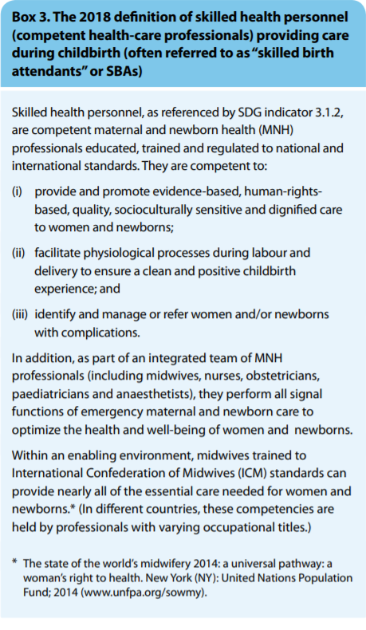
Defining skill birth attendance
Within the model we employ the 2018 WHO, UNFPA, UNICEF, ICM, ICN, FIGO and IPA joint definition of skilled birth attendants as detailed in figure 2 (WHO 2018). Accordingly we have therefore limited the interventions included in the model as those outlined in the signal functions for emergency obstetric and newborns care (EmONC), plus any additional interventions listed with the Malawian Essential Health Package. The signal functions are separated into basic and comprehensive and are listed in the following section.

Figure 7. WHO (2018) definition of a skilled birth attendant

Signal functions of basic and comprehensive EmONC
As described in the WHO (2018) definition of skilled birth attendants, practitioners (as part of a wider clinical team) are expected to be able to manage those complications attributing the highest burden of maternal morbidly and mortality through interventions defined in the 2009 WHO guidelines ‘Monitoring emergency obstetric care’.

The signal functions, which act as an indicator for the regional availability of emergency obstetric care, separate facilities into basic (BEmONC) and comprehensive (CEmONC) depending on the interventions they are expected to provide.

The signal functions of BEmONC, services that should be available at all facilities offering facility delivery (health centre and above) are:
- Administer parenteral antibiotics
- Administer Uterotonic drugs
- Administer parenteral anticonvulsants for preeclampsia and eclampsia (i.e., magnesium sulfate).
- Manually remove the placenta
- Remove retained products (e.g. manual vacuum extraction, dilation and curettage)
- Perform assisted vaginal delivery (e.g. vacuum extraction, forceps delivery)
- Perform basic neonatal resuscitation
Facilities offering CEmONC, all hospitals, must perform all the above signal functions in addition to:
- Perform surgery (e.g., caesarean section)
- Perform blood transfusion
As described later-on we use local clinical guidelines to model intervention(s) that fall within the category of specific signal function (i.e. management of a postpartum haemorrhage may rely on interventions within multiple signal functions such as Uterotonics, removal of retained products and blood transfusion).
In order to ensure the model accurately reflects the Malawian health system we have included a number of interventions that are included in the essential health package but not in the signal functions. These include:
- Methyldopa, Nifedipine, Hydralazine as treatment of severe pre-eclampsia
- Corticosteroids for women in preterm labour

Variables modelled
As with all interactions between individuals and the health system, the skilled birth attendance model uses a framework provided by both the Health System and Health Burden models which were designed and coded by Professor Tim Hallett and described elsewhere.
To avoid storing a large number of variables in the population level data frame which are only required for the process of labour, we created an individual dictionary of temporary variables for each labouring women. These variables are outlined in appendix 1.
Care seeking and elective admissions
Presently women can present for skilled birth attendance via two pathways, at labour onset or during labour if a complication has occurred. Due to the high facilitate delivery rate recorded in Malawi the majority of women will seek care following the onset of labour, whether term or preterm, and will present to a health facility for delivery.
Currently women can present for care at two levels of the health system. These health system levels are defined externally to the module and include:
Table 5. Description of facility levels
Facility Level | Examples of type of facilities within this level
1 | - Health Centres,  - Dispensaries  - Non-District Hospital  - District Hospitals
2 | Referral Hospitals:  - Queen Elizabeth  - Kamuzu Central  - Mzuzu Central

Data from the Malawi Service Provision Assessment (2014) suggests there is a considerable variation in the availability and provision of key EmONC services between health centres and hospitals. Therefore women presenting to facility level 1 will be allocated to either have presented at a health centre or a hospital in order to differentiate between quality of services, this is discussed in more detail in the following section.
As care seeking in labour is distinct from symptom-based care seeking equation used in other diseases within the model we currently use a separate equation derived from an analysis conducted on data from the Malawian DHS. This analysis, a multinomial logistic regression model in which who delivered in hospital were the reference group, is used to determine each woman’s probability of delivering at home, at a health centre or at a hospital.
We include a number of causal predictors in the model which effect a woman’s probability of her choice of delivery setting when compared to hospital delivery. A woman’s choice to deliver at home (odds 0.06) is affected by being aged between 35-39 years old (AOR 0.29), 40-44 years old (AOR 0.15), 45-49 years old (AOR 0.04), having a parity of 3-4 (AOR 3.3) and having a parity of greater than 4 (AOR 9).
A woman’s choice to deliver in a health centre (odds 0.67) is affected by being aged between 25-29 years old (AOR 0.59), 30 -34 years old (AOR 0.27), 35-39 years old (AOR0.13) , 40-44 years old (AOR 0.06), 45-49 years old (AOR 0.02), living rurally (AOR 2.36) , having a parity of 3-4 (AOR 2.21), greater than 4 (AOR 4,36) and being married (AOR 1.48).
Women who develop a complication may choose to then seek care during their delivery, currently this probability is calculated using the results of a paper by Sibley et al (2017) who conducted an analysis of biomedical care-seeking in women in Ethiopia who developed childbirth complications at home. Currently we assume a baseline probability of 0.52 that a woman who develops any complication will then seek care. This will need to be reviewed to hopefully incorporate literature from Malawi with variation between severities of complication.
Table 6. Description of care seeking parameters and proposed values
Parameter | Proposed value | Description | Reference Notes
odds_deliver_in_health_centre | 0.67 | odds of a woman delivering in a health centre compared to a hospital | Malawi DHS 2015
rrr_hc_delivery_age_25_29 | 0.59 | relative risk ratio for a woman aged 25-29 delivering in a health centre compared to a hospital | Malawi DHS 2015
rrr_hc_delivery_age_30_34 | 0.27 | relative risk ratio for a woman aged 30-34 delivering in a health centre compared to a hospital | Malawi DHS 2015
rrr_hc_delivery_age_35_39 | 0.13 | relative risk ratio for a woman aged 35-39 delivering in a health centre compared to a hospital | Malawi DHS 2015
rrr_hc_delivery_age_40_44 | 0.06 | relative risk ratio for a woman aged 40-44 delivering in a health centre compared to a hospital | Malawi DHS 2015
rrr_hc_delivery_age_45_49 | 0.02 | relative risk ratio for a woman aged 45-49 delivering in a health centre compared to a hospital | Malawi DHS 2015
rrr_hc_delivery_rural | 2.36 | relative risk ratio for a woman living in a rural setting delivery in a health centre compared to a hospital | Malawi DHS 2015
rrr_hc_delivery_parity_3_to_4 | 2.21 | relative risk ratio for a woman with a parity of 3-4 delivering in a health centre compared to a hospital | Malawi DHS 2015
rrr_hc_delivery_parity_>4 | 4.36 | relative risk ratio of a woman with a parity >4 delivering in health centre compared to a hospital | Malawi DHS 2015
rrr_hc_delivery_married | 1.48 | relative risk ratio of a married woman delivering in a health centre compared to a hospital | Malawi DHS 2015
odds_deliver_at_home | 0.06 | odds of a woman delivering at home compared to a hospital | Malawi DHS 2015
rrr_hb_delivery_age_35_39 | 0.29 | relative risk ratio for a woman aged 35-39 delivering at home compared to a hospital | Malawi DHS 2015
rrr_hb_delivery_age_40_44 | 0.15 | relative risk ratio for a woman aged 40-44 delivering at home compared to a hospital | Malawi DHS 2015
rrr_hb_delivery_age_45_49 | 0.04 | relative risk ratio for a woman aged 45-49 delivering at home compared to a hospital | Malawi DHS 2015
rrr_hb_delivery_parity_3_to_4 | 3.3 | relative risk ratio for a woman with a parity of 3-4 delivering at home compared to a hospital | Malawi DHS 2015
rrr_hb_delivery_parity_>4 | 9 | relative risk ratio of a woman with a parity >4 delivering at home compared to a hospital | Malawi DHS 2015
odds_careseeking_for_complication | 1.08 | odds of a woman seeking skilled assistance after developing a complication at a home birth | Malawi DHS 2015
or_comp_careseeking_wealth_2 | 2.5 | odds ratio of a woman of wealth level 2 seeking assistance after developing a complication at a home birth | Malawi DHS 2015

Skilled Birth Attendance Interventions
Interventions within the model delivered before, during or following birth can be categorised as prevention and treatment, addressing the complications that are described in the above natural history model. Preventative treatments modify individual risk of associated complications meaning women in receipt of these interventions are less likely to experience those complications during labour. For women who present to the health system for skilled birth attendance their individual risk of complications in labour in recalculated to incorporate the effect of preventative interventions. For example, women who deliver in facilities are less likely to develop sepsis as the facility offers clean delivery services which are shown to reduce the risk of infection.
Both prevention and treatment interventions are sourced from Malawian Obstetrics and Gynaecology Clinical guidelines (The Association of Obstetricians & Gynaecologists of Malawi, 2015), the Malawi Standard Treatment Guidelines (The Malawian Ministry of Health, 2015) and are included in the Malawian Essential Health Package (ref) to best accurately reflect service delivery in Malawi. Figure 8 provides an overview of the health system interaction events housed within the model.

Figure 8 - Overview of module HSIs and interventions

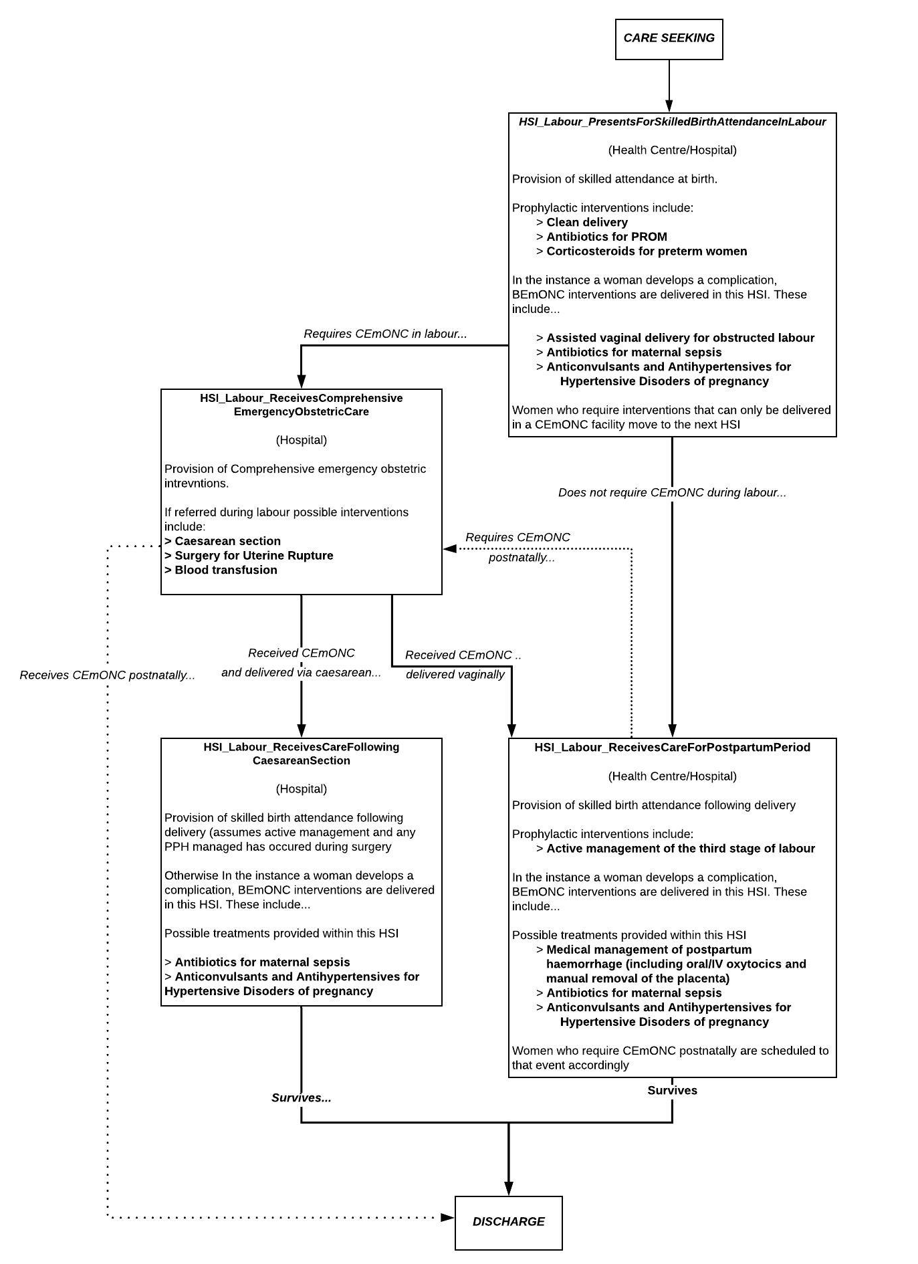

SBA as Health System Interactions
Figure 8 provides an overview of how skilled birth attendance is modelled within the TLO framework. The arrows represent potential pathways that an individual may take through the health system depending on any complications they experience but broadly can be understood that woman who experience no complications (or complications effectively managed with BEmONC interventions (above)) pass through two health system interactions (representing intrapartum and postpartum care) and, if they survive, they are discharged.
If during either of these interactions they require higher level CEmONC interventions then an additional interaction is scheduled. Scheduling is done in such a way that any and all potential interventions can be administered and have effect prior to risk of death being applied during and then following labour.
We assume that all woman who undergo caesarean section require slightly different postpartum management within a further interaction (see figure 8 and description below).
Quality of care
Quality of care delivered during labour is captured primarily through likelihood of intervention delivery. Each C/EmONC intervention is only delivered to a woman, who is experiencing the relevant complication, if a number of predetermined criteria are met:
- The current ‘squeeze factor’ of the health system interaction is below the predetermined threshold under which the intervention can be delivered
- The individual is assessed by a healthcare worker who identifies their complication and that they require care – this varies by facility level
- If these first two conditions are met then the intervention will be delivered IF there are sufficient and correct consumables with which the intervention can be delivered – available of consumables vary by facility level
The ‘squeeze factor’ is a parameter of the Health System Interaction and simply reflects the extent to which the daily requirements for resources within the health system will exceed its estimated capacity. In essence the value represents how ‘over-burdened’ is the most over-burdened health care worker is who required within the interaction. Based on experience within maternity service in Malawi we assume that almost all women will remain at a facility they have presented to in labour to receive care in spite of perceived lack of capacity during that day.
Therefore women who present will deliver at facility but delivery of interventions is gated by squeeze thresholds. Squeeze threshold will vary according to intervention type assuming that interventions seen as less vital (i.e. prophylactics) are more likely not to be delivered at the lowest level of squeeze but more vital interventions (i.e. those seen to preserve life) will have a higher threshold.
If there is low squeeze then interventions pass the first condition. Next we assume women are assessed for their complication prior to correct treatment being delivered. This ‘assessment’ function has both a sensitivity and specificity attached and if a woman’s underlying complication is correctly identified then the second condition is met. The sensitivity parameters vary according the facility type (hospital/health centre). Finally, if squeeze is low and assessment identifies a complication then the intervention will be delivered if the consumables are available. Consumable levels vary according to health facility level.
The primary goal will to calibrate the models quality to the most recent evaluation of maternity service capacity (either via the SARA survey or BEmONC evaluation) to replicate availability and quality of services across Malawi by facility type (health centre/hospital).
BEmONC Interventions – All Facility Levels:
The following section briefly outlines the interventions housed within the health system interactions (treatment algorithms adapted from Malawi Obstetrics and Gynaecology Guidelines) delivered during or after labour to manage the complications described above. Currently the majority of treatment effects are taken from papers used to parameterise the LIST maternal and perinatal health model (as reference) pending independent review of the literature:
Prophylactic interventions
Women delivering with a skilled birth attendant will receive the benefits of a number of prophylactic interventions which have the following effect:
- Clean birth practices
  - reduces risk of all intrapartum and postpartum maternal infections (RR 0.4 (Pollard, Mathai and Walker, 2013))
  - reduces risk of early onset neonatal sepsis (RR 0.73 (Blencowe et al., 2011))

- Prophylactic antibiotics in the instance of preterm labour
  - reduces the risk of early onset neonatal sepsis (RR 0.61 (Cousens et al., 2010))

- Prophylactic corticosteroids in the instance of preterm labour
  - reduces the risk of respiratory distress syndrome (RDS) in preterm neonates (RR 0.69 (Roberts et al., 2017))
  - reduces the risk of death (due to causes other than RDS) in preterm neonates (RR 0.69 (Roberts et al., 2017))

- Active management of the third stage of labour
  - Reduces the risk of uterine atony and retained placenta (RR 0.34 (Begley et al., 2019))
Management of Obstructed Labour – Assisted Vaginal Delivery (AVD)
For women with obstructed labour which is correctly identified during labour we assume that first line treatment will be AVD via a ventouse suction cup vacuum system or by using obstetrical forceps. Lacking equipment is one of the primary reasons that AVD is so rarely performed within LMICs (Bailey et al., 2017) therefore forceps and ventouse equipment are considered as consumables within the model to correctly capture this barrier to use within Malawi.
Within the model we assume that any women whose obstruction is secondary to CPD will not be able to deliver via AVD. If the obstruction is due to malpresentation or position we apply a probability that AVD will be successful in delivering the foetus (currently a dummy value). If AVD is successful no further treatment is required. If AVD is unsuccessful then the individual will require caesarean section. The treatment effect of assisted vaginal delivery is applied to an individual’s risk of intrapartum stillbirth (RR 0.1 – dummy value)
Management of Maternal Sepsis – Intravenous Antibiotics
Presently antibiotic therapy is the primary treatment intervention for maternal sepsis included in the model. We assume women who receive treatment for sepsis have a reduced risk of sepsis-death (RR 0.2 (Pollard, Mathai and Walker, 2013)).
Treatment for sepsis in the Malawi EHP is entitled ‘maternal sepsis case management’ suggesting other interventions are included such as oxygen and fluids. The consumables required to manage sepsis are captured through the health system model but currently we have not independently applied the possible effects of these interventions.
Management of Maternal Hypertension - Intravenous Anti-hypertensives
Women who are determined to be hypertensive during labour will receive intravenous antihypertensive drugs to control their blood pressure during delivery and reduce risk of death from cerebrovascular outcomes of hypertension (i.e. stroke). Receipt of intravenous antihypertensive have varying effects in the model depending on type of hypertension:
- Reduce risk of maternal death in/following labour secondary to hypertension (severe pre-eclampsia, eclampsia, severe hypertension) (RR 0.5 (Pollard, Mathai and Walker, 2013))
- Reduce risk of intrapartum/postpartum progression for women with gestational hypertension (RR 0.49 (Abalos et al., 2018))
Whilst antihypertensives are not an EmONC intervention they are included in the Malawian EHP and therefore are included here.
Management of Severe pre-eclampsia/Eclampsia – Intravenous Anticonvulsants
Additionally to antihypertensives women with either severe pre-eclampsia or eclampsia should receive intravenous anticonvulsant therapy in the form of magnesium sulphate. In women with severe pre-eclampsia administration of magnesium will reduce their risk of progressing to eclampsia during/following labour (RR 0.41 (Duley et al., 2010)) and reduces her risk of death from severe pre-eclampsia (RR 0.4 (Pollard, Mathai and Walker, 2013)). If an individual is eclamptic administration of magnesium will reduce their risk of death (RR (RR 0.4 (Pollard, Mathai and Walker, 2013)).
We do not currently assume women experiencing severe pre-eclampsia/eclampsia will require instrumental delivery.
Management of Postpartum Haemorrhage – Intravenous uterotonics and manural removal of retained placenta
Treatment for postpartum haemorrhage is dependent on underlying aetiology of the bleed. Uterine atony, the most common cause of haemorrhage, is managed medically though the administration of additional uterotonic drugs. We apply a probability that administration of these drugs will be successful in achieve haemostatic (0.8 –dummy adapted from effect of uterotonics on mortality). If successful we assume uterotonics reduce risk of death secondary to PPH (RR 0.2 (Pollard, Mathai and Walker, 2013)) If unsuccessful we assume the individual will need to be referred for CEmONC interventions.
If an individual is experiencing retained placenta we assume HCWs will attempt manual removal at the bedside. Again we apply a probability that this will be successful (0.7) and if so apply an effect on risk of death from PPH (RR 0.7 (Pollard, Mathai and Walker, 2013)) otherwise the individual will need to be referred for CEmONC interventions.
CEmONC Interventions – Facility Level 1 (Hospital) and Facility Level 2:
Referral for CEmONC
Currently indications that a woman will need CEmONC level interventions include:
- Identification of (or admission due to) Antepartum haemorrhage
  - Rewuring caesarean delivery
  - Requiring blood transfusion

- Identification of uterine rupture
  - Requiring caesarean delivery
  - Requiring blood transfusion
  - Requiring surgical repair

- Obstructed labour for which assisted vagianal delivery has not been successful
  - Requiring caesarean delivery

- Postpartum haemorrhage requiring blood and/or failed medical management
  - Requiring blood transfuion
  - Requiring surgerical management
If a woman is delivering at a facility level that is assumed to be able to deliver CEmONC it is assumed she receives this care without referral (despite moving to a different health system interaction). Otherwise it is assumed that the individual is being referred to a higher level facility.
Caesarean Section
In the instance of antepartum haemorrhage, unresolved obstructed labour or uterine rupture a woman will be referred for a caesarean section delivery. We apply a blanket treatment effect of caesarean section on risk of intrapartum still birth (RR 0.1 – dummy value). If the caesarean is indicated due to antepartum bleeding we apply a treatment effect on risk of maternal death (RR 0.1 – dummy value).assuming that without the caesarean bleeding would have continued leading to death. Women who deliver via caesarean receive amended postnatal care as we assume that assessment for postpartum bleeding and management of that bleeding occurs within the caesarean event.
Surgery
Surgery is indicated for refractory postpartum bleeding (not managed medically) or uterine rupture. In both instances we first apply a probability that the surgery is successful in its primary aim (haemostasis/uterine repair). If successful we apply the following treatment effects:
- Reduced risk of death from postpartum haemorrhage (RR 0.1 – Dummy value)
- Reduced risk of death from uterine rupture (RR 0.1– Dummy value)
If unsuccessful we assume the final line of treatment is hysterectomy (RR 0.05) after which this woman is unable to become pregnant in the model again.
Blood transfusion
Women who have suffered significant blood loss should be referred to receive a blood transfusion. We assume blood transfusion reduces risk of death from antepartum haemorrhage, postpartum haemorrhage and uterine rupture (RR 0.4 (Pollard, Mathai and Walker, 2013)).
Inpatient days
TBD.
Table 4. Treatment parameter values
The majority of values provided in this table are not finalised and are pending a more detailed review of the relevant literature
Parameter | Proposed value | Description | Reference/Notes
treatment_effect_maternal_infection_clean_delivery | 0.4 |  | DUMMY VALUE
rr_pph_amtsl | 0.34 |  | (Begley et al., 2019))
prob_haemostatis_uterotonics | 0.2 |  | (Pollard, Mathai and Walker, 2013)
success_rate_pph_surgery | 0.7 |  | DUMMY VALUE
success_rate_surgical_removal_placenta | 0.7 |  | DUMMY VALUE
prob_successful_manual_removal_placenta | 0.75 |  | DUMMY VALUE
success_rate_uterine_repair | 0.7 |  | DUMMY VALUE
prob_successful_assisted_vaginal_delivery | 0.7 |  | DUMMY VALUE
sensitivity_of_assessment_of_obstructed_labour_hc | 0.7 |  | DUMMY VALUE
sensitivity_of_assessment_of_obstructed_labour_hp | 0.9 |  | DUMMY VALUE
sensitivity_of_assessment_of_sepsis_hc | 0.7 |  | DUMMY VALUE
sensitivity_of_assessment_of_sepsis_hp | 0.9 |  | DUMMY VALUE
sensitivity_of_assessment_of_hypertension_hc | 0.7 |  | DUMMY VALUE
sensitivity_of_assessment_of_hypertension_hp | 0.9 |  | DUMMY VALUE
sensitivity_of_assessment_of_severe_pe_hc | 0.7 |  | DUMMY VALUE
sensitivity_of_assessment_of_severe_pe_hp | 0.9 |  | DUMMY VALUE
sensitivity_of_assessment_of_antepartum_haem_hc | 0.7 |  | DUMMY VALUE
sensitivity_of_assessment_of_antepartum_haem_hp | 0.9 |  | DUMMY VALUE
sensitivity_of_assessment_of_uterine_rupture_hc | 0.7 |  | DUMMY VALUE
sensitivity_of_assessment_of_uterine_rupture_hp | 0.9 |  | DUMMY VALUE
sensitivity_of_assessment_of_ec_hc | 0.7 |  | DUMMY VALUE
sensitivity_of_assessment_of_ec_hp | 0.9 |  | DUMMY VALUE
sensitivity_of_assessment_of_pph_hc | 0.7 |  | DUMMY VALUE
sensitivity_of_assessment_of_pph_hp | 0.9 |  | DUMMY VALUE
sepsis_treatment_effect_md | 0.2 |  | (Pollard, Mathai and Walker, 2013)
eclampsia_treatment_effect_severe_pe | 0.41 |  | (Duley et al., 2010)
eclampsia_treatment_effect_md | 0.4 |  | (Pollard, Mathai and Walker, 2013)
anti_htns_treatment_effect_md | 0.5 |  | (Pollard, Mathai and Walker, 2013)
anti_htns_treatment_effect_progression | 0.49 |  | DUMMY VALUE
aph_bt_treatment_effect_md | 0.4 |  | (Pollard, Mathai and Walker, 2013)
pph_treatment_effect_uterotonics_md | 0.2 |  | (Pollard, Mathai and Walker, 2013)
pph_treatment_effect_mrp_md | 0.7 |  | (Pollard, Mathai and Walker, 2013)
pph_treatment_effect_surg_md | 0.1 |  | DUMMY VALUE
pph_treatment_effect_hyst_md | 0.1 |  | DUMMY VALUE
pph_bt_treatment_effect_md | 0.4 |  | (Pollard, Mathai and Walker, 2013)
aph_cs_treatment_effect_md | 0.1 |  | DUMMY VALUE
ur_repair_treatment_effect_md | 0.1 |  | DUMMY VALUE
ur_treatment_effect_bt_md | 0.4 |  | (Pollard, Mathai and Walker, 2013)
ur_hysterectomy_treatment_effect_md | 0.05 |  | DUMMY VALUE
treatment_effect_avd_still_birth | 0.9 |  | DUMMY VALUE
treatment_effect_cs_still_birth | 0.9 |  | DUMMY VALUE
prob_progression_gest_htn | 0.2 |  | DUMMY VALUE
prob_progression_severe_gest_htn | 0.2 |  | DUMMY VALUE
prob_progression_mild_pre_eclamp | 0.2 |  | DUMMY VALUE
prob_progression_severe_pre_eclamp | 0.2 |  | DUMMY VALUE
squeeze_threshold_proph_ints | 0.2 |  | DUMMY VALUE
squeeze_threshold_treatment_spe | 0.2 |  | DUMMY VALUE
squeeze_threshold_treatment_ol | 0.2 |  | DUMMY VALUE
squeeze_threshold_treatment_sep | 0.2 |  | DUMMY VALUE
squeeze_threshold_treatment_htn | 0.2 |  | DUMMY VALUE
squeeze_threshold_treatment_ec | 0.2 |  | DUMMY VALUE
squeeze_threshold_treatment_ur | 0.2 |  | DUMMY VALUE
squeeze_threshold_treatment_aph | 0.2 |  | DUMMY VALUE
squeeze_threshold_treatment_pph | 0.2 |  | DUMMY VALUE
squeeze_threshold_amtsl | 0.2 |  | DUMMY VALUE

Table 5. Model outputs (for 2019) and observed data from Malawi.
As outputs from this model will not be comparable to observed data (i.e. maternal death rates in the absence of interventions) they will be currently used as a “sense check” and compared with estimates from settings where intervention coverage/uptake may have been very low.

Current output comparing maternal mortality ratio with and without the health system functioning
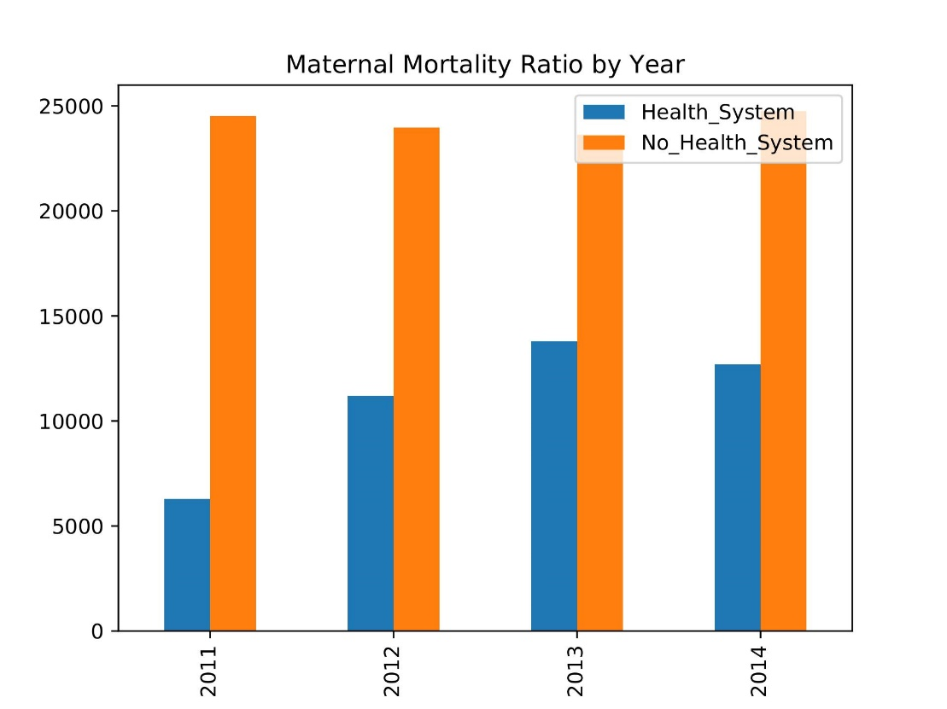

In the absence of interventions... (2019)
 | Model Output | Observed data/Estimate
Maternal Deaths (yearly)
Maternal Mortality Ratio |  | 2000 (Colbourn et al., 2015).
Still Births (Yearly)
Still Birth Ratio |  | 100 (Colbourn et al., 2015).
Incidence of Maternal Sepsis (per 1000 births)
Incidence of Eclampsia (per 10,000 births)
Incidence of Obstructed Labour (per 1000 births)
Incidence of Antepartum Haemorrhage (per 1000 births)
Incidence of Postpartum Haemorrhage (per 1000 births)

In the presence of interventions...
 | Model Output | Observed data
Maternal Deaths (yearly)
Maternal Mortality Ratio
Still Births (Yearly)
Incidence of Maternal Sepsis (per 1000 births)
Incidence of Eclampsia (per 10,000 births)
Incidence of Obstructed Labour (per 1000 births)
Incidence of Antepartum Haemorrhage (per 1000 births)
Incidence of Postpartum Haemorrhage (per 1000 births)

Main Limitations
The primary limitation of the model currently is that parameter values are not finalised. Development of structure and code has been prioritised with full parameterisation and calibration due following this period. Additional limitations include inadequate inclusion of clinical causal or predictive influences on conditions occurring in labour. This will be addressed as models around antenatal care are developed going forward and in conjunction with review by experts/clinicians.

Appendices

Appendix 1- Temporary variables stored in the maternal and new born dictionary

Temporary Variable | Description | Notes and Major Assumptions
labour_state | Whether this woman’s labour is term (TL), early preterm (EPTL), late  preterm (LPTL) or post term (POTL)
delivery_setting | Whether this woman has delivered at a facility (FD) or at home (HB)
induced_labour | Whether this woman’s labour was induced (T/F)
referred_for | TBC
cord_prolapse | Whether this woman has suffered from a cord prolapse during labour | This variable was suggested to be included by Dr Helen Allot pending lit review to determine causal influence on poor neonatal outcome.
PROM | Whether this woman has experience premature rupture of membranes (at term)
PPROM | Whether this woman has experience preterm premature rupture of membranes | Complicated relationship between PPROM and premature labour (causal influence) that will need careful exploration prior to inclusion
risk_ol | This woman’s individual risk of obstructed labour (int)
labour_is_currently_obstructed | This woman’s labour is obstructed and she requires treatment (T/F)
labour_has_previously_been_obstructed | A woman’s labour was previously obstructed but she has been treated (T/F)
risk_ip_sepsis | This woman’s individual risk of developing intrapartum sepsis (int)
risk_pp_sepsis | This woman’s individual risk of developing postpartum sepsis (int)
sepsis_ip | This woman has developed  intrapartum sepsis (T/F)
sepsis_pp | This woman has developed postpartum sepsis (T/F)
source_sepsis | Whether this woman’s sepsis is obstetric or non-obstetric (O/NO)
risk_aph | This woman’s individual risk of experiencing an antepartum haemorrhage (int)
APH | This woman has experienced an antepartum haemorrhage (T/F)
source_aph | Whether this woman’s APH is due to placental praevia or placental abruption (PP/PA)
units_transfused | Number of units of blood transfused to a woman as a treatment for bleeding
risk_ip_eclampsia | This woman’s individual risk of developing intrapartum eclampsia (int)
risk_pp_eclampsia | This woman’s individual risk of developing postpartum eclampsia (int)
eclampsia_ip | This woman has developed intrapartum eclampsia (T/F)
eclampsia_pp | This woman has developed postpartum eclampsia (T/F)
risk_ur | This woman’s individual risk of developing a uterine rupture (int)
UR | This woman has developed a uterine rupture (T/F)
grade_of_UR | TBC
risk_pph | This woman’s individual risk of experiencing a postpartum haemorrhage (int)
PPH | This woman has experienced a postpartum haemorrhage (T/F)
source_pph | Whether this woman’s PPH is due to uterine atony or retained products/placenta (UA/RPP)
severity_pph | Moderate <1000mls, Severe >199mls
risk_newborn_sepsis | This risk of this woman’s neonate developing early onset neonatal sepsis following delivery (int) | Modifiable risk of sepsis in newborns which will be accessed in the newborn module
risk_newborn_ba | This risk of this woman’s neonate developing birth asphyxia following delivery(int)
mode_of_delivery | The final mode of delivery for this woman’s labour. Vaginal deliver (VD), Assisted vaginal delivery via ventouse (AVDV), assisted vaginal delivery via forceps (AVDF), caesarean section (CS).
death_in_labour | Whether this woman has died during labour (T/F)
stillbirth_in_labour | Whether this woman has experience a still-birth during labour (T/F)
death_postpartum | Whether this woman has died in the postpartum period (T/F)

Appendix- 2 Required consumables per intervention

MOGPG 2014- The Association of Obstetricians & Gynaecologists of Malawi, Obstetrics & Gynaecology Protocols and Guidelines.

MSTG 2015 – Malawi Standard Treatment Guidelines 5th Edition

Health System Interaction Event | Intervention | Consumables modelled | Source/ Discrepancies (EmONC/EHP?)
PresentsForSkilled  AttendanceAtBirth  (all facility levels) | Uncomplicated Vaginal Delivery | Package : ‘Vaginal delivery - skilled attendance’ x1 | (BEmONC & EHP)
 | Clean birth practices | Package: ‘Clean Delivery Kit’ x1 | MOPG 2015  (EHP)
 | Prophylactic Antibiotics (PROM) | Benzylpenicillin 2.4 MU 6 hourly till delivery | MSTG 2015: ‘Ampicillin 2 g 6 hourly + Erythromycin 500mg 4 times a day OR Benzylpenicillin 2 MU 6 hourly’  MOGPG 2015: ‘Penicillin 2 MU 6 hourly’  Benzylpenicillin standard dose is 2.4 MU, assumed typo in MSTG. Selected as aligned with both guidelines.  (BEmONC & EHP)
 | Prophylactic Antibiotics (PPROM) | > Erythromycin 250mg QDS for 4 days  +/- Amoxicillin 250mg TDS for 7 days | MOGPG 2014 (see notes in code)  (BEmONC & EHP)
 | Prophylactic Antibiotics (Group B strep prophylaxis) – preterm? | Awaiting confirmation of Malawi dose  From RCOG guidelines:  3g Benzylpenicillin  1.5g 4hrly in Labour  https://www.rcog.org.uk/globalassets/documents/guidelines/research--audit/neonatal_summary_050207a.pdf | MSTG- doesn’t specify  MOPG- ‘Treat with penicillin IV (or erythromycin if allergic)  (BEmONC & EHP)
 | Prophylactic Steroids | Betamethasone 12mg IM x2  Dexamethasone 6mg IM X 4 | MOGPG 2014  (EHP only)
 | Assisted Vaginal Delivery | ‘Obsteric Forceps’ x1  ‘Obstetric Vaccum’ x1  ‘Management of obstructed labour’ x1  n.b. this package is very large and does have some overlap with SBA package…maybe shouldn’t condition on | MOGPG 2014  (BEmONC & EHP)
 | Management of Sepsis
 | Management of Hypertension | Antihypertensives:  Methyldopa 500mg- 1g TDS  …add in Nifedipine SR PO 40mg TD  …or add in Hydralazine 5mg IV (repeat as needed)  For severe pre-eclampsia:  1x 4g 20% MgSO4 + 500ml normal saline  1x 5g 50% MgSO4  1 X 1% lidocaine | MSTG 2014  (BEmONC & EHP)
 | Management of Eclampsia
CaesareanSection
(FacilityLevel1)

LaparotomyAndAdditionalSurgery

BloodTransfusion

Appendix 3- Full consumables list

Health System Interaction Event | Consumables
Induction of Labour | - Misoprostol, tablet, 200 mcg  - Induction of labour (beyond 41 weeks) drugs/supplies to service a client
Skilled Attendance In Labour | TBD: additional interventions (vit k, abx proph)  Uncomplicated Delivery:  - Glove disposable powdered latex  - Gauze, swabs 8-ply 10cm x10cm  - Cotton swab  - Umbilical cord clamp, disposable_50_IDA  - Filter paper No. 1  - Apron, disposable, polythene_100_CMST  - Oxytocin 10 IU/ml, 1ml  - Syringe, 20ml, disposable with 21g needle  - Chlorhexidine 1.5% solution  - Cannula iv (winged with injection pot)  - Cotton wool, 500g  - Surgical face mask, disp., with metal nose piece  - Ampicillin injection 500mg,  - Glove surgeon's size 7 sterile  - Paracetamol 500mg_1000_  - Catheter Foley's suction 53cm FG  - Clean delivery kit, | Complicated delivery:  - Cannula iv (winged with injection pot)  - Glove disposable powdered latex large_  - Gauze, swabs 8-ply 10cm x 10cm_  - Cotton swab,24,20,1.9992,0.85,0.9,0.95,0.99  - umbilical cord clamp, disposable  - Apron, disposable, polythene_100_  - Oxytocin, injection, 10 IU in 1 ml ampoule  - Syringe, 20ml, disposable with 21g needle  - Needle suture abdominal straight 10cm_  - Bandage, plaster of paris 15cm_  - Lignocaine 2% Adrenaline 1/80,000 cartridge 1.8ml  - Catheter Foley's + urine bag (2000ml) 14g  - Pethidine hydrochloride 50mg/1ml, 2ml  - Clean delivery kit
Elective Caesarean Section | - Glove disposable powdered latex large  - Iodine strong 10% solution_500ml  - Chlorhexidine 1.5% solution  - Gauze, swabs 8-ply 10cm x 10cm  - Oxytocin, injection, 10 IU in 1 ml ampoule  - Scalpel blade size 22 (individually wrapped)  - Catgut chromic 1 needle round bodied ½ circle 50mm  - suture Vicryl® (2/0) 70cm + 1/2 rb ndl 26mm,  - Cannula iv (winged with injection pot)  - Giving set iv administration + needle 15 drops/ml  - Gauze pad, 10 x 10 cm, sterile  - Ceftriaxone 1g, PFR  - Catheter Foley's + urine bag (2000ml) 14g  - Pethidine hydrochloride 50mg/1ml, 2ml184  - Declofenac injection  - Plaster, elastic adhesive  - Ampicillin injection 500mg  - Cotton wool, 500g  - Diazepam 5mg/ml, 2ml | (cont.)  - surgical face mask, disp., with metal nose piece  - Glove surgeon's size 8 sterile  - Halothane (fluothane)_250ml  - Ketamine, 10 ml vial, 50 mg/ml  - Lignocaine hydrochloride 5%+glucose 7.5%,heavy spinal,2ml  - Metronidazole 200mg  - Saline solution196  - Paracetamol 500mg _1000  - Needle spinal disposable Luer 22g x 10cm cutting bevel/pencil point  - Suture, catgut, chromic, 0, 150 cm  - Suture, non-absorbable, synthetic, 1/0, curved needle  - Catgut chromic 0 needle round bodied ½ circle 40mm  - Water for injection, 10ml202,  - Benzylpenicillin 3g (5MU),  - Syringe, 50ml, disposable, with 19g needle
Care for Obstructed Labour | - Gloves, surgeon’s, latex, disposable, sterile, pair  - IV giving/infusion set, with needle  - Lidocaine HCl (in dextrose 7.5%), ampoule 2 ml  - Sodium lactate injection (Ringer's), 500 ml, with giving set  - Syringe, needle + swab  - Epinephrine, ampoule, 1 mg/m  - Syringe, needle + swab  - Epinephrine, ampoule, 1 mg/ml  - Atropine sulphate, injection, 1 mg in 1 ml ampoule  - IV giving/infusion set, with needle  - Sodium lactate injection (Ringer's), 500 ml, with giving set  - Syringe, needle + swab  - Ketamine, 10 ml vial, 50 mg/ml  - Ampicillin, powder for injection, 500 mg, vial  - Cefazolin, ampoule, 500 mg  - Bag, urine, collecting, 2000 ml  - Foley catheter  - Gauze pad, 10 x 10 cm, sterile  Equipment:  - Vacuum  - Forceps | (cont.)  - Needle, suture, assorted sizes, round body  - Povidone iodine, solution, 10 %, 5 ml per injection  - Suture, catgut, chromic, 0, 150 cm  - Suture, non-absorbable, synthetic, 3/0, curved needle  - Blade, surgical, no. 22, sterile, disposable"  - Ampicillin, powder for injection, 500 mg, vial  - Gentamycin, injection, 40 mg/ml in 2 ml vial  - IV giving/infusion set, with needle  - Metronidazole, injection, 500 mg in 100 ml vial  - Sodium chloride, injectable solution, 0,9 %, 500 ml  - IV giving/infusion set, with needle  - Oxytocin, injection, 10 IU in 1 ml ampoule  - Paracetamol, tablet, 500 mg  - Pethidine, 50 mg/ml, 2 ml ampoule  - Sodium lactate injection (Ringer's), 500 ml, with giving set  - Syringe, needle + swab
Care for Maternal Sepsis | - Ampicillin, powder for injection, 500 mg, vial  - Gentamycin, injection, 40 mg/ml in 2 ml vial  - Metronidazole, injection, 500 mg in 100 ml vial  - Syringe, needle + swab  - Water for injection, 5 ml ampoule  - Amoxycillin 250mg_1000  - Metronidazole 200mg_1000  - Bag, urine, collecting, 2000 ml  - Foley catheter  - Gloves, surgeon’s, latex, disposable, sterile, pair | (cont.)  - IV giving/infusion set, with needle  - Lancet, blood, disposable  - Oxygen, 1000 liters, primarily with oxygen cylinders  - Paracetamol, tablet, 500 mg  - Sodium chloride, injectable solution, 0,9 %, 500 ml  - Complete blood count  - Plaster, elastic adhesive 5cm x 5m_each_CMST  - Cannula iv (winged with injection pot)  - Gentamicin 40mg/ml, 2ml  - Saline solution
Care for Hypertensive Disorders of Pregnancy | Hypertension:  - Nifedipine retard 20 mg_100  - Hydralazine, powder for injection, 20 mg ampoule  - IV giving/infusion set, with needle  - Syringe, needle + swab  - Water for injection, 10 ml ampoule  Pre-eclampsia:  - Bag, urine, collecting, 2000 ml  - Foley catheter  - Test strips, urine analysist  - Hydralazine, powder for injection, 20 mg ampoule  - IV giving/infusion set, with needle  - Sodium lactate injection (Ringer's), 500 ml, with giving set  - Misoprostol, tablet, 200 mcg  - Oxytocin, injection, 10 IU in 1 ml ampoule  - Sodium chloride, injectable solution, 0,9 %, 500 ml  - Magnesium sulfate, injection, 500 mg/ml in 10-ml ampoule"  Eclampsia:  - Bag, urine, collecting, 2000 ml  - Foley catheter  - Test strips, urine analysis  - Hydralazine, powder for injection, 20 mg ampoule  - IV giving/infusion set, with needle  - Sodium lactate injection (Ringer's), 500 ml, with giving set  - Misoprostol, tablet, 200 mcg  - Oxytocin, injection, 10 IU in 1 ml ampoule  - Sodium chloride, injectable solution, 0,9 %, 500 ml  - Magnesium sulfate, injection, 500 mg/ml in 10-ml ampoule | (cont.)  - Sodium lactate injection (Ringer's), 500 ml, with giving set  - Syringe, needle + swab  - Water for injection, 10 ml ampoule  - Test strips, urine analysis  - Lidocaine HCl (in dextrose 7.5%), ampoule 2 ml  - Magnesium sulfate, injection, 500 mg/ml in 10-ml ampoule  - Lidocaine HCl (in dextrose 7.5%), ampoule 2 ml  - Magnesium sulfate, injection, 500 mg/ml in 10-ml ampoule  - Magnesium sulfate, injection, 500 mg/ml in 10-ml ampoule  (cont.)  - Sodium lactate injection (Ringer's), 500 ml  - Syringe, needle + swab  - Water for injection, 10 ml ampoule  - Test strips, urine analysis"  - Lidocaine HCl (in dextrose 7.5%), ampoule 2 ml  - Magnesium sulfate, injection, 500 mg/ml in 10-ml ampoule  - Lidocaine HCl (in dextrose 7.5%), ampoule 2 ml  - Magnesium sulfate, injection, 500 mg/ml in 10-ml ampoule  - Magnesium sulfate, injection, 500 mg/ml in 10-ml ampoule  - Bag, urine, collecting, 2000 ml
Care for Maternal Haemorrhage | Post-partum haemorrhage:  - Albendazole, tablet, 400 mg  - Lancet, blood, disposable  - Test, hemoglobin  - Saline solution  - Complete blood count  - Haemoglobin test (HB),  - Ampicillin, powder for injection, 500 mg, vial  - Gentamycin, injection, 40 mg/ml in 2 ml vial  - IV giving/infusion set, with needle  - Metronidazole, injection, 500 mg in 100 ml vial  - Sodium chloride, injectable solution, 0,9 %, 500 ml  - Water for injection, 5 ml ampoule  - Cotton swab  - Diazepam, injection, 5 mg/ml, in 2 ml ampoule  - Lidocaine, injection, 1 % in 20 ml vial  - Needle, suture, assorted sizes, round body  - Pethidine, 50 mg/ml, 2 ml ampoule  - Povidone iodine, solution, 10 %, 5 ml per injection  - Suture, catgut, chromic, 0, 150 cm",  - Suture, non-absorbable, synthetic, 2/0, needle"  - Ferrous Salt + Folic Acid, tablet, 200 + 0.25 mg  Antepartum haemorrhage:  - Blood, one unit  - Foley catheter,  - Gloves, surgeon’s, latex, disposable, sterile, pair  - IV giving/infusion set, with needle  - Lancet, blood, disposable  - Test, hemoglobin  - Saline solution  - Complete blood count  - Haemoglobin test (HB), | (cont.)  - Ferrous Salt + Folic Acid, tablet, 200 + 0.25 mg  - Ferrous Salt + Folic Acid, tablet, 200 + 0.25 mg  - Oxytocin, injection, 10 IU in 1 ml ampoule  - Bag, urine, collecting, 2000 ml  - Blood, one unit  - Foley catheter,  - Gloves, surgeon’s, latex, disposable, sterile, pair  - IV giving/infusion set, with needle  - Oxytocin, injection, 10 IU in 1 ml ampoule  - Sodium lactate injection (Ringer's), 500 ml, with giving set  - Syringe, needle + swab  - Plaster, elastic adhesive 10cm x 5m_each_CMST  - Cannula iv (winged with injection pot)  - surgical face mask, disp., with metal nose piece  - gauze compresses 5 x 5 cm ,12 ply, non sterile  - Disposables gloves, powder free, 100 pieces per box
Surgical Care In Labour | Complicated Caesarean (Emergency):  - Iodine strong 10% solution_500ml  - Chlorhexidine 1.5% solution  - Gauze, absorbent 90cm x 40m  - Oxytocin 10 IU/ml, 1ml  - Glove disposable powdered latex large  - Scalpel blade size 22 (individually wrapped)  - Catgut chromic 1 needle round bodied ½ circle 50mm  - Bandage, plaster of paris 15cm_12_CMST  - suture Vicryl® (2/0) 70cm + 1/2 rb ndl 26mm  - Plaster, elastic adhesive 10cm x 5m | (cont.)  - Cannula iv (winged with injection pot)  - Giving set iv administration + needle 15 drops/ml  - Gauze pad, 10 x 10 cm, sterile"  - Ceftriaxone 1g,  - Catheter Foley's + urine bag (2000ml) 14g  - Pethidine, 50 mg/ml, 2 ml ampoule  - Declofenac injection  - Syringe, 50ml, disposable, with 19g needle  - Metronidazole 5mg/ml, 100ml  - Ampicillin injection 500mg, PFR  - Gentamicin Sulphate 40mg/ml, 2ml  - Metronidazole 200mg_1000  - Syringe, 5ml, disposable, hypoluer with 21g needle
Care For Postpartum Period | TBC

References

The American College of Obstetricians and Gynaecologists Practice Bulletin Number 146 (2014): Management of Late-Term and Postterm Pregnancies, August 2014. Obstet Gynecol.124:390-396.

Abalos, E. et al. (2018) ‘Antihypertensive drug therapy for mild to moderate hypertension during pregnancy’, Cochrane Database of Systematic Reviews. John Wiley and Sons Ltd, 2018(10). doi: 10.1002/14651858.CD002252.pub4.

Ahmed, I. et al. (2018) ‘Population-based rates, timing, and causes of maternal deaths, stillbirths, and neonatal deaths in south Asia and sub-Saharan Africa: a multi-country prospective cohort study’, The Lancet Global Health. Elsevier Ltd, 6(12), pp. e1297–e1308. doi: 10.1016/S2214-109X(18)30385-1.

Bailey, P. et al. (2017) ‘Assisted vaginal delivery in low and middle income countries: an overview’, BJOG: An International Journal of Obstetrics & Gynaecology. Blackwell Publishing Ltd, 124(9), pp. 1335–1344. doi: 10.1111/1471-0528.14477.

Begley, C. M. et al. (2019) ‘Active versus expectant management for women in the third stage of labour’, Cochrane Database of Systematic Reviews. John Wiley & Sons, Ltd, (2). doi: 10.1002/14651858.CD007412.pub5.

Blencowe, H. et al. (2011) ‘Clean birth and postnatal care practices to reduce neonatal deaths from sepsis and tetanus: A systematic review and Delphi estimation of mortality effect’, BMC Public Health. BioMed Central Ltd, 11(SUPPL. 3), p. S11. doi: 10.1186/1471-
2458-11-S3-S11.

Bonet, M. et al. (2020) ‘Frequency and management of maternal infection in health facilities in 52 countries (GLOSS): a 1-week inception cohort study’, The Lancet Global Health. Elsevier Ltd, 8(5), pp. e661–e671. doi: 10.1016/S2214-109X(20)30109-1.

Van Den Broek, N. R., Jean-Baptiste, R. and Neilson, J. P. (2014) ‘Factors associated with preterm, early preterm and late preterm birth in Malawi’, PLoS ONE, 9(3). doi: 10.1371/journal.pone.0090128.

Colbourn, T. et al. (2015) ‘Cost-effectiveness and affordability of community mobilisation through women’s groups and quality improvement in health facilities (MaiKhanda trial) in Malawi’, Cost Effectiveness and Resource Allocation. BioMed Central Ltd., 13(1). doi: 10.1186/s12962-014-0028-2.

Cousens, S. et al. (2010) ‘Antibiotics for pre-term pre-labour rupture of membranes: Prevention of neonatal deaths due to complications of pre-term birth and infection’, International Journal of Epidemiology. Oxford University Press, 39(SUPPL. 1), p. i134. doi: 10.1093/ije/dyq030.

Delafield, R., Pirkle, C. M. and Dumont, A. (2018) ‘Predictors of uterine rupture in a large sample of women in Senegal and Mali: cross-sectional analysis of QUARITE trial data’, BMC pregnancy and childbirth. BMC Pregnancy and Childbirth, 18(1), p. 432. doi: 10.1186/s12884-018-2064-y.

Derman, R. et al. (2015) ‘A prospective population-based study of maternal, fetal, and neonatal outcomes in the setting of prolonged labor, obstructed labor and failure to progress in low- and middle-income countries’, Reproductive Health, 12(Suppl 2), pp. 1–10. doi: 10.1186/1742-4755-12-S2-S9 LK - https://maastrichtuniversity.on.worldcat.org/oclc/6012362287.

Dolea, C. and Abouzahr, C. (2000) Global burden of obstructed labour in the year 2000, Global Burden of Disease.

Duley, L. et al. (2010) ‘Magnesium sulphate and other anticonvulsants for women with pre-eclampsia’, Cochrane Database of Systematic Reviews. John Wiley & Sons, Ltd, (11). doi: 10.1002/14651858.CD000025.pub2.

Fan, D. et al. (2017) ‘Prevalence of antepartum hemorrhage in women with placenta previa: A systematic review and meta-analysis’, Scientific Reports. Nature Publishing Group, 7. doi: 10.1038/srep40320.

Fischer, R. et al. (2018) ‘A comparison of induction of labor success rates over three time periods in 20 years at a single academic tertiary care center: are we improving vaginal delivery rates?’, The Journal of Maternal-Fetal & Neonatal Medicine, 31(7), pp. 907–913. doi: 10.1080/14767058.2017.1301422.

Godlonton, S. and Okeke, E. N. (no date) ‘Does a ban on informal health providers save lives? Evidence from Malawi’. doi: 10.1016/j.jdeveco.2015.09.001.

Howells, I. and Israel, J. (2018) ‘Predictors of cephalopelvic disproportion in labour a tertiary hospital in Bayelsa State, Nigeria’, Nigerian Journal of Medicine. Medknow, 27(3), p. 205. doi: 10.4103/1115-2613.278782.

Neilson, J. P. et al. (2003) ‘Obstructed labour’, British Medical Bulletin, 67, pp. 191–204. doi: 10.1093/bmb/ldg018.

Oyelese, Y. and Ananth, C. V. (2010) ‘Postpartum Hemorrhage: Epidemiology, Risk Factors, and Causes’, Clinical Obstetrics and Gynecology, 53(1), pp. 147–156. doi: 10.1097/GRF.0b013e3181cc406d.

Oza, S. et al. (2015) ‘Neonatal cause-of-death estimates for the early and late neonatal periods for 194 countries: 2000-2013’, Bull World Health Organ, 93, pp. 19–28. doi: 10.2471/BLT.14.139790.

Pollard, S. L., Mathai, M. and Walker, N. (2013) Estimating the impact of interventions on cause-specific maternal mortality: a Delphi approach, BMC Public Health. doi: 10.1186/1471-2458-13-S3-S12.

Roberts, D. et al. (2017) ‘Antenatal corticosteroids for accelerating fetal lung maturation for women at risk of preterm birth’, Cochrane Database of Systematic Reviews. John Wiley and Sons Ltd. doi: 10.1002/14651858.CD004454.pub3.

Sentilhes, L. et al. (2016) ‘Expert Review of Hematology Postpartum haemorrhage: prevention and treatment Postpartum haemorrhage: prevention and treatment’. doi: 10.1080/17474086.2016.1245135.

Sibley, L. M. et al. (2017) ‘Appropriateness and timeliness of care-seeking for complications of pregnancy and childbirth in rural Ethiopia: a case study of the Maternal and Newborn Health in Ethiopia Partnership’, Journal of health, population, and nutrition. NLM (Medline), 36(Suppl 1), p. 50. doi: 10.1186/s41043-017-0120-2.

Takai, I. U., Sayyadi, B. M. and Galadanci, H. S. (2017) ‘Antepartum Hemorrhage: A Retrospective Analysis from a Northern Nigerian Teaching Hospital’, International Journal of Applied and Basic Medical Research. Wolters Kluwer -- Medknow Publications, 7(2), p. 112. doi: 10.4103/2229-516X.205819.

Tavares, F. et al. (2016) ‘Stillbirth: Case definition and guidelines for data collection,
analysis, and presentation of maternal immunization safety data’. doi: 10.1016/j.vaccine.2016.03.044.

Tikkanen, M. et al. (2006) ‘Clinical presentation and risk factors of placental abruption’, Acta Obstetricia et Gynecologica Scandinavica. John Wiley & Sons, Ltd, 85(6), pp. 700–705. doi: 10.1080/00016340500449915.

Toh-Adam, R., Srisupundit, K. and Tongsong, T. (2012) ‘Short stature as an independent risk factor for cephalopelvic disproportion in a country of relatively small-sized mothers’, Archives of Gynecology and Obstetrics. Springer, 285(6), pp. 1513–1516. doi: 10.1007/s00404-011-2168-3.

Wang, W. et al. (2018) DHS ANALYTICAL STUDIES 65 EFFECTIVE COVERAGE OF FACILITY DELIVERY IN BANGLADESH, HAITI, MALAWI, NEPAL, SENEGAL, AND TANZANIA.

The World Health Organisation.(2008). Managing eclampsia. Available from: https://apps.who.int/iris/bitstream/handle/10665/44145/9789241546669_2_eng.pdf?sequence=2

The World Health Organisation (2010) WHO Technical Consultation on Postpartum and Postnatal Care. Available from: https://apps.who.int/iris/bitstream/handle/10665/70432/WHO_MPS_10.03_eng.pdf?sequence=1

The World Health Organisation. (2012) WHO recommendations on prevention and treatment of postpartum haemorrhage. Available from: https://www.who.int/reproductivehealth/publications/maternal_perinatal_health/9789241548502/en/

The World Health Organisation (2014). Global Nutrition Targets 2025 Stunting Policy Brief. Available at: https://www.who.int/nutrition/topics/globaltargets_stunting_policybrief.pdf WHO 2014

The World Health Organisation (2017). Statement on Maternal Sepsis. Available from: https://apps.who.int/iris/bitstream/handle/10665/254608/WHO-RHR-17.02-eng.pdf?sequence=1

The World Health Organisation (2018) Definition of skilled health personnel providing care during childbirth: the 2018 joint statement by WHO, UNFPA, UNICEF, ICM, ICN, FIGO and IPA. Availble from: https://apps.who.int/iris/bitstream/handle/10665/272818/WHO-RHR-18.14-eng.pdf?ua=1

