Undernutrition forms modelled 2
Conceptualisation of stunting model structure 3
Summary 3
Module properties 3
Prevalence of stunting at start of simulation 4
Incidence of stunting and disease progression 4
Health System Interactions 5
Parameters of the stunting module 7
References 9

Undernutrition forms modelled

Definition of undernutrition
Undernutrition is defined as insufficient intake of energy and nutrients to meet an individual’s need to maintain good health¹. In the literature, undernutrition and malnutrition are used interchangeably, although, the term malnutrition refers to all forms of deficiencies, excesses, or imbalances in a person’s intake of energy and/or nutrients², including undernutrition, micronutrient-related malnutrition, and overnutrition. In Malawi, undernutrition in terms of protein-energy undernutrition and micronutrient deficiencies are considered of public health significance, particularly to the health of children. Overnutrition is modelled in TLO within other NDC modules that pertain to older ages (from 15 years of age onwards).

Measures of nutritional status
There are several indicators used to measure nutritional imbalances resulting in undernutrition. The commonly used anthropometric measures in community studies are weight and height/length in combination with age and gender. These measurements are used to construct indices that are used to describe nutritional status of individuals or populations. The indices used in childhood are weight-for-height Z-score (WHZ), height-for-age Z-score (HAZ) and weight-for-age Z-score (WAZ). A Z-score is a measure of how far an observation is from the population mean as measured in standard deviations. A standard deviation score of a nutritional indicator for an individual = (individual’s value - median value of reference population)/ standard deviation value of reference population. The currently used reference population is the WHO multicentre Growth Reference Study (MGRS).

Table 1 - Key definitions of undernutrition
Terminology | Definition
Weight-for-height/length | Measure of a child’s weight relative to the weight of a child of the same height or length in a reference population, expressed as a Z-score. Low weight-for-height (WHZ < -2) is known as wasting, the acute form of undernutrition
Height/length-for-age | Measure of a child’s height or length relative to the length or height of a child of the same age in a reference population, expressed as a Z-score. Low height-for-age (HAZ < -2) is known as stunting, a result of chronic or recurrent undernutrition
Weight-for-age | Measure of a child’s weight relative to the weight of a child of the same age in a reference population, expressed as a Z-score. Low weight-for-age (WAZ < -2) is known as underweight
wasting | weight-for-height Z-score < -2 SD,  (severe wasting WHZ < -3, moderate wasting -3 ≤ WHZ < -2)
stunting | height-for-age Z-score < -2 SD,  (severe stunting HAZ < -3, moderate stunting -3 ≥ HAZ < -2)
underweight | weight-for-age Z-score < -2 SD,  (severe underweight WAZ < -3, moderate underweight -3 ≥ WAZ < -2)

The following sections describe the rationale for the model structures of wasting and stunting. As underweight can reflect wasting, stunting, or both, it is difficult to interpret and therefore, not included in the undernutrition modules.

Conceptualisation of stunting model structure

Summary
In the design of a model for chronic malnutrition, the underlying ‘truth’ of an individual’s condition is determined by the height-for-age Z-score (HAZ), or stunting status (HAZ<-2), following the WHO 2006 Child Growth Standards. Stunting classification by the WHO guidelines has two categories: moderate (-3≤HAZ<-2) or severe (HAZ<-3).
Stunting is a result of complex multifactor interaction as represented in Figure 5, a conceptual framework of stunting developed by Fenske and colleagues. For the simplicity of the model, only a few of these variables, which are measurable, will serve as risk factors for stunting.

Figure 5 - Conceptual framework of stunting (source: Fenske 2013) ²¹
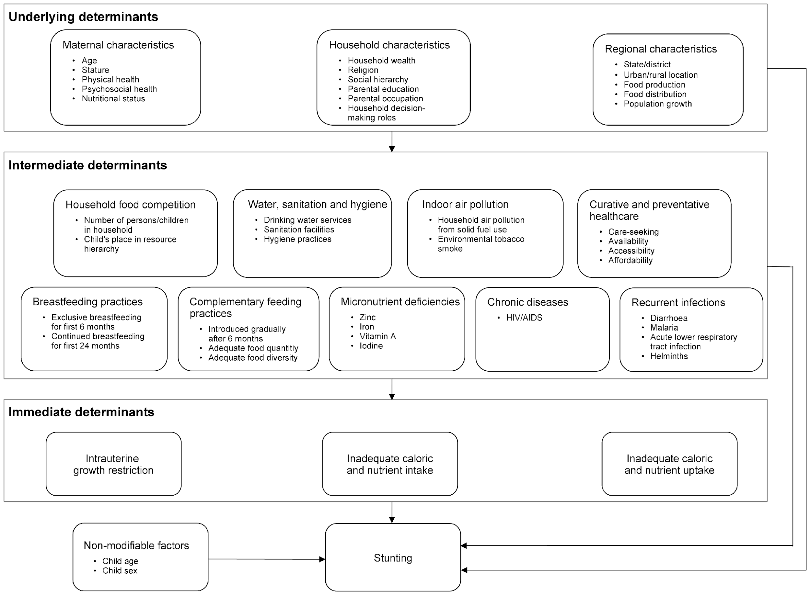

The stunting module updates the chronic nutritional status to all children under 5 years of age. It is responsible for assigning the prevalence at initiation of the simulation, the monthly incidence rate of stunting, changes between stunting states, and scheduling health system interactions where interventions are deployed. Death from stunting is not modelled, stunting serves as a risk factor for morbidity and mortality due to other diseases.

Module properties
Table 6 - Properties of the stunting module, and respective type and description
Property name | Type | Description
un_ever_stunted | Boolean | ever had an episode of stunting (WHZ<-2)
un_HAZ_category | Categorical  ['HAZ<-3', '-3<=HAZ<-2', 'HAZ>=-2'] | height-for-age z-score category
un_clinical_chronic_malnutrition | Categorical  ['moderate_stunting', 'severe_stunting'] | clinical acute malnutrition state based on HAZ
un_last_stunting_date_of_onset | Date | date of onset of last episode of stunting
un_stunting_recovery_date | Date | Date of recovery
un_CM_treatment_type | Categorical  ['education_on_complementary_feeding', 'complementary_feeding_with_food_supplementation'] | treatment types for chronic malnutrition

Prevalence of stunting at start of simulation
At initiation, the prevalence of stunting is set. Based on the DHS 2015-16 data, the mean and standard deviation of the normal distribution of HAZ scores for each age group: <6, 6-11, 12-23, 24-35, 36-47, 48-59 months are used to determine the probability of HAZ< -2 (wasted) for each age category. Then this probability of stunting is converted into odds of stunting, for which the odds ratios of risk factors are added to the linear model of stunting prevalence. Prevalence parameters and respective values are listed in Table 7.

Incidence of stunting and disease progression
The figure below (Figure 1) shows the proposed model structure for stunting (low height-for-age), the chronic form of undernutrition. It focuses on the natural history of stunting without input of the healthcare system interventions.
A regular event, occurring every month, applies the incidence of new stunting cases by age. Then, for each individual, a probability of progression to severe stunting in the next 3 months is applied, as well as the probability of natural improvement by 1 standard deviation – if severely stunted the child can improve to moderate stunting; if moderately stunted, the child can improve to no stunting. Most children once stunted, will remain stunted, as a result of chronic undernutrition.
Figure 6 - Model structure of the natural history of chronic malnutrition
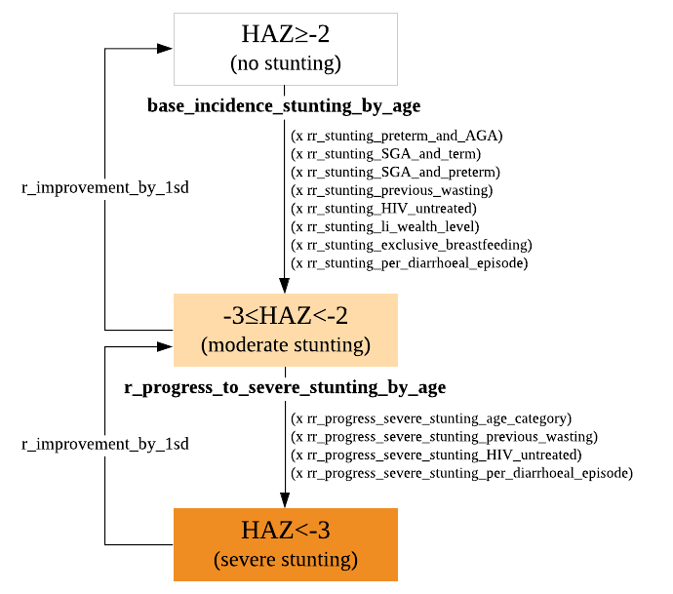
As shown in the proposed model structure, the incidence of stunting is dependent on age and several risk factors including, birth size (preterm birth, gestational age), HIV status, household wealth, exclusive breastfeeding until 6 months of age, prior episodes of diarrhoea, and prior wasting episodes.
Once in a state of moderate stunting (-3≥HAZ<-2), the individual will remain in that state for the following 3 months after onset, and a probability of stunting progression to severe is applied, as well as a probability of natural improvement of moderately stunted to normal height-for-age.
The rate of progression to severe wasting depends on age and risk factors that way have changed since first onset of stunting, such as, HIV under treatment, wasting episode during stunting, and diarrhoeal episodes since onset of stunting. All other risk factors associated with incidence are assumed to remain constant for the individual (immutable), such as birth outcomes, been exclusively breastfed, and wealth level. When in the severe stunting state (HAZ<-3), the individual will remain in that state for 3 months. After this period, the individual may recover to moderate stunting, but not fully recovered to non-stunting state.

Health System Interactions
There is a monthly regular event that checks on the probability of recovery/improvement from stunting based on interventions. Sever stunting cannot revert back to normal state, the individual can only improve by 1 z-score.
Being a complex problem, there is no single nutrition intervention to address stunting in children, but rather multiple, complex and coordinated nutrition-sensitive and nutrition-specific interventions in partnership with other health and non-health actors in development²².
In Malawi’s Essential Health Package, relevant interventions for stunting include:
- Promotion of exclusive breastfeeding (part of the IMCI counselling part)
- Growth monitoring (checked in routine check-ups)
- De-worming (part of the IMCI routine medications)
- Micronutrient supplementation (part of the IMCI routine medications)
- Treatment of severe acute malnutrition
In the stunting module the interventions specific for stunting modelled are complementary feeding (education and supplementation). Other interventions above included in the EHP are applied when the child interacts with the health system.

Although a more comprehensive list of prevention interventions would be:
- zinc supplementation in pregnant women
- micronutrient or macronutrient supplementation in children
- nutrition education for pregnant women
- nutrition systems strengthening targeting children
- complementary feeding (education and supplementation)
- breastfeeding promotion
- multiple micronutrient supplementation
- balanced energy supplementation
- zinc for prevention
- improved sanitation
- water connection in the home
- improved water source
- handwashing with soap

Parameters of the stunting module
Table 7 list all the parameters used in modelling stunting.
Table 7 - Parameters of the stunting module and respective values
 | Parameter | Value | Source | Description | Notes
P  r  e  v  a  l  e  n  c  e | prev_HAZ_distribution_age_0_5mo | [-0.8482, 1.4163] | DHS 2015-16 | mean and standard deviation of height-for-age z-scores distribution for <6 months old
P  r  e  v  a  l  e  n  c  e | prev_HAZ_distribution_age_6_11mo | [-0.9940, 1.5044] | DHS 2015-16 | mean and standard deviation of height-for-age z-scores distribution for 6-11 months old
P  r  e  v  a  l  e  n  c  e | prev_HAZ_distribution_age_12_23mo | [-1.5221, 1.4312] | DHS 2015-16 | mean and standard deviation of height-for-age z-scores distribution for 1 year old
P  r  e  v  a  l  e  n  c  e | prev_HAZ_distribution_age_24_35mo | [-1.6692, 1.3435] | DHS 2015-16 | mean and standard deviation of height-for-age z-scores distribution for 2 year old
P  r  e  v  a  l  e  n  c  e | prev_HAZ_distribution_age_36_47mo | [-1.7973, 1.2124] | DHS 2015-16 | mean and standard deviation of height-for-age z-scores distribution for 3 year old
P  r  e  v  a  l  e  n  c  e | prev_HAZ_distribution_age_48_59mo | [-1.6201, 1.1154] | DHS 2015-16 | mean and standard deviation of height-for-age z-scores distribution for 4 year old
P  r  e  v  a  l  e  n  c  e | or_stunting_male | 1.38 | ⁹ | odds ratio of stunting for males
P  r  e  v  a  l  e  n  c  e | or_stunting_hhwealth_Q5 | 1.69 | ⁹ | odds ratio of stunting for poorest household wealth Q5
P  r  e  v  a  l  e  n  c  e | or_stunting_hhwealth_Q4 | 1.48 | ⁹ | odds ratio of stunting for poorer household wealth Q4
P  r  e  v  a  l  e  n  c  e | or_stunting_hhwealth_Q3 | 1.4 | ⁹ | odds ratio of stunting for middle household wealth Q3
P  r  e  v  a  l  e  n  c  e | or_stunting_hhwealth_Q2 | 1.29 | ⁹ | odds ratio of stunting for richer household wealth Q2
P  r  e  v  a  l  e  n  c  e | or_stunting_preterm_and_AGA | 2.13 | ¹⁰ | odds ratio of stunting if born preterm and adequate for gestational age | pooled OR estimate for sub-saharan africa
P  r  e  v  a  l  e  n  c  e | or_stunting_SGA_and_term | 2.36 | ¹⁰ | odds ratio of stunting if born small for gestational age and term | pooled OR estimate for sub-saharan africa
P  r  e  v  a  l  e  n  c  e | or_stunting_SGA_and_preterm | 5.95 | ¹⁰ | odds ratio of stunting if born small for gestational age and preterm | pooled OR estimate for sub-saharan africa
I  n  c  i  d  e  n  c  e | base_inc_rate_stunting_by_agegp | [0.024,0.09,0.15,0.09,0.06, 0.06] | ¹¹ | baseline incidence rate of stunting by age group [1-5, 6-11, 12-23, 24-35, 36-47, 48-59] | estimates will be calculated, currently dummy values
I  n  c  i  d  e  n  c  e | rr_stunting_preterm_and_AGA | 2.11 | ¹⁰ | relative rate of stunting if born preterm and adequate for gestational age
I  n  c  i  d  e  n  c  e | rr_stunting_SGA_and_term | 2.26 | ¹⁰ | relative rate of stunting if born small for gestational age and term
I  n  c  i  d  e  n  c  e | rr_stunting_SGA_and_preterm | 3.09 | ¹⁰ | relative rate of stunting if born small for gestational age and preterm
I  n  c  i  d  e  n  c  e | rr_stunting_prior_wasting | 1.93 | ²³ | relative rate of stunting if prior wasting
I  n  c  i  d  e  n  c  e | rr_stunting_untreated_HIV | 1.5 | dummy | relative risk of stunting per unit decrease in wealth level
I  n  c  i  d  e  n  c  e | rr_stunting_wealth_level | 0.2 | ⁹ | relative risk of stunting per unit decrease in wealth level
I  n  c  i  d  e  n  c  e | rr_stunting_no_exclusive_breastfeeding | 1.4 | dummy | relative risk of stunting for children<2yo without exclusive breastfeeding
I  n  c  i  d  e  n  c  e | rr_stunting_no_continued_breastfeeding | 1.3 | dummy | relative risk of stunting for children<2yo without continued breastfeeding
I  n  c  i  d  e  n  c  e | rr_stunting_per_diarrhoeal_episode | 1.04 | ²⁴ | Relative risk of stunting per 1 unit increase in diarrhoea episodes since birth
P  r  o  g  r  e  s  s  i  o  n | progression_severe_stunting_by_agegp | [0.02,0.03,0.09,0.05,0.04,0.03] | ¹¹ | risk of progression to severe stunting (HAZ<-3) by age group
P  r  o  g  r  e  s  s  i  o  n | rr_progress_severe_stunting_previous_wasting | 1.93 | ²³ | relative risk of severe stunting if wasting occurred during current stunting | Assumed same value as rr_stunting_prior_wasting
P  r  o  g  r  e  s  s  i  o  n | rr_progress_severe_stunting_untreated_HIV | 1.3 | dummy | relative risk of severe stunting if untreated HIV status
P  r  o  g  r  e  s  s  i  o  n | rr_progress_severe_stunting_per_diarrhoeal_episode | 1.04 | ²⁴ | relative risk of severe stunting if per diarrhoeal episode
P  r  o  g  r  e  s  s  i  o  n | prob_remained_stunted_in_the_next_3months | 0.873 | ²³ | probability of remaining stunted for the next 3 months
I  n  t  e  r  v  e  n  t  i  o  n  s | coverage_supplementary_feeding_program | 0.58 | ¹⁴ | coverage of supplementary feeding program for MAM in health centres | Malawi estimates
I  n  t  e  r  v  e  n  t  i  o  n  s | un_effectiveness_complementary_feeding_promo_education_only_in_stunting_reduction | 0.25 | ²⁴ | effectiveness of complementary feeding programme with education only in reducing stunting
I  n  t  e  r  v  e  n  t  i  o  n  s | un_effectiveness_complementary_feeding_promo_with_food_supplementation_in_stunting_reduction | 0.41 | ²⁴ | effectiveness of complementary feeding programme with provision of supplementary foods in reducing stunting
I  n  t  e  r  v  e  n  t  i  o  n  s | un_effectiveness_zinc_supplementation_in_stunting_reduction | 0.15 | ²⁴ | effectiveness of zinc supplementation in reducing stunting | Not yet used in the code

References
1. Maleta, K. Undernutrition. Malawi Med. J. 189–205 (2006).
2. Fact sheets - Malnutrition. Available at: https://www.who.int/news-room/fact-sheets/detail/malnutrition. (Accessed: 26th April 2021)
3. Williams, P. C. M. & Berkley, J. A. Guidelines for the treatment of severe acute malnutrition: a systematic review of the evidence for antimicrobial therapy. Paediatrics and International Child Health 38, S32–S49 (2018).
4. WHO child growth standards and the identification of severe acute malnutrition in infants and children.
5. Isanaka, S., Grais, R. F., Briend, A. & Checchi, F. Estimates of the Duration of Untreated Acute Malnutrition in Children From Niger. Am. J. Epidemiol. 173, 932–940 (2011).
6. Frison, S., Checchi, F. & Kerac, M. Omitting edema measurement: How much acute malnutrition are we missing? Am. J. Clin. Nutr. 102, 1176–1181 (2015).
7. Grellety, E. & Golden, M. H. Weight-for-height and mid-upper-arm circumference should be used independently to diagnose acute malnutrition: Policy implications. BMC Nutr. 2, 1–17 (2016).
8. Ministry of Health (MOH). Malawi Guidelines for Community-Based Management of Acute Malnutrition, 2nd Edition. (2016).
9. Ntenda, P. A. M. & Chuang, Y. C. Analysis of individual-level and community-level effects on childhood undernutrition in Malawi. Pediatr. Neonatol. 59, 380–389 (2018).
10. Christian, P. et al. Risk of childhood undernutrition related to small-for-gestational age and preterm birth in low- and middle-income countries. Int. J. Epidemiol. 42, 1340–1355 (2013).
11. Maleta, K., Virtanen, S. M., Espo, M., Kulmala, T. & Ashorn, P. Childhood malnutrition and its predictors in rural Malawi. Paediatr. Perinat. Epidemiol. 17, 384–390 (2003).
12. Alvarez, J. L., Dent, N., Browne, L., Myatt, M. & Briend, A. Mid-Upper Arm Circumference (MUAC) shows strong geographical variations in children with edema: Results from 2277 surveys in 55 countries. Arch. Public Heal. 76, 1–10 (2018).
13. Lenters, L., Wazny, K. & Bhutta, Z. A. Management of Severe and Moderate Acute Malnutrition in Children. in Disease Control Priorities, Third Edition (Volume 2): Reproductive, Maternal, Newborn, and Child Health 205–223 (The World Bank, 2016). doi:10.1596/978-1-4648-0348-2_ch11
14. Maleta, K. & Amadi, B. Community-based management of acute malnutrition (CMAM) in sub-Saharan Africa: Case studies from Ghana, Malawi, and Zambia. Food Nutr. Bull. 35, S34–S38 (2014).
15. Schoonees, A., Lombard, M. J., Musekiwa, A., Nel, E. & Volmink, J. Ready-to-use therapeutic food (RUTF) for home-based nutritional rehabilitation of severe acute malnutrition in children from six months to five years of age. Cochrane Database of Systematic Reviews 2019, (2019).
16. Stobaugh, H. C. et al. Including whey protein and whey permeate in ready-to-use supplementary food improves recovery rates in children with moderate acute malnutrition: A randomized, double-blind clinical trial. Am. J. Clin. Nutr. 103, 926–933 (2016).
17. Lagrone, L., Cole, S., Schondelmeyer, A., Maleta, K. & Manary, M. J. Locally produced ready-to-use supplementary food is an effective treatment of moderate acute malnutrition in an operational setting. Ann. Trop. Paediatr. 30, 103–108 (2010).
18. Desyibelew, H. D., Bayih, M. T., Baraki, A. G. & Dadi, A. F. The recovery rate from severe acute malnutrition among under-five years of children remains low in sub-Saharan Africa. A systematic review and meta-analysis of observational studies. PLoS One 15, (2020).
19. Grellety, E. & Golden, M. H. Severely malnourished children with a low weight-for-height have a higher mortality than those with a low mid-upper-arm-circumference: I. Empirical data demonstrates Simpson’s paradox. Nutr. J. 17, (2018).
20. CORTASAM. GUIDANCE TO IMPROVE THE COLLECTING AND REPORTING OF DATA ON RELAPSE IN CHILDREN FOLLOWING TREATMENT IN WASTING PROGRAMMES. (2020).
21. Fenske, N., Burns, J., Hothorn, T. & Rehfuess, E. A. Understanding child stunting in India: A comprehensive analysis of socio-economic, nutritional and environmental determinants using additive quantile regression. PLoS One 8, e78692 (2013).
22. World Health Organization. Reducing Stunting in Children: Equity considerations for achieving the Global Nutrition Targets 2025. (2018).
23. Wright, C. M. et al. Wasting and Stunting in Infants and Young Children as Risk Factors for Subsequent Stunting or Mortality: Longitudinal Analysis of Data from Malawi, South Africa, and Pakistan. J. Nutr. (2021). doi:10.1093/jn/nxab054
24. Bhutta, Z. A. et al. What works? Interventions for maternal and child undernutrition and survival. The Lancet 371, 417–440 (2008).
25. Pajogo, M., Ndholvu, M., Chamambala, P., & Nyondo, W. (2023). Time to death and predictors of mortality among under-five children with severe acute malnutrition hospitalized at Mulanje District Hospital in Southern Malawi: A retrospective cohort study. https://doi.org/10.21203/rs.3.rs-3408843/v1

