Modelling of the postnatal period of pregnancy within the Thanzi La Onse Model
Background: The Thanzi La Onse Model
As part of the Thanzi La Onse program a model is being developed which aims to capture the health experiences of the population of Malawi and the consequent interactions with the health care system. The intent is that this model will help to inform future delivery of health care in Malawi. The model is an individual based model – which means we explicitly simulate the individual life and health experiences of a representative proportion of population of Malawi. The simulation initiates on 1 Jan 2010 and we attempt to simulate the attributes of the population at that point. We can run the model forward to any specified future time point. Each potential intervention and its associated diseases are being modelled. This is being divided into separate disease/intervention modules. This document describes the module on the postnatal period of pregnancy.
Background: General approach to decisions on modelling causal influences and effects of interventions
This module was designed in the context of an overall approach to modelling causal effects in general and causal effects of interventions in particular. The overall intent is to adopt as simple a structure as can be conceived, whilst still capturing the essential elements of a disease and the interventions used to prevent or treatment. We include a causal link between a “variable” (by which we mean a characteristic or property of an individual, whether that be demographic, social or biologic), and risk of disease or another variable if there is strong evidence from an overall body of studies that such a causal link exists and is at least moderately strong. In informing such decisions we place particular value on RCTs or studies with a quasi-experimental design such as analyses based on an instrumental variable. There is no expectation that such studies will be from Malawi or even from Africa. If there are such local studies and in the unlikely event that they provide strong evidence to suggest that the causal link is substantively different in Malawi then the intent is that this is taken into account and the Malawi-specific link included.
In the special case of a potential causal variable which relates to whether an individual has experienced or is experiencing an intervention the intent is to only include interventions if there is substantial RCT evidence of their beneficial effect, based on trials with objectively ascertained clinical endpoints with low risk of serious bias. Whilst DCP-3 (and to some extent the Malawi EHP) provides an initial list of such interventions and the evidence to support them, where possible our intent has been to form our own opinion on intervention efficacy based on the source trials.
Unless there is evidence to the contrary, the intent is to summarize and incorporate intervention effects into the model as relative risks or rates rather than absolute differences due to the fact that such measures are less likely to differ substantively by context. Interactions between characteristics (on the multiplicative scale) are only to be incorporated if there is strong evidence. Again, we have not intended to rely on data from Malawi or Africa for such evidence but if local evidence exists which strongly suggests a different effect than elsewhere then the intent is that this modified effect is incorporated in the model.
Background: Demographic and social characteristics modelled
Based on data on the distribution of the population in Malawi according to geographic location we assign individuals a geographic location, which maps onto whether they are classified as living in a rural or urban area. Informed largely by data from the Malawi DHS, variables are also created indicating the person’s wealth level (based on 5 quintiles), whether the person has access to improved sanitation, clean drinking water, hand washing facilities, and whether they experience indoor air pollution (wood burning stove). We assign individuals a current education status (none, primary, secondary) which is updated 3 monthly from age 5 to 20. We assign individuals a current education status (none, primary, secondary) which is updated 3 monthly from age 5 to 20. From age 15 on BMI (in 5 groups) is assigned, as well as using tobacco, drinking excess alcohol, having low exercise, high salt intake, high sugar intake. The status with regard to such variables for individuals can change over time. The influences between these variables are described in detail in a separate document.

Approach to modelling a natural history of the postnatal period of pregnancy: rationale for model structure and choice of parameter values
This model describes the maternal and neonatal outcomes of the postnatal and neonatal periods (see table 1) including interventions reasonably delivered as part of routine postnatal care (PNC) inpatient care for mothers and newborns with complications during this time. Determining individual outcomes for mother and newborns within the first 24-48 hours after birth is managed by the labour and newborn outcome models respectively – please see the associated methods documents for a full description of this. As with all maternal and perinatal health models a natural history approach was used to develop this model. We have modelled the onset and progression of each condition (where appropriate), including the causal impact of predictor variables, in the absence of healthcare interventions. Likelihood of death, calculated as described below, is applied to all women or neonates who develop complications associated with the postnatal period.
Table 1. Definitions used within this module
Term | Definition and Source
Postnatal Period | The period beginning immediately after the birth of the baby and extending up to six weeks (42 days) after birth (WHO 2010)
Neonatal period | The first 28 days of a child’s life (WHO 2006)
Early neonatal period | Days 0-6 of a child’s life (Oza et al., 2015)
Late neonatal period | Days 7-28 of a child’s life (Oza et al., 2015)
Maternal Sepsis | A life-threatening condition defined as organ dysfunction resulting from infection during pregnancy, childbirth, post-abortion, or postpartum period (The World Health Organisation 2017).
Endometritis | Infection of the upper genital tract including endometrium, myometrium, and surrounding tissue (Dalton and Castillo, 2014)
Secondary postpartum haemorrhage | Abnormal bleeding at 24 hrs to 6-12 weeks postnatal (The Association of Obstetricians & Gynaecologists of Malawi, 2014)
Vesicovaginal fistula | An abnormal opening between the bladder and the vagina that results in continuous and unremitting urinary incontinence. (Stamatakos et al., 2014)
Rectovaginal fistula | An abnormal epithelial-lined connections between the rectum and vagina (Debeche-Adams and Bohl, 2010)
Early-onset neonatal sepsis | Sepsis evident within the first 7 days of life (Chan et al., 2015)
Late-onset neonatal sepsis | Sepsis evident after the first 7 days of life (Chan et al., 2015)

Variables modelled
Variables stored within this model are concerned with information about a woman’s current postnatal period, complications experienced by either a mother or her child during this period and any treatment delivered to mother or baby.
Variables about the current postnatal period include the identification number of a woman’s most recent child (integer) and the number of weeks into the postnatal period a woman is (integer (1-6)). Complication variables for the mother include if she is experiencing postnatal hypertension (none, resolved, gestational hypertension, severe gestational hypertension, mild pre-eclampsia, severe pre-eclampsia, eclampsia), postnatal infection (endometritis, urinary tract, skin/soft tissue or other) or sepsis (True/False), secondary postpartum haemorrhage (True/False), anaemia causing deficiencies (iron/folate/b12) or anaemia (mild, moderate, severe) and obstetric fistula (vesicovaginal, rectovaginal). Currently, in this period, the only complications for neonates that we have modelled are early-onset neonatal sepsis (True/False) and late-onset neonatal sepsis (True/False).
Treatment variables for the mother include the number of PNC visits attended during this postnatal period (integer), if she is receiving oral antihypertensives (True/False) or received intravenous antihypertensives during an emergency (True/False), if she has received case management for secondary postpartum haemorrhage (True/False) if she has received case management for postnatal sepsis (True/False) or if she has received magnesium sulphate as management for severe pre-eclampsia/eclampsia (True/False)
Treatment variables for the neonate include the number of PNC visits attended during this postnatal period (integer), if they received injectable antibiotics as management of neonatal sepsis (True/False) or if they received full supportive care as management of neonatal sepsis (True/False).

Updating variables
This model updates the variables described above at a number of different points as the simulation moves forward in time. When the simulation generates a birth we update variables in the model relating to obstetric fistula and persistence or resolution of maternal antenatal hypertension and or anaemia. Following this, incidence of maternal and neonatal complications is applied weekly, starting in week 1 (day 2-7 post birth) until week 6 (day 36-42 post birth), to a population of women who have just delivered and their newborns. Figure one shows the sequential application of incidence of maternal complications within the model. This format is replicated, unchanged, for weeks 1-6. Not show in this figure, but described below, is the management of progression and resolution of hypertension per week or the risk of maternal death associated with complications.

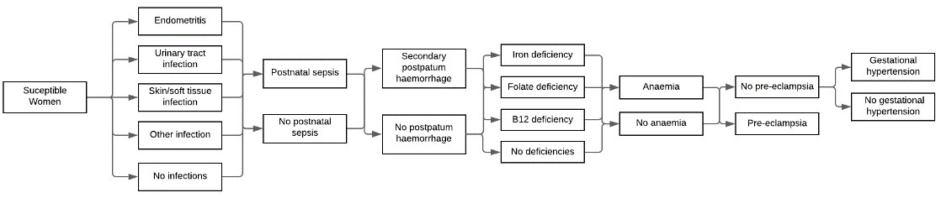
Figure 1. Application of incidence of maternal complications in the postnatal period

We do not replicate the structure in figure one for neonates as we simply apply risk of developing sepsis each week. Currently we use week 7 as the point at which all variables are reset (to prevent issues with future pregnancies) except those which represent properties that remain with the mother/neonate for life. This is a broadly similar structure to the application of risk within the antenatal period, except that individual level risk is applied weekly as opposed to monthly. Variables relating to treatment are updated within the individual health care seeking interactions in order to modify individual risk of death in the instance of successful treatment.
Incidence of Maternal Complications and Death in this model
There are a number of complications, seen in figure 1, which a mother is at risk of developing at multiple time points across the continuum of pregnancy (i.e. hypertension or anaemia). In order to prevent repetition in documentation the following sections will provide detail descriptions of complications that are novel to the postnatal period and only provide information related to how other complications, that have been descried elsewhere, vary contextually within this time period of pregnancy. Additionally we will signpost to relevant documentation where a more detail natural history model is provided. Calculation of individual risk of death is described towards the end of this section.
Secondary Postpartum Haemorrhage (PPH)
Within the labour model, and the labour model methods document, we describe in detail the natural history and associated treatment of primary PPH. Within this model we apply an individual risk of secondary PPH, which constitutes any amount of significant bleeding from the genital tract from 24 hours after birth until 6 weeks postpartum (Babarinsa, Hayman and Draycott, 2011), every week until the end of the postnatal period. The two most common suggested causes of secondary PPH are ‘infection’ and retained products of conception however but there are a multitude of other possible factors increasing risk of bleeding including uterine or placental abnormalities, caesarean section wound dehiscence, bleeding disorders and trauma (Babarinsa, Hayman and Draycott, 2011; Aiken et al., 2012).
Figure 2. Natural history model of secondary PPH
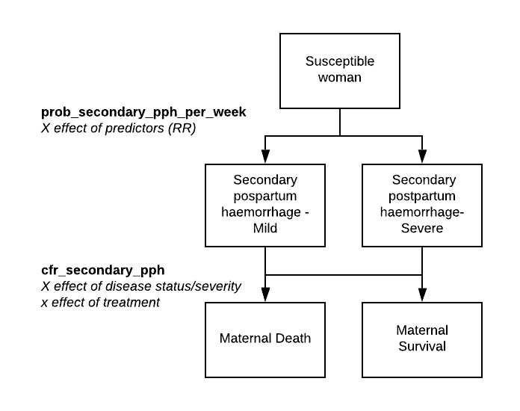

Due to the considerable variation in possible causes, many of which are not explicitly modelled within TLO, we assume all women experience a baseline risk of secondary PPH which will be modified by identified risk factors that are captured within the framework. The search process for these factors has not yet been completed.

Postnatal infection and sepsis
As with PPH, risk of infection and sepsis following birth is first applied in the labour model. A full description of the natural history model of postnatal infection and sepsis is described within the labour model methods document. We use the same model during the remainder of the postnatal period, assuming women are at risk of developing endometritis, urinary tract infection, skin/soft tissue or ‘other’ infections (Dalton and Castillo, 2014; Bonet et al., 2020) during this time which may develop into sepsis requiring treatment. The search process for risk factors has not yet been completed.
Hypertensive disorders
Incidence of the hypertensive disorders is first applied in the antenatal model where women are able to develop pre-eclampsia or gestational hypertension and experience progression of these diseases to more severe forms (severe gestational hypertension, severe pre-eclampsia or eclampsia) during the course of their pregnancy and into the intrapartum period.
Whilst the majority of cases of hypertensive disorders onset during pregnancy there is a significant burden of de novo hypertension which onsets for the first time during the postnatal period (Matthys et al., 2004; Sibai, 2012; Goel et al., 2015) Additionally, whilst a significant proportion of women with hypertension will become normotensive following delivery some will also continue to experience hypertension, and even a worsening of disease, within the postnatal period (Goel et al., 2015). To reflect the epidemiology of these conditions we manage the incidence and resolution of hypertension in the postnatal period in the following ways, varying according to whether the individual is hypertensive at the time of birth. For those women:
- On birth we apply a probability that women with a pre-existing hypertensive disorder of pregnancy will experience resolution of their condition – otherwise they remain in the same disease ‘state’ as during labour
- From week one we apply a probability of resolution to all hypertensive women weekly throughout the postnatal period
- For women whose hypertension doesn’t resolve we apply risk of progression to a more severe state
For women who are not hypertensive at birth:
- We apply a weekly risk of developing either mild pre-eclampsia or mild gestational hypertension (see figure 1) from week 1
- From the following week we apply a apply risk of progression to a more severe state
Risk factors increasing risk of disease onset and the structure of the natural history models remains unchanged from the antenatal model. Please see the associate methods documents for these flow diagrams.
Anaemia and deficiencies
The prevalence of maternal anaemia within the postnatal period remains high in settings contextually similar to Malawi (Kofie et al., 2019; Abebaw, Gudayu and Kelkay, 2020) and remains an important predictor of maternal death (Daru et al., 2018). As with the hypertensive disorders, we assume that individuals with anaemia and/or associated deficiencies will carry these properties into the postnatal period and women therefore retain the ‘severity’ of their anaemia following birth. As with the pregnancy model we do not apply a probability that anaemic women will progress to more severe anaemia either after birth or later within the postnatal period. Women without anaemia are at risk of developing the condition postnatally and this risk is applied weekly. Any risk factors identified for antenatal anaemia are currently used within this model to modify individual risk of anaemia postnatally.
Obstetric fistula
Within low-income countries obstetric fistula (vesicovaginal or rectovaginal – defined in table 1) remains a significant cause of morbidity in women following birth (Tunçalp et al., 2015) with an estimate incidence in Malawi of 1.6 per 1000 women (Kalilani-Phiri et al., 2010) . The impact of fistula on women is profound and complex and can lead to clinical outcomes such as incontinence and repeated infection as well as nuanced social outcome such as degradation of martial relationships and community stigmatisation (Yeakey et al., 2009; Drew et al., 2016; Changole et al., 2019). Within Malawi and similar settings the burden of obstetric fistula is driven, almost exclusively, by delays in women receiving adequate care around the time of delivery- especially in the context of prolonged and/or obstructed labour (Changole, Combs Thorsen and Kafulafula, 2018). Therefore whilst we apply a one-off risk of fistula to all women, to account for other iatrogenic causes, and that risk will be significantly increased in women who have experience obstructed labour.
We do not assume obstetric fistula contributes to maternal mortality as a primary cause of death. Morbidity is captured through the associated DALY weights for both vesicovaginal and rectovaginal fistula.
Incidence of Neonatal Complications and Death in this model
At present neonatal sepsis is the only neonatal complication included in this model. Whilst sepsis is one of the primary causes of neonatal death (Oza et al., 2015) there are a considerable number of other drivers of mortality which are either managed by models already under development (such as pneumonia or diarrhoea) or models that have yet to be developed. As the underlying determinants of early-onset sepsis are largely associated with birth and delivery (see below) late-onset sepsis is largely due to community transmission – which is outside of the focus of the maternal and perinatal health models, but will be a focus of child health modelling.
Neonatal Sepsis
As seen in table 1, the definitions of sepsis within the neonatal period are based around the timing of onset. Therefore the application of risk of early-onset sepsis is split between the newborn outcomes model (responsible for day 0-2) and this model (responsible for the remainder of week 1). As with maternal sepsis we apply the same natural history structure and risk factors first introduced in the newborn outcomes module, within this module also. This is consistent with the literature which suggests that determinants of early-onset infection and sepsis are largely due to vertical transmission from the mother and/or nosocomial factors around the time of delivery (Simonsen et al., 2014; Chan et al., 2015). This means neonates have incidence of early-onset sepsis applied twice, once on birth and again in week one. Currently onset of sepsis within week one is randomised to replicated greater burden towards the first few days of the week.
From week 2 of the neonatal period we apply individual risk of late onset sepsis which follows a very simple natural history model seen in figure 3.
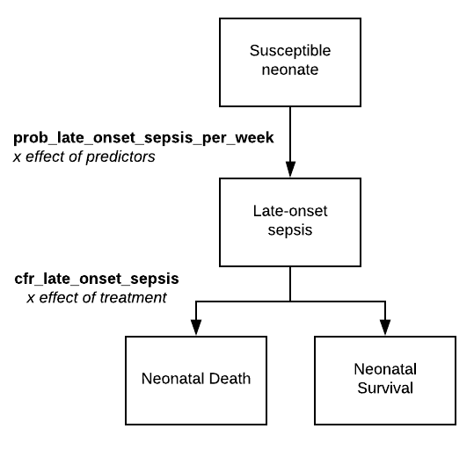
Figure 3. Natural history model of late-onset neonatal sepsis

As mentioned above, we are applying an incidence rate of all-cause late-onset neonatal sepsis for the remaining weeks of the neonatal period. This is currently a placeholder for more detailed work but allows us, for the time being, to replicate incidence, disability and rates of death associated with sepsis in the wider TLO model.
Disability weights for this model
Disability weights for maternal and neonatal complications associated with postnatal period are show in table 2 and are taken from Salomon (2012). We apply the same weights as used within the antenatal, labour and neonatal outcome modules as appropriate. We have highlighted in the table which weights are associated with acute events and which are life-long or until treatment has been received.
Table 2. DALY weights used within this module
Condition | Weight | Notes
Moderate maternal haemorrhage | 0.114 (0.078,0.159) | -
Severe maternal haemorrhage | 0.324 (0.22,0.442)
Maternal sepsis | 0.133 (0.088,0.19)
Vesicovaginal fistula | 0.342 (0.227,0.478)
Rectovaginal fistula | 0.501 (0.339,0.657)
Mild maternal anaemia | 0.004 (0.001,0.008)
Moderate maternal anaemia | 0.052 (0.034,0.076)
Severe maternal anaemia | 0.149 (0.101,0.209)
Mild maternal hypertension | 0.049 (0.031,0.072)
Mild motor impairment due to neonatal sepsis and other neonatal infections | 0.01,0.005,0.019
Moderate motor impairment due to neonatal sepsis and other neonatal infections | 0.061,0.04,0.089
Severe motor impairment due to neonatal sepsis and other neonatal | 0.402,0.268,0.545
Severe infection due to neonatal sepsis and other neonatal infections | 0.133,0.088,0.19
Mild motor plus cognitive impairments due to neonatal sepsis and other neonatal infections | 0.031,0.018,0.05

Maternal death
For any women who experience an acute complication during the postnatal period (sepsis, secondary PPH and eclampsia) we apply a case fatality rate to determine if they will survive or die due to this complication. As with the labour model, women are able to develop multiple complications within the same week and therefore have risk of death for each complication applied- considerably increasing the overall risk of death. For women who seek care for treatment, risk of death is applied after care has been delivered to allow for treatment effects to modify risk. Additionally to the risk of death secondary to acute complications, we apply a weekly risk of death from severe hypertension, which is largely asymptomatic, but can contribute to death.
Neonatal death
Similarly to maternal deaths, neonates who experience early or late onset sepsis have an individual risk of death applied (modified by treatment). Surviving neonates are then at risk of developing disability.

Table 3. Description of variables created relating to the postnatal period
Variable | Description | Notes and Major Assumptions
pn_id_most_recent_child' | person_id of a mothers most recent child
pn_postnatal_period_in_weeks | The number of weeks a woman is in the postnatal period (1-6)
pn_pnc_visits_maternal | The number of postnatal care visits a woman has undergone following her most recent delivery
pn_pnc_visits_neonatal | The number of postnatal care visits a neonate has undergone following delivery
pn_htn_disorders | Hypertensive disorders of the postnatal period ('none', 'resolved', 'gest_htn', 'severe_gest_htn', 'mild_pre_eclamp', 'severe_pre_eclamp', 'eclampsia'
pn_mag_sulph_treatment | Whether this woman has received magnesium sulphate as treatment for eclampsia/ severe pre-eclampsia'
pn_gest_htn_on_treatment | Whether this woman is receiving regular oral medication for hypertension in the postnatal period
pn_iv_anti_htn_treatment | Whether this woman has received IV anti-hypertensive therapy during a hypertensive emergency
pn_postpartum_haem_secondary | Whether this woman is experiencing a secondary postpartum haemorrhage
pn_postpartum_haem_secondary  _treatment' | Whether this woman has received treatment for secondary PPH
pn_sepsis_late_postpartum | Whether this woman is experiencing postnatal (day7+) sepsis
pn_sepsis_late_postpartum_treatment | Whether this woman has received treatment for postpartum sepsis
pn_maternal_pp_infection | bitset column for infection
pn_obstetric_fistula | Type of fistula developed after birth ( 'none', 'vesicovaginal', 'rectovaginal')
pn_sepsis_early_neonatal | Whether this neonate has developed early onset neonatal sepsis during week one of life
pn_sepsis_late_neonatal | Whether this neonate has developed late neonatal sepsis following discharge
pn_neonatal_sepsis_disab | Level of disability experience from a neonate post sepsis', ('none', 'mild_motor_and_cog', 'mild_motor', 'moderate_motor', 'severe_motor')
pn_sepsis_neonatal_inj_abx | Whether this neonate has received injectable antibiotics as treatment for late onset sepsis
pn_sepsis_neonatal_full_supp_care | Whether this neonate has received full supportive care as treatment for late onset sepsis
pn_deficiencies_following_pregnancy | bitset column, stores types of anaemia causing deficiencies following pregnancy
pn_anaemia_following_pregnancy | severity of anaemia following pregnancy ( 'none', 'mild', 'moderate', 'severe')
pn_emergency_event_mother | Whether a mother is experiencing an emergency complication postnatally

Table 4. Description of natural history parameters and proposed values.
Value provided in this table are not finalised and are pending a more detailed review of the relevant literature. This is a working document updated regularly.
Parameter | Proposed value | Description | Reference/ Notes
prob_htn_resolves | 0.8 | weekly probability hypertension resolves during postpartum
prob_secondary_pph | 0.05 | baseline probability of secondary PP
prob_secondary_pph_severity | [0.33, 0.33, 0.34] | probability of mild, moderate or severe secondary PPH
prob_obstetric_fistula | 0.1 | probability of a woman developing an obstetric fistula after birth
prevalence_type_of_fistula | [0.5, 0.5] | Prevalence of 1.) vesicovaginal 2.)rectovaginal fistula
prob_iron_def_per_week_pn | 0.01 | weekly probability of a women developing iron deficiency following pregnancy
prob_folate_def_per_week_pn | 0.0025 | weekly probability of a women developing folate deficiency following pregnancy
prob_b12_def_per_week_pn | 0.0025 | weekly probability of a women developing b12 deficiency following pregnancy
baseline_prob_anaemia_per_week | 0.001 | Weekly probability of anaemia in pregnancy
prob_type_of_anaemia_pn | [0.33, 0.33, 0.34] | probability of a woman with anaemia having mild, moderate or severe anaemia
rr_anaemia_if_iron_deficient_pn | 1.5 | risk of developing anaemia when iron deficient
rr_anaemia_if_folate_deficient_pn | 1.25 | risk of developing anaemia when folate deficient
rr_anaemia_if_b12_deficient_pn | 1.25 | risk of developing anaemia when b12 deficient
prob_endometritis_pn | 0.1 | probability of endometritis in week one
prob_urinary_tract_inf_pn | 0.1 | probability of urinary tract infection in week one
prob_skin_soft_tissue_inf_pn | 0.1 | probability of skin and soft tissue infection in week one
prob_other_inf_pn | 0.1 | probability of other maternal infections in week one
prob_late_sepsis_urinary_tract_inf | 0.1 | probability of developing sepsis following postpartum UTI
prob_late_sepsis_skin_soft_tissue_inf | 0.1 | probability of developing sepsis following postpartum skin/soft tissue infection
prob_late_sepsis_other_maternal_infection_pp | 0.1 | probability of developing sepsis following postpartum other infection
prob_late_onset_neonatal_sepsis | 0.1 | probability of late onset neonatal sepsis (all cause)
prob_sepsis_disabilities | [0.4, 0.1, 0.3, 0.1, 0.1] | Probabilities of varying disability levels after neonatal sepsis
prob_htn_persists | 0.2 | Probability that women who are hypertensive during pregnancy remain hypertensive in the postnatal period
weekly_prob_gest_htn_pn | 0.001 | weekly probability of a woman developing gestational hypertension during the postnatal period
cfr_eclampsia_pn | 0.0014 | 'case fatality rate of eclampsia in the postnatal period
cfr_severe_htn_pn | 0.0014 | case fatality rate of severe hypertension in the postnatal period
cfr_early_onset_neonatal_sepsis | 0.25 | case fatality for early onset neonatal sepsis
cfr_secondary_pph | 0.0014 | case fatality rate for secondary PPH
cfr_postnatal_sepsis | 0.0014 | case fatality rate for postnatal sepsis

Approach to modelling interventions related to Postnatal Care: rationale for model structure and choice of parameter values
Postnatal care in Malawi
The Malawi Essential Health Package (EHP) separates reproductive, maternal and neonatal health interventions into three broad packages; antenatal care, modern family planning and delivery care (Government of the Republic of Malawi, 2017). Whilst postnatal care (PNC) does not fall within any of these packages, and is not explicitly listed within the EHP as a service delivered via the public sector, it does feature prominently within the National Reproductive Health Service Delivery Guidelines (NRHSDG) (Government of the Republic of Malawi, 2014) as part of essential care for mothers and newborns . Additionally postnatal care and essential newborn care form part of the minimum package of high impact Interventions which target maternal and neonatal mortality reduction in the Ministry of Health’s ‘Road Map for Accelerating the reduction of Maternal and Neonatal Morbidity and Mortality’ (Malawi Ministry of Health, 2012). We have used the NRHSDG to structure the health system interactions within this model after confirmation with ministry officials that this is the most relevant national policy in regards to PNC.
The NRHSDG does not have an explicit PNC schedule or intervention matrix (as it does with ANC) but does provide suggested visit times for women depending on place of delivery (facility vs home). Women, and their newborns, who delivered at home should receive a first PNC visit within three days of birth whilst those women who have delivered in a facility should receive initial postnatal management and care prior to discharge. Following this women should then be encouraged to return at 7 and 42 days postnatal for additional assessment. This schedule is mimicked within our model as discussed in the following section.
Care seeking
Within the model we assume, as discussed above, that immediate postnatal care for the mother and the newborn is delivered to any individuals who deliver/have been delivered in a facility. The details of these interventions are covered in the next section. For all women and/or newborns who have survived until the first week postnatal, we apply a probability that mother and baby will seek routine postnatal care around day 7 after we have applied risk of complications in that week.
Historically, and according to recent estimates, uptake of routine postnatal care for both mothers and neonates is poor within Malawi (Machira and Palamulen, 2017; Khaki and Sithole, 2019; Kim et al., 2019). Analysis from the 2015-2016 DHS in Malawi found that only 48.4% of women in the sample received routine postnatal care within 42 days of birth (Khaki and Sithole, 2019). Factors associated with maternal PNC attendance reported in Khaki and Sithole’s study (2019) included:
- Being aged 30-35 - aOR 1.75 (95% CI 1.22 - 2.51)
- Being aged 36 and older - aOR 1.86 (95% CI 1.19-2.92)
- Being employed - aOR 1.44 (95% CI 1.22-1.70)
- Living rurally - aOR 0.55 (95% CI 0.40-0.76)
- Living in the central region – aOR 0.55 (95% CI 0.41-0.7)
- Living in the southern region – aOR 0.47 (95% CI 0.35-0.61)
- Richest wealth quintile – aOR 0.72 (95% CI 0.53-0.98)
- 4+ ANC visits – aOR 1.20 (95% CI 1.02-1.40)
- Caesarean delivery – aOR 1.93 (95% CI 1.38-2.69)
- Facility birth – aOR 1.91 (95% CI 1.03-3.55)
- Number of living children greater than 5 – aOR 0.33 (95% CI 0.46-0.95)
Currently care- seeking is determined with a fixed probability, not influenced by the above risk factors, which is increased for women who experience complications in week one, as we assume they are more likely to return to a facility for additional treatment. Following a finalised comparison of studies evaluating the effect of maternal characteristics on PNC attendance we intend to include relevant effects within a care seeking equation.
Postnatal care interventions
We have adapted the recommended postnatal interventions from the NRHSDG document (Government of the Republic of Malawi, 2014) and the Malawi Standard Treatment Guidelines (Ref). Figure 4 provides an overview of the health system interactions relevant to the postnatal period.

Figure 4. Flow of health system interactions in the postnatal period
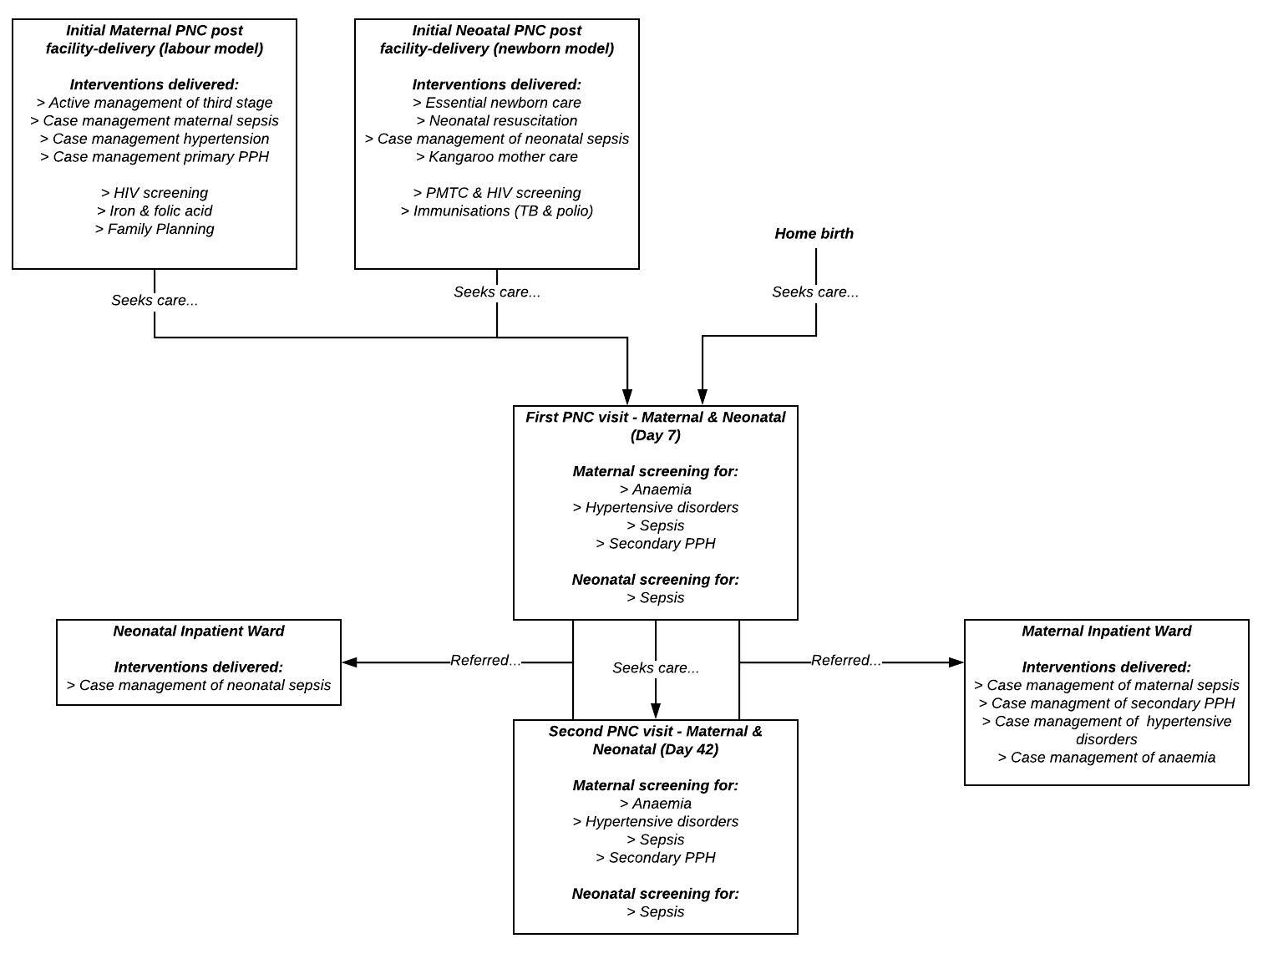

Initial PNC following delivery
As described above and seen in figure 4, initial prophylactic and curative interventions provided by skilled birth attendants to women and newborns immediately following birth are managed within the Labour and newborn models. For reference these interventions are:
- Active management of the third stage of labour
- Case management of primary postpartum haemorrhage
- Case management of hypertension and severe pre-eclampsia/eclampsia
- Case management of maternal sepsis (prior to discharge)
- Case management of neonatal sepsis (prior to discharge)
- Neonatal resuscitation
- Essential newborn care (chlorhexidine cord care, vitamin K prophylaxis, tetracycline eye care, early initiation of breastfeeding)
- Kangaroo mother care
The modelled effects, underlying descriptions of these interventions and the approach to modelling quality of care are provided in the labour and newborn model methods documentation. Prior to discharge, for those who have survived the immediate postnatal period guidelines recommend a number of interventions for mother and/or baby – described in the following sections.
HIV screening and prophylaxis
The NRHSDG offer guidance for the management of HIV and HIV related risk in the postnatal period. The natural history of HIV in the population, all related interventions and screening are managed by the HIV model. This model links with the HIV model in regards to scheduling some screening interventions during antenatal care and postnatal care.
For women with unknown serostatus, HIV testing is recommended. Currently all women in the model who deliver in a facility are scheduled to receive a routine HIV testing following delivery. This testing intervention is managed by the HIV model which will initiate treatment and monitoring for any women found to be HIV positive (and not currently on treatment) after delivery. Additionally to testing the HIV model is responsible for interventions around prevention of mother to child transmission of HIV (PMTC). Broadly, neonates born to mothers who are HIV positive are tested for HIV following delivery. If the neonate is found to be HIV+ they are started on treatment and monitoring, if they are negative they are started on prophylaxis. Additional follow-up screening for HIV in exposed neonates occurs in future PNC visits described below.

Immunisation
As part of PNC pre-discharge we assume all neonates are offered routine post-birth vaccinations including tuberculosis and polio. The effect of these interventions on disease burden are managed via the EPI model but consumables are managed within this model.
Family planning
Routine post birth family planning is managed by the contraception model and described in detail in the associated methods documentation.
Iron and Folic acid
Daly iron and folic acid supplementation is recommended for three months following all deliveries and is imitated prior to discharge. We use an identical approach to that of the pregnancy supervisor and antenatal care models in that we apply a treatment effect (RR 0.44 (Peña-Rosas et al., 2015)) to an individual woman’s risk of developing an iron or folate deficiency which may lead to anaemia in the postnatal period.
Outpatient PNC visits
Additional PNC visits, following discharge, should then occur on days 7 and 42 for both mother and baby. As mentioned above, national reproductive health guidelines in Malawi do not provide an explicit matrix of interventions to be delivered during each of these routine PNC visits. In order to model intervention delivered as part of routine PNC within Malawi we reviewed possible data sources that would provide details of care delivered as part of PNC as described below.
Quality of care in outpatient PNC
In order to capture variations in quality of care between PNC contacts we have adopted the same approach used within antenatal care to determine if an intervention (predominantly screening/assessment) will be conducted during the PNC visit. These probabilities will be informed by the SPA data (2014) for each intervention to replicate the quality of care of PNC contact in Malawi. These probabilities appear to vary by facility type (hospital vs health centre) and this will need to be modelled accordingly. Including this logic, delivery of interventions is therefore conditional on:
- Probability that the HCW will initiate this intervention/screening process
- (if applicable) sensitivity and specificity of the screening test
- Probability that the consumables required for this intervention are available at the facility level
Content of PNC for newborns
The Malawi DHS (2015) collected data related to care delivered to newborns as part of PNC and included responses for the following interventions; examination of the cord, temperature check, weight measurement, counselling on possible neonatal danger signs and counselling and observation of breastfeeding. This aligns with WHO recommendations on the content of PNC for newborns which includes assessment of the baby, initiation and monitoring of breastfeeding and cord care (WHO 2013). For neonates who were delivered in a facility we assume that recommend interventions (breastfeeding, cord care, immunisations) have been delivered and the content of PNC revolves around assessment for neonatal sepsis and referral for inpatient care. If the HCW performs an assessment and detects that the neonate is suffering from sepsis they will be admitted for inpatient care (described below).
Content of PNC for mothers
Similarly to neonates, PNC for mothers revolves around assessment for potential complications and referral for additional treatment. Within each PNC visit women should receive:
- Blood pressure measurement to assess for hypertension
- Urine dipstick to detect proteinuria
- Point of care test for anaemia
- Assessment for maternal sepsis
- Assessment for secondary PPH
If one or more complications are detected then the mother is scheduled to receive additional treatment as an inpatient via the postnatal ward.
Inpatient PNC
Postnatal ward
Women in the model are admitted for inpatient care if assessment during PNC has led to the detection of a hypertensive disorder, anaemia (any severity), sepsis or secondary postpartum haemorrhage. As with care delivered on the antenatal ward clinical management of these conditions is modelled to match treatment protocols outlined in the Malawian Obstetrics and Gynaecology Guidelines (The Association of Obstetricians & Gynaecologists of Malawi, 2014) and Standard Treatment Guidelines ().
Treatment for maternal sepsis
As with the management of maternal sepsis during labour, antibiotic therapy is the primary treatment intervention for maternal sepsis included in the model. We apply the same treatment effect and therefore assume women who receive treatment for sepsis have a reduced risk of sepsis-death (RR 0.2 (Pollard, Mathai and Walker, 2013a)). Please see labour documentation for further details.
Treatment for hypertensive disorders
Inpatient treatment of hypertension varies according to severity and underlying hypertensive disorder. Women with more mild hypertension (mild gestational hypertension/mild pre-eclampsia) are simply initiated on regular oral antihypertensives and discharged- we assume that oral antihypertensives administered postnatally work similar to the antenatal period in that they reduce a woman’s risk of developing severe gestational hypertension (RR 0.49 (Abalos et al., 2018a)) but no other significant effects on maternal or perinatal outcomes.
Severe hypertension (severe gestational hypertension, severe pre-eclampsia and eclampsia) is treated with intravenous antihypertensives which reduces risk of death in severe pre-eclamsia and eclampsia (RR 0.5 (Pollard, Mathai and Walker, 2013b)) or reverts severe gestational hypertension to the milder state, reducing monthly risk of death.
Severe pre-eclampsia and eclampsia are also treated with magnesium sulphate which reduces risk of death from eclampsia (RR 0.5 (Pollard, Mathai and Walker, 2013b) and reduces the likelihood that a woman with severe pre-eclampsia will develop eclampsia (RR 0.41 (Duley et al., 2010)).
Treatment for secondary PPH
TBD.
Treatment for anaemia
TBD. Not modelled.
Neonatal ward
Neonates admitted to the neonatal ward due to sepsis will receive full supportive case management of sepsis (see newborn module methods document for description). Risk of death associated with sepsis is reduced by 80% (treatment effect 0.2 (Zaidi et al., 2011))

Table 5. Description of treatment parameters and proposed values.
Parameter | Proposed value | Description | Reference Notes
rr_iron_def_ifa_pn | 0.43 | effect of iron and folic acid treatment on risk of iron deficiency | (Peña-Rosas et al., 2015)
rr_folate_def_ifa_pn | 0.43 | effect of iron and folic acid treatment on risk of folate deficiency | (Peña-Rosas et al., 2015)
treatment_effect_early_init_bf | 0.85 | 'effect of early initiation of breastfeeding on neonatal sepsis rates | Breastfeeding effect sizes on mortality in LiST (technical note found in spectrum help section)
treatment_effect_abx_prom | 0.61 | effect of early antibiotics given to a mother with PROM on neonatal sepsis rates | (Cousens et al., 2010)
treatment_effect_inj_abx_sep | 0.35 | effect of injectable antibiotics on neonatal sepsis mortality | (Zaidi et al., 2011)
treatment_effect_supp_care_sep | 0.2 | effect of full supportive care on neonatal sepsis mortality | (Zaidi et al., 2011)
treatment_effect_cord_care | 0.77 | Treatment effect of chlorhexidine cord care on early onset neonatal sepsis risk | (Blencowe et al., 2011)
treatment_effect_clean_birth | 0.73 | Treatment effect of clean birth practices on early onset neonatal sepsis risk | (Blencowe et al., 2011)
prob_attend_pnc2 | 0.25 | Probability that a woman receiving PNC1 care will return for PNC2 care | DUMMY
prob_attend_pnc3 | 0.25 | Probability that a woman receiving PNC2 care will return for PNC3 care | DUMMY
treatment_effect_anti_htns_progression_pn | 0.49 | Treatment effect of oral anti hypertensives on progression from mild/mod to severe gestational hypertension | (Abalos et al., 2018b)
treatment_effect_parenteral_antibiotics | 0.2 | Treatment effect of parenteral antibiotics on maternal sepsis mortality | (Pollard, Mathai and Walker, 2013a)
treatment_effect_bemonc_care_pph | 0.25 | Treatment effect of BEmONC care on postpartum haemorrhage mortality | (Pollard, Mathai and Walker, 2013a)
treatment_effect_anti_htns | 0.5 | Treatment effect of hypertensive therapy on death from eclampsia | (Pollard, Mathai and Walker, 2013a)
treatment_effect_mag_sulph | 0.4 | Treatment effect of magnesium sulphate therapy on death from eclampsia | (Pollard, Mathai and Walker, 2013a)
neonatal_sepsis_treatment_effect | 0.2 | Treatment effect for neonatal sepsis | (Zaidi et al., 2011)
prob_care_seeking_postnatal_emergency | 0.5 | baseline probability of emergency care seeking for women in the postnatal period' | DUMMY
prob_care_seeking_postnatal_emergency_neonate | 0.5 | baseline probability care will be sought for a neonate with a complication | DUMMY
prob_pnc1_at_day_7 | 0.4 | baseline probability a woman will seek PNC for her and her newborn at day + 7 | DUMMY
multiplier_for_care_seeking_with_comps | 2 | number by which prob_pnc1_at_day_7 is multiplied by to increase care seeking for PNC1 in women with complications | DUMMY
sensitivity_bp_monitoring_pn | 0.9 | sensitivity of BP monitoring during PNC | DUMMY
specificity_bp_monitoring_pn | 0.9 | specificity of BP monitoring during PNC | DUMMY
sensitivity_urine_protein_1_plus_pn | 0.9 | sensitivity of urine dipstick during PNC | DUMMY
specificity_urine_protein_1_plus_pn | 0.9 | specificity of urine dipstick monitoring during PNC | DUMMY
sensitivity_poc_hb_test_pn | 0.9 | sensitivity of point of care testing during PNC | DUMMY
specificity_poc_hb_test_pn | 0.9 | specificity of urine dipstick monitoring during PNC | DUMMY
sensitivity_maternal_sepsis_assessment | 0.9 | sensitivity of assessment for maternal sepsis' | DUMMY
sensitivity_pph_assessment | 0.9 | sensitivity of assessment for secondary pph | DUMMY
sensitivity_lons_assessment | 0.9 | sensitivity of assessment for late onset neonatal sepsis' | DUMMY
sensitivity_eons_assessment | 0.9 | sensitivity of assessment for earl onset neonatal sepsis | DUMMY
prob_intervention_delivered_sep_assessment_pnc | 0.9 | 'probability a woman will be assessed for sepsis during PNC | DUMMY
prob_intervention_delivered_pph_assessment_pnc | 0.9 | 'probability a woman will be assessed for PPH during PNC | DUMMY
prob_intervention_delivered_urine_ds_pnc | 0.9 | 'probability a woman will receive a urine dipstick during PNC | DUMMY
prob_intervention_delivered_bp_pnc | 0.9 | probability a woman will receive blood pressure testing during PNC' | DUMMY
prob_intervention_poct_pnc | 0.9 | probability a woman will receive point of care Hb testing during PNC | DUMMY
prob_intervention_neonatal_sepsis_pnc | 0.9 | probability a newborn will be assessed for sepsis during PNC | DUMMY

References
Abalos, E. et al. (2018a) ‘Antihypertensive drug therapy for mild to moderate hypertension during pregnancy’, Cochrane Database of Systematic Reviews. John Wiley and Sons Ltd. doi: 10.1002/14651858.CD002252.pub4.
Abalos, E. et al. (2018b) ‘Antihypertensive drug therapy for mild to moderate hypertension during pregnancy’, Cochrane Database of Systematic Reviews. John Wiley and Sons Ltd, 2018(10). doi: 10.1002/14651858.CD002252.pub4.
Abebaw, A., Gudayu, T. W. and Kelkay, B. (2020) ‘Proportion of Immediate Postpartum Anaemia and Associated Factors among Postnatal Mothers in Northwest Ethiopia: A Cross-Sectional Study’, Anemia. Hindawi Limited, 2020. doi: 10.1155/2020/8979740.
Babarinsa, I. A., Hayman, R. G. and Draycott, T. J. (2011) ‘Secondary post-partum haemorrhage: Challenges in evidence-based causes and management’, European Journal of Obstetrics and Gynecology and Reproductive Biology. Elsevier Ireland Ltd, pp. 255–260. doi: 10.1016/j.ejogrb.2011.07.029.
Blencowe, H. et al. (2011) ‘Clean birth and postnatal care practices to reduce neonatal deaths from sepsis and tetanus: A systematic review and Delphi estimation of mortality effect’, BMC Public Health. BioMed Central Ltd, 11(SUPPL. 3), p. S11. doi: 10.1186/1471-2458-11-S3-S11.
Bonet, M. et al. (2020) ‘Frequency and management of maternal infection in health facilities in 52 countries (GLOSS): a 1-week inception cohort study’, The Lancet Global Health. Elsevier Ltd, 8(5), pp. e661–e671. doi: 10.1016/S2214-109X(20)30109-1.
Chan, G. J. et al. (2015) ‘Prevalence of early-onset neonatal infection among newborns of mothers with bacterial infection or colonization: a systematic review and meta-analysis’. doi: 10.1186/s12879-015-0813-3.
Changole, J. et al. (2019) ‘Community perceptions of obstetric fistula in Malawi’, Culture, Health and Sexuality. Routledge, 21(5), pp. 605–617. doi: 10.1080/13691058.2018.1497813.
Changole, J., Combs Thorsen, V. and Kafulafula, U. (2018) ‘A road to obstetric fistula in Malawi: capturing women&rsquo;s perspectives through a framework of three delays’, International Journal of Women’s Health. Dove Medical Press Ltd, Volume 10, pp. 699–713. doi: 10.2147/IJWH.S171610.
Cousens, S. et al. (2010) ‘Antibiotics for pre-term pre-labour rupture of membranes: Prevention of neonatal deaths due to complications of pre-term birth and infection’, International Journal of Epidemiology. Oxford University Press, 39(SUPPL. 1), p. i134. doi: 10.1093/ije/dyq030.
Dalton, E. and Castillo, E. (2014) ‘Post partum infections: A review for the non-OBGYN’, Obstetric Medicine. Royal Society of Medicine Press Ltd, 7(3), pp. 98–102. doi: 10.1177/1753495X14522784.
Daru, J. et al. (2018) ‘Risk of maternal mortality in women with severe anaemia during pregnancy and post partum: a multilevel analysis’, The Lancet Global Health. Elsevier Ltd, 6(5), pp. e548–e554. doi: 10.1016/S2214-109X(18)30078-0.
Debeche-Adams, T. H. and Bohl, J. L. (2010) ‘Rectovaginal fistulas’, Clinics in Colon and Rectal Surgery. Thieme Medical Publishers, 23(2), pp. 99–103. doi: 10.1055/s-0030-1254296.
Drew, L. B. et al. (2016) ‘Long-term outcomes for women after obstetric fistula repair in Lilongwe, Malawi: A qualitative study’, BMC Pregnancy and Childbirth. BioMed Central Ltd., 16(1), p. 2. doi: 10.1186/s12884-015-0755-1.
Duley, L. et al. (2010) ‘Magnesium sulphate and other anticonvulsants for women with pre-eclampsia’, Cochrane Database of Systematic Reviews. John Wiley & Sons, Ltd, (11). doi: 10.1002/14651858.CD000025.pub2.
Goel, A. et al. (2015) ‘Epidemiology and mechanisms of de novo and persistent hypertension in the postpartum period’, Circulation. Lippincott Williams and Wilkins, 132(18), pp. 1726–1733. doi: 10.1161/CIRCULATIONAHA.115.015721.
Government of the Republic of Malawi (2017) Health Sector Strategic Plan II (2017-2022).
Kalilani-Phiri, L. V. et al. (2010) ‘Prevalence of obstetric fistula in Malawi’, International Journal of Gynecology & Obstetrics. No longer published by Elsevier, 109(3), pp. 204–208. doi: 10.1016/j.ijgo.2009.12.019.
Khaki, J. J. and Sithole, L. (2019) ‘Factors associated with the utilization of postnatal care services among malawian women’, Malawi Medical Journal. Malawi Medical Journal, 31(1), pp. 2–11. doi: 10.4314/mmj.v31i1.2.
Kim, E. T. et al. (2019) ‘Availability of health facilities and utilization of maternal and newborn postnatal care in rural Malawi’, BMC Pregnancy and Childbirth, 19(1), p. 503. doi: 10.1186/s12884-019-2534-x.
Kofie, P. et al. (2019) ‘Prevalence and associated risk factors of anaemia among women attending antenatal and post-natal clinics at a public health facility in Ghana’, BMC Nutrition. BioMed Central, 5(1), p. 40. doi: 10.1186/s40795-019-0303-x.
M Aiken, C. E., Mehasseb, M. K. and Prentice, A. (2012) ‘SECONDARY POSTPARTUM HAEMORRHAGE’, Fetal and Maternal Medicine Review. Cambridge University Press, 23, pp. 1–1. doi: 10.1017/S096553951100012X.
Machira, K. and Palamulen, M. (2017) ‘Rural–urban differences in the use of postnatal care services in Malawi’, Journal of Egyptian Public Health Association. Egypts Presidential Specialized Council for Education and Scientific Research, 92(1), pp. 1–10. doi: 10.21608/epx.2017.7003.
Malawi Ministry of Health (2012) Road Map for Accelerating the reduction of Maternal and Neonatal Morbidity and Mortality in Malawi.
Matthys, L. A. et al. (2004) ‘Delayed postpartum preeclampsia: An experience of 151 cases’, American Journal of Obstetrics and Gynecology. Mosby Inc., 190(5), pp. 1464–1466. doi: 10.1016/j.ajog.2004.02.037.
Oza, S. et al. (2015) ‘Neonatal cause-of-death estimates for the early and late neonatal periods for 194 countries: 2000-2013’, Bull World Health Organ, 93, pp. 19–28. doi: 10.2471/BLT.14.139790.
Peña-Rosas, J. P. et al. (2015) ‘Daily oral iron supplementation during pregnancy’, Cochrane Database of Systematic Reviews. John Wiley and Sons Ltd, pp. 1–527. doi: 10.1002/14651858.CD004736.pub5.
Pollard, S. L., Mathai, M. and Walker, N. (2013a) Estimating the impact of interventions on cause-specific maternal mortality: a Delphi approach, BMC Public Health. doi: 10.1186/1471-2458-13-S3-S12.
Pollard, S. L., Mathai, M. and Walker, N. (2013b) ‘Estimating the impact of interventions on cause-specific maternal mortality: A Delphi approach’, BMC Public Health. BioMed Central, p. S12. doi: 10.1186/1471-2458-13-S3-S12.
Sibai, B. M. (2012) ‘Etiology and management of postpartum hypertension-preeclampsia’, American Journal of Obstetrics and Gynecology. Am J Obstet Gynecol, 206(6), pp. 470–475. doi: 10.1016/j.ajog.2011.09.002.
Simonsen, K. A. et al. (2014) ‘Early-onset neonatal sepsis’, Clinical Microbiology Reviews. American Society for Microbiology (ASM), 27(1), pp. 21–47. doi: 10.1128/CMR.00031-13.
Stamatakos, M. et al. (2014) ‘Vesicovaginal Fistula: Diagnosis and Management’, Indian Journal of Surgery. Springer India, pp. 131–136. doi: 10.1007/s12262-012-0787-y.
The Association of Obstetricians & Gynaecologists of Malawi (2014) ‘Obstetrics & Gynaecology Protocols and Guidelines’, (September), pp. 1–105.
The Government of the Republic of Malawi (2014) ‘Malawi National Reproductive Health Service Delivery Guidelines’.
Tunçalp, Ö. et al. (2015) ‘Measuring the incidence and prevalence of obstetric fistula: approaches, needs and recommendations’, Bull World Health Organ. doi: 10.2471/BLT.14.141473.
Yeakey, M. P. et al. (2009) ‘The lived experience of Malawian women with obstetric fistula’, Culture, Health and Sexuality. Taylor & Francis Group , 11(5), pp. 499–513. doi: 10.1080/13691050902874777.
Zaidi, A. K. M. et al. (2011) ‘Effect of case management on neonatal mortality due to sepsis and pneumonia’, BMC Public Health. BioMed Central, p. S13. doi: 10.1186/1471-2458-11-S3-S13.

