Modelling of Chronic Obstructive Pulmonary Disease (COPD) within the Thanzi La Onse Model

Background: The Thanzi La Onse Model
As part of the Thanzi La Onse program a model is being developed which aims to capture the health experiences of the population of Malawi and the consequent interactions with the health care system. The intent is that this model will help to inform future delivery of health care in Malawi. The model is an individual based model – which means we explicitly simulate the individual life and health experiences of a representative proportion of population of Malawi. The simulation initiates on 1 Jan 2010 and we attempt to simulate the attributes of the population at that point. We can run the model forward to any specified future time point. Each potential intervention and its associated diseases are being modelled. This is being divided into separate disease/intervention modules. This document describes the module on chronic obstructive pulmonary disease (COPD).

Background: General approach to decisions on modelling causal influences and effects of interventions
This module was designed in the context of an overall approach to modelling causal effects in general and causal effects of interventions in particular. The overall intent is to adopt as simple a structure as can be conceived, whilst still capturing the essential elements of a disease and the interventions used to prevent or treat. We include a causal link between a “variable” (by which we mean a characteristic or property of an individual, whether that be demographic, social or biologic), and risk of disease or another variable if there is strong evidence from an overall body of studies that such a causal link exists and is at least moderately strong. In informing such decisions we place particular value on RCTs or studies with a quasi-experimental design such as analyses based on an instrumental variable There is no expectation that such studies will be from Malawi or even from Africa. If there are such local studies and in the unlikely event that they provide strong evidence to suggest that the causal link is substantively different in Malawi then the intent is that this is taken into account and the Malawi-specific link included.
In the special case of a potential causal variable which relates to whether an individual has experienced or is experiencing an intervention the intent is to only include interventions if there is substantial RCT evidence of their beneficial effect, based on trials with objectively ascertained clinical endpoints with low risk of serious bias. Whilst DCP-3 (and to some extent the Malawi EHP) provides an initial list of such interventions and the evidence to support them, where possible our intent has been to form our own opinion on intervention efficacy based on the source trials.
Unless there is evidence to the contrary, the intent is to summarize and incorporate intervention effects into the model as relative risks or rates rather than absolute differences due to the fact that such measures are less likely to differ substantively by context. Interactions between characteristics (on the multiplicative scale) are only to be incorporated if there is strong evidence. Again, we have not intended to rely on data from Malawi or Africa for such evidence but if local evidence exists which strongly suggests a different effect than elsewhere then the intent is that this modified effect is incorporated in the model.

Background: Demographic and social characteristics modelled
Based on data on the distribution of the population in Malawi according to geographic location we assign individuals a geographic location, which maps onto whether they are classified as living in a rural or urban area. Informed largely by data from the Malawi DHS, variables are also created indicating the person’s wealth level (based on 5 quintiles), whether the person has access to improved sanitation, clean drinking water, hand washing facilities, and whether they experience indoor air pollution (wood burning stove). We assign individuals a current education status (none, primary, secondary) which is updated 3 monthly from age 5 to 20. From age 15 we assign BMI in 5 categories, tobacco use status, drinking excess alcohol, having low exercise, high sugar intake, high salt intake, and marital status (never, currently, widowed/divorced). The status with regard to such variables for individuals can change over time. The influences between these variables are described in detail in a separate document.

Approach to modelling COPD: rationale for model structure and choice of parameter values
Variables (properties) modelled
The model updates information on each individual with regard to lung function status every 3 months. ch_lung function is a property taking the values 0 – 6 with 3 considered to represent mild COPD, 4 moderate, 5 severe and 6 very severe lung obstruction (as reported in Njoroge et al 2021). Levels 1 and 2 represent pre-clinical low level obstruction. ch_has_inhaler indicates whether the person has access to an inhaler, whether that be short or long acting, and whether it be a bronchodilator or a steroid inhaler.

Causal influences on COPD progression
There is assumed to be a (very low) underlying rate of progression to the next higher lung function category. This rate is affected by whether the person is currently a smoker (rel_risk_tob), and whether they have a woodburning stove in their home (rel_risk_wood_burn_stove).

Incidence of moderate and severe COPD exacerbation
prob_mod_exacerb and prob_sev_exacerb. Each of these depends on the current level of ch_lungfunction.

Initiation of bronchodilator (alpha 2 agonist or antimuscarinic) and/or steroid inhaler
We assume that a person with ch_lung_function = 5 or 6 with a moderate or severe exacerbation will present for care and be given an inhaler to use thereafter.

Disability weights
Lungfunction category 4 0.02 Lungfunction category 5 0.20 Lungfunction category 6 0.40

Symptoms
breathless_moderate and breathless_severe are synonymous with currently having a moderate or severe exacerbation. Each of these prompts presentation for health care.

Health System Interactions
breathless_moderate or breathless_severe prompt presentation for health care. An inhaler is given (if available). If breathless_severe then oxygen is provided if available.

Risk of death from COPD given a severe exacerbation
Given a severe exacerbation, the risk of death is dependent on age.

Effect of oxygen on risk of death from severe exacerbation
Access to oxygen during the exacerbation reduces the risk by multiplying by 0.6.

Main Limitations
We consider that the structure conveys the progression and outcomes of COPD at an adequate level, given current knowledge, but some uncertainty remains. There are very few direct data from Malawi available. The effect on progression of lung obstruction (increase in ch_lungfunction) of living in a home with a woodburning stove is very uncertain. More generally, it is often unclear from epidemiologic and trial data what is the role of COPD per se compared with other effects of smoking.

Outstanding Issues
Uncertain whether to assume an effect of inhaler use on progression of underlying lung function (Tashkin et al). There perhaps should be an effect of inhaler access/use on the current disability weight.

Contributors to this module
Emmanuel Mnjowe, Andrew Phillips, Tim Colbourn, Joe Collins, Timothy Hallett.

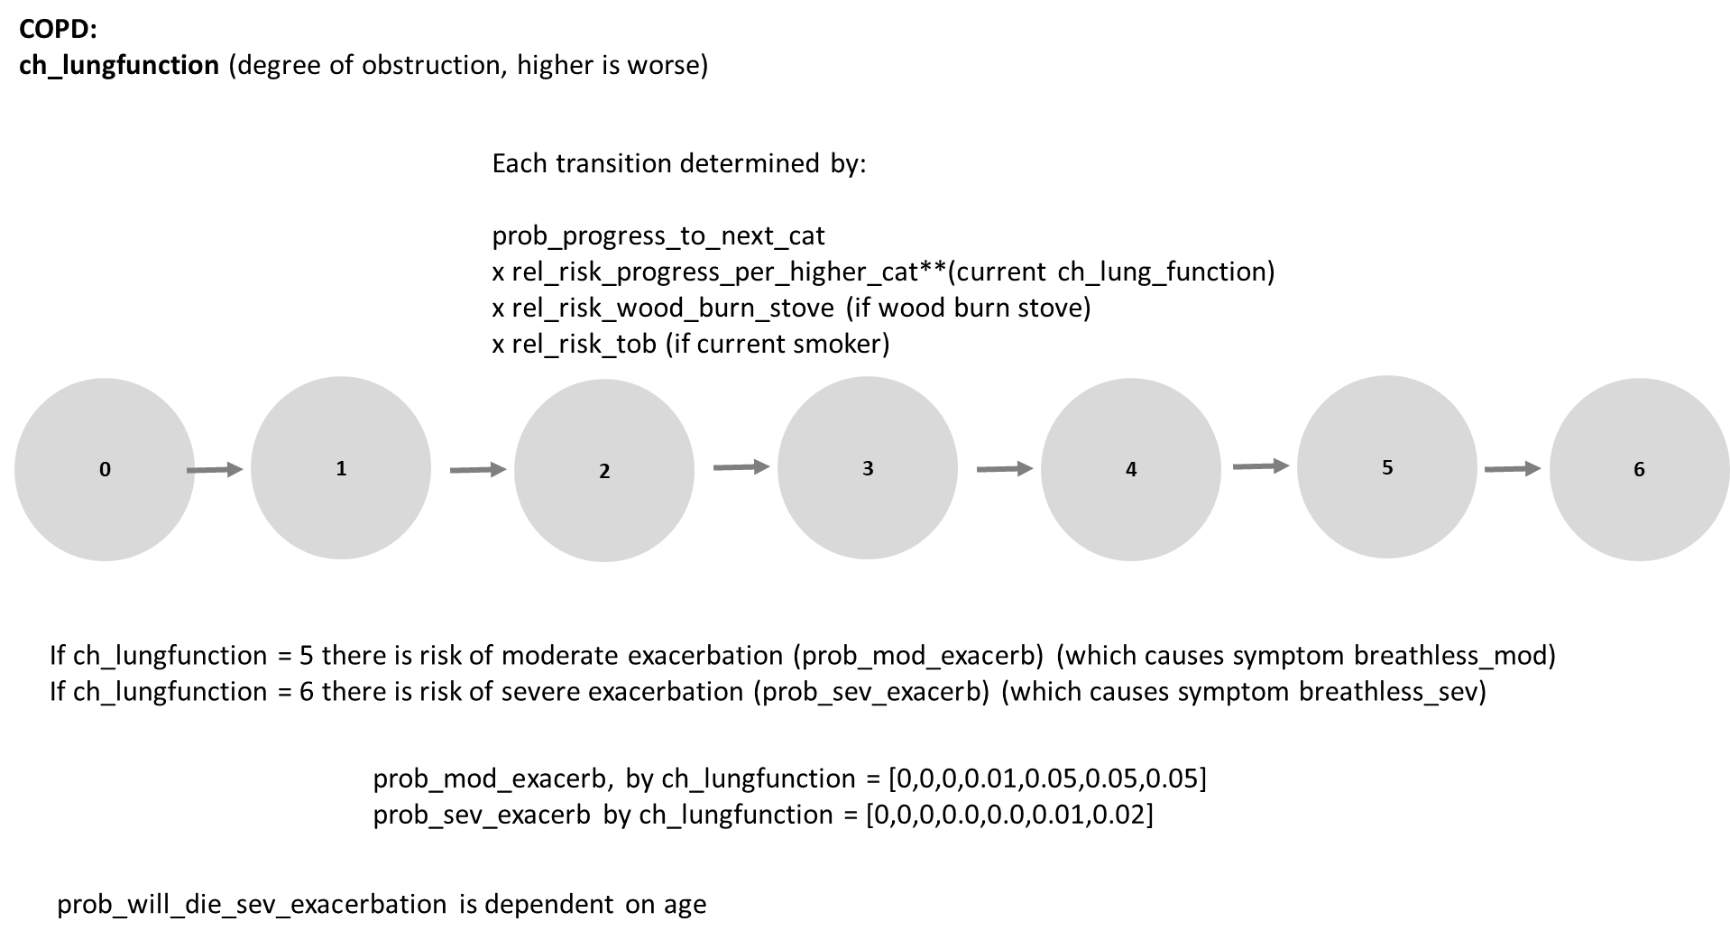
Figure 1. Model structure and parameters.

Table 1. Individual properties.
Variable | Description
ch_lungfunction | Level of lung obstruction of the person, taking the values 0 – 6 with 3 considered to represent mild COPD, 4 moderate, 5 severe and 6 very severe lung obstruction
ch_has_inhaler | whether the person has access to an inhaler, whether that be short or long acting, and whether it be a bronchodilator or a steroid inhaler

Table 2. Description of parameters and proposed values.
Parameter | Proposed value | Description | Notes
prob_progress_to_next_cat | 0.01 | probability per 3 months of an increase in category to one level poorer lung function | There are very few data to directly inform parameter values. The model structure and these values are selected based on a reading of the below.  DHS. Malawi 2010, 2015/16 https://dhsprogram.com/  Njoroge MW, Mjojo P, Chirwa C, Rylance S, Nightingale R, Gordon SB, Mortimer K, Burney P, Balmes J, Rylance J, Obasi A, Niessen LW, Devereux G; IMPALA consortium. Changing lung function and associated health-related quality-of-life: A five-year cohort study of Malawian adults. EClinicalMedicine. 2021 Oct 18;41:101166. doi: 10.1016/j.eclinm.2021.101166. PMID: 34712931; PMCID: PMC8529201.  Meghji J, Nadeau G, Davis KJ, Wang D, Nyirenda MJ, Gordon SB, Mortimer K. Noncommunicable Lung Disease in Sub-Saharan Africa. A Community-based Cross-Sectional Study of Adults in Urban Malawi. Am J Respir Crit Care Med. 2016 Jul 1;194(1):67-76. doi: 10.1164/rccm.201509-1807OC. PMID: 26788760; PMCID: PMC4960629.  Nightingale R, Jary H, Meghji J, Rylance S, Masiye J, Chiumia H, Rylance J, Mortimer K, Lesosky M. Non-communicable respiratory disease in Malawi: a systematic review and meta-analysis. Malawi Med J. 2020 Jun;32(2):64-73. doi: 10.4314/mmj.v32i2.3. PMID: 35140842; PMCID: PMC8788589.  Mulupi S, Ayakaka I,Tolhurst R, et al. What are the barriers to the diagnosis and management of chronic respiratory disease in sub-Saharan Africa? A qualitative study with healthcare workers, national and regional policy stakeholders in five countries. BMJ Open 2022;12:e052105. doi:10.1136/bmjopen-2021-052105  2022 Global Strategy for Prevention, Diagnosis and Management of COPD. https://goldcopd.org/2022-gold-reports/  Berry C, Wise RA. Mortality in COPD: Causes, Risk Factors, and Prevention. COPD. 2010 October ; 7(5): 375–382. doi:10.3109/15412555.2010.510160  Suissa S, Dell’Aniello S,Ernst P. Long-term natural history of chronic obstructive pulmonary disease: severe exacerbations and mortality. Thorax 2012;67:957–963. doi:10.1136/thoraxjnl-2011-201518  Alupo P, Wosu AC, Mahofa A, Mugenyi L, Semakula D, Katagira W, et al. (2021) Incidence and predictors of COPD mortality in Uganda: A 2-year prospective cohort study. PLoS ONE 16(2): e0246850. https://doi.org/10.1371/journal. pone.0246850  Austin MA, Wills KE, Blizzard L, Walters EH, Wood-Baker R. Effect of high flow oxygen on mortality in chronic obstructive pulmonary disease patients in prehospital setting: randomised controlled trial. BMJ 2010;341:c5462 doi:10.1136/bmj.c5462  Tashkin DP, Celli B, Senn S, et al. A 4-year trial of tiotropium in chronic obstructive pulmonary disease. N Engl J Med. 2008;359:1543–54
rel_risk_progress_per_higher_cat | 0.5 | The rate of progression to the next higher category is multiplied by rel_risk_progress_per_higher_cat to the power of current ch_lungfunction
prob_mod_exacerb (by ch_lungfunction)  prob_sev_exacerb (by ch_lungfunction) | 0,0,0,0.01,0.05,0.20,0.30  0,0,0,0.0,0.0,0.05,0.10 | Probability of moderate / severe exacerbation given current lung function category
prob_will_die_sev_exacerbation_ge80  prob_will_die_sev_exacerbation_7079  prob_will_die_sev_exacerbation_6099  prob_will_die_sev_exacerbation_5059  prob_will_die_sev_exacerbation_4049  prob_will_die_sev_exacerbation_3039  prob_will_die_sev_exacerbation_lt30 | 0.95,  0.7,  0.5,  0.05,  0.02,  0.01  0 | probability that a person with a severe exacerbation will die.
eff_oxygen | 0.6 | reduction in risk of death in a person with severe exacerbation if receive titrated oxygen.
rel_risk_wood_burn_stove | 2.0 | Relative increase in rate of progression to next ch_lungfunction category if living in a home with a woodburn stove.
rel_risk_tob | 7.0 | Relative increase in rate of progression to next ch_lungfunction category if a current smoker.

Table 3. Model outputs (for 2023) and observed data as available.
Measure (all ages) | Model output | Observed data / Notes
Prevalence of mild, moderate, severe, very severe COPD at mean age 49 (SD 17 years)* | 7.6355  2.9472  0.7265  0.1582 | Njoroge et al 2021  9.8%  9.5%  1.6%  0.6%
Rate of death (per 100 per year) by COPD stage (mild, moderate, severe, very severe) | 0.598999  2.355645  3.070482  3.846154 | Alupo P et al (2021)  3.8  5.1  15.3  27.8
Relative rate of (all cause) death according to COPD stage (none, mild, moderate, severe + v severe) | 1.000000  27.724000  112.169082  360.619991 | Mannino et al 2003 (United States)  1.0  2.4  3.5  6.6

* where we equate mild COPD to ch_lungfunction = 3, moderate COPD to ch_lungfunction = 4, severe COPD to ch_lungfunction = 5, very severe COPD to ch_lungfunction = 6.

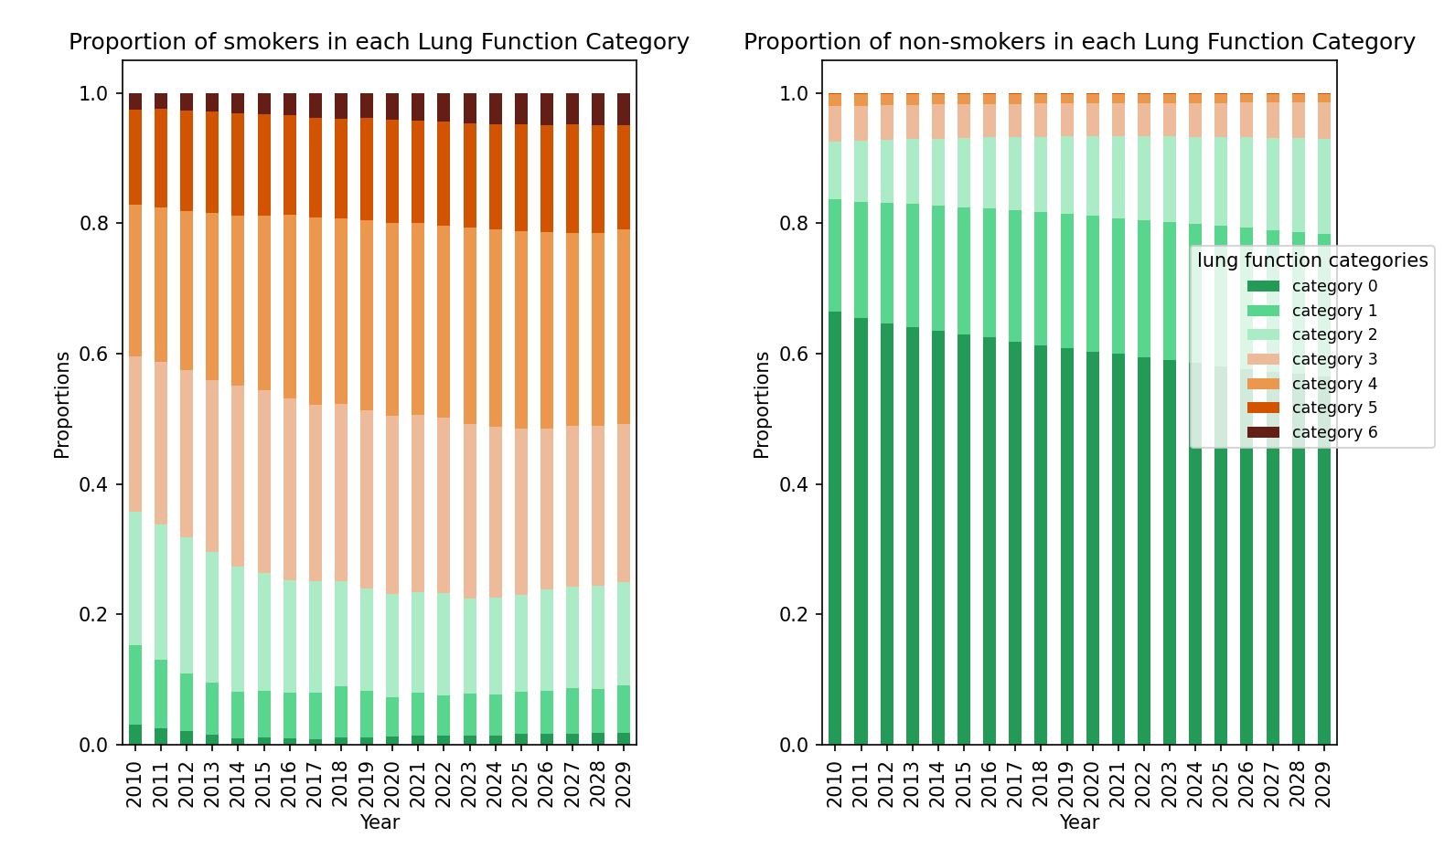
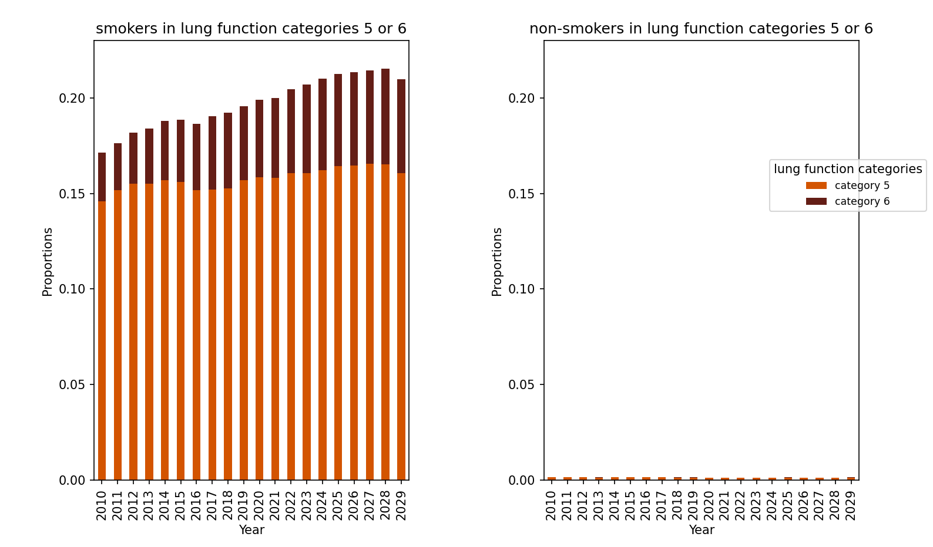
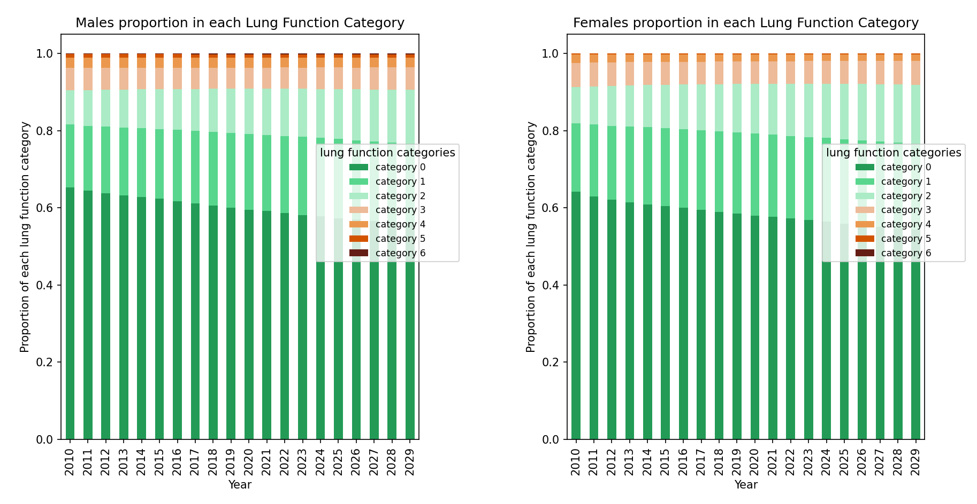
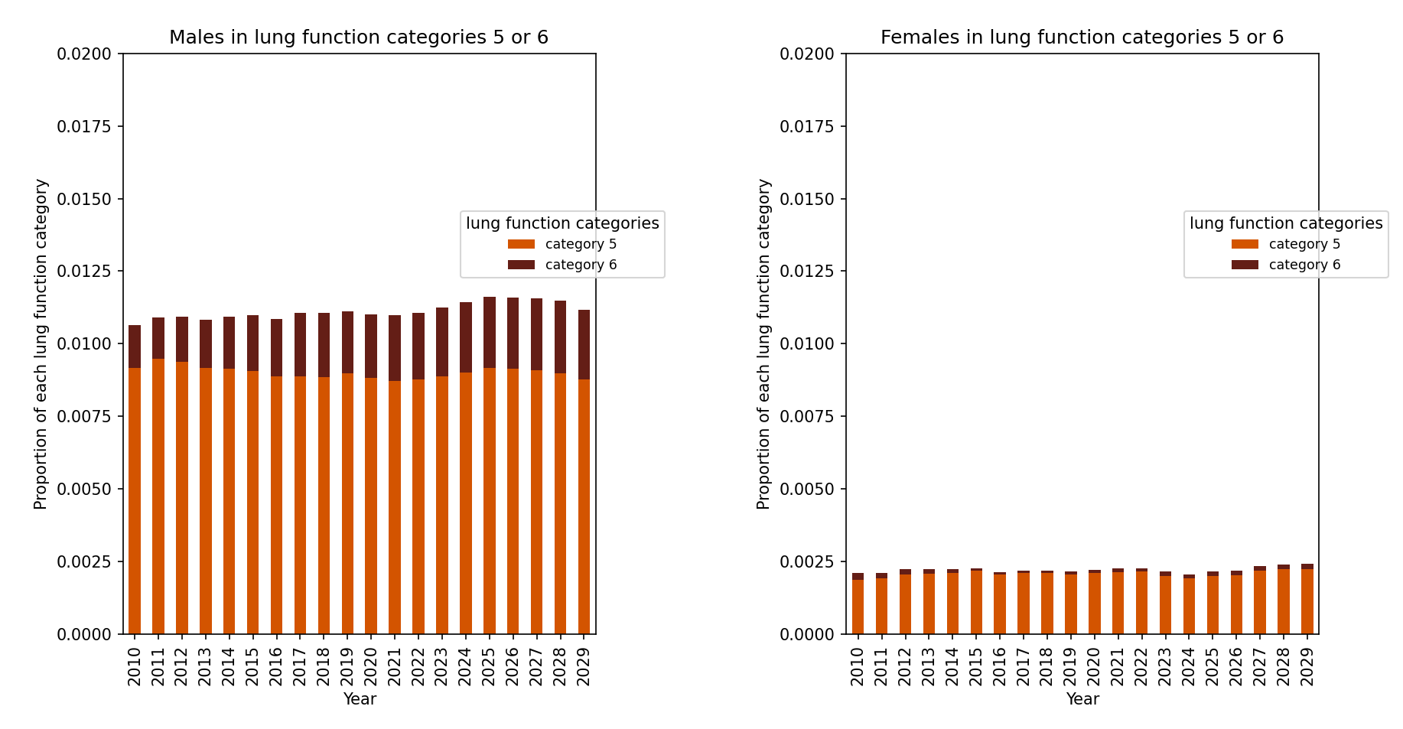
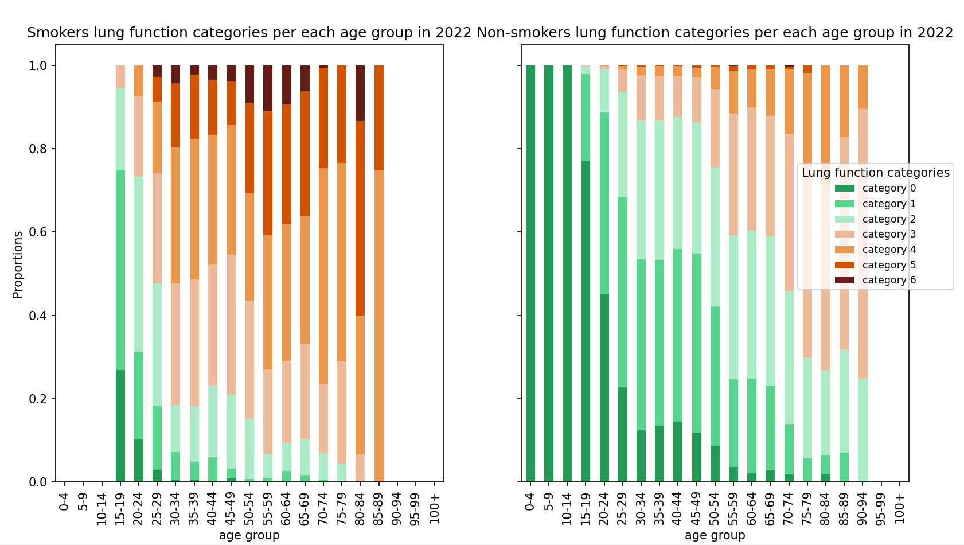
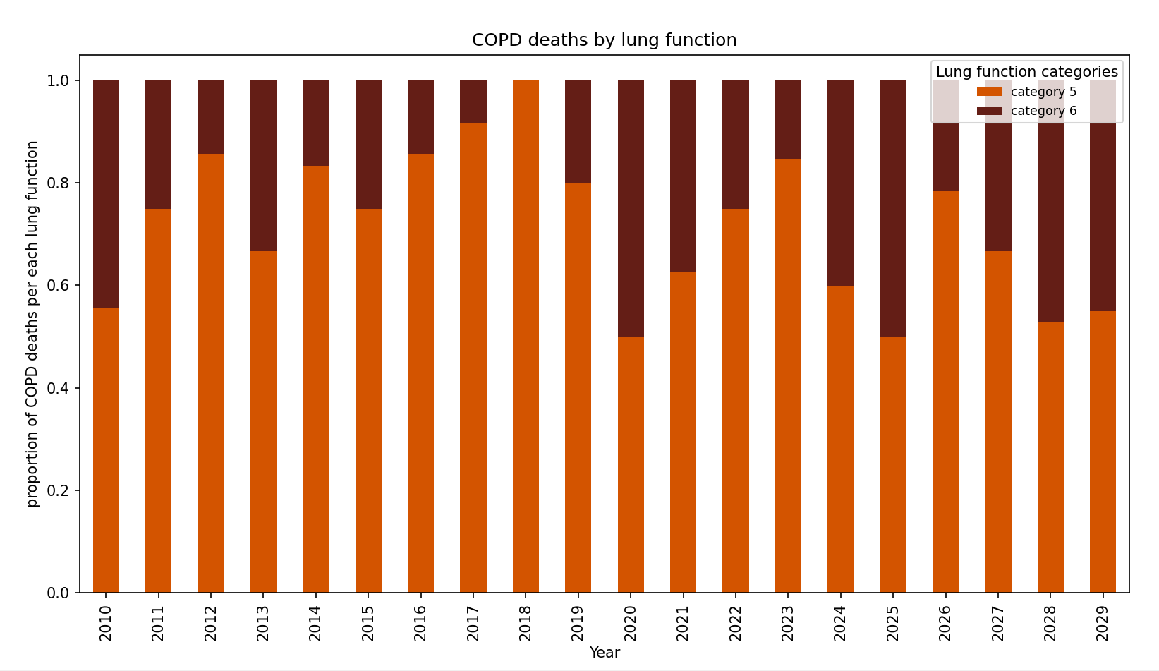
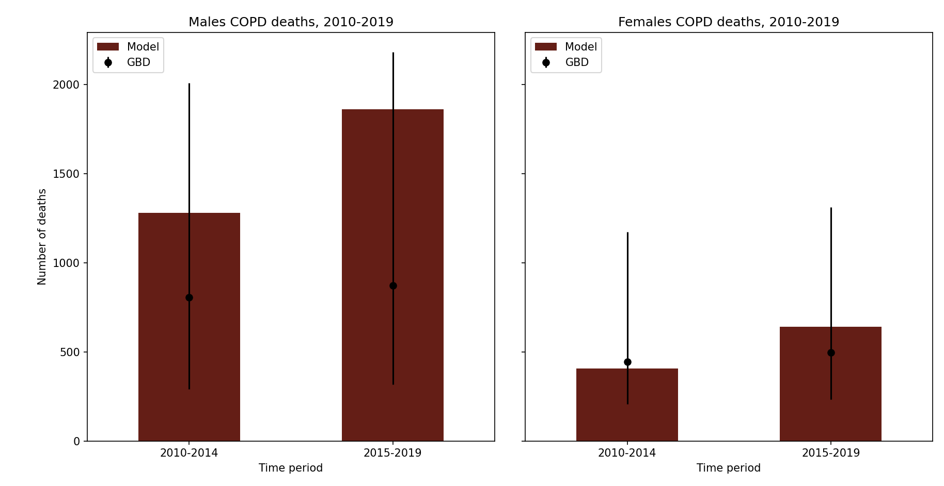
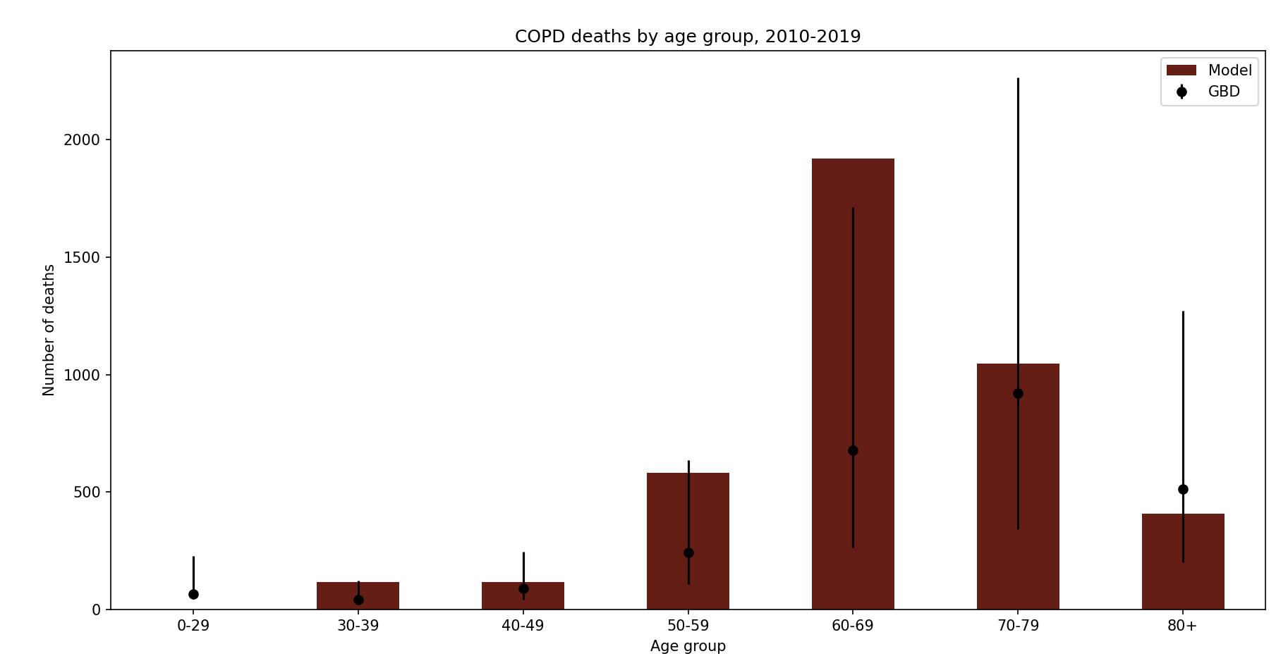

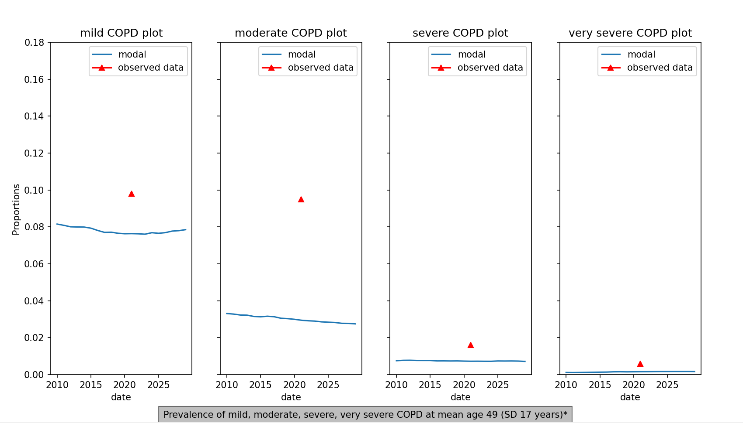

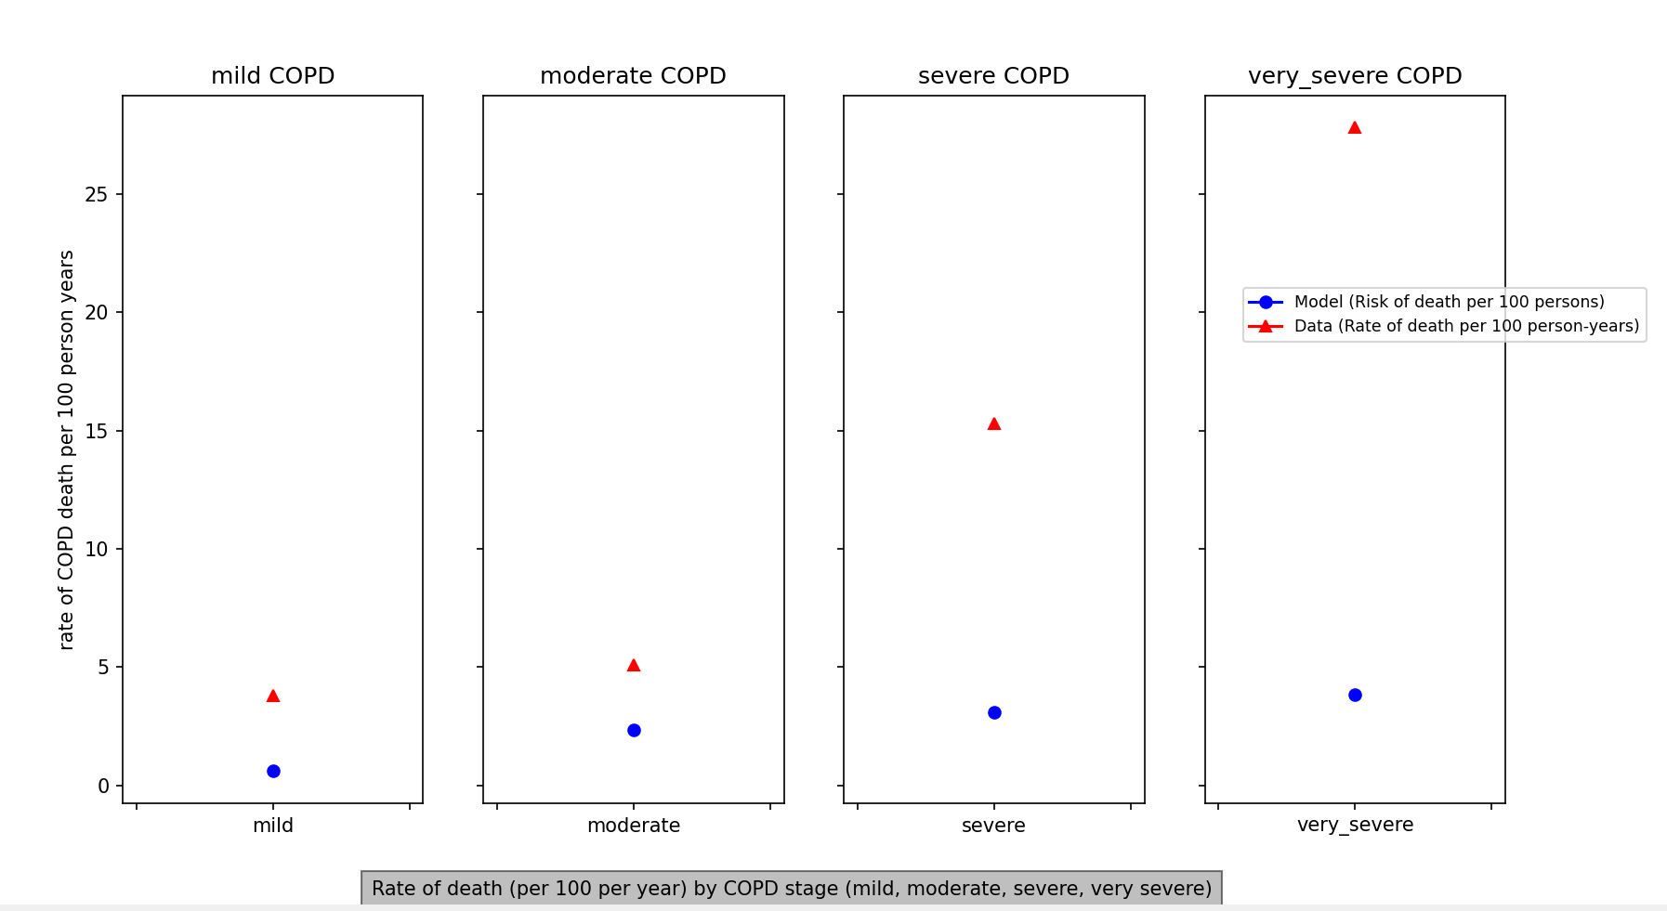

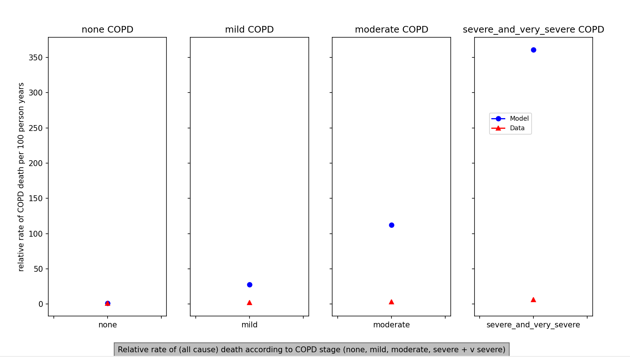

References
DHS. Malawi 2010, 2015/16 https://dhsprogram.com/
Njoroge MW, Mjojo P, Chirwa C, Rylance S, Nightingale R, Gordon SB, Mortimer K, Burney P, Balmes J, Rylance J, Obasi A, Niessen LW, Devereux G; IMPALA consortium. Changing lung function and associated health-related quality-of-life: A five-year cohort study of Malawian adults. EClinicalMedicine. 2021 Oct 18;41:101166. doi: 10.1016/j.eclinm.2021.101166. PMID: 34712931; PMCID: PMC8529201.

Meghji J, Nadeau G, Davis KJ, Wang D, Nyirenda MJ, Gordon SB, Mortimer K. Noncommunicable Lung Disease in Sub-Saharan Africa. A Community-based Cross-Sectional Study of Adults in Urban Malawi. Am J Respir Crit Care Med. 2016 Jul 1;194(1):67-76. doi: 10.1164/rccm.201509-1807OC. PMID: 26788760; PMCID: PMC4960629.
Nightingale R, Jary H, Meghji J, Rylance S, Masiye J, Chiumia H, Rylance J, Mortimer K, Lesosky M. Non-communicable respiratory disease in Malawi: a systematic review and meta-analysis. Malawi Med J. 2020 Jun;32(2):64-73. doi: 10.4314/mmj.v32i2.3. PMID: 35140842; PMCID: PMC8788589.
Mulupi S, Ayakaka I,Tolhurst R, et al. What are the barriers to the diagnosis and management of chronic respiratory disease in sub-Saharan Africa? A qualitative study with healthcare workers, national and regional policy stakeholders in five countries. BMJ Open 2022;12:e052105. doi:10.1136/bmjopen-2021-052105
2022 Global Strategy for Prevention, Diagnosis and Management of COPD. https://goldcopd.org/2022-gold-reports/
Berry C, Wise RA. Mortality in COPD: Causes, Risk Factors, and Prevention. COPD. 2010 October ; 7(5): 375–382. doi:10.3109/15412555.2010.510160
Suissa S, Dell’Aniello S,Ernst P. Long-term natural history of chronic obstructive pulmonary disease: severe exacerbations and mortality. Thorax 2012;67:957–963. doi:10.1136/thoraxjnl-2011-201518
Alupo P, Wosu AC, Mahofa A, Mugenyi L, Semakula D, Katagira W, et al. (2021) Incidence and predictors of COPD mortality in Uganda: A 2-year prospective cohort study. PLoS ONE 16(2): e0246850. https://doi.org/10.1371/journal. pone.0246850
Austin MA, Wills KE, Blizzard L, Walters EH, Wood-Baker R. Effect of high flow oxygen on mortality in chronic obstructive pulmonary disease patients in prehospital setting: randomised controlled trial. BMJ 2010;341:c5462 doi:10.1136/bmj.c5462
Tashkin DP, Celli B, Senn S, et al. A 4-year trial of tiotropium in chronic obstructive pulmonary disease. N Engl J Med. 2008;359:1543–54
Mannino et al; Lung function and mortality in the United States: data from the First National Health and Nutrition Examination Survey follow up study Thorax 2003;58:388–393
Mebrahtom et al. Chronic obstructive pulmonary disease in East Africa: a systematic review and meta-analysis. International Health 2024.

