The TLO Model Framework

The modelling framework is of a modularised design implemented in Python and numerical libraries (See Figure 1). An efficient individual-based simulation engine is used to track a population and the action of ‘events’ that are generated ‘modules’. There are three main types of module:

- Core modules: these represent basic processes, such as, the ‘Demography’ module determines the district of residence of each person, the ‘Lifestyle’ module which determines patterns of risk factors in the population, the ‘Contraception’ module, which represents the contraceptive use of each women, and the ‘HealthSeekingBehaviour’ module which determines if and how persons seek healthcare following onset of an illness.
- The ‘HealthSystem’ module: this represents all functions of the healthcare system – its resources and how these are used to generate effective capabilities, and how these capabilities are distributed among the healthcare needs in the population (generated by the disease modules).
- Disease modules: these represents a specific disease, or set of diseases, including the onset, progression, health outcomes and the effect of any treatment received. If the disease is communicable, transmission is represented within the population. The framework comprises a full grammar of disease module construction and interaction designed such that the access to and effects of treatments are subject to gating/modifying according to resource availability and management decisions in the HealthSystem.

The framework also comprises a suite of utilities that simplify programming and running of these modules; including, the ‘SymptomManager’, which tracks patterns of symptoms in each person, the ‘DxManager’, which represents the usage of diagnostics (and their imperfect performance) and the ‘HealthBurden’ module which tracks the life-years and disability-adjusted life-years in the population.

The model is developed using a system of continuous integration, review, testing and profiling of code. The model runs on cloud computing platforms using a bespoke system of batch-run management.

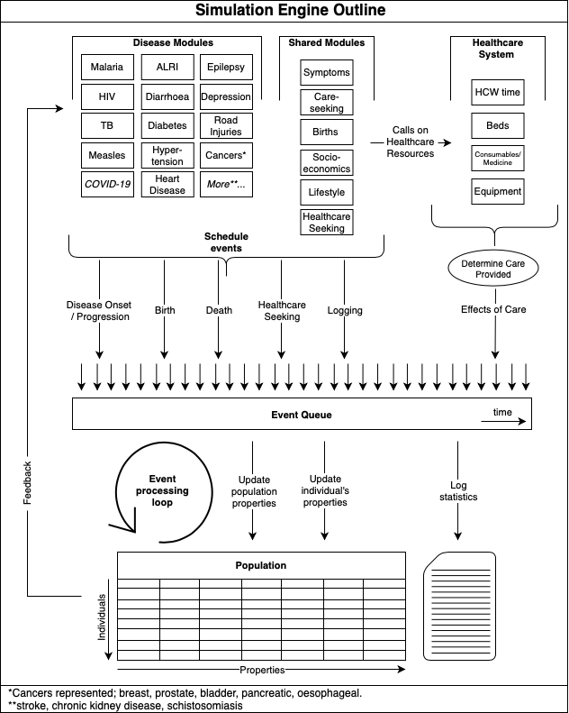

Figure 1: Schematic of model structure.

