Childhood Diarrhoea Module
Background 2
The Thanzi La Onse (TLO) Model 2
General approach to decisions on modelling causal influences and effects of interventions 2
Demographic and social characteristics modelled 2
Placing diarrhoea within TLO model 2
Approach to modelling diarrhoea: rationale for model structure and choice of parameter values 4
Disease definition and clinical classifications 4
Conceptualisation of diarrhoea model structure 4
Limitations in the design of diarrhoea model concept 9
Properties and parameters of diarrhoea model 10
Disability Adjusted Life Year 14
Integrating Diarrhoea with the Health System 15
Health care seeking 15
Delivery of interventions at the health system 15
Notes 19
Next steps 20
Literature review 20
Code in Python program 21
Things to consider adding to the model: 21
Model outputs 22
Preliminary model outputs – without health systems input 22
References 24

Background

The Thanzi La Onse (TLO) Model
The Thanzi La Onse program is a multi-disciplinary research with the core objective to improve population health and reduce health inequities through data-informed prioritization of resource allocation in Malawi, Uganda, Southern and East Africa. As the basis of the analysis of the TLO program, the Epidemiology and Modelling stream is developing a model that aims to capture the health experiences of the population of Malawi and the consequent interactions with the health care system. The model will be used to inform prioritisation of health resources for Malawi’s next Health Sector Strategic Plan III (2022-2027). The model is an individual based model – which means we explicitly simulate the individual life and health experiences of a representative proportion of population of Malawi. The simulation initiates on 1 Jan 2010 and we attempt to simulate the attributes of the population at that point. We can run the model forward to any specified future time point. Each potential intervention and its associated diseases are being modelled. This is being divided into separate disease/intervention modules. This document describes the childhood diarrhoea module.

General approach to decisions on modelling causal influences and effects of interventions
This module was designed in the context of an overall approach to modelling causal effects in general and causal effects of interventions in particular. The overall intent is to adopt as simple a structure as can be conceived, whilst still capturing the essential elements of a disease and the interventions used to prevent or treatment. We include a causal link between a “variable” (by which we mean a characteristic or property of an individual, whether that be demographic, social or biologic), and risk of disease or another variable if there is strong evidence from an overall body of studies that such a causal link exists and is at least moderately strong. In informing such decisions, we place particular value on RCTs or studies with a quasi-experimental design such as analyses based on an instrumental variable. There is no expectation that such studies will be from Malawi or even from Africa. If there are such local studies and in the unlikely event that they provide strong evidence to suggest that the causal link is substantively different in Malawi then the intent is that this is taken into account and the Malawi-specific link included.
In the special case of a potential causal variable which relates to whether an individual has experienced or is experiencing an intervention the intent is to only include interventions if there is substantial RCT evidence of their beneficial effect, based on trials with objectively ascertained clinical endpoints with low risk of serious bias. Whilst DCP-3 (and to some extent the Malawi EHP) provides an initial list of such interventions and the evidence to support them, where possible our intent has been to form our own opinion on intervention efficacy based on the source trials.
Unless there is evidence to the contrary, the intent is to summarize and incorporate intervention effects into the model as relative risks or rates rather than absolute differences due to the fact that such measures are less likely to differ substantively by context. Interactions between characteristics (on the multiplicative scale) are only to be incorporated if there is strong evidence. Again, we have not intended to rely on data from Malawi or Africa for such evidence but if local evidence exists which strongly suggests a different effect than elsewhere then the intent is that this modified effect is incorporated in the model.

Demographic and social characteristics modelled
Based on data on the distribution of the population in Malawi according to geographic location we assign individuals a geographic location, which maps onto whether they are classified as living in a rural or urban area. Informed largely by data from the Malawi DHS, variables are also created indicating the person’s wealth level (based on 5 quintiles), whether the person has access to improved sanitation, clean drinking water, hand washing facilities, and whether they experience indoor air pollution (wood burning stove). We assign individuals a current education status (none, primary, secondary) which is updated 3 monthly from age 5 to 20. From age 15 BMI (in 5 groups) is assigned, as well as using tobacco, drinking excess alcohol, having low exercise, high salt intake, high sugar intake. The status with regard to such variables for individuals can change over time. The influences between these variables are described in detail in a separate document.

Placing diarrhoea within TLO model
This simulation model is coded in Python, an object-oriented programming language, and it takes a modular approach, in which the functionality of the program is separated into independent, interconnected modules that can be executed on their own. Diarrhoea model resides in the epidemiological engine domain, responsible for assigning disease incidence, progression and the effects of health care activities.
Figure 1 - Schematic diagram of the interaction between diarrhoea and the health system
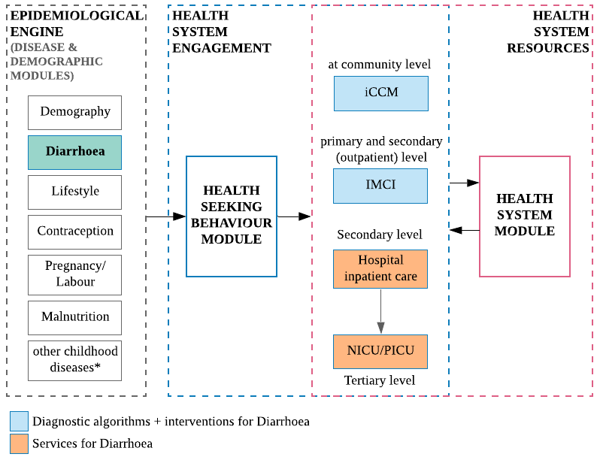
*other childhood diseases include: Acute Lower Respiratory Infection, HIV, TB, and Malaria – might not interact with the latter two.

Interactions with the health system require careful conceptualisation to not only accurately reflect current burden of disease during the neonatal and childhood periods, but also to fit within the larger TLO model of all health and health care provision in Malawi, and to allow tailoring of the interventions to improve health outcomes given available and projected resources. The diarrhoea module will be based on parts of the epidemiological and health systems aspects of the TLO model, developed by members of the Epidemiology and Modelling team – this includes, demographic and social characteristics (Demography module), lifestyle-related risk factors (Lifestyle module), fertility rate deriving the under-5 population number (Contraception Module), characteristics of the newborn at birth (Pregnancy and Labour modules), interactions with other childhood-related disease modules, health care seeking (Health Seeking Behaviour module) and the interactions with the Health Systems module which will provide the availability of resources (health facility type, staff availability, drug stock, diagnostic tests) for the interventions to take place.

Approach to modelling diarrhoea: rationale for model structure and choice of parameter values

Disease definition and clinical classifications
Diarrhoea continues to be the second leading cause of death in children under 5 years of age, and the leading cause of malnutrition (WHO, diarrhoea fact sheet). Children are particularly at greater risk of life-threatening dehydration since water constitutes a great proportion of a child’s bodyweight.
It is usually a symptom of an infection in the intestinal tract, but is not a single disease entity and has many different aetiologies. Thus, there has been considerable variability in the definition of diarrhoeal episodes¹. According to WHO, diarrhoea is defined as the passage of loose or watery stools at least three times per day (or more frequent passage than is normal for the individual) (WHO, diarrhoea fact sheet). Because WHO-definition of diarrhoea is the most widely used in field studies in low- and middle income countries and therefore, in the estimation of global burden of diarrhoea, it will be the definition used in the design of model structure.

Based on the WHO classification of diarrhoeal diseases, there are three clinical types:
Acute watery diarrhoea – the most common type of acute diarrhoea, usually lasting for several hours or days. It is classified according to stool volume: it is a mild episode if less than 5% of body weight, moderate if between 5 to 10% of body weight, and severe if over 10%². Most episodes are mild and self-limited, lasting an average of 4.3 days³, but severe cases can be potentially life-threatening due to the significant fluid loss and rapid dehydration in an infected individual. This clinical type does not require antibiotics to treat the gastrointestinal infection, only suspected cholera cases need antibiotic treatment.
Acute bloody diarrhoea or dysentery – this clinical type includes any diarrhoeal episode in which loose or watery stools contain visible blood, with or without mucus. The most common bacterial pathogen is Shigella dysenteriae, it causes inflammation and damage of the intestinal mucosa, with direct nutrient losses. It generally requires antibiotics to treat the infection, to limit the acute complications and long-term health impacts.
Persistent diarrhoea – a diarrhoeal episode that begins acutely and persists for more than 14 days. The progression to persistent diarrhoea, with or without blood, is more common in children with poor immunity: protein-energy malnutrition, micronutrient deficiencies in vitamin A and zinc, and AIDS can result in poor mucosal healing and persistent diarrhoea. Diarrhoea, in turn, tends to worsen their condition, in a vicious cycle of infection and malnutrition, leading to stunted growth and cognitive impairment in some children².
By categorising into these three main types, it enables health workers following WHO recommendations to recognise the problem and to provide rapid and effective treatment through standard case management. The correct strategy for the treatment of diarrhoea can prevent up to 90% of deaths due to diarrhoea.
Table 1 - The three types of diarrhoea and respective percentage of death preventable by standard case management ⁴
Type of diarrhoea | % of all cases of childhood diarrhoea | % of all childhood deaths due to diarrhoea | % of death preventable by standard case management
Acute watery | 80 | 50 | 100
Dysentery | 10 | 15 | 80
Persistent | 10 | 35 | 80
Total | 100 | 100 | 90

Conceptualisation of diarrhoea model structure
The natural history of diarrhoea depends on several factors including, the biology of the pathogens, its virulence and inoculum size; the susceptibility of the host, previous exposure and pre-existing immunity or passively acquired immunity from breast milk; and the health and nutritional status of the individual at the time of exposure². Exposure to gastro-enteric pathogens does not necessarily lead to infections, and infection does not necessarily lead to clinical illness. It can manifest from no symptoms, to self-limiting mild or moderate diarrhoea, to severe and life-threatening condition. The susceptible individual can develop one of the three clinical types of diarrhoea described above, which will be the focus in the modelling of the natural history of diarrhoea for TLO.
Figure 2 - Proposed structure of diarrhoea natural history model
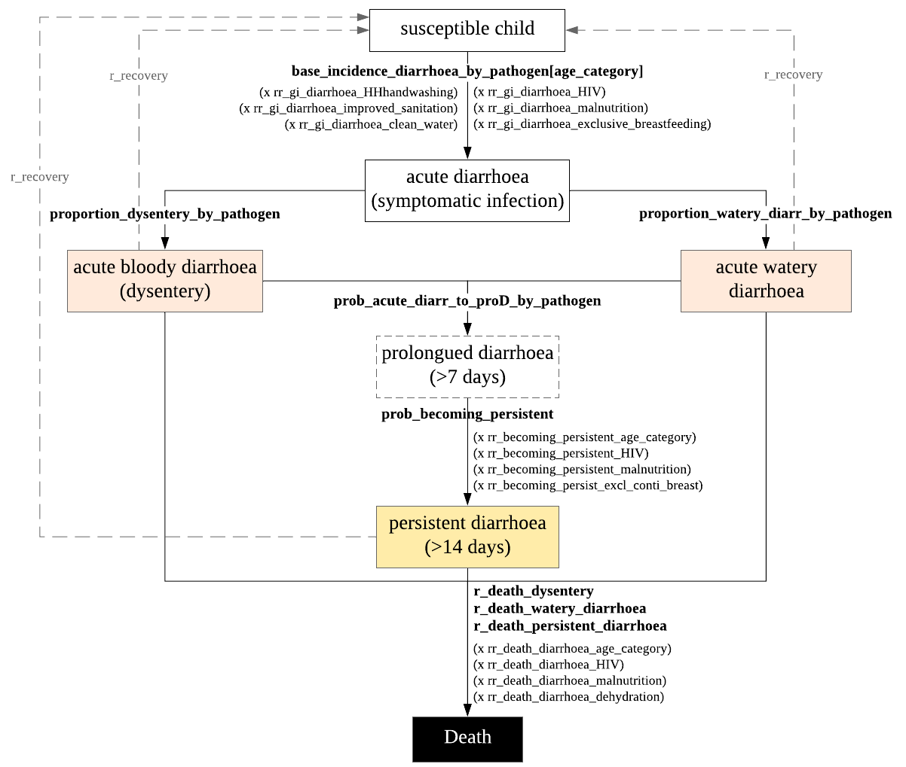
*This current structure does not include associated complications arising from diarrhoea. The main acute complications from diarrhoea is dehydration, from which life-threatening complications arise: shock (circulatory failure, multi-organ dysfunction) to death. Dehydration is not included in the natural history structure, though it will be a key condition in the causal pathway to death, among other important conditions associated with diarrhoea mortality, such as, malnutrition, and HIV.
The WHO pocketbook pointed out complications associated with dysentery: dehydration, potassium depletion, high fever, rectal prolapse, convulsions (hypoglycaemia), haemolytic uraemic syndrome, toxic megacolon, intestinal perforation.

The proposed structure is based on the WHO’s definition and classification of clinical diarrhoea. The parameterization of diarrhoea model is be based on the results of two important studies on the burden of diarrhoeal disease among children in developing countries. These are the Global Enteric Multicentre Study (GEMS), a case-control at seven sites⁵ and the Aetiology, Risk Factors, and Interactions of Enteric Infections and Malnutrition and the Consequences for Child Health and Development (MAL-ED) multisite birth cohort study⁶.
The GEMS study was a 3-year, population-based, case-control of acute moderate-to-severe diarrhoea (MSD) among children under-5 seeking care at a health centre, in Kenya, Mali, Mozambique, The Gambia, Bangladesh, India and Pakistan. This study captured cases that were more severe: bloody stools, evidence of dehydration, hospitalization, or administration of intravenous fluids⁵. Whereas, the MAL-ED study was a longitudinal community-based study following a newborn cohort until their second birthday in Bangladesh, Brazil, India, Nepal, Peru, Pakistan, South Africa, Tanzania. The latter study was able to capture milder forms of diarrhoea disease and provides a more accurate measure of incidence. For the model, the study results used to inform the parameters are the most recent reanalysis studies of the data using quantitative PCR, as this method has higher sensitivity than the original methodology with microbiology⁷ ⁸.
Due to the magnitude of biological diversity⁹, the childhood diarrhoea module models the top 10 pathogens responsible for pathogen-attributable diarrhoea, results from the reanalysis study of MAL-ED data⁷ and the reanalysis study of GEMS data⁸.
The model of childhood diarrhoeal disease begins with the susceptible population of children under 5 years of age. The incidence of diarrhoea caused by individual pathogens per age group [0-11, 12-23, 24-59 months] will directly assign diarrhoea status (symptomatic infection). Currently the model uses the incidence estimates from the MAL-ED reanalysis study in Tanzania for ages 0-11 and 12-24 months. For the 24-59 months old, the pathogen-attributable incidence is based on the GEMS total-countries estimate of less severe diarrhoea (LSD) + MSD in the 24-59 months category, adding to a total LSD+MSD incidence of 22.2 episodes per 100 child-years¹⁰ – which is then fractioned into pathogen-specific rate of diarrhoea based on the attributable fractions (AFs) for MSD in Mozambique (no reanalysis data on the LSD pathogen AFs). In terms of WHO’s classification of diarrhoea types, LSD are acute watery diarrhoea with no dehydration, whereas MSD include dysentery (with or without dehydration present) and acute watery diarrhoea with some or severe dehydration. The calculated estimates are shown in last column of Table 2. It assumes that AFs for the 10 pathogens causing MSD applies to the less severe diarrhoea cases.

Table 2 - Incidence of attributable diarrhoea episodes per 100 child-years using MAL-ED estimates from Tanzania for children aged 0-24 months and GEMS estimates for ages 24-59 months
Pathogen | incidence among 0-11 months old | incidence among 12-23 months old | incidence among 24-59 months old*
rotavirus | 17.5245863 | 9.7007598 | 0.9324
shigella | 11.7936462 | 7.8794104 | 9.3018
adenovirus 40/41 | 5.8661803 | 8.7727311 | 0.6438
cryptosporidium | 3.0886699 | 1.1792363 | 0.4662
campylobacter | 9.8663257 | 2.7915478 | 0.4884
ETEC | 27.9251462 | 17.0477152 | 1.9758
sapovirus | 10.0972179 | 13.2603114 | 0.555
norovirus | 20.4864004 | 6.6146727 | 0.0888
astrovirus | 5.4208352 | 3.5974076 | 0.1332
tEPEC | 6.0822457 | 2.2716889 | 0.1998
Top 10 total | 118.1512538 | 73.1154812 | 14.7852
other causes | 33 |  | 7.4148
Total | 128.5 |  | 22.2
*incidence of diarrhoea by attributable pathogen in this age group was derived using the results from two GEMS studies.

The total incidence of diarrhoea among children aged 0-24 months in the Tanzanian study site was estimated to be 128.5 episodes per 100 child-years. These 10 pathogens make up 95.5 ep/100cy, or 74.32% of all-cause diarrhoea episodes.
Depending on the attributable pathogen, it can cause an episode of acute watery diarrhoea or bloody diarrhoea. The proportions for each clinical type are also based on the MAL-ED results.
Immunity overtime with recurrent infections is hindered in the incidence of diarrhoea by age category, as it decreases with age. And therefore, it is not included in the model.

Risk factors for acquiring diarrhoea
After the assignment of base incidence of diarrhoea by pathogen for each age group, the effects of risks factors are added to the incidence rate. These are WASH components: clean drinking water, improved sanitation and handwashing with soap¹¹ (values from lifestyle module), host factors such as, passive immunity through breastfeeding, impaired immunity (HIV/AIDS), nutrition status and rotavirus vaccination (for the incidence of diarrhoea by rotavirus only). The relative rate of diarrhoea for these risk factors are assumed to be the same across all pathogens.

Table 3 - Risk factors to consider for incidence of diarrhoea
Risk factor | Description |  | Value | Ref | Notes
improved sanitation |  |  | RR = 0.75 (0.63-0.88) | ¹² | meta-analysis and meta-regression
improved source of drinking water |  |  | RR = 0.67 (0.62-0.73)
handwashing with soap | *interventions promoting handwashing with soap |  | RR = 0.70 (0.64-0.77)
Exclusive breastfeeding | Exclusive vs partial breastfeeding 0-5 months |  | RR=1.68 (1.03-2.76) | ¹³ | Meta-analysis
 | Exclusive vs no breastfeeding 0-5 months |  | RR=2.65 (1.72-4.07) |  | Risk ratio on Diarrhoea incidence
 | Any breastfeeding vs no breastfeeding 6-11 months |  | RR=1.32 (1.06-1.63)
Underweight | -3 to <-2 WAZ vs reference group less than 1 WAZ |  | RR=1.2 (1.1-1.4) | ¹⁴ | RR- relative risk
HIV status | HIV-infected children were more likely to have MSD |  | OR=5.6 | ¹⁵ | HIV+ MSD vs LSD GEMS Mozambique
Rotavirus vaccination | < 1 year old | RV1 prevents 63% of severe rotavirus cases | RR=0.37, (0.23-0.60) | ¹⁶ | Cochrane review, RR – risk ratio  High-certainty evidence
 |  | RV1 prevents 27% of severe all cause diarrhoea | RR=0.73, (0.56-0.95) |  | High-certainty evidence
 |  | RV5 prevents 57% of severe rotavirus | RR=0.43, (0.29-0.62) |  | High-certainty evidence
 |  | RV5 prevents 15% of severe all cause diarrhoea | - |  | Moderate-certainty evidence
 | 1-2 years old | RV1 prevents 35% of severe rotavirus | RR=0.65, (0.51-0.83) |  | High-certainty evidence
 |  | RV1 prevents 17% of severe all cause diarrhoea | RR=0.83, (0.72-0.96) |  | Moderate-certainty evidence
 |  | RV5 prevents 41% of severe rotavirus diarrhoea | RR=0.59, (0.43 to 0.82) |  | High-certainty evidence
 |  | RV5 prevents 15% of severe all cause diarrhoea | RR=0.85, (0.75 to 0.98) |  | High-certainty evidence

Risk factors for becoming persistent diarrhoea
An extra step in the acute phase of a diarrhoeal episode (< 14 days) was included in the model: the prolonged diarrhoea phase. Most episodes are mild and self-limited, lasting an average of 4.3 days³, but when an acute diarrhoea is not resolved in less than 7 days, it is considered to be prolonged (7- 13 days), before it is classified as persistent diarrhoea if the episode has been occurring for 14 days or longer.
Up to 20% of diarrhoea episodes can become persistent¹⁷, with higher risk of death. If dehydration is present, then in the health system it is considered to be severe persistent diarrhoea and managed differently from non-dehydration persistent diarrhoea. In the model, a proportion of those acute episodes will be prolonged, based on the MAL-ED reanalysis data, for which a probability of becoming a persistent episode is applied with added effects of risk factors on this progression: malnutrition, age, and HIV status.
Currently in the model risk factors for persistent diarrhoea are dummy values for temporary properties of HIV status, malnutrition and breastfeeding. Which will interact with the responsible modules when merged in the Master code.

Risk factors for death from diarrhoea
The biggest threat posed by a diarrhoeal illness is the associated dehydration. Severe dehydration causes up to 80% of diarrhoea fatalities¹⁸. During a diarrhoeal episode, the loss of water and salts causes a disturbance of electrolytes. Without replacement of fluid (rehydration), it can progress to circulatory failure, dysfunction of critical organs and death. The WHO’s definition of dehydration level are stratified into: no dehydration (loss of less than 5% of body weight), some dehydration (loss of 5-10% of body weight) and severe dehydration (loss of over 10% of body weight).
If the pathogen is causing ‘any dehydration’ in that diarrhoeal episode, dehydration level is then categorised into ‘some’ or severe dehydration’. Levels of dehydration are classified from no dehydration, some dehydration to severe dehydration. Different levels require appropriate treatment plan.
Death rate from each diarrhoea type differ (watery vs. bloody), also depending on dehydration status and other important co-morbidities, such as malnutrition. Children with acute and chronic malnutrition are at increased risk of morbidity and mortality following a diarrhoeal episode. Malnutrition can make a diarrhoeal episode more severe, prolonged and more frequent than well-nourished children. With diarrhoea causing decreased nutrient absorption, aggravates malnutrition by causing weight loss and growth impairment. Treatment regimen for children with malnutrition is different¹⁷.
Table 5 - Risk factors to consider for death from diarrhoea
Risk factor | Description | Value | Ref | Notes
Dehydration | Diarrhoea without dehydration vs with dehydration | HR=0.29 (0.14-0.59) | ¹⁹ | LSD vs non-dysenteric MSD - risk of death in hazard ratio
Shigella | Presence of Shigella in non-dysenteric MSD | HR=2.2 (1.2-3.9) |  | Shigella was strongly associated with increased risk of death
 | Shigella associated with mortality while dysentery was not | OR=2.8, (1.6-4.8) | ²⁰ | Meta-analysis pooled OR
Severe acute malnutrition | Just ‘malnutrition’ in the study | HR=4.13 (2.428- 6.877) | ²¹ | GEMS Mozambique MSD, Multivariate analysis
ALRI |  | HR=3.51 (2.158-5.682) |  | Hazard Ratio is the relative change in Hazard per one month increase in age
Cryptosporidium infection |  | HR=2.14 (1.289-3.487)
Invasive bacterial disease |  | HR=6.8 (2.435, 15.516)
HIV | Univariate analysis for HIV | HR=5.05
Underweight | -2 to <-1 WAZ | OR=2.1 (1.6-2.7) | ²² | Reference group - more than -1 WAZ/HAZ/WHZ,  adjusted for socio-economic factors
 | -3 to <-2 WAZ | OR=3·4 (2.7–4.4)
 | <-3 WAZ | OR=9.5 (5.5-16.5)
Stunting | -2 to <-1 HAZ | OR = 1.2 (0.9 – 1.7)
 | -3 to <-2 HAZ | OR= 1.6 (1.1-2.5)
 | <-3 HAZ | OR = 4.6 (2.7-8.1)
Wasting | -2 to <-1 WHZ | OR = 1.2 (0.7 – 1.9)
 | -3 to <-2 WHZ | OR= 2.9 (1.8-4.5)
 | <-3 WHZ | OR = 6.3 (2.7-14.7)

All these risk factors (disease acquisition, persistent diarrhoea and death) are not final, just place holder for the parameters’ values. It will require a more thorough review of the literature.

Limitations in the design of diarrhoea model concept
The community-based attributable incidence of diarrhoea from MAL-ED study used to parameterise the model is based on the Tanzanian study site estimates. These were of a small sample size, n=145 analysed diarrhoeal stools in the 0-11 months old and n=26 in the 12-24 months old. However, using the overall countries incidence estimate may overestimate the population-incidence of diarrhoea in Malawi, due to the high burden of diarrhoea in some sites (Dhaka, Bangladesh; Vellore, India; and Bhaktapur, Pakistan).
Additionally, for the calculation of the attributable-incidence among the 24-59 months old, the GEMS data was used. The results from the GEMS study are based on active care-seeking population and therefore, may not reflect the overall and pathogen-specific population-based incidence values. Also, the attributable fractions of each pathogens used in this calculation, were based on the Mozambique estimates, with a sample size of MSD n=86 case-control pairs.
The model does not incorporate mixed infections, which may increase in diarrhoea severity. The case-control methodology of both studies can only inform an association between pathogens and diarrhoea, whereas we assume causal pathway in a mathematical model.
No seasonality of diarrhoeal infections is included in the model; it would need published data to inform these for each pathogen modelled, and to be specific to Malawi.
Modelling dehydration as the underlying complication in children with diarrhoea will not be accurate, as there is no gold standard in detecting dehydration in real-life settings, but only proxy measure through signs and symptoms severity.

Properties and parameters of diarrhoea model
The Diarrhoea module updates information on each individual (under 5 years of age) with regards to their diarrhoea status every 3 months. The variables describing the state of the disease include diarrhoea status (yes/no), the attributable pathogen, the clinical type of the current/last episode (acute watery diarrhoea or dysentery), the duration of the episode (if >14 days it is considered to be persistent diarrhoea and treated accordingly) the level of dehydration (no dehydration, some dehydration, severe dehydration), and date of onset of diarrhoea, recovery and death, as described in Table 6.
Table 6 - Properties owned by the childhood diarrhoea module
Variable name (Properties) | Type | Description
gi_has_diarrhoea | Boolean | Clinical manifestation of an enteric infection - symptomatic infection
gi_pathogen | Categorical  ‘rotavirus’, ‘adenovirus’, ‘cryptosporidium’, ‘shigella’, ‘campylobacter’,  ‘ST-ETEC’, ‘sapovirus’, ‘norovirus’, ‘astrovirus’, ‘tEPEC’, ‘other’ | Attributable pathogens
gi_type | Categorical  ‘acute watery diarrhoea’, ‘dysentery’ | Type of acute diarrhoea
gi_duration_longer_than_13days | Boolean | Acute or persistent diarrhoeal episode
gi_dehydration | Categorical  ‘none’  ‘some’  ‘severe’ | Dehydration level  These are based on WHO categorization of dehydration
gi_date_of_onset | Date | Date of onset of diarrhoea
gi_scheduled_date_recovery | Date | Date of recovery from diarrhoea
gi_scheduled_date_death | Date | Date of death due to diarrhoea
gi_date_end_of_last_episode | Date | The date on which the last episode of diarrhoea is fully resolved
gi_treatment_date | Date | Date on which treatment is first administered
‘gi_’ stands for gastrointestinal infection – as a prefix representation of properties within the Diarrhoea module.
ST-ETEC – Heat-Stable Enterotoxigenic Escherichia coli; tEPEC – typical Enteropathogenic Escherichia coli
The values of diarrhoea incidences by pathogen by age group are displayed in Table 7 as episodes per child per year, together with all other parameters of the natural history model and suggested values.
Table 7 - Parameters of the natural history of diarrhoea
Parameters | Description | Value | Reference and Notes
base_inc_rate_diarrhoea_by_rotavirus | a list of incidence of diarrhoea caused by rotavirus in each age group [0-11, 12-23, 24-59] | 0.1752, 0.0970, 0.0093 | Platts-Mills et al 2018, Liu et al, 2016, Nasin, et al. 2019. Yearly incidence rate, ideally the base group of no improved sanitation, no clean drinking water, no handwashing with soap, and no exclusive breastfeeding, HIV negative, no SAM, no rotavirus vaccination. For ages 0-11 and 12-23 months, the attributable incidences are given by the MAL-ED study in Tanzania. Values were calculated from the GEMS study results using the total incidence of LSM + MSD for each age category 24-59 months, then multiplied by the attributable fraction of each pathogen in GEMS Mozambique to get the incidence of diarrhoea (non-severe and severe) by pathogen in age category 24-59 months
base_inc_rate_diarrhoea_by_shigella | a list of incidence of diarrhoea caused by shigella in each age group [0-11, 12-23, 24-59] | 0.1179, 0.0788, 0.0930
base_inc_rate_diarrhoea_by_adenovirus | a list of incidence of diarrhoea caused by adenovirus in each age group [0-11, 12-23, 24-59] | 0.0587, 0.0877, 0.0064
base_inc_rate_diarrhoea_by_cryptosporidium | a list of incidence of diarrhoea caused by cryptosporidium in each age group [0-11, 12-23, 24-59] | 0.0309, 0.00118, 0.00466
base_inc_rate_diarrhoea_by_campylobacter | a list of incidence of diarrhoea caused by campylobacter in each age group [0-11, 12-23, 24-59] | 0.0986, 0.00279, 0.00488
base_inc_rate_diarrhoea_by_ETEC | a list of incidence of diarrhoea caused by ST-ETEC in each age group [0-11, 12-23, 24-59] | 0.2792, 0.1705, 0.01976
base_inc_rate_diarrhoea_by_sapovirus | a list of incidence of diarrhoea caused by sapovirus in each age group [0-11, 12-23, 24-59] | 0.10097, 0.1326, 0.00555
base_inc_rate_diarrhoea_by_norovirus | a list of incidence of diarrhoea caused by norovirus in each age group [0-11, 12-23, 24-59] | 0.2049, 0.06614, 0.00088
base_inc_rate_diarrhoea_by_astrovirus | a list of incidence of diarrhoea caused by astrovirus in each age group [0-11, 12-23, 24-59] | 0.0542, 0.03597, 0.00133
base_inc_rate_diarrhoea_by_tEPEC | a list of incidence of diarrhoea caused by tETEC in each age group [0-11, 12-23, 24-59] | 0.0608, 0.02271, 0.002
rr_diarrhoea_HHhandwashing | relative rate of acquiring diarrhoea for children with household handwashing practice | 0.7 | independent risk factors assumed to have the same values for all pathogens for now
rr_diarrhoea_improved_sanitation | relative rate of acquiring diarrhoea for children with improved sanitation | 0.75
rr_diarrhoea_clean_water | relative rate of acquiring diarrhoea for children with access to clean drinking water | 0.67
rr_diarrhoea_exclusive_vs_partial_breastfeeding_<6mo | relative rate of acquiring diarrhoea for children under 6 months that are exclusively breastfeed vs partial breasfeeding | 1.68 | Lamberti et al. 2011
rr_diarrhoea_exclusive_vs_no_breastfeeding_<6mo | relative rate of acquiring diarrhoea for children under 6 months that are exclusively breastfeed vs no breasfeeding | 2.65 | Lamberti et al. 2011
rr_diarrhoea_any_vs_no_breastfeeding_6_11mo | relative rate of acquiring diarrhoea for children aged 6-11 months with any breastfeeding vs no breasfeeding | 1.32 | Lamberti et al. 2012
rr_diarrhoea_untreated_HIV | relative rate of diarrhoea for untreated HIV+ status | 5.4 | Groome and Madhi 2011
rr_diarrhoea_SAM | relative rate of diarrhoea for severe acute malnutrition | 1.2 | Black et al. 2013, RR for underweight not wasting or SAM
proportion_AWD_in_rotavirus | proportion of acute watery diarrhoea caused by rotavirus | 0.977 | Platts-Mills et al 2018, pathogen causing AWD or dysentery, assumed to be constant throughout the age groups, estimates from MAL-ED study
proportion_AWD_in_shigella | proportion of acute watery diarrhoea caused by shigella | 0.862
proportion_AWD_in_adenovirus | proportion of acute watery diarrhoea caused by adenovirus | 0.95
proportion_AWD_in_cryptosporidium | proportion of acute watery diarrhoea caused by cryptosporidium | 0.971
proportion_AWD_in_campylobacter | proportion of acute watery diarrhoea caused by campylobacter | 0.897
proportion_AWD_in_ETEC | proportion of acute watery diarrhoea caused by ETEC | 0.95
proportion_AWD_in_sapovirus | proportion of acute watery diarrhoea caused by sapovirus | 0.966
proportion_AWD_in_norovirus | proportion of acute watery diarrhoea caused by norovirus | 0.962
proportion_AWD_in_astrovirus | proportion of acute watery diarrhoea caused by astrovirus | 0.974
proportion_AWD_in_tEPEC | proportion of acute watery diarrhoea caused by tEPEC | 0.961
prob_dehydration_by_rotavirus | probability of dehydration for rotavirus-attributed diarrhoea | 0.153 | Platt-Mills et al. 2018, pathogen-specific dehydration probability, assumed to be constant throughout the age groups, estimates from MAL-ED study
prob_dehydration_by_shigella | probability of dehydration for shigella-attributed diarrhoea | 0.103
prob_dehydration_by_adenovirus | probability of dehydration for adenovirus-attributed diarrhoea | 0.079
prob_dehydration_by_cryptosporidium | probability of dehydration for cryptosporidium-attributed diarrhoea | 0.121
prob_dehydration_by_campylobacter | probability of dehydration for campylobacter-attributed diarrhoea | 0.073
prob_dehydration_by_ETEC | probability of dehydration for ST-ETEC-attributed diarrhoea | 0.076
prob_dehydration_by_sapovirus | probability of dehydration for sapovirus-attributed diarrhoea | 0.104
prob_dehydration_by_norovirus | probability of dehydration for norovirus-attributed diarrhoea | 0.091
prob_dehydration_by_astrovirus | probability of dehydration for astrovirus-attributed diarrhoea | 0.123
prob_dehydration_by_tEPEC | probability of dehydration for EPEC-attributed diarrhoea | 0.113
prob_prolonged_diarr_rotavirus | probability of prolonged episode for rotavirus-attributed diarrhoea | 0.117706 | Platt-Mills et al. 2018, pathogen-specific probability of a prolonged episode, assumed to be constant throughout the age groups, estimates from MAL-ED study
prob_prolonged_diarr_shigella | probability of prolonged episode for shigella-attributed diarrhoea | 0.165342
prob_prolonged_diarr_adenovirus | probability of prolonged episode for adenovirus-attributed diarrhoea | 0.116406
prob_prolonged_diarr_cryptosporidium | probability of prolonged episode for cryptosporidium-attributed diarrhoea | 0.169134
prob_prolonged_diarr_campylobacter | probability of prolonged episode for campylobacter-attributed diarrhoea | 0.152206
prob_prolonged_diarr_ETEC | probability of prolonged episode for ST-ETEC-attributed diarrhoea | 0.114177
prob_prolonged_diarr_sapovirus | probability of prolonged episode for sapovirus-attributed diarrhoea | 0.133209
prob_prolonged_diarr_norovirus | probability of prolonged episode for norovirus-attributed diarrhoea | 0.118223
prob_prolonged_diarr_astrovirus | probability of prolonged episode for astrovirus-attributed diarrhoea | 0.13511
prob_prolonged_diarr_tEPEC | probability of prolonged episode for EPEC-attributed diarrhoea | 0.190845
prob_prolonged_to_persistent_diarr | rate of dysentery becoming persistent diarrhoea, baseline group 0-11 months, HIV negative, no SAM, exclusive or continued breastfeeding, with no vitamin A and zinc deficiency | 0.2866 | Moore et al. 2010
rr_bec_persistent_age>6mo | relative rate of diarrhoea to become persistent for >6 months | 0.26 | Ochoa et al. 2009, RR applicable to >6 months old, ref group < 6 months
rr_bec_persistent_HIV | relative rate of diarrhoea to become persistent for HIV+ status | dummy
rr_bec_persistent_SAM | relative rate of diarrhoea to become persistent for severe acute malnutrition | dummy
rr_bec_persistent_stunted | relative rate of becoming persistent for stunted chlildren | 33.3 | Schilling et al 2017
rr_becoming_persistent_zinc | relative rate of diarrhoea to become persistent for zinc supplementation | 0.73 | Lazzerini and Wanzira 2016, zinc reduces the number of children whose diarrhoea persists until day seven
min_dur_acute | minimum duration for acute diarrhoea | 1
min_dur_prolonged | minimum duration for prolonged diarrhoea | 5
min_dur_persistent | minimum duration for persistent diarrhoea | 13
max_dur_persistent | maximum duration for persistent diarrhoea | 30
prob_fever_by_rotavirus | probability of fever for rotavirus-attributed diarrhoea | 0.384925 | Platt-Mills et al. 2018, pathogen-specific probability of fever, assumed to be constant throughout the age groups, estimates from MAL-ED study
prob_fever_by_shigella | probability of fever for shigella-attributed diarrhoea | 0.319876
prob_fever_by_adenovirus | probability of fever for adenovirus-attributed diarrhoea | 0.271513
prob_fever_by_cryptosporidium | probability of fever for cryptosporidium-attributed diarrhoea | 0.322385
prob_fever_by_campylobacter | probability of fever for campylobacter-attributed diarrhoea | 0.312807
prob_fever_by_ETEC | probability of fever for ST-ETEC-attributed diarrhoea | 0.258931
prob_fever_by_sapovirus | probability of fever for sapovirus-attributed diarrhoea | 0.292276
prob_fever_by_norovirus | probability of fever for norovirus-attributed diarrhoea | 0.251071
prob_fever_by_astrovirus | probability of fever for astrovirus-attributed diarrhoea | 0.195905
prob_fever_by_tEPEC | probability of fever for EPEC-attributed diarrhoea | 0.384547
prob_vomiting_by_rotavirus | probability of vomiting for rotavirus-attributed diarrhoea | 0.471793 | Platt-Mills et al. 2018, pathogen-specific probability of vomiting, assumed to be constant throughout the age groups, estimates from MAL-ED study
prob_vomiting_by_shigella | probability of vomiting for shigella-attributed diarrhoea | 0.209852
prob_vomiting_by_adenovirus | probability of vomiting for adenovirus-attributed diarrhoea | 0.308677
prob_vomiting_by_cryptosporidium | probability of vomiting for cryptosporidium-attributed diarrhoea | 0.243581
prob_vomiting_by_campylobacter | probability of vomiting for campylobacter-attributed diarrhoea | 0.218669
prob_vomiting_by_ETEC | probability of vomiting for ST-ETEC-attributed diarrhoea | 0.283139
prob_vomiting_by_sapovirus | probability of vomiting for sapovirus-attributed diarrhoea | 0.303154
prob_vomiting_by_norovirus | probability of vomiting for norovirus-attributed diarrhoea | 0.299343
prob_vomiting_by_astrovirus | probability of vomiting for astrovirus-attributed diarrhoea | 0.276018
prob_vomiting_by_tEPEC | probability of vomiting for tEPEC-attributed diarrhoea | 0.285661
adjustment_factor_on_cfr | adjustment factor for case-fatality rate | 2 | Can be used in fitting.
case_fatality_rate_AWD | case fatality rate of acute watery diarrhoea | 0.0015 | To be calibrated. Guideline values: Bhandari et al 1992 (0.0056); GBD 2016 paper (0.0015)
rr_diarr_death_bloody | relative rate of death for bloody diarrhoea | 7.6 | Relative CFR for bloody versus non-bloody diarrhoea, per Bhandari et al., 1992
rr_diarr_death_age24to59mo | relative rate of death for age 24-59 months | 0.38 | Walker et al. 2013
rr_diarr_death_if_duration_longer_than_13_days | relative rate of death for persistent diarrhoea | 0.0035 | * dummy
rr_diarr_death_severe_dehydration | relative rate of death for severe dehydration | 3.45 | Levine et al. 2020
rr_diarr_death_untreated_HIV | relative rate of death for untreated HIV+ status | 5.05 | Acacio et al. 2016
rr_diarr_death_SAM | relative rate of death for SAM | 4.13 | Acacio et al. 2016
rr_diarr_death_alri | relative rate of death for cocurrent ALRI infection | 3.51 | Acacio et al. 2016
rr_diarr_death_cryptosporidium | relative rate of death for cryptosporidium infection | 2.14 | Acacio et al. 2016
rr_diarr_death_shigella | relative rate of death for shigella infection | 2.8 | Tickell et al. 2017
sensitivity_some_dehydration_visual_inspection | sensitivity of IMCI algorithm for some dehydration | 0.97 | Levine et al. 2016
specificity_some_dehydration_visual_inspection | specificity of IMCI algorithm for some dehydration | 0.26 | Levine et al. 2016
sensitivity_severe_dehydration_visual_inspection | sensitivity of IMCI algorithm for severe dehydration | 0.77 | Levine et al. 2016
specificity_severe_dehydration_visual_inspection | specificity of IMCI algorithm for severe dehydration | 0.67 | Levine et al. 2016
prob_hospitalization_on_danger_signs | probability of hospitalisation / referral for severe dehydration | 0.7 | * dummy
prob_WHOPlanC_cures_dehydration_if_severe_dehydration | probability of cure of severe dehydration by WHO Plan C | 0.9 | * dummy
prob_ORS_cures_dehydration_if_severe_dehydration | probability of cure of severe dehydration by ORS | 0.721 | Pulungsih et al 1992
prob_ORS_cures_dehydration_if_non_severe_dehydration | probability of cure of non-severe dehydration by ORS | 0.93 | Munos et al. 2010
prob_antibiotic_cures_dysentery | probability of cure of dysentery by antibiotic | 0.99 | Traa et al. 2010
number_of_days_reduced_duration_with_zinc | number of days of diarrhoeal episode reduced by zinc supplementation | 1 | Lazzerini and Wanzira et al 2016
days_between_treatment_and_cure | days between treatment and cure | 5

Disability Adjusted Life Year
DALYs for Diarrhoea will be computed by the Health Burden Module. Currently we consider three diarrhoeal states; mild, moderate and severe which relate to the DALY weights presented below.
Table 8 - DALY weights associated with diarrhoea disease
TLO-Code | Sequelae | Health state name | Description | Disability weight | Lower | Upper
32 | Mild diarrhoeal disease | Diarrhoea, mild | has diarrhoea three or more times a day with occasional discomfort in the belly. | 0.074 | 0.049 | 0.104
35 | Moderate diarrhoeal diseases | Diarrhoea, moderate | has diarrhoea three or more times a day, with painful cramps in the belly and feeling thirsty | 0.188 | 0.125 | 0.264
34 | Severe diarrhoeal diseases | Diarrhoea, severe | has diarrhoea three or more times a day with severe belly cramps. The person is very thirsty and feels nauseous and tired. | 0.247 | 0.164 | 0.348

The sequelae ‘mild diarrhoeal disease’ equals to diarrhoea without dehydration, ‘moderate diarrhoeal disease’ equals to diarrhoea with some dehydration, and ‘severe diarrhoeal disease’ equals to diarrhoea with severe dehydration, as per WHO classification of dehydration. (Assumption)

Integrating Diarrhoea with the Health System

Health care seeking
A set of signs and symptoms arising from diarrhoea module are incorporated in the Symptoms Manager. This is a module in the TLO model that manges all symptoms coming from all disease modules and organises them for Health Seeking Behaviour module's use. The latter will then assign a probability of care seeking based on the Ng’ambi et al. 2020 analyses of the 2016 Malawi Integrated Household Survey data²³. Those who sought care will then interact will the health system.
Diarrhoea module generates the following symptoms: diarrhoea, bloody stools, fever, vomiting, and dehydration signs (ideally, each sign on the WHO IMCI algorithm for dehydration – though dependent on data available to inform these). Symptoms of fever, vomiting, and blood in stools are assigned to each individual with diarrhoea according to the attributable pathogen, as well as the prolonged episode and any dehydration. These parameter values are informed by the MAL-ED reanalysis supplementary material.

Delivery of interventions at the health system
Key measures to prevent diarrhoea:
- Vitamin A supplementation
- Vaccination: rotavirus
- Access to safe drinking water & use of improved sanitation, handwashing with soap
- Exclusive breastfeeding for the first 6 months of life
- HIV prevention / Cotrimoxazole prophylaxis for HIV-infected and exposed children
Key measures to treat diarrhoea:
- Improved care seeking and referral
- Case management at the health facility and community level
- Supplies: Low-osmolality oral rehydration salts (ORS), zinc, and continued feeding (including breastfeeding)
Additional interventions to consider adding to the model to estimate impact:
- Probiotics

At the health system level, the interventions are delivered in the context of Integrated Management of Childhood Illnesses (IMCI), an integrated approach to manage sick child present to health facility and in the community through integrated Community Case Management (iCCM). With case management of diarrhoea, the IMCI programme trains health workers to assess and treat diarrhoea, by evaluating signs of dehydration, the presence of blood in the stools, and establishing the duration of the diarrhoea episode. The three essential interventions in the management of all children with diarrhoea are rehydration therapy, zinc supplementation, and counselling for continued feeding and prevention. WHO guidelines recommend antibiotic therapy for dysentery. However, the presence of blood in stools is a poor marker of Shigella infection. In the MAL-ED TAC study, 86·2% of the attributable incidence for Shigella was non-dysenteric.
WHO classification of dehydration is based on signs displayed by the child (Table 10). All children presenting diarrhoea at the health facilities are assessed for dehydration levels. Since there is no test for dehydration, and dehydration detection is based on score systems, this may present a challenge in referencing values for the determination of these signs for the natural history model, to then feed into the health systems algorithm module. Currently, in the diagnosis of severe dehydration, we consider the loss of >9% of total body weight as the gold standard for diagnosing severe dehydration²⁴, and apply a sensitivity and specificity of IMCI severe dehydration of 77% and 67%, respectively ²⁵, based on the DHAKA study.
The rehydration regimen is selected according to the degree of dehydration.

Table 10 - Signs of dehydration in children and classification by IMCI WHO
SIGNS | Level of dehydration
two of the following: | SEVERE DEHYDRATION
lethargic or unconscious
sunken eyes
not able to drink or drinking poorly
skin pinch goes back very slowly
two of the following: | SOME DEHYDRATION
restless, irritable
sunken eyes
drinks eagerly, thirsty
skin pinch goes back slowly
not enough signs to classify with severe or some dehydration | NO DEHYDRATION

Figure 3 - Flow diagram of a health system interaction

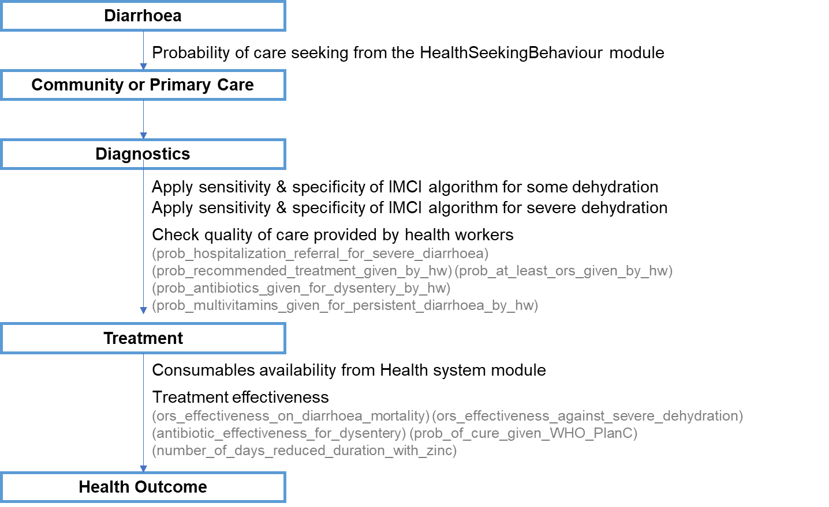

The assessment of diarrhoea is based on the duration of the episode, the presence of blood and the signs of dehydration which determine the severity of diarrhoea. In the community, the HSA can treat uncomplicated diarrhoea (acute diarrhoea with none or some dehydration, without blood), and refer complicated cases to the health facility. At the primary health facility, the health care worker can treat those complicated cases, and hospitalize or refer diarrhoea with severe dehydration to the hospital for inpatient care.
In the health system interaction, the sensitivity and specificity of the IMCI algorithm for dehydration is applied, representing the IMCI algorithm as the diagnostic tool. As well as the assessment of dehydration, the health worker should assess for blood in stools to classify the episode as acute bloody or acute watery diarrhoea, and the duration of the episode to classify the episode as acute or persistent and manage accordingly. The quality of care provided by the health workers is therefore applied to determine the treatment decision. Then, depending on the consumables availability, treatment is given, which has an effect on mortality and/or cure rate.

Figure 4 - Diagnostic process and care quality provided
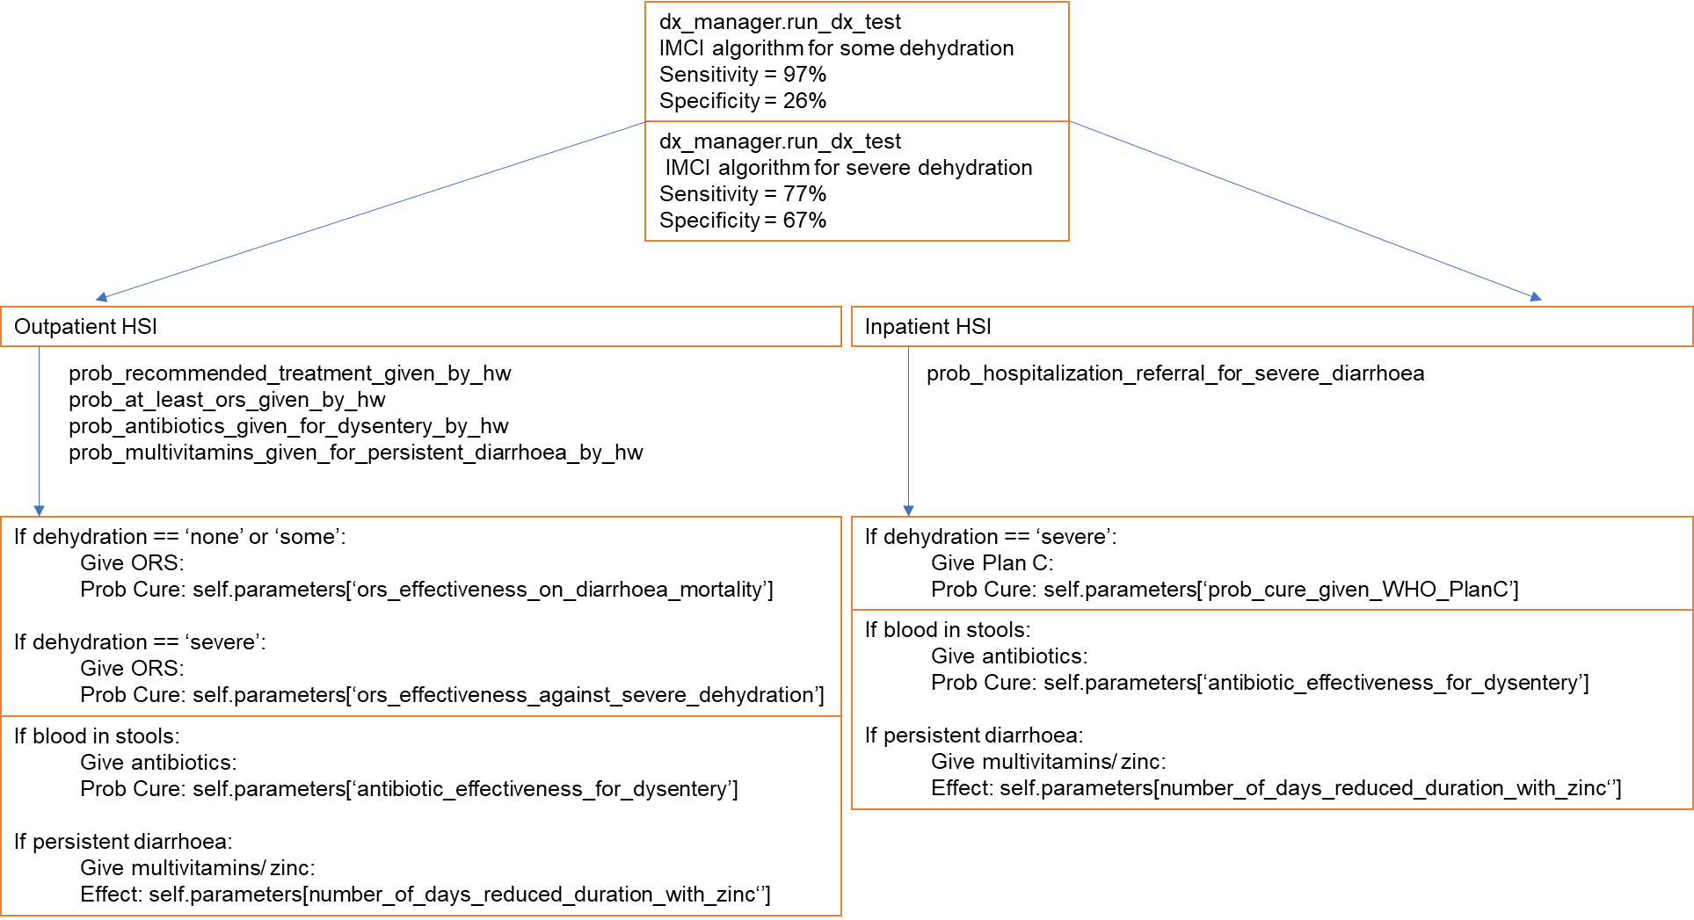

Based on the diagnostic performance of the IMCI algorithm for detecting dehydration severity, if the outcome of the diagnostic tool is no dehydration or some dehydration, the patient is treated at the outpatient facility. If the diagnostic tool results in severe dehydration, the patient is treated at the inpatient level (by hospitalisation or referral to a hospital).
At the outpatient HSI, the treatment for diarrhoea with or without dehydration is ORS with zinc supplementation. If the intrinsic dehydration level of the individual is no dehydration (<3% body weight loss) or some dehydration (3-<9%), the ORS treatment will have the effectiveness given by the parameter ‘ors_effectiveness_on_diarrhoea_mortality’. If the intrinsic dehydration level of the individual is severe (≥9% body weight loss), the effectiveness of ORS treatment of severe dehydration is reduced and is given by the parameter ‘ors_effectiveness_against_severe_dehydration’.
On the other hand, at the inpatient HSI, where severe dehydration is treated with the recommended treatment for IMCI-defined severe dehydration, the effectiveness is given by the ‘prob_cure_given_WHO_PlanC’.
For each episode of diarrhoea, dysentery and persistent diarrhoea are managed with antibiotics and multivitamin supplementation, respectively. The antibiotic works on shigella infections and zinc reduces the duration of diarrhoea by 1 day.

Table 9 – Diarrhoea-related intervention effectiveness
Intervention | Health outcome | Effectiveness | Ref | Notes
ORS | Mortality | Prevent upto 93% with 100% coverage | ²⁶ | meta-analysis, pooled effect size
Zinc | Acute diarrhoea >6 months | Shortens duration by half day MD −11.46 hours, 95% CI −19.72 to −3.19 | ²⁷ | Cochrane review, Zinc for treatment of diarrhoea
 | Acute diarrhoea with malnutrition >6 months | Shortens duration by a day MD −26.39 hours, 95% CI −36.54 to −16.23 |  | High certainty evidence
 | Persistent diarrhoea duration | Shortens duration by 16 hours MD −15.84 hours, 95% CI −25.43 to −6.24 |  | moderate certainty evidence
 | Incidence | RR=0.87 (0.85-0.89) | ²⁸ | moderate quality evidence, Cochrane review, Zinc supplementation
Vitamin A supplementation | mortality due to diarrhoea | RR=0.88, (0.79-0.98) | ²⁹ | high-quality evidence, 9 trials
 |  |  |  | Cochrane review, reduction for vitamin A supplementation
Antibiotics for dysentery | Mortality | cure rate > 99% | ³⁰ | ciprofloxacin, ceftriaxone and pivmecillinam
Promotion of breastfeeding
Probiotics | Persistent diarrhoea duration | reduce duration by mean difference 4.02 days (4.61-3.43 days) n = 324, two trials | ³¹ | Cochrane review
 | Acute diarrhoea duration | mean difference 24.76 hours (15.9 to 33.6 hours) n=4555, trials=35 | ³² | Cochrane review
 |  | reduced diarrhoea lasting ≥4 days (risk ratio 0.41; 0.32 to 0.53)

Next steps

Literature review
- Consider the dehydration levels and its association with death rate.
- Less likely to become persistent if sought care and treated early?? Consider how specific signs and symptoms will prompt care seeking
- Add low birth weight as risk factor?
- Diarrhoea in the neonates
- Dehydration level - dehydration distribution in time and severity (lack of published data)

Code in Python program
- Interventions to be added to the model: Monovalent rotavirus vaccine (Rotarix, RV1) was introduced on 29th October 2012 in Malawi at the WHO recommended schedule of 6 and 10 weeks of age. The diarrhoea module will use the properties from the EPI module for Rotavirus vaccine.

Things to consider adding to the model:
- Risk of death by pathogen
- Signs and symptoms related to diarrhoea and dehydration to then compute scores - Vesikari / Clark/ Dhaka
- Apply the results on pathogen AFs from the Malawi case-control study among hospitalized children ³³

Model outputs

Preliminary model outputs – without health systems input
The following model outputs are from a simulation run from 01/01/2010 to 01/01/2020 for a population size of N=20,000 people (all ages) under no health system interactions.
Figure 10 - Incidence of diarrhoea by pathogen in each age group (model output vs calibrating data)
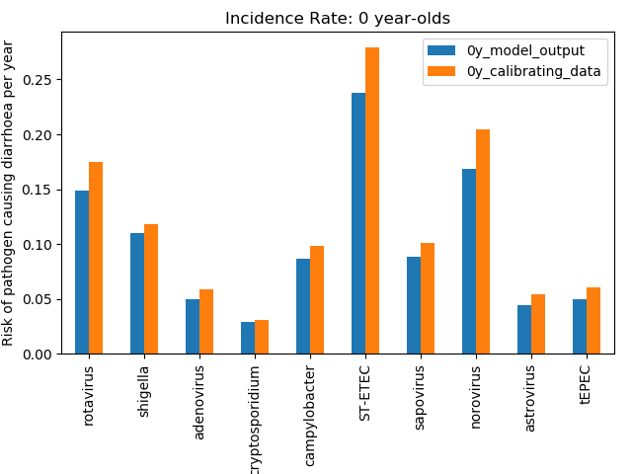
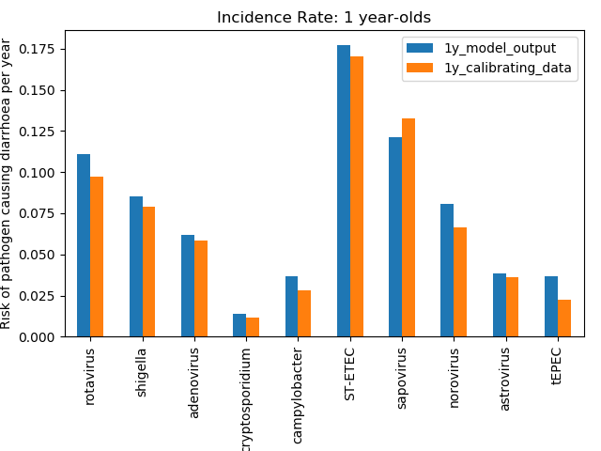
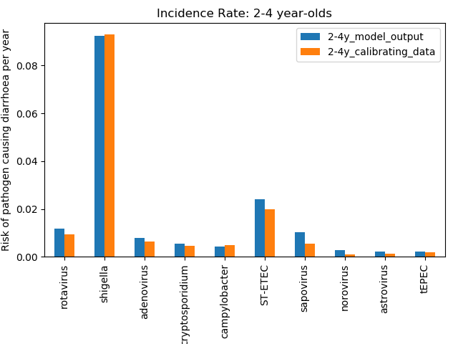
The calibrating data is the input values for the incidence of diarrhoea by pathogen by age group informed by the MAL-ED study, displayed in parameters table 7. The risk of pathogen causing diarrhoea per child per year is a mean of all years in the simulation.

Figure 11 - Incidence rate by pathogen in infants per year (model output vs calibrating data)
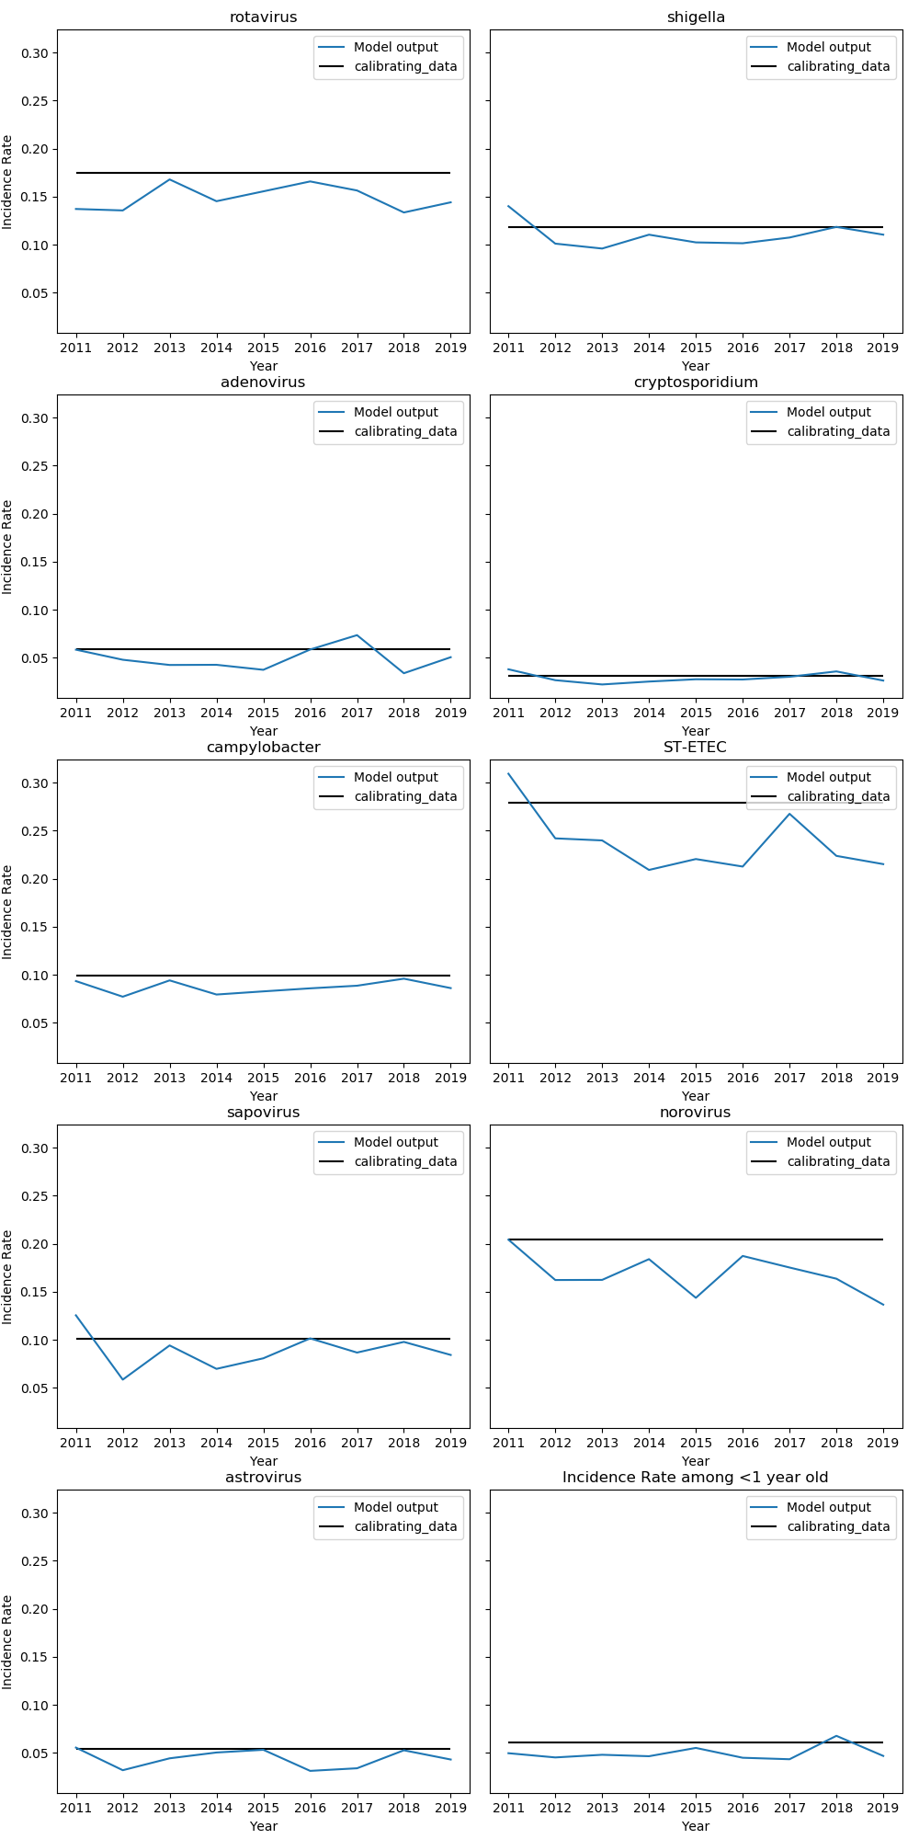
Here is another way of viewing the model run, with a graph showing the incidence by pathogen for infants only, overtime during the simulation. The flat calibrating_data line is the input value.
Figure 12 - Death rate from 2010 to 2019 (model output vs Global Burden of Disease estimates)
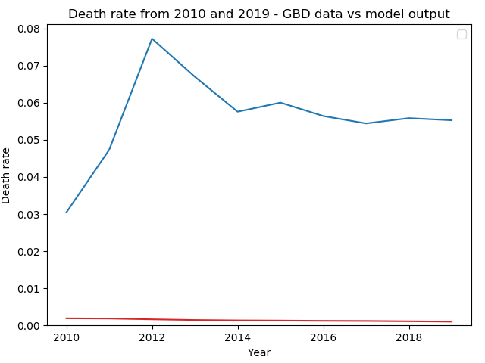
Death rate per child per year from the model is dictated by the input values in the parameters table 7. The case-fatality rate for each diarrhoea type (dysentery, acute watery, and persistent) is informed by a cohort study in rural North India in 1992³⁴. As we aim to simulate the natural history of diarrhoea, currently we use historic CFR, although ORS were already in use at the time.

References
1. Baqui, A. H. et al. Methodological Issues in Diarrhoeal Diseases Epidemiology: Definition of Diarrhoeal Episodes. International Journal of Epidemiology 20, 1057–1063 (1991).
2. Keusch, G. T., Walker, C. F., Das, J. K., Horton, S. & Habte, D. “Diarrheal Diseases”. In: Disease Control Priorities (third edition): Volume 2, Reproductive, Maternal, Newborn, and Child Health, . (2016).
3. Lamberti, L. M., Fischer Walker, C. L. & Black, R. E. Systematic review of diarrhea duration and severity in children and adults in low- and middle-income countries. BMC Public Health vol. 12 276 (2012).
4. Improving Child Health, IMCI: The integrated approach.
5. Kotloff, K. L. et al. Burden and aetiology of diarrhoeal disease in infants and young children in developing countries (the Global Enteric Multicenter Study, GEMS): a prospective, case-control study. The Lancet 382, 209–222 (2013).
6. Acosta, A. M. et al. The MAL-ED Study: A Multinational and Multidisciplinary Approach to Understand the Relationship Between Enteric Pathogens, Malnutrition, Gut Physiology, Physical Growth, Cognitive Development, and Immune Responses in Infants and Children Up to 2 Years of Age in Resource-Poor Environments. Clinical Infectious Diseases 59, S193–S206 (2014).
7. Platts-Mills, J. A. et al. Use of quantitative molecular diagnostic methods to assess the aetiology, burden, and clinical characteristics of diarrhoea in children in low-resource settings: a reanalysis of the MAL-ED cohort study. The Lancet Global Health 6, e1309–e1318 (2018).
8. Liu, J. et al. Use of quantitative molecular diagnostic methods to identify causes of diarrhoea in children: a reanalysis of the GEMS case-control study. The Lancet 388, 1291–1301 (2016).
9. Kotloff, K. L. et al. The Global Enteric Multicenter Study (GEMS) of Diarrheal Disease in Infants and Young Children in Developing Countries: Epidemiologic and Clinical Methods of the Case/Control Study. Clinical Infectious Diseases 55, S232–S245 (2012).
10. Nasrin, ( D et al. Center for Vaccine Development and Global Health The incidence, aetiology, and adverse clinical consequences of less severe diarrhoeal episodes among infants and children residing in low-income and middle-income countries: a 12-month case-control study as. The Lancet Global Health vol. 7 (2019).
11. Darvesh, N. et al. Water, sanitation and hygiene interventions for acute childhood diarrhea: a systematic review to provide estimates for the Lives Saved Tool. BMC Public Health 17, 776 (2017).
12. Wolf, J. et al. Impact of drinking water, sanitation and handwashing with soap on childhood diarrhoeal disease: updated meta-analysis and meta-regression. Tropical Medicine & International Health 23, 508–525 (2018).
13. Lamberti, L. M., Fischer Walker, C. L., Noiman, A., Victora, C. & Black, R. E. Breastfeeding and the risk for diarrhea morbidity and mortality. BMC Public Health vol. 11 S15 (2011).
14. Black, R. E. et al. Maternal and child undernutrition: global and regional exposures and health consequences. The Lancet vol. 371 243–260 (2008).
15. Acácio, S. et al. The role of HIV infection in the etiology and epidemiology of diarrheal disease among children aged 0–59 months in Manhiça District, Rural Mozambique. International Journal of Infectious Diseases 73, 10–17 (2018).
16. Soares-Weiser, K., Bergman, H., Henschke, N., Pitan, F. & Cunliffe, N. Vaccines for preventing rotavirus diarrhoea: vaccines in use. The Cochrane database of systematic reviews 2019, (2019).
17. IMCI Integrated Management of Childhood Illness HANDBOOK Department of Child and Adolescent Health and Development (CAH). (2005).
18. D, P. Oral rehydration in infants in developing countries. Drugs 36 Suppl 4, 39–47 (1988).
19. Levine, M. M. et al. Diarrhoeal disease and subsequent risk of death in infants and children residing in low-income and middle-income countries: analysis of the GEMS case-control study and 12-month GEMS-1A follow-on study. The Lancet Global Health 8, e204–e214 (2020).
20. Tickell, K. D. et al. Identification and management of Shigella infection in children with diarrhoea: a systematic review and meta-analysis. The Lancet Global Health 5, e1235–e1248 (2017).
21. Acácio, S. et al. Risk factors for death among children 0–59 months of age with moderate-to-severe diarrhea in Manhiça district, southern Mozambique. BMC Infectious Diseases 19, 322 (2019).
22. Black, R. E. et al. Maternal and child undernutrition: global and regional exposures and health consequences. www.thelancet.com 243 doi:10.1016/S0140.
23. Ng’ambi, W. et al. Factors associated with healthcare seeking behaviour for children in Malawi: 2016. Tropical Medicine and International Health (2020) doi:10.1111/tmi.13499.
24. Guarino, A. et al. European society for pediatric gastroenterology, hepatology, and nutrition/european society for pediatric infectious diseases evidence-based guidelines for the management of acute gastroenteritis in children in Europe: Update 2014. Journal of Pediatric Gastroenterology and Nutrition 59, 132–152 (2014).
25. AC, L. et al. External validation of the DHAKA score and comparison with the current IMCI algorithm for the assessment of dehydration in children with diarrhoea: a prospective cohort study. The Lancet. Global health 4, e744–e751 (2016).
26. Munos, M. K., Fischer Walker, C. L. & Black, R. E. The effect of oral rehydration solution and recommended home fluids on diarrhoea mortality. International Journal of Epidemiology 39, i75–i87 (2010).
27. Lazzerini, M. & Wanzira, H. Oral zinc for treating diarrhoea in children. Cochrane Database of Systematic Reviews vol. 2016 CD005436 (John Wiley and Sons Ltd, 2016).
28. Mayo-Wilson, E., Imdad, A., Junior, J., Dean, S. & Bhutta, Z. A. Preventive zinc supplementation for children, and the effect of additional iron: A systematic review and meta-analysis. BMJ Open vol. 4 (2014).
29. Imdad, A., Mayo-Wilson, E., Herzer, K. & Bhutta, Z. A. Vitamin A supplementation for preventing morbidity and mortality in children from six months to five years of age. Cochrane Database of Systematic Reviews 2017, (2017).
30. Traa, B. S., Fischer Walker, C. L., Munos, M. & Black, R. E. Antibiotics for the treatment of dysentery in children. International Journal of Epidemiology 39, (2010).
31. Bernaola Aponte, G., Bada Mancilla, C. A., Carreazo, N. Y. & Rojas Galarza, R. A. Probiotics for treating persistent diarrhoea in children. Cochrane Database of Systematic Reviews vol. 2013 (2013).
32. Allen, S. J., Martinez, E. G., Gregorio, G. V. & Dans, L. F. Probiotics for treating acute infectious diarrhoea. Cochrane Database of Systematic Reviews vol. 2010 (2010).
33. Iturriza-Gómara, M. et al. Etiology of Diarrhea Among Hospitalized Children in Blantyre, Malawi, Following Rotavirus Vaccine Introduction: A Case-Control Study. The Journal of Infectious Diseases 220, 213–218 (2019).
34. Bhandari, N., Bhan, M. K. & Sazawal, S. Mortality associated with acute watery diarrhea, dysentery and persistent diarrhea in rural north India. Acta paediatrica (Oslo, Norway : 1992). Supplement 381, 3–6 (1992).

