Modelling of HIV within the Thanzi La Onse Model

The Thanzi La Onse Model
As part of the Thanzi La Onse program a model is being developed which aims to capture the health experiences of the population of Malawi and the consequent interactions with the health care system. The intent is that this model will help to inform future delivery of health care in Malawi. The model is an individual based model – which means we explicitly simulate the individual life and health experiences of a representative proportion of the population of Malawi. The simulation initiates on 1 Jan 2010 and we attempt to simulate the attributes of the population at that point. We can run the model forward to any specified future time point. Each potential intervention and its associated diseases are being modelled. This is being divided into separate disease/intervention modules. This document describes the module on HIV transmission and AIDS.

General approach to decisions on modelling causal influences and effects of interventions
This module was designed in the context of an overall approach to modelling causal effects in general and causal effects of interventions in particular. The overall intent is to adopt as simple a structure as can be conceived, whilst still capturing the essential elements of a disease and the interventions used to prevent or treatment. We include a causal link between a “variable” (by which we mean a characteristic or property of an individual, whether that be demographic, social or biologic), and risk of disease or another variable if there is strong evidence from an overall body of studies that such a causal link exists and is at least moderately strong. In informing such decisions we place particular value on RCTs or studies with a quasi-experimental design such as analyses based on an instrumental variable. There is no expectation that such studies will be from Malawi or even from Africa. If there are such local studies and in the unlikely event that they provide strong evidence to suggest that the causal link is substantively different in Malawi, then the intent is that this is taken into account and the Malawi-specific link included.
In the special case of a potential causal variable which relates to whether an individual has experienced or is experiencing an intervention the intent is to only include interventions if there is substantial RCT evidence of their beneficial effect, based on trials with objectively ascertained clinical endpoints with low risk of serious bias. Whilst DCP-3 (and to some extent the Malawi EHP) provides an initial list of such interventions and the evidence to support them, where possible our intent has been to form our own opinion on intervention efficacy based on the source trials.
Unless there is evidence to the contrary, the intent is to summarize and incorporate intervention effects into the model as relative risks or rates rather than absolute differences due to the fact that such measures are less likely to differ substantively by context. Interactions between characteristics (on the multiplicative scale) are only to be incorporated if there is strong evidence. Again, we have not intended to rely on data from Malawi or Africa for such evidence but if local evidence exists which strongly suggests a different effect than elsewhere then the intent is that this modified effect is incorporated in the model.

Demographic and social characteristics modelled
Based on data on the distribution of the population in Malawi according to geographic location we assign individuals a geographic location, which maps onto whether they are classified as living in a rural or urban area. Informed largely by data from the Malawi DHS, variables are also created indicating the person’s wealth level (based on 5 quintiles), whether the person has access to improved sanitation, clean drinking water, hand washing facilities, and whether they experience indoor air pollution (wood burning stove). We assign individuals a current education status (none, primary, secondary) which is (updated every 3 months) from age 5 to 20. From age 15 we assign BMI in 5 categories, tobacco use status, drinking excess alcohol, having low exercise, high sugar intake, high salt intake, and marital status (never, currently, widowed/divorced). The status with regard to such variables for individuals can change over time. The influences between these variables are described in detail in a separate document.

The HIV module
The HIV module is responsible for assigning new HIV infections to individuals and scheduling relevant health system interactions. At baseline (2010), the model reproduces the HIV prevalence in Malawi using the prevalence estimates generated by the Avenir Health Spectrum/EPP model, distributed by age and sex. A simple transmission model estimates the numbers of new infections in adults and the relative risk of acquisition is determined for each individual based on their lifestyle characteristics and demographic information. New infections in infants are estimated from the prevalence of infection in mothers combined with the rate of mother-to-child transmission, length of time breastfeeding and antiretroviral coverage. The predicted survival times for each infected individual are drawn from probability distributions and those adherent to ART experience no AIDS-mortality. HIV Testing and ART coverage estimates from 2011 onwards are derived from the Malawi Ministry of Health Integrated HIV Program Reports. Once health care events such as testing or treatment initiation are scheduled, they enter the health system event queue and are executed chronologically subject to any resource constraints. After the event occurs, the individual’s health state may change as the disease progresses or treatment is started, or a sequence of linked health care system events can be triggered.

Model structure

Variables modelled
The individual properties managed by the HIV module are summarised in Table 1. Other disease modules can also call on the HIV module to request HIV tests, or in the case of TB (an AIDS-defining condition), the TB module can request the symptom “AIDS” to be assigned in co-infected individuals.

Table 1. Individual properties managed by the HIV module.
Property | Description | Values
hv_inf | HIV infection status | True / False
hv_art | Current ART status | Categorical: "not", "on_VL_suppressed", "on_not_VL_suppressed"
hv_is_on_prep | Whether or not the person is currently taking and receiving a protective effect from Pre-Exposure Prophylaxis | True / False
hv_behaviour_change | Has this person been exposed to effective HIV prevention counselling which will lower risk following a negative HIV test result | True / False
hv_diagnosed | Knows that they are HIV+: i.e. is HIV+ and tested as HIV+ | True / False
hv_number_tests | Number of HIV tests ever administered | Integer
hv_last_test_date | Date of last HIV test | Date
hv_date_inf | Date infected with HIV | Date

Initialising the simulation
  - Baseline prevalence
The prevalence of HIV in adults and children (under 15 years) in 2010 is taken from the Spectrum/EPP projections. The estimated overall prevalence of HIV in children under 14 years of age in 2010 was 2.1% and the age distribution of prevalent infections is shown below (Figure 1).[Source: Spectrum projections 2017_version_5] We assume that there are no differences in the distribution of infections in children by sex. HIV infections in the baseline population are distributed according to their relative risk of infection, determined using a logistic regression of Malawi DHS data which examined a number of demographic characteristics such as education, wealth and risk behaviour and their influence on the risk of HIV infection (see Table 2). We infer the length of time infected for the baseline population using the projections from the Spectrum model to build up a representative population of HIV-infected individuals experiencing varying stages of disease. Infection dates are constrained to occur on or after the date of birth.

  - Baseline testing and ART coverage
The proportion of HIV-infected individuals on ART in 2010 is estimated using the Spectrum/EPP outputs. Each HIV-infected individual is assigned a probability of being on treatment in 2010 based on their age and sex, then random draws determine which individuals are assigned ART. Once on ART, a second random draw determines the likelihood that an individual on ART at that time will be virally suppressed using the estimates reported in the 2015-2016 MPHIA survey.
All persons who are assigned ART are assumed to have had one HIV test. HIV testing coverage (definition: ever tested and received results) by 2010 was reported to be 71.6% in women aged 15-49 and 50.9% in men aged 15-54.(National Statistical Office (NSO) [Malawi] 2011) We use the 2010 HIV testing coverage levels to assign any remaining HIV tests to the rest of the population, sampling amongst adults (both infected and non-infected) aged 15 years or over and assigning dummy dates for the date of last test. Testing rates in children are not widely reported and so we assume all those not currently on treatment have also not been tested.
  - Baseline mortality projections
Any individuals who have been infected for at least 10 years and are not currently on ART are classified as having AIDS and a projected date of death due to AIDS is scheduled. Those infected for less than 10 years and not currently on ART will have their AIDS onset date scheduled according to the mean time between infection and AIDS onset. Any individuals on ART (either virally suppressed or unsuppressed) will have no further events (AIDS or death) scheduled at this point.

Figure 1. Age distribution of prevalence HIV infections in children in 2010.

Incidence of HIV infection
  - Mother-to-child transmission
New infections occurring in those aged <15 years can only occur through mother-to-child transmission (Figure 2). The probability of transmission from a mother with HIV to an infant is divided into two distinct risk periods: gestational/delivery and breastfeeding. The risk of HIV acquisition in infants during pregnancy or delivery is dependent on the timing of infection in the mother. Infections occurring in the mother during pregnancy will carry a higher risk of mother-to-child transmission than infections which have occurred prior to pregnancy (probability=0.3 if mother is infected during pregnancy, 0.22 if infected prior).(Rollins, Mahy et al. 2012) If the infant is not infected during pregnancy or delivery and is being breastfed, they will be exposed to a risk of HIV infection through breastfeeding. The time to infection through breastfeeding is calculated using a random draw from an exponential distribution with rate parameter equal to 1/monthly probability of mother-to-child transmission (monthly probability=0.01) through breastfeeding. If breastfeeding has ceased by the time the infection event is scheduled to occur, the child will remain HIV-negative.

If the mother is on ART and is virally suppressed, there will be no risk of vertical transmission. Infants of mothers that are on ART but not virally suppressed will be susceptible to the same risks as if the mother is untreated. We assume that if mothers are on ART and adherent (virally suppressed), the infant will also receive AZT or NVP until one week after breastfeeding cessation.

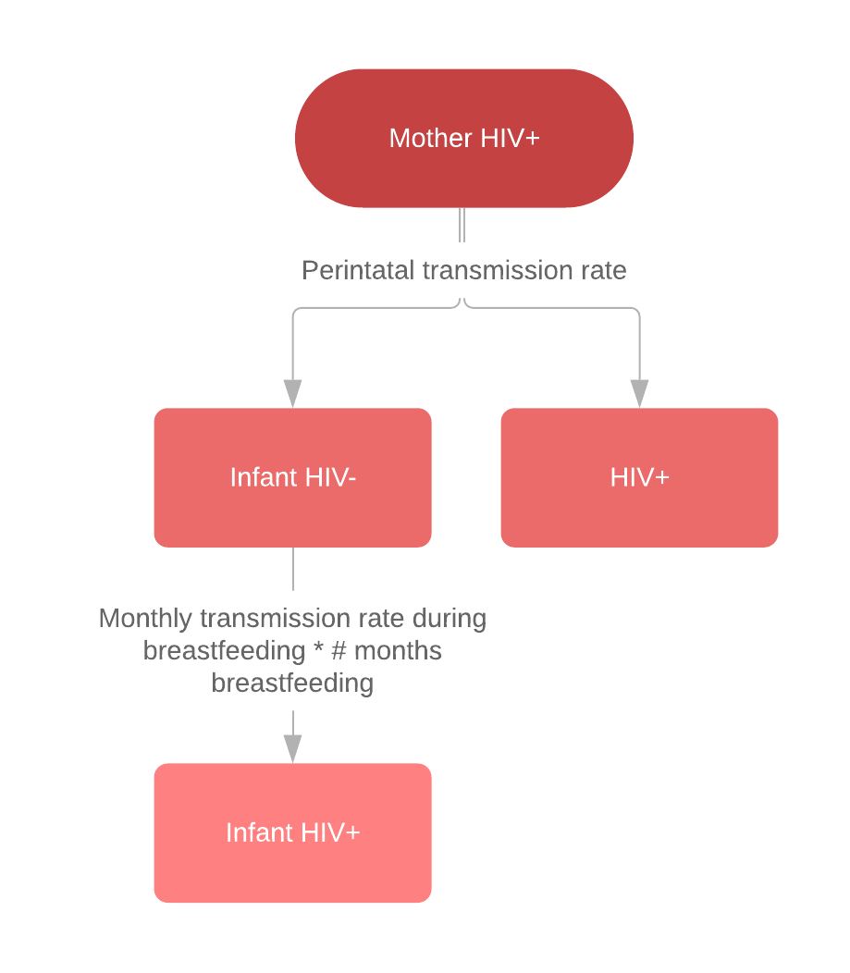
Figure 2. Flow diagram showing the risks of mother-to-child transmission applied at birth to infants of mothers with HIV.

  - Transmission in adults
The HIV polling event runs each year and schedules people becoming newly infected through horizontal transmission. The onset dates for all newly infected people are randomly distributed across the year. The probability that a susceptible person (i) will become infected is scaled by the individual relative risk of infection:
$${p_inf}_{i}=\frac{βI}{N}*{RR}_{i}$$
Where the transmission probability (β) is calibrated to HIV surveillance data and the number of infected individuals (I) includes all those currently infected and not on ART and those on ART but not virally suppressed. The total number (N) is the sum of the infectious and susceptible populations. The individual relative risk of acquisition (RR_{i}) is based on demographic properties, such as age, sex, wealth index and education along with behavioural characteristics such as female sex work, exposure to behaviour change counselling and pre-exposure prophylaxis (PrEP). The probabilities of transmission from males to females and vice versa are calculated separately. We do not differentiate between homosexual versus heterosexual transmission and assume that intravenous drug use as a risk factor for HIV acquisition is not widespread in Malawi.

Table 2. Relative risks for incident HIV infections in adults by demographic characteristics. Source: analysis of Malawi DHS data.
Demographic characteristic | Relative risk
Residence
urban | 1.0
rural | 0.52
Wealth index
poorest | 1.0
poorer | 0.96
middle | 1.18
richer | 1.19
richest | 1.56
Sex
male | 1.0
female | 1.43
Age group
15-19 | 1.0
20-24 | 2.15
25-29 | 3.75
30-34 | 5.88
35-39 | 7.57
40-44 | 7.93
45-49 | 6.72
50+ | 7.9
Education level
none | 1.0
primary | 1.18
secondary | 1.15
higher | 1.0

Progression to AIDS and mortality
Infants
AIDS onset is scheduled at the time of infection. For infants infected before the age of 5 years, the time from infection to AIDS is equal to the projected survival time, which follows an exponential distribution for infants infected prior to or during birth (median survival time 0.64 years) and a Weibull distribution if infected after birth and before the age of 5 years (median survival time 16 years).(Ferrand, Corbett et al. 2009) The projected death date is then scheduled to occur 18 months after AIDS onset.
Adults
The projected survival times for adult infections in the absence of treatment follow a 2-parameter Weibull distribution with a fixed shape parameter and scale parameter dependent on age, resulting in a median survival time of 10.6 years (95% CI 9.7-12.8) for 25-34 year olds (Figure 3).(Todd, Glynn et al. 2007) The individual scale parameter is calculated using the age at the time of infection as follows:
$$log⁡(weibull scale parameter)=2.55-0.025(age-30)$$
The onset of AIDS in adults is scheduled to occur prior to the projected death date using a random draw from the exponential distribution with a mean of 18 months.

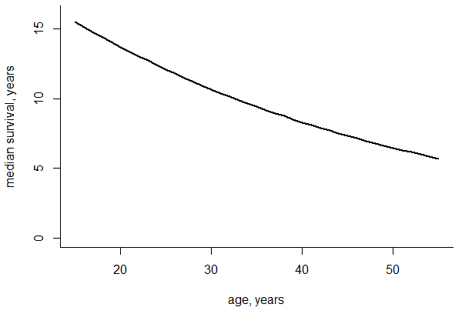
Figure 3. Median survival times by age at seroconversion for adults if untreated with ART (men and women)

Disability weights

Table 3. DALY weights associated with HIV symptoms.
HIV specific symptoms | WHO classification | DALY weight definition | DALY weight
HIV infection | WHO stage 3 | Symptomatic HIV without anemia,"HIV cases, symptomatic, pre-AIDS","has weight loss, fatigue, and frequent infections. | 0.274  (0.184-0.377)
AIDS | WHO stage 4 | AIDS without antiretroviral treatment without anemia,"AIDS cases, not receiving ARV treatment","has severe weight loss, weakness, fatigue, cough and fever, and frequent infections, skin rashes and diarrhea | 0.582  (0.406-0.743)

Female sex work
The size of the female sex worker population is assumed to be constant over time and we use the most recent estimate from UNAIDS, 31,200 women, corresponding with 0.0069 of all women aged 15-49. All other estimates agree that the proportion of women engaging in sex work is below 1%. Women are randomly recruited into sex work if they are between the ages of 15 and 49 and unmarried. The annual probability of transitioning from sex work to a low sexual risk group is 1/5.5, given the average duration of sex work reported in African countries.(Fazito, Cuchi et al. 2012)

Sources: (Chizimba and Malera 2011, [Malawi] 2014, Joint United Nations Programme on HIV/AIDS 2017, PEPFAR 2017)
Notes: Pepfar estimate from Global Fund concept note 2014, PLACE study conducted in 6 districts
Pepfar using same estimate for 2016, 2017 and 2018

Health System Interactions

Care Seeking & health system interactions
HIV tests are scheduled to occur in the simulation through four routes:
- a regular event poll running annually and randomly allocating tests to individuals of any age at any point in that year
- following the onset of AIDS symptoms which trigger healthcare seeking through the healthcare seeking algorithm
- through another healthcare-seeking event, e.g. TB diagnosis or antenatal care appointment, which triggers a request for an HIV test
- when an infant is born to an HIV-positive mother
Following the HIV test, they may or may not then present for further health services, such as ART (if HIV-positive), voluntary male medical circumcision (if HIV-negative and male), behaviour change counselling (if HIV-negative and aged 15 years or older) or PrEP (if HIV-negative and a female sex worker). The overall number of tests performed each year are calibrated to match the MoH reports of testing coverage. HIV testing is assumed to be 100% sensitive and specific.(Wright and Stringer 2004)

  - Treatment for HIV
Following a positive HIV test, a follow-up appointment for referral to ART is scheduled. The decision to start ART is informed by a linear model which predicts the probability of starting ART after a positive HIV test given the presence or absence of AIDS symptoms. The probability is currently set to 1, but this will be calibrated to match the overall number of new ART initiators. First-line treatment for adults and children also includes cotrimoxazole dispensation, both of which must be available for ART initiation to run in the model.

The ART initiation event first checks whether the required drugs are available (Figure 4). If available, the person will start ART and a decision is made on whether they will be virally suppressed using the probabilities of viral suppression by age and sex. If a person is virally suppressed, any existing HIV-related symptoms will be cleared and AIDS onset and death due to AIDS will not occur. Another event is then scheduled in 6 months to decide whether to continue or interrupt treatment.

If the required drugs or an appropriate appointment type are not available at that time, the person can seek another appointment to pick up medication and the consumables/appointment checks will run again.

At every 6-month continuation appointment, the decision to continue treatment is a random draw based on the probability of retention (assumed to be 98%). If continued, viral load monitoring is scheduled along with ART dispensation.

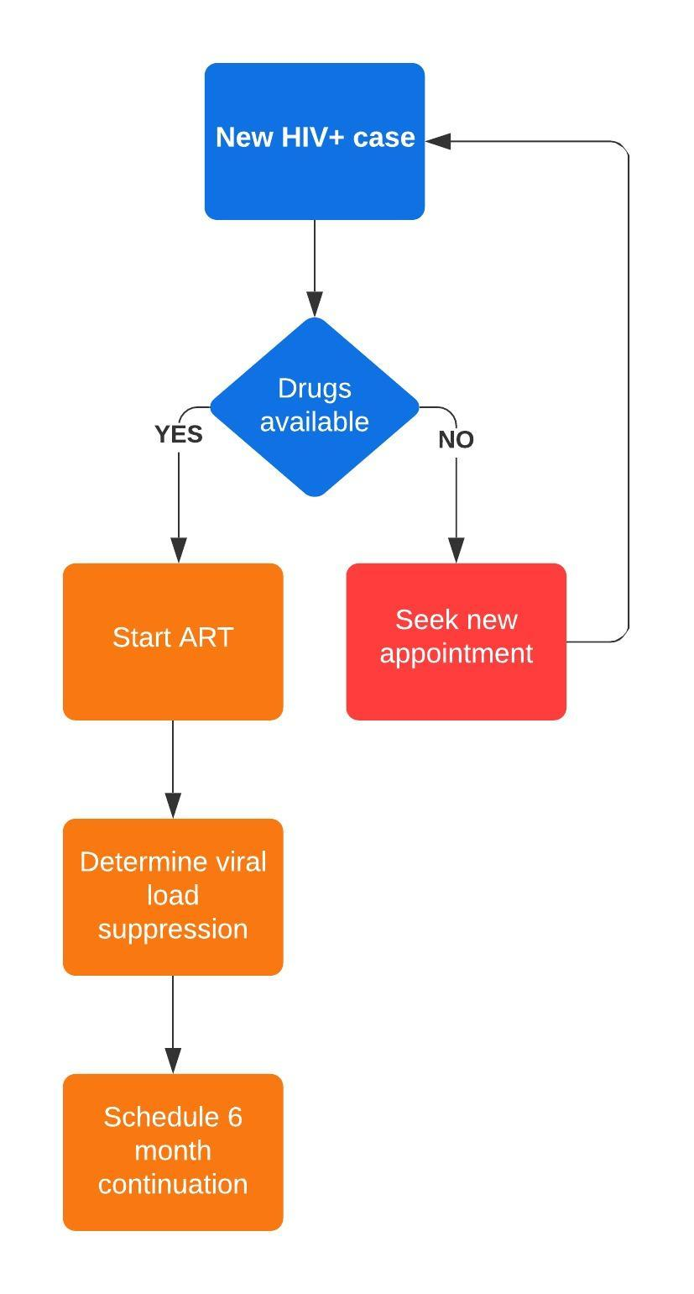
Figure 4. Process for new ART initiators

Interventions for HIV prevention
If a person tests negative for HIV, they can be referred to behaviour change counselling, voluntary male medical circumcision or pre-exposure prophylaxis (PrEP) as appropriate. Currently PrEP is only offered to female sex workers from 2018 onwards. Each of these interventions will reduce a person’s risk of acquiring HIV (see Table 4).

Voluntary medical male circumcision
WHO/UNAIDS recommend that male circumcision be part of a comprehensive HIV prevention package which includes testing and counselling, treatment for STIs, promotion of safer sex practices and the provision of condoms. Male circumcision reduces the risk of HIV acquisition through heterosexual sex in males by 60%. Circumcision is often practiced for cultural reasons and prevalence varies widely by age, region and ethnicity. The age distribution at which circumcisions are performed along with the regional distribution and indications are below. Circumcisions for religious reasons are frequently performed outside health facilities and would therefore be undocumented. The propensity to seek a medical male circumcision will therefore be a function of age and region, as we don’t model religious practices in the model.
The prevalence of circumcision at baseline prevalence in men aged ≥ 15 years is 23%, derived from the Knowledge Attitude Behaviour and Practices Survey (KABP) documented in the Situation analysis of male circumcision in Malawi Report 2010.(Bengo, Chalulu et al. 2010) This baseline prevalence (and the individual property) is managed by the lifestyle module.
The HIV module assigns voluntary medical male circumcision to men following a negative test with a probability calibrated to match the reported national coverage. The National Voluntary Medical Male Circumcision (VMMC) program launched in 2011 and conducted a total of 150,000 male circumcisions by September 2014, approximately 37,500 procedures per year.(National AIDS Commission 2014) Target coverage levels are taken from the 2015-2020 National Strategic Plan for HIV Malawi which aims for 60% coverage of VMMC by 2020 (revised down from 80% given the slower than expected scale-up following the introduction of the programme) and would require 1,300,568 circumcisions to be conducted across the country.(National AIDS Commission 2014) The MDHS 2015-2016 report estimates that 27.9% of men had been circumcised at the time of the survey, far below the target level and so we calibrate the annual number of circumcisions in the model to match the 2013 National Strategic Plan and 2015 MDHS coverage estimates, allocating randomly across all eligible adult males.

Pre-exposure prophylaxis
Following a negative test, female sex workers (FSW) become eligible for pre-exposure prophylaxis (PrEP). This is available from 2018 onwards and women classified as FSW, who are not currently on PrEP, are randomly selected to start PrEP with a fixed probability. If PrEP is available, a three-month dispensation is given and the woman’s relative risk of HIV acquisition will change. After three months, another random draw will determine whether that woman will continue or default. If the woman has transitioned out of sex work, they are no longer eligible for PrEP and no further drugs will be prescribed. The probability of initiating PrEP and the probability of being retained on PrEP are calibrated to match the reported national coverage levels in FSW for each year.

Main Limitations

The likelihood that a person will test is dependent on the severity of symptoms, age, sex and previous testing history. Currently we incorporate only AIDS symptoms as a strong predictor of whether a person will seek care and assume that an HIV test will be given if they attend a health facility.
The likelihood that an infant exposed to HIV will be tested for HIV is dependent on the location of birth (health facility, at home etc.). This is currently not linked with the labour and delivery modules but this will be incorporated in future.
People are determined as being adherent / non-adherent to treatment at ART initiation using the reported estimates of viral suppression in treated individuals. Transitions from adherent to non-adherent or vice versa are not included in the model are there are few data to inform the frequency of these transitions. We include treatment interruptions which can occur in two ways; either a person fails to attend the six-month follow-up appointment or there are constraints on the availability of ARVs in that district at the time of the appointment. If treatment is recommenced after an interruption, there will be another random draw to determine whether they will be adherent and virally suppressed, which is independent of their treatment history.
We assume that all HIV treatment is administered in the community or at-home, no inpatient stays are linked with HIV/AIDS as yet. With further data on lengths of hospital admissions in Malawi and inpatient treatment guidelines for advanced disease, this could be a future refinement.

Table 4. List of parameters used in the HIV module.
Parameter | Value | Source
Fraction of population at baseline who are HIV+ with AIDS symptoms | 0.05
Proportion of the adult male population who have had an HIV test | 0.509 | MoH Quarterly Reports
Proportion of the adult female population who have had an HIV test | 0.716 | MoH Quarterly Reports
HIV transmission rate | 0.045 | Calibrated
Probability of mother-to-child transmission if mother is not treated | 0.22 | (Rollins, Mahy et al. 2012)
Probability of mother-to-child transmission if mother is treated and virally suppressed | 0 | (Rollins, Mahy et al. 2012)
Probability of mother-to-child transmission if mother is infected during pregnancy | 0.3 | (Rollins, Mahy et al. 2012)
Probability of mother-to-child transmission during breastfeeding if mother is untreated per month | 0.01 | (Rollins, Mahy et al. 2012)
Probability of mother-to-child transmission during breastfeeding if mother is treated per month | 0 | (Rollins, Mahy et al. 2012)
Relative risk of HIV acquisition with female sex work | 20 | Assumption
Relative risk of HIV acquisition with circumcision compared with not circumcised | 0.4 | (Hallett, Singh et al. 2008)
Relative risk of HIV acquisition in rural location compared with urban | 0.52 | wingston_dhs_analysis
Relative risk of HIV acquisition with wealth index poorer compared with poorest | 0.96 | wingston_dhs_analysis
Relative risk of HIV acquisition with wealth index middle compared with poorest | 1.18 | wingston_dhs_analysis
Relative risk of HIV acquisition with wealth index richer compared with poorest | 1.19 | wingston_dhs_analysis
Relative risk of HIV acquisition with wealth index richest compared with poorest | 1.56 | wingston_dhs_analysis
Relative risk of HIV acquisition for females compared with males | 1.43 | wingston_dhs_analysis
Relative risk of HIV acquisition for ages 20-24 compared with 15-19 | 2.15 | wingston_dhs_analysis
Relative risk of HIV acquisition for ages 25-29 compared with 15-19 | 3.75 | wingston_dhs_analysis
Relative risk of HIV acquisition for ages 30-34 compared with 15-19 | 5.88 | wingston_dhs_analysis
Relative risk of HIV acquisition for ages 35-39 compared with 15-19 | 7.57 | wingston_dhs_analysis
Relative risk of HIV acquisition for ages 40-44 compared with 15-19 | 7.93 | wingston_dhs_analysis
Relative risk of HIV acquisition for ages 45-49 compared with 15-19 | 6.72 | wingston_dhs_analysis
Relative risk of HIV acquisition for ages 50+ compared with 15-19 | 7.9 | wingston_dhs_analysis
Relative risk of HIV acquisition with primary education compared with none | 1.18 | wingston_dhs_analysis
Relative risk of HIV acquisition with secondary education compared with none | 1.15 | wingston_dhs_analysis
Relative risk of HIV acquisition with higher education compared with none | 1 | wingston_dhs_analysis
Relative risk of HIV acquisition with exposure to behaviour change counselling | 0.75 | Assumption
Reduction in risk of HIV acquisition for those on pre-exposure prophylaxis | 0.9 | Assumption, equates to 90% efficacy when on PrEP
Mean months between AIDS onset and death | 18 | Assumption
Weibull distribution describing time from infection to death in adults
Shape parameter for ages 15-19 | 2 | (Todd, Glynn et al. 2007, Hallett, Zaba et al. 2008)
Shape parameter for ages 20-24 | 2 | (Todd, Glynn et al. 2007, Hallett, Zaba et al. 2008)
Shape parameter for ages 25-29 | 2 | (Todd, Glynn et al. 2007, Hallett, Zaba et al. 2008)
Shape parameter for ages 30-34 | 2 | (Todd, Glynn et al. 2007, Hallett, Zaba et al. 2008)
Shape parameter for ages 35-39 | 2 | (Todd, Glynn et al. 2007, Hallett, Zaba et al. 2008)
Shape parameter for ages 40-44 | 2 | (Todd, Glynn et al. 2007, Hallett, Zaba et al. 2008)
Shape parameter for ages 45-49 | 2 | (Todd, Glynn et al. 2007, Hallett, Zaba et al. 2008)
Scale parameter for ages 15-19 | 16 | (Todd, Glynn et al. 2007, Hallett, Zaba et al. 2008)
Scale parameter for ages 20-24 | 15.4 | (Todd, Glynn et al. 2007, Hallett, Zaba et al. 2008)
Scale parameter for ages 25-29 | 14.1 | (Todd, Glynn et al. 2007, Hallett, Zaba et al. 2008)
Scale parameter for ages 30-34 | 12.1 | (Todd, Glynn et al. 2007, Hallett, Zaba et al. 2008)
Scale parameter for ages 35-39 | 11 | (Todd, Glynn et al. 2007, Hallett, Zaba et al. 2008)
Scale parameter for ages 40-44 | 10.01 | (Todd, Glynn et al. 2007, Hallett, Zaba et al. 2008)
Scale parameter for ages 45-49 | 7.9 | (Todd, Glynn et al. 2007, Hallett, Zaba et al. 2008)
Mean years between when a person stops being on treatment to when AIDS is onset in the absence of resuming treatment | 5
Mean survival time (years) for infants infected prior to birth | 1.08 | (Ferrand, Corbett et al. 2009)
Weibull distribution describing time from infection to death for infants infected after birth
Shape parameter | 16 | (Ferrand, Corbett et al. 2009)
Scale parameter | 2.7 | (Ferrand, Corbett et al. 2009)
Probability that a person will seek an HIV test per 12-month period | 0.2
Probability that a person will start treatment, if HIV-positive, following testing | 0.9
Relative probability of a person starting treatment if they have AIDS symptoms compared to if they do not | 1
Probability that a person will change risk behaviours, if HIV-negative, following testing | 0.5
Probability that a FSW will start PrEP, if HIV-negative, following testing | 0.05
Probability that a male will be circumcised, if HIV-negative, following testing | 0.05
Probability that someone who has initiated on prep will attend an appointment and be on prep for the next 3 months, until the next appointment | 0.5
Probability that someone who has initiated on treatment will attend an appointment and be on treatment for next 6 months, until the next appointment | 0.98
Probability that a person who 'should' be on art will seek another appointment (the following day and try for each of the next 7 days) if drugs were not available | 0.8
probability that a person who 'should' be on art will seek another appointment if the health-system has not been able to provide them with an appointment | 0.5
Rates of viral load suppression in adult males | 0.897 | (Malawi 2018)
Rates of viral load suppression in adult females | 0.921 | (Malawi 2018)
Rates of viral load suppression in children aged 0-14 years | 0.579 | (Malawi 2018)
Calendar year from which PrEP is available | 2018

Model outputs

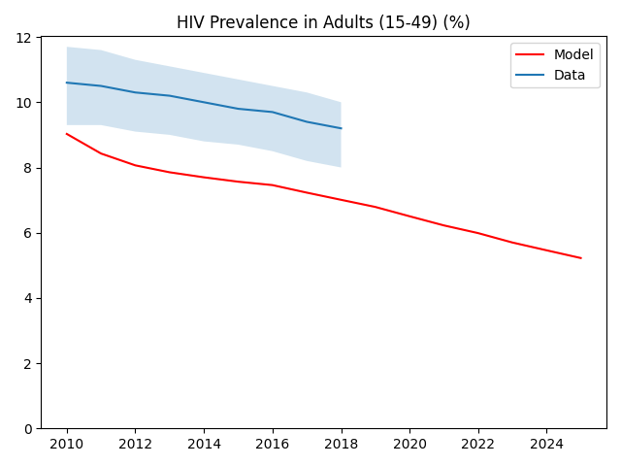

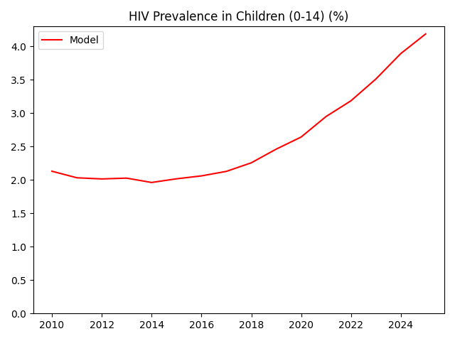

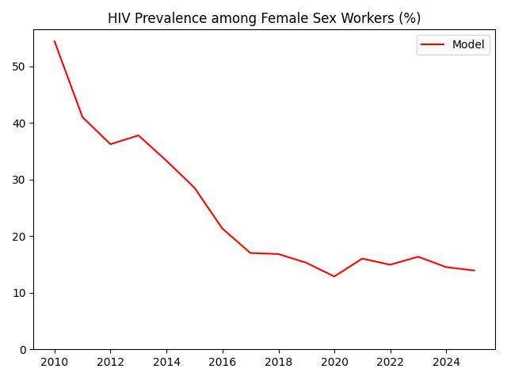
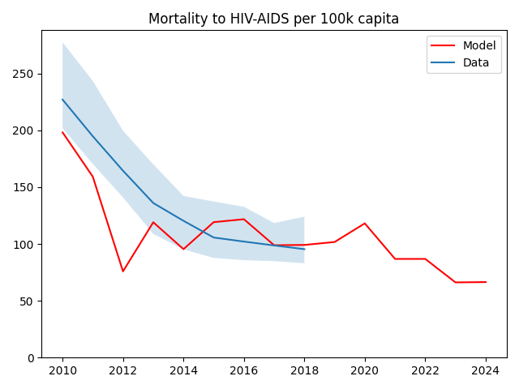
Data are taken from AIDSinfo (2020) and show the mortality rates due to HIV/AIDS per year per 100,000 population (irrespective of HIV status).

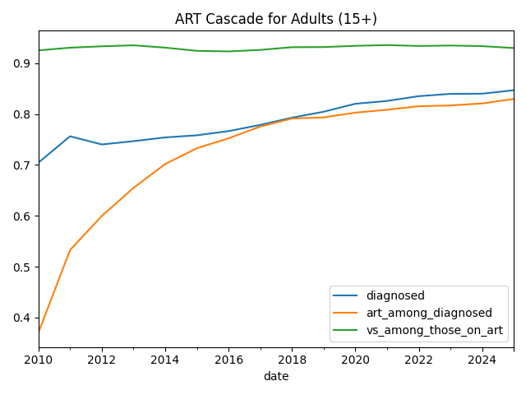
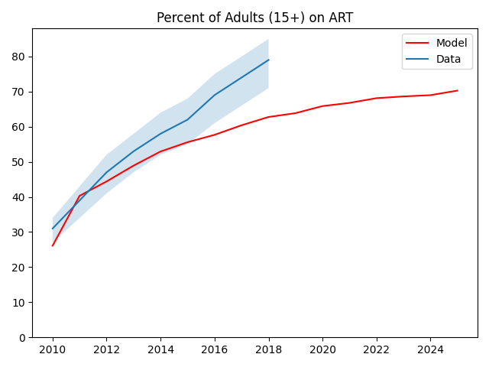

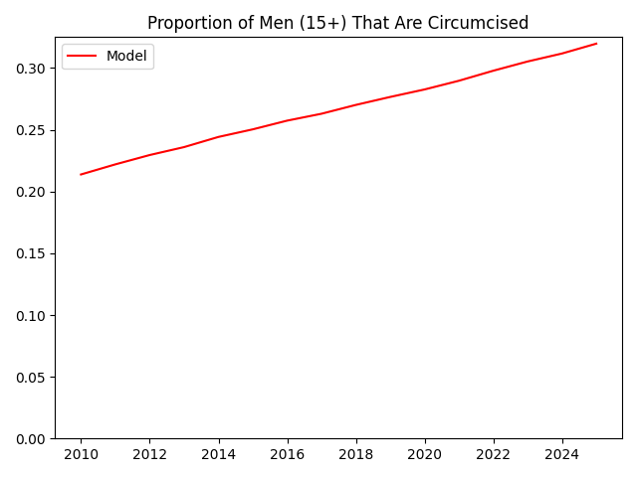

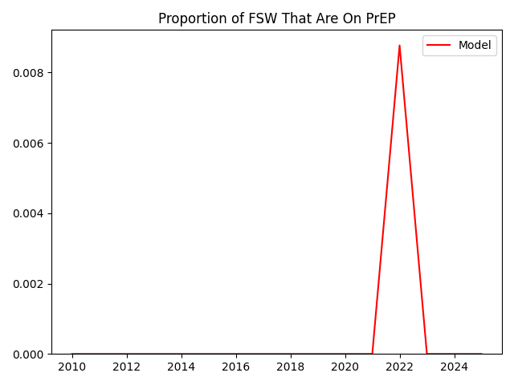

References
[Malawi], N. S. O. N. (2014). Malawi Biological and Behavioural Surveillance Survey (BBSS), 2013-2014. Lilongwe, Malawi.
Bengo, J. M., K. Chalulu, J. Chinkhumba, L. Kazembe, K. M. Maleta, F. Masiye and D. Mathanga (2010). Situation analysis of male circumcision in Malawi. Lilongwe, Malawi, College of Medicine.
Chizimba, R. M. and G. T. Malera (2011). Counting the Uncatchables! Report of the situation analysis of the magnitude, behavioural patterns, contributing factors, current interventions and impact of sex work in HIV prevention in Malawi. F. Family Planning Association of Malawi. Lilongwe, Malawi.
Fazito, E., P. Cuchi, M. Mahy and T. Brown (2012). "Analysis of duration of risk behaviour for key populations: a literature review." Sexually Transmitted Infections 88(Suppl 2): i24-i32.
Ferrand, R. A., E. L. Corbett, R. Wood, J. Hargrove, C. E. Ndhlovu, F. M. Cowan, E. Gouws and B. G. Williams (2009). "AIDS among older children and adolescents in Southern Africa: projecting the time course and magnitude of the epidemic." AIDS (London, England) 23(15): 2039.
Hallett, T. B., K. Singh, J. A. Smith, R. G. White, L. J. Abu-Raddad and G. P. Garnett (2008). "Understanding the impact of male circumcision interventions on the spread of HIV in southern Africa." PloS one 3(5): e2212.
Hallett, T. B., B. Zaba, J. Todd, B. Lopman, W. Mwita, S. Biraro, S. Gregson, J. T. Boerma and A. Network (2008). "Estimating incidence from prevalence in generalised HIV epidemics: methods and validation." PLoS Med 5(4): e80.
Joint United Nations Programme on HIV/AIDS (2017). AIDSinfo. Geneva, UNAIDS. 2018.
Malawi, M. o. H. (2018). "Malawi Population‐based HIV Impact Assessment (MPHIA) 2015–16."
National AIDS Commission (2014). National Strategic Plan for HIV and AIDS. Lilongwe, Malawi.
National Statistical Office (NSO) [Malawi], I. M. (2011). Malawi Demographic and Health Survey 2010. Zomba, Malawi, and Calverton, Maryland, USA.
PEPFAR (2017). "Malawi Country Operational Plan 2017. Strategic Direction Summary.".
Rollins, N., M. Mahy, R. Becquet, L. Kuhn, T. Creek and L. Mofenson (2012). "Estimates of peripartum and postnatal mother-to-child transmission probabilities of HIV for use in Spectrum and other population-based models." Sexually Transmitted Infections 88(Suppl 2): i44-i51.
Todd, J., J. R. Glynn, M. Marston, T. Lutalo, S. Biraro, W. Mwita, V. Suriyanon, R. Rangsin, K. E. Nelson and P. Sonnenberg (2007). "Time from HIV seroconversion to death: a collaborative analysis of eight studies in six low and middle-income countries before highly active antiretroviral therapy." AIDS (London, England) 21(Suppl 6): S55.
Wright, R. J. and J. S. Stringer (2004). "Rapid testing strategies for HIV-1 serodiagnosis in high-prevalence African settings." American journal of preventive medicine 27(1): 42-48.

